8.2 ABORIGINAL AND TORRES STRAIT ISLANDER PEOPLE:
STRATEGIC PRIORITIES AND ACTIONS
Note: italicised words indicate where the action has been tailored for this population.
- Ensure that Australia has access to timely and accurate cervical cancer incidence and mortality data.
  - Review the timeliness of cervical cancer notifications from each of the state and territory cancer registers to the Australian Cancer Database (ACD) and investigate opportunities to accelerate the availability of national cervical cancer data. Aim to have the data from the preceding year available by November 1st of each calendar year.
  - Ensure that this accelerated reporting also includes currently reported stratifications, including rates for Aboriginal and Torres Strait Islander people, by remoteness, by socio-economic status and by all states and territories.
  - Build on the currently available breakdowns to ensure timely reporting of cancer incidence and mortality for Aboriginal and Torres Strait Islander people in all jurisdictions, people of culturally and linguistically diverse backgrounds, people with disability, people who identify as lesbian, gay, bisexual, transgender, queer, and asexual, people who are intersex, and other priority populations as these data become available.
  - Add cancer registry data into the data assets that are included as enduring linkages in the Multi-Agency Data Integration Project (MADIP) to facilitate this. When cancer data are included in MADIP, consider reporting on individual-level socioeconomic status, rather than area-level measures. Facilitate dissemination of disaggregated data and key findings to Aboriginal and Torres Strait Islander communities in timely and culturally safe ways.

Vaccination
- Optimise the delivery of school-based HPV immunisation programs in all jurisdictions to maximise equity and achieve high coverage for all Aboriginal and Torres Strait Islander students.
  - In partnership with Aboriginal and Torres Strait Islander health and communication experts, review and revise communication planning materials for Aboriginal and Torres Strait Islander students and their communities and provide educational opportunities in schools and communities to improve Aboriginal and Torres Strait Islander adolescent, parent, family and caregiver as well as school staff understanding of HPV vaccination and the elimination strategy. This should occur through strong partnerships between health and education to provide an integrated approach to HPV vaccination literacy that spans key learning areas, is supported by a whole-of-school approach, and fosters health literacy.⁹
  - Utilise technology to support digital reminders and put clear communication and follow-up protocols in place to ensure that the school and the consenting carer are aware when a vaccine dose has been missed and that they then receive clear remedial instructions, including how to access vaccination locally through Aboriginal Community Controlled Health Organisations (ACCHOs) and other culturally appropriate services.
9 Coordinated with actions 5.1 and 8.1

2.3 Provide in-school vaccination catch up opportunities where possible. Should a single dose vaccination strategy be introduced, ensure that the implementation plan does not reduce opportunities for inschool vaccination as part of the reduction in required doses; and that the evidence of equal efficacy is communicated clearly to providers and the community.
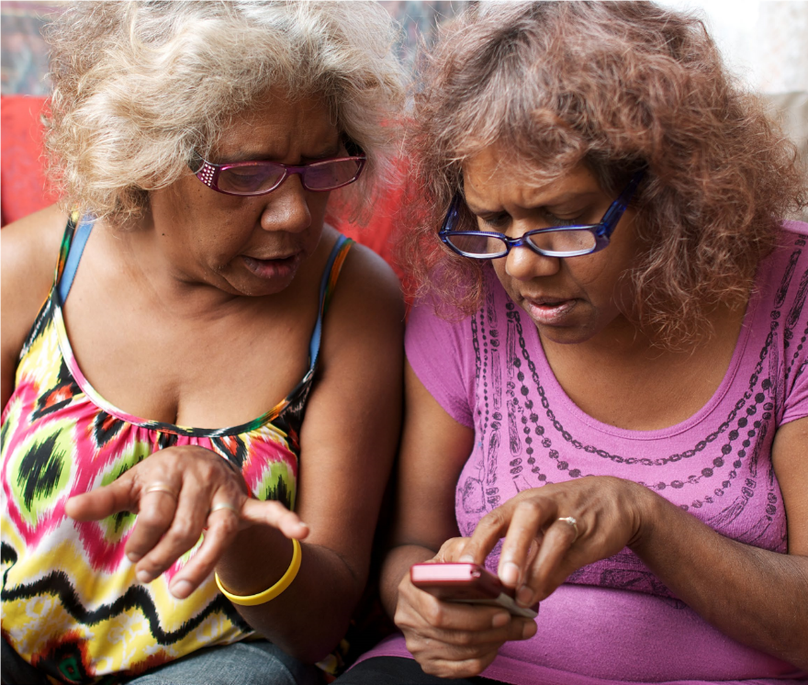
2.4 Fund and develop routine program processes that can identify schools with lower coverage and develop tailored solutions to improve HPV vaccination uptake, including working in partnership with Aboriginal and Torres Strait Islander community-controlled services, peak bodies and community. Fund and support Aboriginal liaison staff with dedicated time in schools to promote engagement with vaccination. Build on the strengths of the ACCHO sector and their leadership to develop tailored solutions that will support the acceptability, community support for, experience and understanding of school-based HPV vaccination among Aboriginal and Torres Strait Islander adolescents.
- Optimise the reach and funding of complementary out-of-school HPV immunisation programs to achieve equity in delivery for all, including Aboriginal and Torres Strait Islander people and medically high-risk populations (catch up).
  - Fund and promote catch-up of an individual’s allocated dose of HPV vaccination for adults 19 and over in medically higher risk groups and for Aboriginal and Torres Strait Islander people.
  - Fund and promote HPV vaccine catch-up strategies with out-of-school Aboriginal and Torres Strait Islander people, their peak bodies, communities and ACCHOs. Ensure equity in availability of catch-up opportunities across jurisdictions and for the most marginalised groups, for example adolescents in youth detention. Consider alternative community locations and providers, for example GP clinic settings, ACCHOs, pharmacies, community events, and Aboriginal Immunisation Officers in Public Health Units. Develop workforce strategies to expand the reach of Aboriginal Health Practitioners.
  - Implement GP and health care provider education, training and quality improvement activities relating to immunisation that support routine use of the Australian Immunisation Register (AIR) data to check HPV vaccination status for all patients aged 14-19 years, address vaccine hesitancy, assess decision-making capacity among vaccine recipients for the decision to vaccinate, and ensure cultural competence to meet the needs of Aboriginal and Torres Strait Islander patients.
- Develop a method to enable annual reporting of HPV vaccination coverage for Aboriginal and Torres Strait Islander people and medically high-risk populations to monitor equity in immunisation.
  - Leverage data linkage through the MADIP to monitor engagement, elimination progress and outcomes for Aboriginal and Torres Strait Islander people, using demographic and other variables and a reference group to develop a community-accepted definition as to whether a person is identified as Aboriginal and/or Torres Strait Islander within the linked dataset. Facilitate dissemination of key findings to Aboriginal and Torres Strait Islander communities in timely and culturally safe ways.

Screening and precancer treatment
- Promote cervical screening regularly with the public and strategically with under-screened groups.
  - Undertake regular targeted, tailored campaigns and activities for under-screened groups including campaigns and activities specifically focussed on and designed by and for Aboriginal and Torres Strait Islander peoples, complemented by evidence-based, inclusive population-wide public awareness activities and mass media, delivered through appropriate channels.¹⁰
  - Work with priority communities, in particular Aboriginal and Torres Strait Islander peoples, including community leaders and community Elders, cervical cancer survivors, ACCHOs and other community-controlled organisations who serve these communities, to co-create, design and test best approaches to reach the community, including the content of campaigns and information materials. Ensure campaigns are informed by the success and implementation strategies from previous campaigns and formative research, noting that materials may need to enhance community health literacy about the purpose and function of the cervix.
  - Trial and utilise technology to support digital invitations, reminders, and navigation to follow-up activities for people with screening results that require further investigation.
- Increase access to screening, colposcopy and follow-up for Aboriginal and Torres Strait Islander peoples by expanding who can offer these services, and where and how they are offered, to improve reach and uptake.
  - Provide a clear pathway to enable appropriately trained registered nurses, Aboriginal and Torres Strait Islander Health Workers and Practitioners, and midwives to independently request and sign the pathology form for a cervical screening test (and be eligible for Medicare reimbursement). Expand the scope of practice for Aboriginal and Torres Strait Islander Health Workers and Aboriginal Health Practitioners to more actively participate in the provision of screening services.
  - Establish a clear national pathway to train and accredit registered nurses and GPs to provide colposcopy.
  - Fund and support ACCHOs to scale promotion, screening and follow up services for and with community.
  - Resource a pilot to scale-up point-of-care HPV testing for remote communities, with links to care. Pilots in remote Aboriginal and Torres Strait Islander communities need to be developed with specific communities to meet their needs. Genuine community engagement, partnership and leadership is critical. See Screening Case Study 2 (The PREVENT Project) for an example.
  - Resource pilots and, where successful, resource scale-up and routine provision of innovative screening models such as peer-led and community-developed services. Work with community-controlled organisations, including ACCHOs, across a range of settings (urban, suburban and regional, as well as remote/very remote as noted in 6.4) to develop models, scale up successful models, and share best practice approaches.

10 Coordinated with actions 2.1 and 8.1

- Collect, use, and release data to enable and monitor equity of access to cervical screening and precancer treatment services for Aboriginal and Torres Strait Islander peoples.
  - Routinely report all program indicators stratified by key population demographics including Aboriginal and/ or Torres Strait Islander status, expand reporting to include all priority populations, and introduce routine monitoring of performance against the WHO precancer treatment indicator.
  - Promote the importance of data collection, training all staff to collect demographic data sensitively in order to improve the recording of all demographic fields (such as Aboriginal and/or Torres Strait Islander status, country of birth and gender), additional fields not yet captured on the National Cancer Screening Register (NCSR) and information that affects clinical management (such as immune status). Aboriginal and Torres Strait Islander people should lead the development of training, and data collection should align with standard questions and ethnicity data protocols, including the National Agreement on Closing the Gap.
  - Enhance clinical information systems in primary health care settings to enable automated uploading for relevant demographic information to integrate with NCSR.
  - Add cancer registry data and screening data from the NCSR into the data assets that are included as enduring linkages in the MADIP. There are limitations with using routinely collected data for this purpose and different data collections may contain differing Aboriginal and/or Torres Strait Islander identification for an individual. Data governance must include Aboriginal and/or Torres Strait Islander people to optimise how to resolve these differences to maximise the utility, safety and validity of the data, from the perspectives of monitoring health care for an individual, and data sovereignty principles.
  - Enable clinicians and healthcare services to readily generate reports that can support continuous quality improvement initiatives through identifying patients who are under-screened and indicating current participation rates to inform efforts that drive engagement.
  - Provide visibility to primary health care providers of current waiting times for colposcopy services, so that this can be factored into referrals and improve timeliness of care. Take into account whether services are culturally safe and appropriate, and individual circumstances, such as the need for travel.

Treatment
- Ensure communities and patients have equitable access to quality information about cervical cancer symptoms and that each cancer patient has tailored information about their diagnosis, intended treatment and planned optimal care pathway.
  - Promote public understanding of cervical cancer signs and symptoms, the role of early detection and the opportunity for cure through working in partnerships with Aboriginal and Torres Strait Islander people and community-controlled services.¹¹
  - Provide information, consultation, and support (for example, utilising the expertise of Aboriginal and Torres Strait Islander health workers and practitioners, nurses, allied health professionals) such that patients and their families/carers fully understand and contribute their own preferences and needs to their individual care pathway, ensuring cultural competence to meet the needs of Aboriginal and Torres Strait Islander patients and their families.
  - Provide patients with the information, access to financial support and support personnel they need to navigate the health system, including informing them that they can have a person/people of their choice accompanying them whenever needed, as well as providing access to Aboriginal and Torres Strait liaison staff within the health system. Expand the inclusion and involvement of Aboriginal and Torres Strait Islander Health Workers and Practitioners within the wider health system to improve cultural safety for Aboriginal and Torres Strait Islander patients.
  - Facilitate continual quality improvement by conducting routine patient-related evaluation measures (PREMs) to assess patient satisfaction, feeding results back to shape training and development of personnel, patientinformation materials and health service systems as appropriate. Aboriginal and Torres Strait Islander people should lead the development of relevant training materials. Ensure information collected captures patient diversity and experiences according to their sex, gender and sexual orientation, ethnicity, Aboriginal and Torres Strait Islander status, and disability status. Ensure this information accords to national standards for data collection.
- Develop and implement a road map of coordinated care, with communities of practice, to optimise the delivery of safe, quality care to all patients.
  - Realise a coordinated approach to patient care from diagnosis to survivorship and palliative care that is tailored to local population needs and diversity. This includes: identifying and meeting the training and resourcing needs of key professionals (including but not limited to ensuring access to culturally safe services and a supportive workforce for Aboriginal and Torres Strait Islander peoples; inclusive and accessible care for those with disability; in-language culturally relevant resources and provision of care for culturally and linguistically diverse communities and; sex, gender and identity-sensitive services and care forLGBTQ+ people and people who are intersex); and supporting culturally safe patient journeys and transition of care between primary, secondary, tertiary and quaternary services.
  - Establish communities of practice, where multidisciplinary teams oversee processes and standards of care, and take responsibility for actively building relationships within and across jurisdictions, ensuring services are culturally safe and appropriate for Aboriginal and Torres Strait Islander peoples. This can enable a level of safety and trust when a patient is required to travel to receive quality care. Tertiary centres should actively nurture relationships with services expert in caring for priority populations (for example, ACCHOs, LGBTQ+ specialised health services).
  - Optimise a hub-and-spoke model ensuring continuity of care for those diagnosed with cervical cancer to bring “quality to patients” where possible (for example palliative care) and “patients to quality” where necessary for highly specialist care (for example brachytherapy), ensuring access to culturally safe services and a supportive workforce for Aboriginal and Torres Strait Islander peoples. Noting that palliative care services should be integrated into all levels of health care systems including primary care.
11 Coordinated with actions 2.1 and 5.1
9.4. Identify and leverage quick wins by translating successful service models to new jurisdictions and ensure longer-term solutions that may require policy change or workforce reforms. Consider models aimed at addressing workforce issues, such as building an additional supportive role for gynaecologic nurses. Genuine partnership with priority populations and communities will improve the provision of culturally safe care and enhance access to treatment.
- Drive improvements in cervical cancer management through a data collection framework supporting systematic monitoring and enhancement of the quality of care, in alignment with the Australian Cancer Plan, the National Aboriginal and Torres Strait Islander Cancer Plan and National Agreement on Closing the Gap.
  - Enhance and harness the data collected in the National Gynaecological Oncology Registry (NGOR) cervical cancer module to inform continuous improvement in care (equity of access, quality, and safety) based on incidence, stage and mortality data, key clinical quality indicators, as well as patient reported evaluation and outcome measures (PROMs). Facilitate dissemination of disaggregated data and key findings to Aboriginal and Torres Strait Islander communities in timely and culturally safe ways.
  - Conduct annual cervical cancer audits using data from the NSCR, cancer registries and NGOR together with HPV genotype information determined and reported for all cervical cancers
  - Consolidate current clinical guidance and quality standards through developing national guidelines for the management of cervical cancer and utilise the NGOR to monitor adherence.
