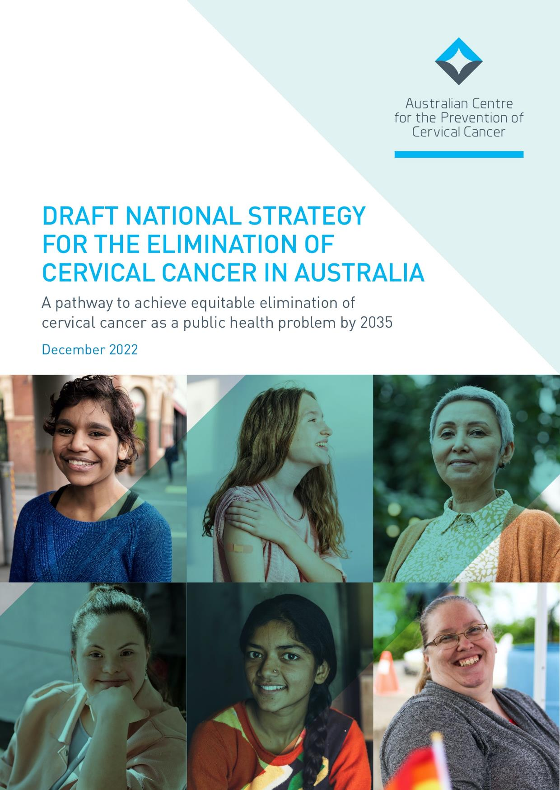
CONTENTS |  | DRAFT NATIONAL STRATEGY FOR THE ELIMINATION OF CERVICAL CANCER IN AUSTRALIA
CONTENTS
GOVERNANCE 1
ACKNOWLEDGEMENT 1
1. EXECUTIVE SUMMARY 2
Australia’s elimination targets 2
Australia’s vision 3
10 strategic priorities to achieve cervical cancer elimination by 2035 3
Next steps 4
2. INTRODUCTION 5
The global context 5
Australia’s current status against the WHO cervical cancer elimination targets 6
Australia’s elimination targets 6
3. VISION 8
4. ACHIEVING EQUITY 9
An equity and a strengths-based approach 9
5. STRATEGIC PRIORITIES AND ACTIONS 12
Timely availability of cancer incidence and mortality data 12
Vaccination 13
Screening and pre-cancer treatment 17
Treatment 20
6. NEXT STEPS 24
7. GLOSSARY 26

On 17 November 2021, the Australian Minister for Health announced a collaboration with the Australian Centre for the Prevention of Cervical Cancer (ACPCC) to develop a National Strategy for the Elimination of Cervical Cancer in Australia (Strategy). This Strategy was funded by the Australian Government, with the aim to inform the Department of Health and Aged Care’s future activities to eliminate cervical cancer as a public health problem in Australia by 2035.
Following extensive consultation, this draft Strategy has been developed and is now available for final public consultation. The final version of the Strategy will then be considered by the Minister for Health and Aged Care the Hon Mark Butler MP.

GOVERNANCE
This draft Strategy was developed with guidance from many partners and subject matter experts.
A Department of Health and Aged Care Steering Committee provided strategic advice and oversight from health policy areas that are important to the success of this Strategy. Additionally, an expert advisory group and four sub-advisory groups were established to represent the health sector and community members across Australia, including priority community groups.
These groups have provided strategic guidance and deep expertise to help develop this Strategy. For our full list of advisory and working group members, refer to the project website https://acpcc.org.au/elimination/

ACKNOWLEDGEMENT
ACPCC, together with our project partners, would like to acknowledge the Traditional Custodians of the lands and waterways on which we all work together to provide the information, supports, and services needed to eliminate cervical cancer across all parts of Australia.
We acknowledge the Elders, past, present and future, and the ongoing connection of Aboriginal and Torres Strait Islander people to this land. We especially thank all Aboriginal and Torres Strait Islander people who have provided their leadership, excellence, and partnership in the development of this Strategy and support the right of Aboriginal and Torres Strait Islander people to lead and develop the initiatives needed to support the health and wellbeing of their own communities.
Thank you to all our partners, stakeholders, and subject matter experts for their contribution and guidance in the development of the National Strategy for the Elimination of Cervical Cancer in Australia.

1. EXECUTIVE SUMMARY
The National Strategy for the Elimination of Cervical Cancer (Strategy) outlines Australia’s commitment to achieving equitable elimination of cervical cancer as a public health problem by 2035, and the objectives and actions needed to achieve this goal.
Australia has aligned its goal of achieving elimination of cervical cancer with the World Health Organization’s (WHO) goal; the agreed elimination threshold is below four cases per 100,000 women in all countries worldwide within the next century. To put countries on the path to elimination, the WHO set three targets that each country should achieve by 2030 and then maintain and improve upon in the coming decades, the so-called 90:70:90 targets. These targets have been set for all countries worldwide, regardless of current income, Human Papillomavirus (HPV) vaccination and cervical screening status.
WHO targets*
- 90% of girls to be fully vaccinated with the HPV vaccine by 15 years of age
- 70% of women to be screened by 35 and again by 45 years of age using a high precision test i.e., an HPV polymerase chain reaction (PCR) test
- 90% of women identified with cervical disease receive treatment for precancerous lesions or management of invasive cancer
* The WHO 2030 targets have been developed for a global context, particularly for Low- and Middle-income countries and therefore focus only on cis-gender girls and women. We respectfully acknowledge that these targets may not be inclusive of all people with a cervix as they are currently written.
The Australian Strategy aligns with and builds upon the associated targets of the WHO Global Strategy across HPV vaccination, cervical screening, and treatment, often called the ‘three pillars of elimination’.
Whilst this Strategy focuses on cervical cancer elimination, it is worth noting that there are broader benefits of HPV vaccination given HPV also causes other cancers in the vulva, vagina, penis, anus, and oropharynx.
In 2020, Australia reported that 80.5% of girls were fully vaccinated by age 15; 67.3% of people aged 45 to 49 years participated in cervical screening in 2018 to 2021 (and participation was 62% of people aged 25 to 74 years); 85.8% of those with precancer identified in 2020 received treatment within six months; and Queensland data showed over 90% treatment rates for cervical cancer (no national data available).
Given Australia’s track record of success in cervical cancer prevention and control, the global targets are well within our reach. This Strategy therefore builds upon the WHO targets.

AUSTRALIA’S ELIMINATION TARGETS
By 2030, Australia will achieve the following targets:
- Extending the 90% HPV vaccination target to include boys as well as girls
- Extending the 70% screening target to 5-yearly participation for eligible 25- to 74-year-olds, rather than twice in a lifetime and
- Lifting the target for treatment to 95%, as a commitment to achieving elimination as equitably as possible, leaving no-one behind.
As well as achieving these targets, this Strategy aims to strengthen the positive experience of eligible people during cervical cancer prevention and care.
Eliminating cervical cancer in Australia by the year 2035 could make Australia the first country in the world to actively achieve this goal.
This Strategy should be read in conjunction with the Australian Cancer Plan, the National Preventive Health
Strategy 2021-2030 and the Aboriginal and Torres Strait Islander Cancer Plan being developed by the National Aboriginal Community Controlled Health Organisation. Many challenges and their solutions for cervical cancer also apply broadly to other cancers and will also be considered in both documents.
As cervical cancer is almost entirely preventable, any disparities in cervical cancer outcomes are largely due to inequity. It is therefore vital that this Strategy is concurrent with whole-of-systems approaches to address wider societal inequities and determinants of health in Australia. This Strategy aligns with the vision, and cervical cancer prevention related goals, outlined in the National Preventive Health Strategy. This Strategy focuses exclusively on priorities and actions that are specific to eliminating cervical cancer in Australia.

AUSTRALIA’S VISION
Elimination is within Australia’s reach, and, with timely commitment and action, this Strategy’s vision can be achieved:
An Australia where preventable cervical cancer is a disease of the past, in which Australia’s diverse communities have equitable access to information and to culturally safe and inclusive vaccination, screening and treatment services.
In line with the vision, this Strategy:
- Addresses current inequities and does not entrench further inequity
- Takes a strengths-based, community-led approach
- Recognises the importance of active partnerships with civil society, Aboriginal Community Controlled Health
Organisations and other priority population groups to co-design and deliver community initiatives and services
- Promotes cultural appropriateness, inclusivity, safety, and trust, and
- Focuses on person-centred approaches.

10 STRATEGIC PRIORITIES TO ACHIEVE CERVICAL CANCER ELIMINATION BY 2035
To reach Australia’s 2030 targets and achieve cervical cancer elimination by 2035, Australia will focus on 10 strategic priorities:
Timely availability of cancer incidence data
- Ensure that Australia has access to timely and accurate cervical cancer incidence and mortality data.
Vaccination
- Optimise the delivery of school-based HPV immunisation programs in all jurisdictions to maximise equity and achieve high coverage.
- Optimise the reach and funding of complementary out-of-school HPV immunisation programs to achieve equity in delivery for all, including priority and medically high-risk populations (catch up).
- Develop a method to enable annual reporting of HPV vaccination coverage for priority and medically high-risk populations to monitor equity in immunisation.
Screening and pre-cancer treatment
- Promote cervical screening regularly with the public and strategically with under-screened groups.
- Increase access to screening, colposcopy and follow-up by expanding who can offer these services, and where and how they are offered, to improve reach and uptake.
- Collect, use, and release data to enable and monitor equity of access to cervical screening and precancer treatment services.
Treatment
- Ensure communities and patients have equitable access to quality information about cervical cancer symptoms and that each cancer patient has tailored information about their diagnosis, intended treatment and planned optimal care pathway.
- Develop and implement a road map of coordinated care, with communities of practice, to optimise the delivery of safe, quality care to all patients.
- Drive improvements in cervical cancer management through a data collection framework supporting systematic monitoring and enhancement of the quality of care, in alignment with the Australian Cancer Plan.

NEXT STEPS
This Strategy is the result of evidence synthesis, quality insights and ideas from multiple stakeholders. Continued engagement is important to bring the strategic priorities and actions to life and uphold the right of women and people with a cervix to high quality, people-centred health services and care.
Key elements for implementation of this Strategy include:
- Coordinated efforts to expand and establish new, strategic, adaptable, and innovative partnerships to support and sustain implementation. Working with communities that understand the diverse nature of the implementation challenges will honour the commitment of this Strategy to tackling inequities.
- Close alignment with the other emerging targets of key areas of health reform and with whole-of-government approaches by the Australian Government. This includes the Australian Cancer Plan, Aboriginal and Torres Strait Islander Cancer Plan, National Preventive Health Strategy, Primary Health Care 10 Year Plan, National Aboriginal and Torres Strait Islander Health Plan, and the National Agreement on Closing the Gap.
- Transparent accountability mechanisms to maintain momentum and uphold responsibility. Interim milestones which best deliver the achievement of equity for 2025 and 2030 should be identified from the strategic actions. These interim milestones should be used in conjunction with the annual C4 Cervical Cancer Elimination Report to track progress towards cervical cancer elimination and enable Australia to report back against global commitments to the WHO Global Strategy.
- Prioritising timeliness of national cervical cancer incidence data to be able to confirm attainment of the elimination threshold in Australia. We have the potential to be the first country in the world to actively achieve elimination. Knowing when the goal has been achieved is currently impacted by a four-to-five-year delay in the availability of national cervical cancer incidence data.

2. INTRODUCTION
This draft Strategy for the Elimination of Cervical Cancer in Australia (Strategy) outlines Australia’s commitment to achieving equitable elimination of cervical cancer as a public health problem by 2035. Further it outlines objectives and actions needed to achieve this goal.

THE GLOBAL CONTEXT
In 2018, the World Health Organization (WHO) first proposed that cervical cancer could be eliminated as a public health problem (see Box 1) and in 2020, following endorsement from Member States, the WHO’s strategy of achieving the elimination of cervical cancer was released, with Australia playing a major role in the development of the Global Strategy, see Appendix 8.1.
Box 1: The meaning of elimination
Elimination of any disease as a public health problem is achieved when there are fewer cases than an agreed low threshold.
The World Health
Organization and member states have agreed on an elimination target of below 4 cases of cervical cancer for every 100,000 women.
Elimination differs from eradication, which is when there are no recorded cases.
Crucially, when a disease is eliminated, prevention measures need to continue to maintain the low rates of disease.
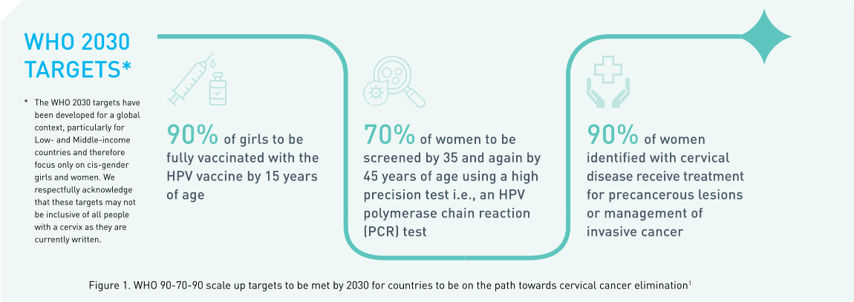
The Global Strategy defines the threshold for elimination as below four cases of cervical cancer per 100,000 women and associated 2030 global scale up targets for elimination for vaccination, screening and treatment, to put countries on the path to elimination, the so-called 90:70:90 targets (shown in Figure 1). These are supported by modelling demonstrating that implementation of the Global Strategy can achieve elimination in all countries within the next 100 years.¹ These targets have been set for all countries worldwide regardless of income and current HPV vaccination and cervical screening status.
There has been remarkable progress made in technologies available for both primary prevention (through HPV vaccination), secondary prevention (through cervical screening using HPV testing and treatment of pre-cancer) and management of invasive cancer. Achieving a cervical cancer incidence rate of less than or equal to four per 100,000 is therefore realistic.
1 Global strategy to accelerate the elimination of cervical cancer as a public health problem. Geneva: World Health
Organization; 2020. Licence: CC BY-NC-SA 3.0 IGO. Available at: https://www.who.int/publications/i/item/9789240014107

AUSTRALIA’S CURRENT STATUS AGAINST THE WHO CERVICAL CANCER ELIMINATION TARGETS
Australia reported that 80.5% of girls were fully vaccinated by age 15 in 2020; 67.3% of people aged 45 to 49 years participated in cervical screening in 2018 to 2021 (participation was 62% of people aged 25 to 74 years); 85.8% of those with precancer identified in 2020 received treatment within 6 months; and Queensland data showed over 90% treatment rates for cervical cancer (no national data available) as highlighted in Figure 2.

AUSTRALIA’S ELIMINATION TARGETS
Given Australia’s track record of success in cervical cancer prevention and control, this Strategy builds upon the Global WHO targets with more ambitious but still achievable targets that are appropriate to our setting:
- Extending the 90% HPV vaccination target to include boys as well as girls
- Extending the 70% screening target to 5-yearly participation for eligible 25- to 74-year-olds, rather than twice in a lifetime and
- Lifting the target for treatment to 95%, as a commitment to achieving elimination as equitably as possible, leaving no-one behind.
As well as achieving these targets (Figure 3), this Strategy aims to strengthen the positive experience of eligible people during the cervical cancer prevention and care.

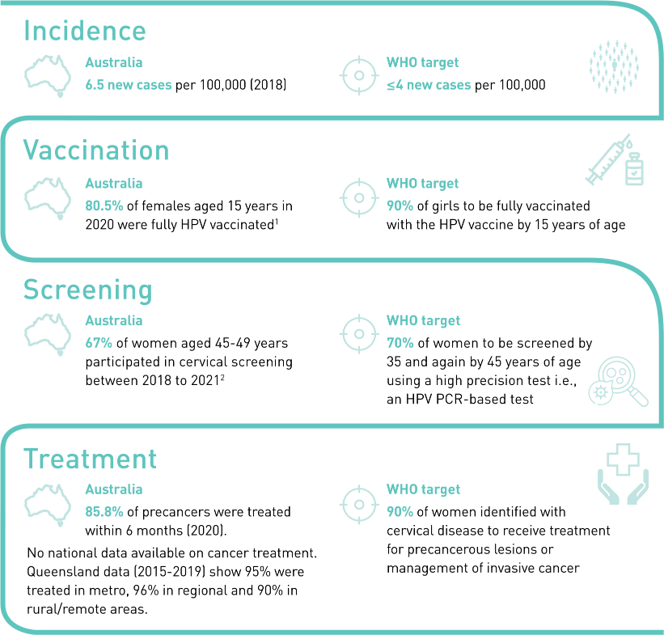
  - Australian Immunisation Register (AIR) via the National Centre for Immunisation Research and Surveillance. Sex (Female) as recorded on AIR (Medicare derived).
  - Australian Institute of Health and Welfare (2022). Cancer screening programs: quarterly data, AIHW, Australian Government, accessed 26 October 2022.
Figure 2. Australia’s current status against the WHO cervical cancer elimination targets
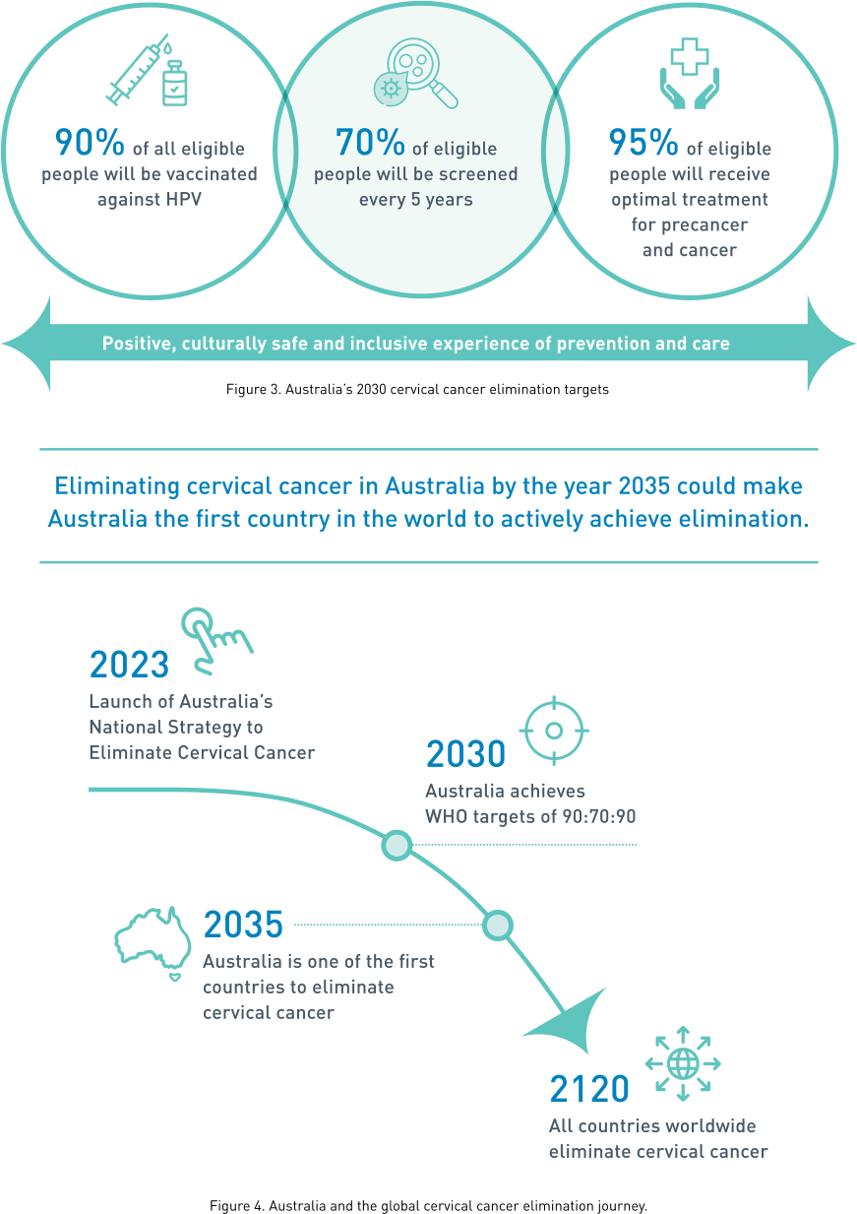

3. VISION
Our vision is of an Australia where preventable cervical cancer is a disease of the past, in which Australia’s diverse communities have equitable access to information and to culturally safe and inclusive vaccination, screening and treatment services.
By implementing this Strategy, Australia will create an environment in which all people have inclusive and equitable access to vaccination, screening, pre-cancer treatment and cancer management services that meet their needs. This will make preventing, curing, and surviving cervical cancer a reality ultimately leading to elimination by 2035. This Strategy also outlines the systems that need to be developed to enable timely, accurate and transparent reporting of progress towards elimination and maintenance of this status in the years beyond.

4. ACHIEVING EQUITY

AN EQUITY AND A STRENGTHS-BASED APPROACH
Cervical cancer is almost entirely a disease of inequity; without systematically addressing inequities, Australia will not achieve elimination. Cervical cancer occurs most commonly in people who do not have access to culturally appropriate and inclusive information, vaccination services and/or screening services. This may be compounded by limited access to culturally safe, inclusive, and high-quality treatment services.
Throughout the development of this Strategy, the need to address inequities has been recognised, starting with the approach to governance, the structure of the sub-advisory groups, the development of the Technical Paper, the consultation process and the structure and content of this document.
This Strategy aims to address known disparities in access to services and outcomes, and to build upon the many strengths of our existing health systems and communities. While this Strategy focuses on health systems and care to prevent and control cervical cancer, it recognises that it is vital to have concurrent whole of systems approaches to address wider societal inequities and social determinants of health in Australia.
Every level of our health systems need to ensure that the services it provided meet the needs of all people in their respective communities. Eliminating cervical cancer requires genuine community-led models to ensure that services are truly fit for purpose.
This Strategy embraces a set of five principles to guide equitable and impactful action at national, state and territory, and local level. Each strategic priority and action recommended in this Strategy:
- Aims to address existing inequities and to not entrench further inequity
- Takes a strengths-based, community-led approach
- Embraces active partnerships with civil society, community-controlled organisations and priority population groups to co-design and deliver community initiatives and services 4. Has cultural appropriateness, safety, and trust at its core, and
5. Focuses on person-centred approaches.
This Strategy recognises the right to equitable prevention and care for all people, including but not limited to:
- Aboriginal and Torres Strait Islander people
- People from culturally and linguistically diverse backgrounds (including immigrants, refugees, and asylum seekers)
- People who identify as lesbian, gay, bisexual, transgender, queer, and/or asexual
- People who are intersex
- People with disability, and
- People regardless of their access to economic resources and housing or remoteness of residence.
This Strategy has dedicated strategic priorities and actions for each of these priority populations (refer to Appendices 8.2-8.6). This Strategy also recognises that some people identify with a number of populations which can expose them to compounding forms of health inequity, discrimination and marginalisation.
“Everyone who is presenting with advanced cervical disease is, by definition, a part of a priority population in that they are under-screened or unscreened.”
- Kim Hobbs, Clinical Specialist Social Worker, Westmead Hospital, NSW
This Strategy should also be read in conjunction with the Australian Cancer Plan, the National Preventive Health
Strategy and the forthcoming Aboriginal and Torres Strait Islander Cancer Plan being developed by the National Aboriginal Community Controlled Health Organisation. Many issues in cervical cancer also apply broadly to other cancers and will be considered in the Australian Cancer Plan and the Aboriginal and Torres Strait Islander Cancer Plan.

Aboriginal and Torres Strait Islander peoples, communities and organisations
This Strategy acknowledges the prevailing strength and endurance of Aboriginal and Torres Strait Islander people, their families and communities as the world’s oldest living cultures. It acknowledges that colonisation, enduring dispossession and racist policies have – and continue to – actively produce unacceptable health inequities.
In line with the commitment from all Australian governments and Aboriginal and Torres Strait Islander representatives in the National Agreement on Closing the Gap (National Agreement), this Strategy recognises its obligations to overcome the entrenched inequities and inequality faced by too many Aboriginal and Torres Strait Islander people in relation to cervical cancer. This is a part of ensuring Aboriginal and Torres Strait Islander rights to health and a future free from this almost entirely preventable disease.
The four priority reforms outlined in the National Agreement provide a powerful roadmap to strong and positive ways of working together towards cervical cancer elimination: 1) formal partnerships and shared decision making, 2) building the community-controlled sector, 3) transforming government organisations and 4) shared access to data and information at a regional level.
The Aboriginal Community Controlled Health sector plays a vital role in realising a future free from cervical cancer through exceptional leadership in holistic care with strong Aboriginal and Torres Strait Islander governance and self-determination.
Addressing cervical cancer inequities is at the core of achieving cervical cancer elimination for all, including Aboriginal and Torres Strait Islander women and people with a cervix. Addressing inequities requires recognition of the ongoing and unwavering commitment, self-determination and leadership of Aboriginal and Torres Strait Islander people, communities and organisations.
Refer to Appendix 8.2: Strategic priorities and actions for Aboriginals and Torres Strait Islander people.

CASE STUDY 1
My story, Ashlee Williams
Cervical cancer survivor and consumer representative on the
Treatment Sub-Advisory Group for the National Strategy for the
Elimination of Cervical Cancer in Australia
“Thank you for this amazing opportunity to have a say and share my voice on behalf of First Nations People, young women, my family and community. I feel it is such an honour and this really does help me feel that my experience was for a greater purpose.”
I am a very proud Wadi Wadi, Dharawal and Wandi Wandian young woman of the Yuin Nation, from the south coast of NSW.
I am the second youngest of 11. I have seven sisters and three brothers. My dad is the eldest of 16 and my mum the eldest of four. Big immediate family.
At the time of my diagnosis, I was a 26-year-old mum of two children. I suffered unaware from symptoms of cervical cancer for years. I was referred to Chris O’Brien Lifehouse in Sydney – three hours away from my home – where my cancer was identified as advanced. Radiation, brachytherapy, and chemotherapy had to begin immediately. I was away from family, my children and my community for four months.
I had an aggressive tumour, over 5cm. The cancer had already reached my lymph nodes and invaded my whole cervix. I was deemed inoperable.
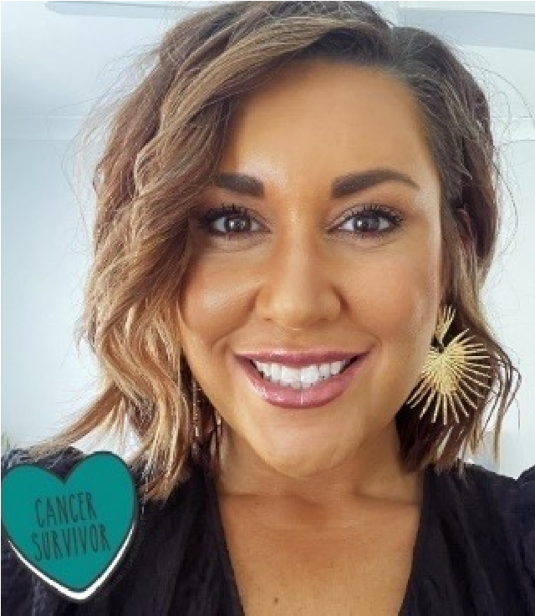
As a survivor looking back on the whole process from finding out information about the symptoms, the treatments, therapies, appointments … it is a serious task. I was lucky to have my partner caring and managing the steps. All the staff we met were so compassionate, empathetic and welcoming, especially for the two of us who are First Nations people.
I worry for those who are not so lucky and are battling their cancer journey solo. We need a platform where information is easily accessible. We need community Champions to give us hope. We need agencies to provide personal, individualised care. We need the Federal Government to support life-saving treatments.
We need health practitioners and specialists to use language that we understand and not medical jargon. We need everyone, from administrative staff to specialists and senior leaders, to have ongoing cultural awareness training. We need to normalise cancer conversations in the community and in education.
Key things to consider are:
- My experience is not isolated – First Nations women are seven times more likely to receive sub-optimal care and late detection of cervical cancer
- Trials and services need to be equitably accessible
- Elders, influential and trusted healthcare practitioners and/or survivors, need to be invited into the conversations

5. STRATEGIC PRIORITIES AND ACTIONS
This Strategy is centred around 10 strategic priorities (highlighted in boxes) that are accompanied by a set of actions. They were informed by the findings of the Technical Paper and the consultation process. The potential impact of these strategies and actions, and examples of initiatives and approaches that could be scaled up, are illustrated with cases studies selected from the consultation process.
This Strategy also aims to strengthen the positive experiences of eligible people across cervical cancer prevention and care. This includes facilitating increased participation in immunisation programs, removing barriers to screening, and encouraging people to seek timely treatment. Common elements across this Strategy include:
- The ongoing need to improve access, cultural safety and inclusivity across the health system.
- The need to work in partnership with communities to effectively communicate with and inform them about the vision, timeline and goal of cervical cancer elimination.
- A focus on training and education of the workforce to increase cultural safety, provide trauma informed care, and reduce the stigma and discrimination that people from priority populations often feel when accessing health care.
- The need for improvements in data to allow more effective and meaningful monitoring and evaluation, supporting the improvement of services and the degree to which these services meet the needs of priority populations.

TIMELY AVAILABILITY OF CANCER INCIDENCE AND MORTALITY DATA

- Ensure that Australia has access to timely and accurate cervical cancer incidence and mortality data.

Actions
- Ensure that Australia has access to timely and accurate cervical cancer incidence and mortality data.
  - Review the timeliness of cervical cancer notifications from each of the state and territory cancer registers to the Australian Cancer Database (ACD) and investigate opportunities to accelerate the availability of national cervical cancer data, aiming to have it available by November 1st of each calendar year, for the preceding year.
  - Ensure that this accelerated reporting also includes currently reported stratifications including rates for Aboriginal and Torres Strait Islander people, by remoteness, by socio-economic status, and by state and territory.
  - Build on the currently available breakdowns to ensure timely reporting of cancer incidence and mortality for Aboriginal and Torres Strait Islander people in all jurisdictions, people of culturally and linguistically diverse backgrounds, people with disability, people who identify as lesbian, gay, bisexual, transgender, queer, and asexual, people who are intersex, and other priority populations as these data become available.
  - Add cancer registry data into the data assets that are included as enduring linkages in the Multi-Agency Data Integration Project (MADIP) to facilitate this. When cancer data are included in MADIP, consider reporting on individual-level socioeconomic status, rather than area-level measures.

VACCINATION
- Optimise the delivery of school-based HPV immunisation programs in all jurisdictions to maximise equity
and achieve high coverage.
- Optimise the reach and funding of complementary out-of-school HPV immunisation programs to achieve
equity in delivery for all, including priority and medically high-risk populations (catch up).
- Develop a method to enable annual reporting of HPV vaccination coverage for priority and medically high
risk populations to monitor equity in immunisation.

Actions
- Optimise the delivery of school-based HPV immunisation programs in all jurisdictions to maximise equity and achieve high coverage.
  - Review and revise communication planning materials and provide educational opportunities in schools to improve adolescent, parent, family, and caregiver as well as school staff understanding of HPV vaccination and the elimination strategy. This should occur through strong partnerships between health and education to provide an integrated approach to HPV vaccination literacy that spans key learning areas, is supported by a whole-of-school approach, and fosters health literacy.²
  - Utilise technology to support digital reminders and put clear communication and follow up protocols in place to ensure that the school and the consenting carer are aware when a vaccine dose has been missed and receive clear remedial instructions.
  - Provide in-school vaccination catch up opportunities where possible. Should a single dose vaccination strategy be introduced, the implementation plan should ensure that the reduction in required doses does not reduce opportunities for in-school vaccination and that the evidence of equal efficacy is communicated clearly to providers and the community.
  - Fund and develop routine program processes that can identify lower coverage schools and develop tailored solutions to improve local coverage.
2 Coordinated with actions 5.1 and 8.1
- Optimise the reach and funding of complementary out-of-school HPV immunisation programs to achieve equity in delivery for all, including priority and medically high-risk populations (catch up).
  - Fund and promote catch up of an individual’s allocated dose of HPV vaccination for adults aged 19 and over in medically higher risk groups and for priority populations.
  - Fund and promote HPV vaccine catch up strategies with out-of-school and priority populations, their representatives and service providers. Ensure equity in availability of catch-up opportunities across jurisdictions and for the most marginalised groups, for example, adolescents in youth detention. Consider alternative community locations and providers, for example, GP clinic settings, Aboriginal Community Controlled Health Organisations, pharmacies and community events. Develop workforce strategies to expand reach, for example, Aboriginal Health Practitioners and sexual health nurses.
  - Implement GP and health care provider education, training and quality improvement activities relating to immunisation that support routine use of the Australian Immunisation Register (AIR) data to check HPV vaccination status for all patients aged 14-19 years, address vaccine hesitancy and assess mature minor competence.
- Develop a method to enable annual reporting of HPV vaccination coverage for priority and medically high-risk populations to monitor equity in immunisation.
  - Leverage data linkage through the MADIP, to monitor engagement, elimination progress and outcomes for priority populations, using demographic and other variables to define priority populations and medically higher risk groups within the linked dataset.

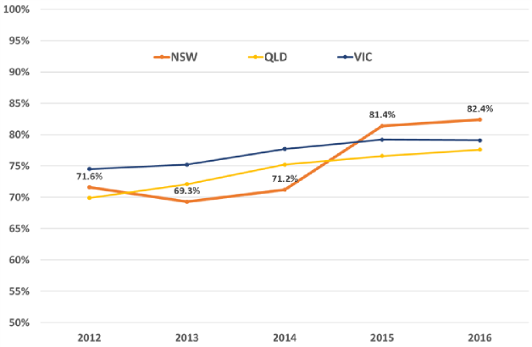
VACCINATION CASE STUDY 1:

NSW school-based catch-up program
ISSUE: Since the HPV immunisation program started in 2007 in Australia, school programs have experienced challenges in ensuring that students complete the full course. Studies indicated that many parents were not aware that a dose had been missed nor how to organise a catch-up dose through primary care.^{3,4} In NSW in 2011 there was a 10% gap between dose 1 and 3 despite routine processes to advise parents when a dose was missed and a follow up letter from the HPV vaccine register the following year.⁵
From 2012, NSW progressively increased catch-up opportunities so that students who receive at least one dose of HPV vaccine in Year 7 can receive the second (and now final) dose during Year 8. This has significantly improved course completion rates.
SOLUTION: The NSW Department of Health worked closely with education authorities to facilitate a new process by which those who had missed a dose in Year 7 were able to catch up that dose in the subsequent school year. Following implementation in 2012, dose 3 coverage rose to 81.4%, an 11-percentage point improvement.⁵ As shown below, there was no similar improvement in other jurisdictions (the two second-most populous states of Victoria and Queensland are shown, where more gradual improvements in coverage were achieved over the period.)
CONCLUSION: Routinely providing catch up doses in the school setting, rather than requiring parents to organise these through primary care, significantly improves coverage and course completion.
Figure 5. Dose 3 coverage in NSW, Queensland and Victoria, in females by age 15 between 2012 and 2016.⁵ The NSW 2015 15-year-old cohort were the first offered catch up vaccination in school the following year (age 12 in 2012).
- Staples C, Butler M, Nguyen J, Durrheim DN, Cashman P, Brotherton JML. Opportunities to increase rates of human papillomavirus vaccination in the New South Wales school program through enhanced catch-up. Sex Health. 2016 Nov;13(6):536-539. doi: 10.1071/SH15132.
- Watson M, Lynch J, D’Onise K, Brotherton JML. Barriers to better three-dose coverage with HPV vaccination in school-based programs. Aust N Z J Public Health 2014;38(1):91-92.
- Historical Human Papillomavirus (HPV) immunisation coverage rates. Available at: https://www.health.gov.au/resources/publications/historical-humanpapillomavirus-hpv-immunisation-coverage-rates

VACCINATION CASE STUDY 2:
Developing Optimised Vaccination Engagement in

Specialist Schools for HPV – the DOVES (HPV) project
“As we edge closer to the elimination of cervical cancer in Australia, we must ensure that no one is left behind and that we address vaccine equity so that no-one suffers this almost entirely preventable disease”
- Professor Margie Danchin, Group Leader, Vaccine Uptake, Murdoch Children’s Research Institute
Young people with disabilities experience lower HPV vaccination rates than their typically developing peers⁶ and also face additional barriers to cervical screening and accessing cancer treatment. As such, HPV vaccination provides a crucial safety net against HPV-related cancers in this vulnerable population. There is limited understanding of the multiple barriers to HPV vaccine uptake in specialist school-based programs and how best to address them to ensure increased vaccine confidence and uptake.
The Cancer Council Victoria and the Murdoch Children’s Research Institute, funded by the Victorian Department of Health, undertook research to identify barriers to vaccine uptake among adolescents with disabilities in Victorian specialist schools. Formative qualitative research with adolescents with disabilities, their families, school staff and council staff identified a complex array of access and acceptance barriers in both urban and rural schools.
Drawing on the insights and relationships generated from the research, co-design workshops are being conducted with adolescents, parents, schools, and council staff to design tailored strategies to increase HPV and routine vaccine uptake.
Future phases of this project will pilot these strategies in schools, and then develop and promote best practice guidelines.
6 O’Neill J, Newall F, Antolovich G, Lima S, Danchin M. Vaccination in people with disability: a review. Hum Vaccin Immunother. 2020;16(1):7-15. doi: 10.1080/21645515.2019.1640556.

SCREENING AND PRE-CANCER TREATMENT

Actions

- Promote cervical screening regularly with the public and strategically with under-screened groups.
  - Undertake regular targeted tailored campaigns and activities for under-screened groups complemented by evidence-based, inclusive population-wide public awareness activities and mass media delivered through appropriate channels.⁷
  - Work with priority communities, including respected members, cervical cancer survivors, and communitycontrolled organisations who serve these communities, to co-create, design and test best approaches to reach the community, including the content of campaigns and information materials. Ensure campaigns are informed by the success and implementation strategies from previous campaigns and formative research, noting that materials may need to enhance community health literacy about HPV and cervical cancer.
  - Trial and utilise technology to support digital invitations, reminders, and navigation to follow up activities for people with screening results that require further investigation.
- Increase access to screening, colposcopy and follow-up by expanding who can offer these services, and where and how they are offered, to improve reach and uptake.
- Promote cervical screening regularly with the public and strategically with under-screened groups.
- Increase access to screening, colposcopy and follow-up by expanding who can offer these services, and
where and how they are offered, to improve reach and uptake.
- Collect, use, and release data to enable and monitor equity of access to cervical screening and precancer
treatment services.
  - Provide a clear pathway to enable appropriately trained registered nurses, Aboriginal Health Workers, and midwives to be able to independently request and sign the pathology form for a cervical screening test (and be eligible for Medicare reimbursement).
  - Establish a clear national pathway to train and accredit registered nurses and GPs to provide colposcopy.
  - Resource a pilot to scale up point-of-care HPV testing, with links to care, for remote communities.
  - Resource pilots and, where successful, resource scale-up and routine provision of innovative screening models such as peer-led and community-developed services. Work with community-controlled organisations to develop models, scale up successful models, and share best practice approaches.
7. Collect, use, and release data to enable and monitor equity of access to cervical screening and precancer treatment services
  - Routinely report all program indicators stratified by key population demographics, expanding reporting to include all priority populations, and introduce routine monitoring of performance against the WHO precancer treatment indicator.
  - Promote the importance of data collection, training all staff to collect demographic data sensitively in order to improve the recording of all demographic fields (Aboriginal and/or Torres Strait Islander status, country of birth, gender), including additional fields not yet captured on the National Cancer Screening Register (NCSR) and information that affects clinical management such as immune status.
  - Enhance clinical information systems in primary health care settings to enable automated uploading for relevant demographic information to integrate with NCSR.
  - Add cancer registry data and screening data from the NCSR into the data assets that are included as enduring linkages in the MADIP.
  - Enable clinicians and healthcare services to readily generate reports that can support continuous quality improvement initiatives by identifying patients who are under-screened and indicate current participation rates to inform efforts that drive engagement.
  - Provide visibility to primary care providers of current waiting times for colposcopy services so that this can be factored into referrals and improve timeliness of care.
7 Coordinated with actions 2.1 and 8.1

SCREENING CASE STUDY 1:

CheckOUT: Community-designed solutions to overcome barriers to care
“I liked being asked about language for my anatomy – I’ve never been asked that before and I never even thought it was ok to ask doctors to use different language.”
ACON is Australia’s largest community-based LGBTQ+ health organisation, located in NSW. In 2015/16, ACON commenced health promotion work to increase awareness about cervical screening and improve screening rates among LGBTQ+ people with a cervix.
Starting with a project called At Your Cervix, ACON evolved this work into an inclusive, narrative-driven, award winning cervical screening campaign directed at sexuality and gender diverse people with a cervix: The Inner Circle.
Linked to the aims of the campaign, ACON and Family Planning NSW (FPNSW) developed a clinical service that directly addressed barriers to cervical screening among LGBTQ+ people. This service, CheckOUT, was co-designed by community and clinicians to address and remove barriers in each element of the clinical service.
Experiences of discrimination, judgement, needing to ‘educate the clinician’ and inappropriate language were identified as strong deterrents for LGBTQ+ people accessing cervical screening. ACON and FPNSW co-designed training for both clinicians and peer workers to ensure knowledge, skills and competence within the service were aligned to providing a safe, inclusive, culturally competent and clinically excellent service.
Peer workers provide leadership within the clinic which is immediately reassuring to clients. The Peer greets the client, and asks them to fill out a registration form, which allows the client to select their pronouns, gender, sex assigned at birth and intersex status. Following trauma-informed practices and health expertise, the Peer then guides the consultation, explaining and sign-posting each step, reversing the onus of ‘education burden’ often felt by LGBTQ+ people in clinical settings. The service user experience is one of seamless cooperation by the Peer workers and the nurse.
Demand for this service exceeded expectations. In client surveys, the service received almost 100% satisfaction ratings, with significant feedback expressing relief and happiness with the service. Working in partnership, community and clinicians can design and deliver the highest quality healthcare that puts the person at the centre – and in more control – of their health care experience. CheckOUT is an important model for consideration with other priority populations who are key to Australia reaching its cervical cancer elimination goals.
“The entire experience was awesome (I know it’s strange to say that a medical check-up was awesome) but the people there were so, so nice, understanding, and very informative. They were all respectful and I felt no shame when sharing my personal details. They’re there to genuinely help and that’s exactly how it felt. 10/10 *applause*.”

SCREENING CASE STUDY 2:
The Prevent Project,
University of Notre Dame Australia (WA)

The Prevent Project, led by the University of Notre Dame Australia in partnership with other leading experts in cervical screening, is trialling a portable screening and same day colposcopic assessment model in the Kimberley region. It allows eligible participants to collect their own screening sample, receive a test result within an hour of testing, and access a specialist doctor during the same visit. This service is delivered by the Kimberley Obstetrics and Gynaecology Outreach Team who provide medical care to some of the most remote communities in the world. Through community invitation (critical to success), this service model has been offered to participants who attend the Broome Regional Aboriginal Medical Service (an Aboriginal Community Controlled Health Organisation), or who reside in the Warmun, Beagle Bay and Bidyadanga communities.
To date, approximately 100 Aboriginal and/or Torres Strait Islander people have been screened, and our anecdotal evidence suggests that participants acceptability and preference for this service model is very high and appears to be attracting women who were not participating in the standard screening program.
Further information and updates can be viewed at: https://www.thepreventproject.com/. The final project evaluation will be released in early 2023.

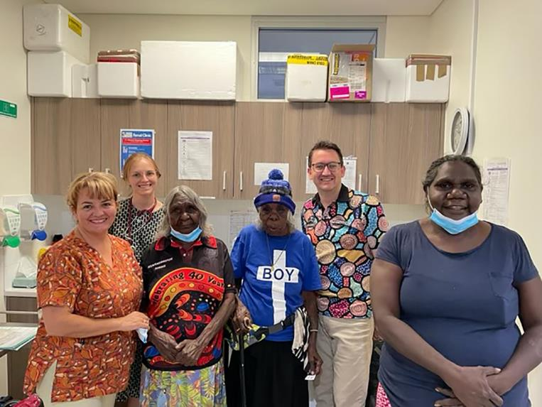

TREATMENT
8. Ensure communities and patients have equitable access to quality information about cervical cancer symptoms and that each cancer patient has tailored information about their diagnosis, intended treatment and planned optimal care pathway.
9. Develop and implement a road map of coordinated care, with communities of practice, to optimise the delivery of safe, quality care to all patients.
10. Drive improvements in cervical cancer management through a data collection framework supporting systematic monitoring and enhancement of the quality of care, in alignment with the Australian Cancer Plan.

Actions
- Ensure communities and patients have equitable access to quality information about cervical cancer symptoms and that each cancer patient has tailored information about their diagnosis, intended treatment and planned optimal care pathway.
  - Promote public understanding of cervical cancer signs and symptoms, the role of early detection, and the opportunity for cure.⁸
  - Provide information, consultation and support (for example, utilising the expertise of nurses and allied health professionals) such that patients and their families/carers fully understand and contribute their own preferences and needs to their individual care pathway.
  - Provide patients with the information, access to financial support and support personnel needed to navigate the health system, including informing them that they can have a person/people of their choice accompanying them whenever needed.
  - Enable incremental improvement by conducting routine patient-related evaluation measures (PREMs) to assess patient satisfaction, feeding results back to shape training and development of personnel, patient information materials and health service systems as appropriate. Ensure information collected captures patient diversity and experiences according to their sex, gender and sexual orientation, ethnicity, Aboriginal and Torres Strait Islander status and disability. Ensure this information accords to national standards for data collection.
8 Coordinated with actions 2.1 and 5.1 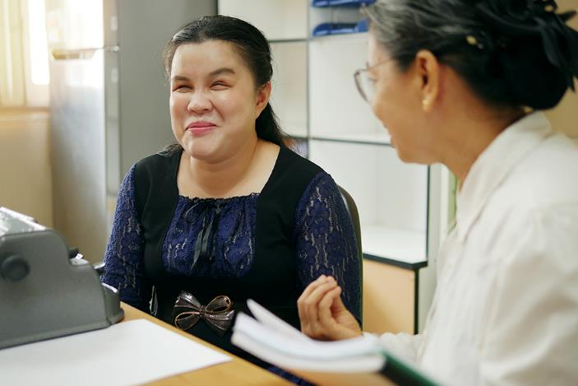

9. Develop and implement a road map of coordinated care, with communities of practice, to optimise the delivery of safe, quality care to all patients.
9.1. Realise a coordinated approach to patient care, from diagnosis to survivorship and palliative care, that is tailored to local population needs and diversity. This includes identifying and meeting the training and resourcing needs of key professionals.
9.2. Establish communities of practice, whereby multidisciplinary teams oversee processes and standards of care and take responsibility for actively building relationships within and across jurisdictions. This can enable a level of safety and trust when a patient is required to travel to receive quality care. Tertiary centres should actively nurture relationships with services expert in caring for priority populations, for example Aboriginal Community-Controlled Health Organisations and LGBTQ+ specialised health services.
9.3. Optimise a hub-and-spoke model ensuring continuity of care for those diagnosed with cervical cancer to bring “quality to patients” where possible (for example palliative care) and “patients to quality” where necessary for highly specialist care (for example brachytherapy). Noting that palliative care services should be integrated into all levels of health care systems including primary care.
9.4. Identify and leverage quick wins by translating successful service models to new jurisdictions and ensure longer-term solutions that may require policy change or workforce reforms. Consider models aimed at addressing workforce issues, such as building an additional supportive role for gynaecologic nurses or additional workforce skills within a multidisciplinary team. Genuine partnership with priority populations and communities will improve the provision of culturally safe care and enhance access to treatment.
- Drive improvements in cervical cancer management through a data collection framework supporting systematic monitoring and enhancement of the quality of care, in alignment with the Australian Cancer Plan.
  - Enhance and harness the data collected in the National Gynaecological Oncology Registry (NGOR) cervical cancer module to inform continuous improvement in care (equity of access, quality, and safety) based on incidence, stage, and mortality data, key clinical quality indicators, as well as patient reported evaluation and outcome measures (PROMs).
  - Conduct annual cervical cancer audits using data from the NSCR, cancer registries and NGOR together with HPV genotype information determined and reported for all cervical cancers.
  - Consolidate current clinical guidance and quality standards through developing national guidelines for the management of cervical cancer and utilise the NGOR to monitor adherence.

TREATMENT CASE STUDY 1:
Nadia’s story.

“Does my oncologist think I’m a prostitute?”

NADIA’S HISTORY
Nadia* is a 45-year-old single, nulliparous woman of Islamic faith. She migrated to Australia with her mother 15 years ago as a refugee, following the death of her husband in armed conflict. Nadia has no other family living in Australia. She lives with her mother in rented accommodation and works in casual employment as a cleaner. Nadia only had access to minimal education in her home country, has basic English language skills and poor health literacy. There were no HPV immunisation or cervical screening programs in her country of origin.

NADIA’S PRESENTATION
Nadia presented to the Emergency Department with vaginal bleeding, anaemia and enlarged kidneys, due to obstruction of her urine outlet. She had symptoms for several months but was frightened to see a doctor and thought her symptoms were due to menopause. Nadia was admitted to hospital and investigations confirmed late-stage cervical cancer (stage 3B Squamous Cell Carcinoma). Recommended treatment was chemoradiation and vault brachytherapy.
“My oncologist asked about my screening history. My reaction was only sex workers in my country have cervical screening. I thought I am an unworthy person. My cancer is punishment”.

NADIA’S EXPERIENCES
Nadia didn’t attend her simulation appointment and explained to her Clinical Nurse Consultant, “I can’t take that much time off work. I won’t have any income”. She was referred to a Social Worker for comprehensive psychosocial assessment to facilitate completing her treatment and improve her patient experience. Nadia learnt about Centrelink payments and other support organisations. She also received psycho-education to address her feelings of stigma and shame, and work through her beliefs about cervical screening and cancer.
“My oncologist offered me a healthcare interpreter, but I declined as I am concerned about confidentiality and “gossip” in my community”.
Nadia was offered the following support:
- A multidisciplinary team to deliver culturally safe care that included being respectful of Muslim beliefs, using female examiners/chaperones, and being aware of taboos around communication about cancer and prognosis.
- Referral to a clinical psychologist (there was significant trauma history identified with Nadia, and her cancer diagnosis triggered and exacerbated PTSD symptoms).
- Provision of plain language and translated information about treatment and expected side-effects.
* Not her real name

TREATMENT CASE STUDY 2:
Daisy’s story. WA Cancer & Palliative Care Network,

Clinical Implementation Unit, North Metropolitan Health Service

DAISY’S HISTORY
Daisy* is a 44-year-old Aboriginal woman from Wiluna (a small town from the Midwest region in WA). She is a single mother with four children of varying ages between four and 21. Daisy and her children live with Daisy’s mother in government housing. Daisy did not complete school and her literacy is poor. She does not have a job and relies on welfare to provide for herself and her family. She has not had the HPV vaccine or ever had any cervical screening. She has a history of marijuana and alcohol use.

DAISY’S DIAGNOSIS AND PRESENTATION
Daisy presented to Carnarvon hospital with abnormal, heavy vaginal bleeding and pelvic pain. After further investigations were completed, she was transferred by the Royal Flying Doctors Service to King Edward Memorial Hospital where she was confirmed to have a late stage (stage 4B) cervical cancer. She was recommended to have combined chemotherapy and radiotherapy followed by vault brachytherapy. In WA chemotherapy and radiotherapy for cervical cancer is treated at two separate tertiary sites.

DAISY’S TREATMENT AND ONGOING CARE
Due to the complexities of this case the multidisciplinary team were heavily involved from diagnosis, in planning her treatment, arranging accommodation and transport from Wiluna to Perth and supporting her psychosocial and financial needs.
The Gynaecology Cancer Nurse Coordination team located in Perth liaised with Daisy’s GP who arranged a face-to-face appointment with her explaining the importance of compliance with appointments and treatment. They liaised with the Patient Assisted Transport Scheme (PATS) in WA to find her suitable accommodation for a lengthy period in Perth as well as the rural Cancer Nurse Coordination team located in the mid-west to support Daisy when she returned home, to assist her with getting to Perth and to ensure her children were cared for at home while she was away.
The social work team including our Aboriginal Liaison Officer were heavily involved ensuring Daisy’s psychosocial and financial needs were met whilst receiving treatment. PATS also arranged for a weekend trip home during treatment so she could see her children.
Daisy was very concerned about her community at home not finding out about her diagnosis, she felt she would be rejected from the community.
“If my community find out about this, I’ll be kicked out, turned away, they’ll think I’ve been sleeping around and me and my kids won’t be accepted anymore.”
Daisy’s journey was a turbulent one, despite the many health care workers involved in her care, she missed her children, she struggled being in the city and wanted to get home to family and country.
* Not her real name

6. NEXT STEPS
This Strategy is the result of evidence synthesis, quality insights and ideas from multiple stakeholders.
Implementation of this strategy will require close coordination between the Australian Government and States and Territories to bring together different constituencies, sectors, relevant peak bodies and professional organisations, civil society groups, Aboriginal Community Controlled Health Organisations, local program leaders and community partners for a coherent and coordinated effort, particularly through expanding or establishing new, strategic, adaptable, and innovative partnerships to support and sustain implementation.
The continued engagement of these and new partners is an important component in bringing the identified strategic priorities and actions to life. Working with communities that understand the diverse nature of the implementation challenges will honour the commitment of this strategy to tackling inequities and uphold the right of women and people with a cervix to high quality, people-centred health services.
For successful and equitable cervical cancer elimination in Australia, there needs to be close alignment with the emerging targets of other key areas of health reform and with whole-of-government approaches by the Australian Government. This includes the Australian Cancer Plan, Aboriginal and Torres Strait Islander Cancer Plan, the Primary Health Care 10 Year Plan, National Aboriginal and Torres Strait Islander Health Plan, the National Agreement on Closing the Gap, and the National Preventive Health Strategy 2021-2030. The implementation of this
Strategy should build on the National Consumer Engagement Strategy for Preventive Health and National Health Literacy Strategy, both of which were listed as immediate priorities in the National Preventive Health Strategy and are currently under development (due for completion in mid-2023).
Australia has the potential to be the first country in the world to actively achieve elimination. Knowing whether the goal has been achieved is currently impacted by the current four-to-five-year delay in the availability of cervical cancer incidence data. To be able to confirm reaching the elimination threshold in Australia, it is a priority to address the timeliness of national cervical cancer incidence data.
Transparent accountability mechanisms are essential to maintain momentum and uphold responsibility. Interim milestones which best deliver the achievement of equity for 2025 and 2030 should be identified from the strategic actions. These interim milestones should be used in conjunction with the annual C4 Cervical Cancer Elimination Report to track progress towards cervical cancer elimination and enable Australia to report back against global commitments to the WHO Global Strategy.
Elimination is within Australia’s reach, and with timely commitment and action, this Strategy’s vision can be achieved:
An Australia where preventable cervical cancer is a disease of the past, in which Australia’s diverse communities have equitable access to information and to culturally safe and inclusive vaccination, screening and treatment services.

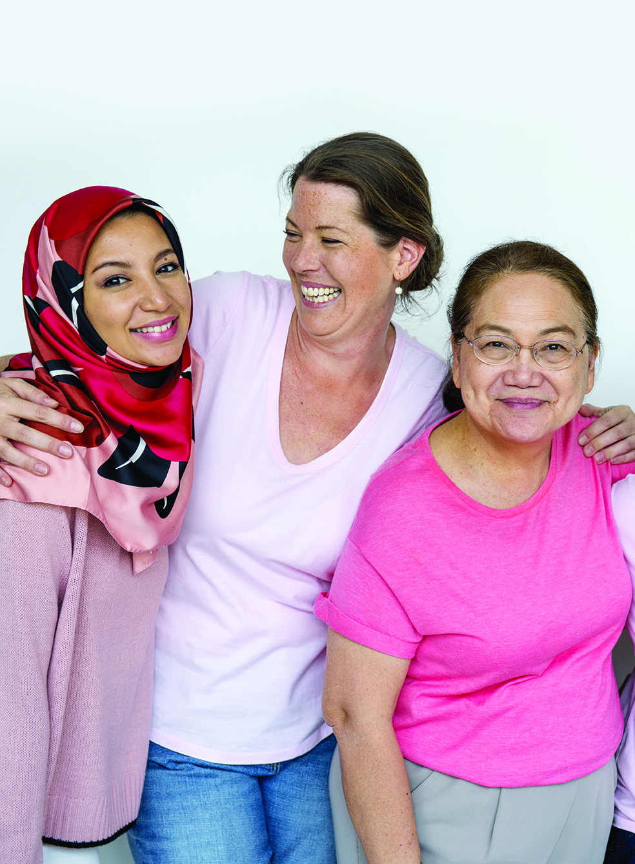

7.GLOSSARY
Aboriginal or Torres Strait Islander person | A person of Aboriginal and/or Torres Strait Islander descent who identifies as an Aboriginal and/or Torres Strait Islander. Other terms are sometimes used interchangeably, such as Indigenous and First Nations people.
ABS | Australian Bureau of Statistics
ACD | Australian Cancer Database
ACPCC | Australian Centre for the Prevention of Cervical Cancer
ACCHO | Aboriginal Community Controlled Health Organisation.  A primary health care service initiated and operated by the local Aboriginal community to deliver holistic, comprehensive, and culturally appropriate health care to the community which controls it, through a locally elected Board of Management.
AIHW | Australian Institute of Health and Welfare
AIR | Australian Immunisation Register
Allied health | Health professionals who are not specialists, doctors, dentists, nurses or midwives. They use evidence-based practices to prevent, diagnose and treat various conditions and illnesses.
CALD | People who are culturally and linguistically diverse
Cancer incidence | The number or rate of new cases of cancer diagnosed in a population during a given time period.
Cancer mortality | Number or rate of cancer deaths in a population during a given time period.
Cervical screening | Cervical screening tests look for HPV infections in the cervix. If HPV is found, the screening participant can be monitored and have further tests to make sure any signs of abnormal cell changes are found early and can be treated.  In Australia, women and people with a cervix can have a screening test every five years from age 25 to 74 through the National Cervical Screening Program. An HPV test is the recommended cervical screening test for the best prevention and early detection outcomes.
Cervical cancer treatment | Ensuring that people diagnosed with cervical cancer receive high quality, timely, affordable and effective treatment, support, and palliative care when required is an important part of achieving cervical cancer elimination in Australia.  Australia has no official national clinical guidelines for cervical cancer treatment. However, the Cancer Institute NSW operates the eviQ program, providing nationally endorsed evidence-based cancer treatment information in Australia. It is embedded into clinical practice, policy and oncology information systems (OMIS) across the country.  The optimal care pathway for cervical cancer was released in January 2020, to guide healthcare practitioners in providing patient-centred, optimal cancer care at each step of the cancer prevention to treatment pathway.
Co-design | The term ‘co-design’ reflects shared decision-making authority through genuine partnerships.
Community | A group of people sharing a common interest (for example, cultural, social, political, health, economic interests). Different types of communities are likely to have different perspectives and approaches to their involvement in the health system.

PAGE 27 |  | DRAFT NATIONAL STRATEGY FOR THE ELIMINATION OF CERVICAL CANCER IN AUSTRALIA

Community-controlled | A process which allows the local Aboriginal community to be involved in its affairs in accordance with whatever protocols or procedures are determined by the Community.
Community-led | Community-led approaches are those that are led by a collective, community process rather than organisations or authorities outside the community. It has become an essential way of working to combat power imbalances that exist between traditional 'authorities' and the communities who are facing inequities.
Cultural safety | Cultural safety is determined by individuals, families and communities. Culturally safe practice is the ongoing critical reflection of health practitioner knowledge, skills, attitudes, practising behaviours and power differentials in delivering safe, accessible and responsive healthcare free of racism.
Disability | An umbrella term for any or all of the following: an impairment of body structure or function, a limitation in activities, or a restriction in participation.
Eligible people (for HPV vaccination) | People aged up to 19 can receive two doses of the HPV vaccine free of charge as part of the National Immunisation Program and is delivered through school-based programs for children aged 12-13. Eligible people under 20 years old and refugees and other humanitarian entrants of any age can get 2 doses of HPV vaccine free.
Eligible people (for screening) | People eligible for a Cervical Screening Test are aged between 25 and 74, are sexually active or ever have been and are a woman or person with a cervix.
Elimination of disease | Elimination of any disease, as a public health problem, is achieved when there are fewer cases than an agreed low threshold.  This differs from eradication when there are no recorded cases, and this is permanent.  Crucially, when a disease is eliminated, prevention measures with associated enabling environment need to continue to maintain the low rates of disease.  The World Health Organization and member states have agreed on an elimination target of below four cases of cervical cancer for every 100,000 women.
Health equity | All people having a fair opportunity to attain their full health potential, and no one should be disadvantaged in achieving this potential if it can be avoided.
Health inequity | Differences in health status between population groups that are socially produced, systematic in their unequal distribution across the population, avoidable and unfair
Health literacy | The capacity to access, understand, appraise and use information to make healthrelated decisions in everyday life.
HPV | Human papillomavirus, known as HPV, causes almost all cases of cervical cancer. HPV is an extremely common virus that around 90% of people will have at least once in their lifetime. It is transmitted during sexual activities through skin-to-skin or skin-tomouth contact of the genital parts of the body.  Some cancers of the vulva, vagina, penis, anus, and oropharynx (back of the throat, including the base of the tongue and tonsils) are also caused by HPV.
HPV immunisation | Australia’s HPV Immunisation Program offers an HPV vaccine that protects against nine different types of HPV which can cause cancer (or genital warts). All young Australians are offered this vaccination at school at the age of 12-13 years, or they can access it through their general practitioner.
Intersex | People who have innate sex characteristics that do not fit medical and social norms for female or male bodies, and that create risks or experiences of stigma, discrimination and harm.
LGBTQ+ | People who identify as Lesbian, Gay, Bisexual, Trans, Queer, and '+' represents minority gender identities and sexualities not explicitly included in the term LGBTQ.
PAGE 28 |  | DRAFT NATIONAL STRATEGY FOR THE ELIMINATION OF CERVICAL CANCER IN AUSTRALIA

MADIP | Multi-Agency Data Integration Project  A secure data asset combining information on health, education, government payments, income and taxation, employment, and population demographics (including the Census) over time.
NCSP | National Cervical Screening Program
NCSR | National Cancer Screening Register
NDIS | National Disability Insurance Scheme
Never-screened | The term “never screened” refers to women and people with a cervix who are eligible to have a cervical screening test through the National Cervical Screening Program but have never had one, for any reason.
Partnerships | Partnerships require the sharing of decision-making, power, control, resources, responsibility and accountability. In partnerships, trust is built and there is an agreed and shared purpose, vision and intent in working together in a supportive and transparent way. Partners design and review outcomes together and problem solve solutions.
Peak Body | A peak body is an Australian term for an advocacy group or trade association, an association of industries or groups with allied interests. They are generally established for the purposes of developing standards and processes, or to act on behalf of all members when lobbying government or promoting the interests of the members. While there is no official granting of Peak Body status, peak bodies are widely accepted as the legitimate “voice” or representative of a profession or industry, as opposed to just a geographic/commercial/cultural/political subset of that profession, as evidenced by requests for media comment and inclusion in government consultations.
Person-centred | Where the person is placed at the centre of the service and treated as a person first.
Pre-cancerous lesions | Early changes to the cells of the cervix that are abnormal and may eventually develop into cervical cancer.
Pre-cancer treatment | Pre-cancers of the cervix are treated by identifying the area of abnormal cervical tissue and removing it to prevent worsening or spread to other areas of the cervix.
Priority populations | Communities who are under-screened and never screened. It also includes groups of people who experience inequities in access to HPV vaccination and cervical cancer treatment and palliative care.
Strengths-based | Strengths-based approaches are based on the premise that inherent strengths and resilience can by unlocked with structured support. This approach recognises that individuals live within families, communities and a culture that also have strengths and resources that will contribute to wellbeing.
Three pillars | The three tools to eliminate cervical cancer as a public health problem:  - Pillar 1: human papillomavirus (HPV) vaccination  - Pillar 2: cervical screening and treatment for cervical precancers  - Pillar 3: treatment and care of cervical cancer.
Under-screened | The term under-screened includes women and people with a cervix who have had a cervical screening test at least once and are eligible to have another screening test through the National Cervical Screening Program, but they are currently significantly overdue for their next screening test for any reason.
WHO | World Health Organization

