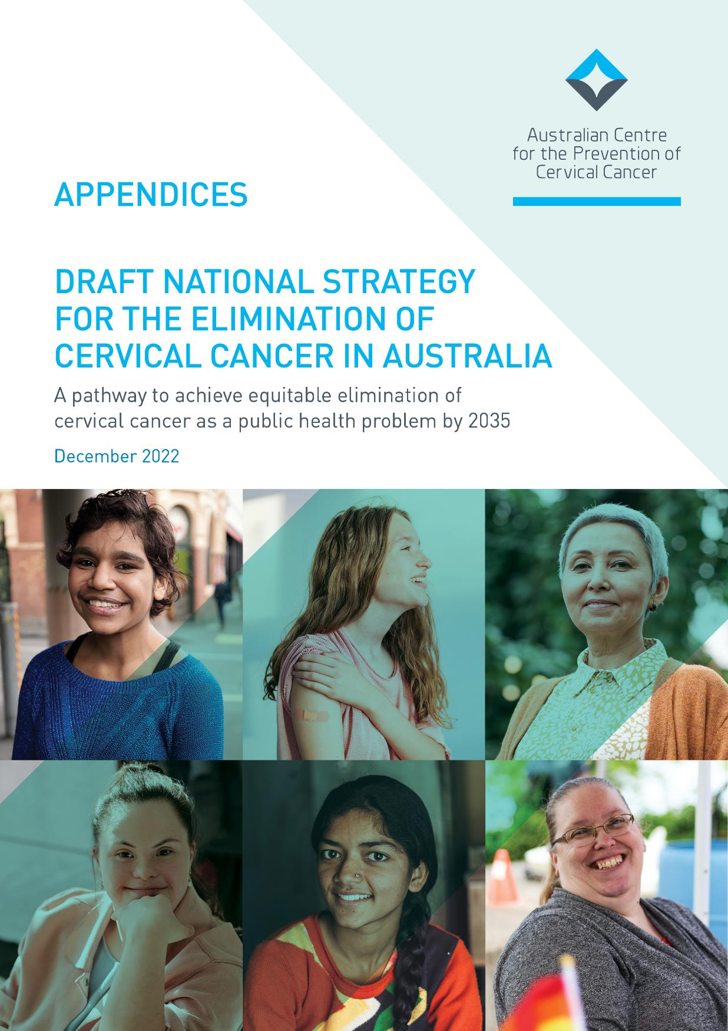

CONTENTS

- APPENDICES 1
  - Australia’s role in the development of the global elimination strategy 1
  - Aboriginal and Torres Strait Islander people: Strategic priorities and actions 2
  - Culturally and linguistically diverse people: Strategic priorities and actions 9
  - People who are LGBTQ+ and people who are intersex: Strategic priorities and actions 15
  - People with disability: Strategic priorities and actions 22
  - People living in rural and remote areas: Strategic priorities and actions 28
  - Related documents and papers 33
  - More information 33

8. APPENDICES

8.1 AUSTRALIA’S ROLE IN THE DEVELOPMENT OF THE GLOBAL ELIMINATION STRATEGY
The Australian Government and our leading cervical cancer research experts provided strong support for the WHO’s efforts to develop the Global Strategy to Accelerate the Elimination of Cervical Cancer. Australia led the way by sponsoring first a decision tasking the WHO secretariat to consult on and develop an elimination strategy and then the following year a successful resolution at the 73rd World Health Assembly which called on all countries to adopt the Global Strategy.
On the one-year anniversary of the Global Strategy to Accelerate the Elimination of Cervical Cancer, 17 November
2021, the Australian Government announced the development of a collaborative National Strategy for the
Elimination of Cervical Cancer in Australia (this Strategy), led by the Australian Centre for the Prevention of Cervical Cancer (ACPCC). This Strategy will inform the Australian Government Department of Health and Aged Care’s future activities to eliminate cervical cancer as a public health problem in Australia by 2035.
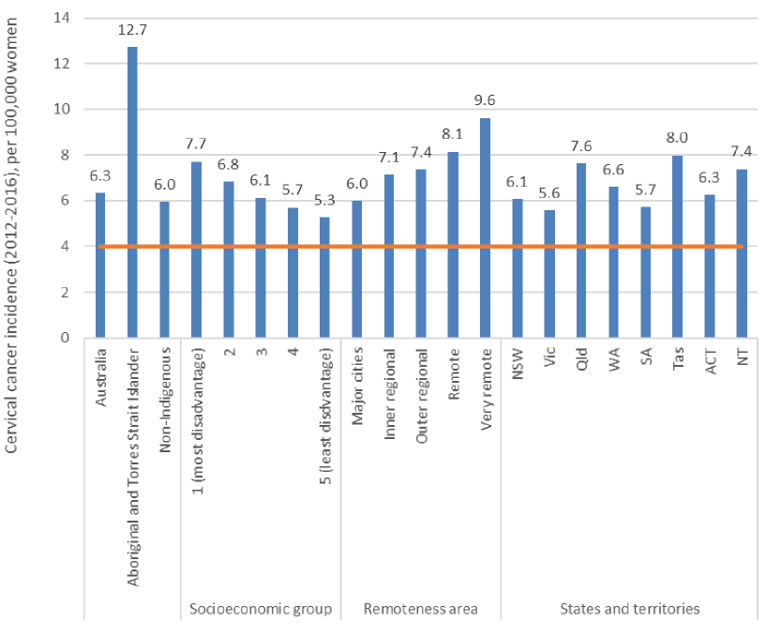
Figure 6. National cervical cancer incidence per 100,000 women, by Indigenous status*, socioeconomic status and remoteness, Australia 2012–2016.
Source data: National Cancer Database. Age-standardised using WHO elimination methodology (World 2015 female population, all ages). *Data for Aboriginal and Torres Strait Islander women are from NSW, QLD, NT and WA only.

8.2 ABORIGINAL AND TORRES STRAIT ISLANDER PEOPLE:
STRATEGIC PRIORITIES AND ACTIONS
Note: italicised words indicate where the action has been tailored for this population.
- Ensure that Australia has access to timely and accurate cervical cancer incidence and mortality data.
  - Review the timeliness of cervical cancer notifications from each of the state and territory cancer registers to the Australian Cancer Database (ACD) and investigate opportunities to accelerate the availability of national cervical cancer data. Aim to have the data from the preceding year available by November 1st of each calendar year.
  - Ensure that this accelerated reporting also includes currently reported stratifications, including rates for Aboriginal and Torres Strait Islander people, by remoteness, by socio-economic status and by all states and territories.
  - Build on the currently available breakdowns to ensure timely reporting of cancer incidence and mortality for Aboriginal and Torres Strait Islander people in all jurisdictions, people of culturally and linguistically diverse backgrounds, people with disability, people who identify as lesbian, gay, bisexual, transgender, queer, and asexual, people who are intersex, and other priority populations as these data become available.
  - Add cancer registry data into the data assets that are included as enduring linkages in the Multi-Agency Data Integration Project (MADIP) to facilitate this. When cancer data are included in MADIP, consider reporting on individual-level socioeconomic status, rather than area-level measures. Facilitate dissemination of disaggregated data and key findings to Aboriginal and Torres Strait Islander communities in timely and culturally safe ways.

Vaccination
- Optimise the delivery of school-based HPV immunisation programs in all jurisdictions to maximise equity and achieve high coverage for all Aboriginal and Torres Strait Islander students.
  - In partnership with Aboriginal and Torres Strait Islander health and communication experts, review and revise communication planning materials for Aboriginal and Torres Strait Islander students and their communities and provide educational opportunities in schools and communities to improve Aboriginal and Torres Strait Islander adolescent, parent, family and caregiver as well as school staff understanding of HPV vaccination and the elimination strategy. This should occur through strong partnerships between health and education to provide an integrated approach to HPV vaccination literacy that spans key learning areas, is supported by a whole-of-school approach, and fosters health literacy.⁹
  - Utilise technology to support digital reminders and put clear communication and follow-up protocols in place to ensure that the school and the consenting carer are aware when a vaccine dose has been missed and that they then receive clear remedial instructions, including how to access vaccination locally through Aboriginal Community Controlled Health Organisations (ACCHOs) and other culturally appropriate services.
9 Coordinated with actions 5.1 and 8.1

2.3 Provide in-school vaccination catch up opportunities where possible. Should a single dose vaccination strategy be introduced, ensure that the implementation plan does not reduce opportunities for inschool vaccination as part of the reduction in required doses; and that the evidence of equal efficacy is communicated clearly to providers and the community.
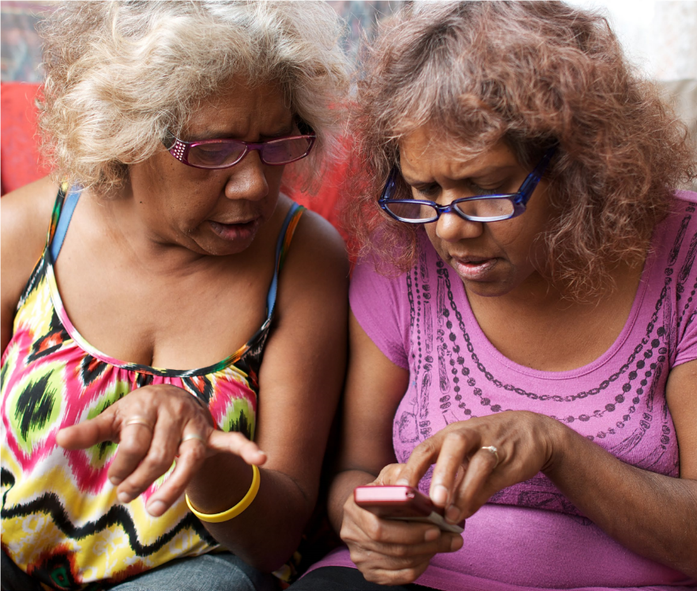
2.4 Fund and develop routine program processes that can identify schools with lower coverage and develop tailored solutions to improve HPV vaccination uptake, including working in partnership with Aboriginal and Torres Strait Islander community-controlled services, peak bodies and community. Fund and support Aboriginal liaison staff with dedicated time in schools to promote engagement with vaccination. Build on the strengths of the ACCHO sector and their leadership to develop tailored solutions that will support the acceptability, community support for, experience and understanding of school-based HPV vaccination among Aboriginal and Torres Strait Islander adolescents.
- Optimise the reach and funding of complementary out-of-school HPV immunisation programs to achieve equity in delivery for all, including Aboriginal and Torres Strait Islander people and medically high-risk populations (catch up).
  - Fund and promote catch-up of an individual’s allocated dose of HPV vaccination for adults 19 and over in medically higher risk groups and for Aboriginal and Torres Strait Islander people.
  - Fund and promote HPV vaccine catch-up strategies with out-of-school Aboriginal and Torres Strait Islander people, their peak bodies, communities and ACCHOs. Ensure equity in availability of catch-up opportunities across jurisdictions and for the most marginalised groups, for example adolescents in youth detention. Consider alternative community locations and providers, for example GP clinic settings, ACCHOs, pharmacies, community events, and Aboriginal Immunisation Officers in Public Health Units. Develop workforce strategies to expand the reach of Aboriginal Health Practitioners.
  - Implement GP and health care provider education, training and quality improvement activities relating to immunisation that support routine use of the Australian Immunisation Register (AIR) data to check HPV vaccination status for all patients aged 14-19 years, address vaccine hesitancy, assess decision-making capacity among vaccine recipients for the decision to vaccinate, and ensure cultural competence to meet the needs of Aboriginal and Torres Strait Islander patients.
- Develop a method to enable annual reporting of HPV vaccination coverage for Aboriginal and Torres Strait Islander people and medically high-risk populations to monitor equity in immunisation.
  - Leverage data linkage through the MADIP to monitor engagement, elimination progress and outcomes for Aboriginal and Torres Strait Islander people, using demographic and other variables and a reference group to develop a community-accepted definition as to whether a person is identified as Aboriginal and/or Torres Strait Islander within the linked dataset. Facilitate dissemination of key findings to Aboriginal and Torres Strait Islander communities in timely and culturally safe ways.

Screening and precancer treatment
- Promote cervical screening regularly with the public and strategically with under-screened groups.
  - Undertake regular targeted, tailored campaigns and activities for under-screened groups including campaigns and activities specifically focussed on and designed by and for Aboriginal and Torres Strait Islander peoples, complemented by evidence-based, inclusive population-wide public awareness activities and mass media, delivered through appropriate channels.¹⁰
  - Work with priority communities, in particular Aboriginal and Torres Strait Islander peoples, including community leaders and community Elders, cervical cancer survivors, ACCHOs and other community-controlled organisations who serve these communities, to co-create, design and test best approaches to reach the community, including the content of campaigns and information materials. Ensure campaigns are informed by the success and implementation strategies from previous campaigns and formative research, noting that materials may need to enhance community health literacy about the purpose and function of the cervix.
  - Trial and utilise technology to support digital invitations, reminders, and navigation to follow-up activities for people with screening results that require further investigation.
- Increase access to screening, colposcopy and follow-up for Aboriginal and Torres Strait Islander peoples by expanding who can offer these services, and where and how they are offered, to improve reach and uptake.
  - Provide a clear pathway to enable appropriately trained registered nurses, Aboriginal and Torres Strait Islander Health Workers and Practitioners, and midwives to independently request and sign the pathology form for a cervical screening test (and be eligible for Medicare reimbursement). Expand the scope of practice for Aboriginal and Torres Strait Islander Health Workers and Aboriginal Health Practitioners to more actively participate in the provision of screening services.
  - Establish a clear national pathway to train and accredit registered nurses and GPs to provide colposcopy.
  - Fund and support ACCHOs to scale promotion, screening and follow up services for and with community.
  - Resource a pilot to scale-up point-of-care HPV testing for remote communities, with links to care. Pilots in remote Aboriginal and Torres Strait Islander communities need to be developed with specific communities to meet their needs. Genuine community engagement, partnership and leadership is critical. See Screening Case Study 2 (The PREVENT Project) for an example.
  - Resource pilots and, where successful, resource scale-up and routine provision of innovative screening models such as peer-led and community-developed services. Work with community-controlled organisations, including ACCHOs, across a range of settings (urban, suburban and regional, as well as remote/very remote as noted in 6.4) to develop models, scale up successful models, and share best practice approaches.

10 Coordinated with actions 2.1 and 8.1

- Collect, use, and release data to enable and monitor equity of access to cervical screening and precancer treatment services for Aboriginal and Torres Strait Islander peoples.
  - Routinely report all program indicators stratified by key population demographics including Aboriginal and/ or Torres Strait Islander status, expand reporting to include all priority populations, and introduce routine monitoring of performance against the WHO precancer treatment indicator.
  - Promote the importance of data collection, training all staff to collect demographic data sensitively in order to improve the recording of all demographic fields (such as Aboriginal and/or Torres Strait Islander status, country of birth and gender), additional fields not yet captured on the National Cancer Screening Register (NCSR) and information that affects clinical management (such as immune status). Aboriginal and Torres Strait Islander people should lead the development of training, and data collection should align with standard questions and ethnicity data protocols, including the National Agreement on Closing the Gap.
  - Enhance clinical information systems in primary health care settings to enable automated uploading for relevant demographic information to integrate with NCSR.
  - Add cancer registry data and screening data from the NCSR into the data assets that are included as enduring linkages in the MADIP. There are limitations with using routinely collected data for this purpose and different data collections may contain differing Aboriginal and/or Torres Strait Islander identification for an individual. Data governance must include Aboriginal and/or Torres Strait Islander people to optimise how to resolve these differences to maximise the utility, safety and validity of the data, from the perspectives of monitoring health care for an individual, and data sovereignty principles.
  - Enable clinicians and healthcare services to readily generate reports that can support continuous quality improvement initiatives through identifying patients who are under-screened and indicating current participation rates to inform efforts that drive engagement.
  - Provide visibility to primary health care providers of current waiting times for colposcopy services, so that this can be factored into referrals and improve timeliness of care. Take into account whether services are culturally safe and appropriate, and individual circumstances, such as the need for travel.

Treatment
- Ensure communities and patients have equitable access to quality information about cervical cancer symptoms and that each cancer patient has tailored information about their diagnosis, intended treatment and planned optimal care pathway.
  - Promote public understanding of cervical cancer signs and symptoms, the role of early detection and the opportunity for cure through working in partnerships with Aboriginal and Torres Strait Islander people and community-controlled services.¹¹
  - Provide information, consultation, and support (for example, utilising the expertise of Aboriginal and Torres Strait Islander health workers and practitioners, nurses, allied health professionals) such that patients and their families/carers fully understand and contribute their own preferences and needs to their individual care pathway, ensuring cultural competence to meet the needs of Aboriginal and Torres Strait Islander patients and their families.
  - Provide patients with the information, access to financial support and support personnel they need to navigate the health system, including informing them that they can have a person/people of their choice accompanying them whenever needed, as well as providing access to Aboriginal and Torres Strait liaison staff within the health system. Expand the inclusion and involvement of Aboriginal and Torres Strait Islander Health Workers and Practitioners within the wider health system to improve cultural safety for Aboriginal and Torres Strait Islander patients.
  - Facilitate continual quality improvement by conducting routine patient-related evaluation measures (PREMs) to assess patient satisfaction, feeding results back to shape training and development of personnel, patientinformation materials and health service systems as appropriate. Aboriginal and Torres Strait Islander people should lead the development of relevant training materials. Ensure information collected captures patient diversity and experiences according to their sex, gender and sexual orientation, ethnicity, Aboriginal and Torres Strait Islander status, and disability status. Ensure this information accords to national standards for data collection.
- Develop and implement a road map of coordinated care, with communities of practice, to optimise the delivery of safe, quality care to all patients.
  - Realise a coordinated approach to patient care from diagnosis to survivorship and palliative care that is tailored to local population needs and diversity. This includes: identifying and meeting the training and resourcing needs of key professionals (including but not limited to ensuring access to culturally safe services and a supportive workforce for Aboriginal and Torres Strait Islander peoples; inclusive and accessible care for those with disability; in-language culturally relevant resources and provision of care for culturally and linguistically diverse communities and; sex, gender and identity-sensitive services and care forLGBTQ+ people and people who are intersex); and supporting culturally safe patient journeys and transition of care between primary, secondary, tertiary and quaternary services.
  - Establish communities of practice, where multidisciplinary teams oversee processes and standards of care, and take responsibility for actively building relationships within and across jurisdictions, ensuring services are culturally safe and appropriate for Aboriginal and Torres Strait Islander peoples. This can enable a level of safety and trust when a patient is required to travel to receive quality care. Tertiary centres should actively nurture relationships with services expert in caring for priority populations (for example, ACCHOs, LGBTQ+ specialised health services).
  - Optimise a hub-and-spoke model ensuring continuity of care for those diagnosed with cervical cancer to bring “quality to patients” where possible (for example palliative care) and “patients to quality” where necessary for highly specialist care (for example brachytherapy), ensuring access to culturally safe services and a supportive workforce for Aboriginal and Torres Strait Islander peoples. Noting that palliative care services should be integrated into all levels of health care systems including primary care.
11 Coordinated with actions 2.1 and 5.1
9.4. Identify and leverage quick wins by translating successful service models to new jurisdictions and ensure longer-term solutions that may require policy change or workforce reforms. Consider models aimed at addressing workforce issues, such as building an additional supportive role for gynaecologic nurses. Genuine partnership with priority populations and communities will improve the provision of culturally safe care and enhance access to treatment.
- Drive improvements in cervical cancer management through a data collection framework supporting systematic monitoring and enhancement of the quality of care, in alignment with the Australian Cancer Plan, the National Aboriginal and Torres Strait Islander Cancer Plan and National Agreement on Closing the Gap.
  - Enhance and harness the data collected in the National Gynaecological Oncology Registry (NGOR) cervical cancer module to inform continuous improvement in care (equity of access, quality, and safety) based on incidence, stage and mortality data, key clinical quality indicators, as well as patient reported evaluation and outcome measures (PROMs). Facilitate dissemination of disaggregated data and key findings to Aboriginal and Torres Strait Islander communities in timely and culturally safe ways.
  - Conduct annual cervical cancer audits using data from the NSCR, cancer registries and NGOR together with HPV genotype information determined and reported for all cervical cancers
  - Consolidate current clinical guidance and quality standards through developing national guidelines for the management of cervical cancer and utilise the NGOR to monitor adherence.
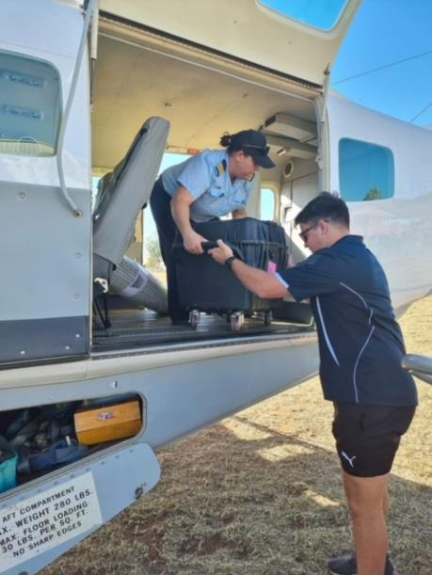

8.3 CULTURALLY AND LINGUISTICALLY DIVERSE PEOPLE:
STRATEGIC PRIORITIES AND ACTIONS
Note: italicised words indicate where the action has been tailored for this population.
- Ensure that Australia has access to timely and accurate cervical cancer incidence and mortality data.
  - Review the timeliness of cervical cancer notifications from each of the state and territory cancer registers to the Australian Cancer Database (ACD) and investigate opportunities to accelerate the availability of national cervical cancer data. Aim to have the data for the preceding year available by 1st November each calendar year.
  - Ensure that this accelerated reporting also includes currently reported stratifications including rates for
Aboriginal and Torres Strait Islander people, by remoteness, by socio-economic status and by state and territory.
  - Build on the currently available breakdowns to ensure timely reporting of cancer incidence and mortality for Aboriginal and Torres Strait Islander people in all jurisdictions, people of culturally and linguistically diverse (CALD) backgrounds, people with disability, people who identify as lesbian, gay, bisexual, transgender, queer, and asexual, people who are intersex, and other priority populations as these data become available.
  - Add cancer registry data into the data assets that are included as enduring linkages in the Multi-Agency Data Integration Project (MADIP) to facilitate this. When cancer data are included in MADIP, consider reporting on individual-level socioeconomic status, rather than area-level measures.

Vaccination
- Optimise the delivery of school-based HPV immunization programs in all jurisdictions to maximise equity and achieve high coverage for students from culturally and linguistically diverse backgrounds.
  - Review and revise communication planning materials for students from CALD backgrounds and their communities, and provide educational opportunities in schools in a culturally safe and appropriate way, and in language, if necessary, to improve adolescent, parent, family, and caregiver as well as school staff understanding of HPV vaccination and the elimination strategy. This should occur through strong partnerships between health and education to provide an integrated approach to HPV vaccination literacy that spans key learning areas, is supported by a whole-of-school approach, and fosters health literacy.¹²
  - Utilise technology to support digital reminders and put clear communication and follow-up protocols in place to ensure that schools and consenting caregivers are aware when a vaccine dose has been missed and receive clear instruction on how to catch up, including how to access vaccination locally through General Practitioners, community health services and other organisations that provide culturally safe and appropriate services to people from culturally and linguistically diverse backgrounds.
  - Provide in-school vaccination catch up opportunities where possible. Should a single dose vaccination strategy be introduced, ensure that the implementation plan does not reduce opportunities for in-school vaccination given the reduction in required doses; and that the evidence of equal efficacy is communicated clearly to providers and the communities.
12 Coordinated with actions 5.1 and 8.1

  - Fund and develop routine program processes that can identify schools with lower coverage and develop tailored solutions to improve HPV vaccination uptake, including working in partnership with CALD community health champions, peak bodies and communities. Fund and support CALD and other liaison staff with dedicated time in schools to promote engagement with vaccination. Build on the strengths of the community health sector and their leadership to develop tailored solutions that will support the acceptability, community support for, experience and understanding of school-based HPV vaccination among CALD adolescents.

- Optimise the reach and funding of complementary out-of-school HPV immunisation programs to achieve equity in delivery for all, including people from culturally and linguistically diverse backgrounds, refugees and asylum seekers and medically high-risk populations (catch up).
  - Fund and promote catch up of an individual’s allocated dose of HPV vaccination for adults 19 and over in medically higher risk groups, including people from culturally and linguistically diverse backgrounds, refugees and asylum seekers.
  - Fund, implement and promote HPV vaccine catch up strategies with out-of-school adolescents including those from CALD backgrounds, refugees and asylum seekers, their peak bodies, health services and communities. Ensure equity in availability of catch-up opportunities across jurisdictions and for the most marginalised groups, for example, adolescents in youth detention. Consider alternative community locations, events and providers, for example, community health services, and develop workforce strategies to expand reach.
  - Implement GP and healthcare provider education, training and quality improvement activities relating to immunisation that support routine use of the Australian Immunisation Register (AIR) data to check HPV vaccination status for all patients aged 14-19 years, address vaccine hesitancy, and assess decision-making capacity among vaccine recipients for the decision to vaccinate, including familiarity with HPV vaccine catch up schedules for migrants, refugees and asylum seekers.
- Develop a method to enable annual reporting of HPV vaccination coverage for people from culturally and linguistically diverse backgrounds and medically high-risk populations to monitor equity in immunisation.
  - Leverage data linkage through the MADIP, to monitor engagement, elimination progress and outcomes for people from culturally and linguistically diverse backgrounds, using demographic and other variables and a reference group to develop community-accepted definitions as to whether a person is identified as part of a CALD community within the linked dataset.

Screening and precancer treatment
- Promote cervical screening regularly with the public and strategically with under-screened groups including culturally and linguistically diverse people.
  - Undertake regular targeted tailored campaigns and activities for under-screened groups including campaigns and activities specifically focussed on and designed by and for CALD people, complemented by evidence-based, inclusive population-wide public awareness activities and mass media delivered through appropriate channels.¹³
  - Work with priority communities, including a range of respected members, community influencers, and cervical cancer survivors from CALD peoples, and community-based organisations that serve these communities, to co-develop campaign and information materials, and come up with best approaches to reach the community, including the content (language and visual) of campaigns and information materials. Ensure campaigns are informed by the success and implementation strategies from previous campaigns and formative research, noting that materials may need to enhance community health literacy about HPV and cancer of the cervix.
  - Trial and utilise technology to support digital invitations, reminders, and navigation to follow-up activities for CALD people with screening results that require further investigation.

13 Coordinated with actions 2.1 and 8.1

- Increase access to screening, colposcopy and follow-up for culturally and linguistically diverse people by expanding who can offer these services, and where and how they are offered, to improve reach and uptake.
  - Provide a clear pathway to enable appropriately trained registered nurses, Aboriginal Health Workers and Practitioners, and midwives to independently request and sign the pathology form for a cervical screening test (and be eligible for Medicare reimbursement).
  - Establish a clear national pathway to train and accredit registered nurses and GPs to provide colposcopy.
  - Resource a pilot to scale up point-of-care HPV testing, with links to care, for remote communities.
  - Resource pilots and, where successful, resource scale-up and routine provision of innovative screening models such as peer-led and community-developed services. Work with community-based organisations that provide services to CALD people to develop models, scale up successful models, and share best practice approaches. Deliver targeted solutions to people arriving from countries with no screening programs to address issues/concern/disparities associated with stigma, discrimination and trauma when providing cervical screening.
- Collect, use and release data to enable and monitor equity of access to cervical screening and precancer treatment services for culturally and linguistically diverse people.
  - Routinely report all program indicators stratified by key population demographics, expand reporting to include all priority populations, including CALD people, and introduce routine monitoring of performance against the WHO precancer treatment indicator. Work with a reference group representing culturally and linguistically diverse people to develop appropriate stratification of indicators that balance granularity and meaningful differences with the availability, validity and size of data for different measures.
  - Promote the importance of data collection on cultural and linguistic diversity, and train all staff to collect demographic data sensitively in order to improve the recording of all demographic fields (Aboriginal and/ or Torres Strait Islander status, country of birth, language spoken at home, gender). This can be expanded to include additional fields not yet captured on the National Cancer Screening Register (NCSR) and information that affects clinical management such as immune status.
  - Enhance clinical information systems in primary health care settings to enable automated uploading for relevant demographic information to integrate with NCSR.
  - Add cancer registry data and screening data from the NCSR into the data assets that are included as enduring linkages in the MADIP. There are limitations with using routinely collected data for this purpose and the different routine data collections may contain differing information about an individual. Data governance should include representatives from CALD communities to optimise how to resolve these differences and maximise the utility and validity of the data, from the perspectives of both monitoring and health care for an individual.
  - Enable clinicians and healthcare services to readily generate reports that can support continuous quality improvement initiatives by identifying patients who are under-screened and indicate current participation rates in terms of priority population to inform efforts that drive engagement.
  - Provide visibility to primary care providers of current waiting times for colposcopy services, so that this can be factored into referrals and improve timeliness of care. Take an individual’s cultural and language needs, including for translation, into account when referring.

Treatment
- Ensure communities and patients have equitable access to quality information about cervical cancer symptoms and that each cancer patient has tailored information about their diagnosis, intended treatment and planned optimal care pathway.
  - Promote public understanding of cervical cancer signs and symptoms, the role of early detection and the opportunity for cure including campaigns and activities specifically focussed on, and designed by and for, CALD people. Including providing the information in the primary language of key communities to increase CALD communities’ understanding of cervical cancer and reduce the stigma and fear associated with a cervical cancer diagnosis by reiterating that most cervical cancers can be successfully treated if detected early.¹⁴
  - Provide information, consultation, and support (for example, utilising the expertise of nurses and allied health professionals) such that patients and their families/carers fully understand, voice their needs, and contribute to a patient-centred care pathway. The information should be designed by and be specifically for CALD people.
  - Provide patients with the information and access to financial support and support personnel for navigating the health system. This includes information regarding having a person/people of their choice accompanying them whenever needed and that an interpreter will always be provided, in person whenever possible. Information provided should be designed by and for culturally and linguistically diverse people.
  - Enable incremental improvement by conducting routine patient-related evaluation measures (PREMs) to assess patient satisfaction, feeding results back to shape training and development of personnel, patient information materials and health service systems as appropriate. Ensure information collected captures patient diversity and experiences relevant for CALD people. Ensure this information accords to national standards for data collection.

14 Coordinated with actions 2.1 and 5.1

- Develop and implement a road map of coordinated care, with communities of practice, to optimise the delivery of safe, quality care to all patients.
  - Realise a coordinated approach to patient care from diagnosis to survivorship and palliative care that is tailored to local population needs and diversity. This includes identifying and meeting the training and resourcing needs of key professionals (including but not limited to in-language culturally relevant resources and provision of care for CALD communities).
  - Establish communities of practice, where multidisciplinary teams oversee processes and standards of care, and take responsibility for actively building relationships within and across jurisdictions. This can enable a level of safety and trust when a patient is required to travel to receive quality care. Tertiary centres should actively nurture relationships with services expert in caring for priority populations, which will require liaising with specialised community-controlled organisations for CALD people. It will also require engagement with community leaders, community influencers and being aware of cultural differences that may prevent some patients from accessing optimal care.
  - Optimise a hub-and-spoke model ensuring continuity of care for those diagnosed with cervical cancer to bring “quality to patients” where possible (for example palliative care) and “patients to quality” where necessary for highly specialist care (for example brachytherapy). The design of these models should include representation from CALD people.
  - Identify and leverage quick wins by translating successful service models to new jurisdictions and ensure longer-term solutions that may require policy change or workforce reforms. Consider models aimed at addressing workforce issues, such as building an additional supportive role for gynaecologic nurses. Genuine partnership with priority populations and communities will improve the provision of culturally safe care and enhance access to treatment.
- Drive improvements in cervical cancer management through a data collection framework supporting systematic monitoring and enhancement of the quality of care, in alignment with the Australian Cancer Plan.
  - Enhance and harness the data collected in the National Gynaecological Oncology Registry (NGOR) cervical cancer module to inform continuous improvement in care (equity of access, quality, and safety) based on incidence, stage, and mortality data, key clinical quality indicators, as well as patient reported evaluation and outcome measures (PROMs). Where feasible, data on patients’ country of birth, duration of time living in Australia, first language and language spoken at home, should be collected.
  - Conduct annual cervical cancer audits using data from the NSCR, cancer registries and NGOR together with HPV genotype information determined and reported for all cervical cancers.
  - Consolidate current clinical guidance and quality standards through developing national guidelines for the management of cervical cancer and utilise the NGOR to monitor adherence.

8.4 PEOPLE WHO ARE LGBTQ+ AND PEOPLE WHO ARE INTERSEX: STRATEGIC PRIORITIES AND ACTIONS
Note: italicised words indicate where the action has been tailored for this population.
- Ensure that Australia has access to timely and accurate cervical cancer incidence and mortality data.
  - Review the timeliness of cervical cancer notifications from each of the state and territory cancer registers to the Australian Cancer Database (ACD) and investigate opportunities to accelerate the availability of national cervical cancer data. Aim to have the data for the preceding year available by November 1st of each calendar year.
  - Ensure that this accelerated reporting also includes currently reported stratifications including rates for
Aboriginal and Torres Strait Islander people, by remoteness, by socio-economic status, and by state and territory.
  - Build on the currently available breakdowns to ensure timely reporting of cancer incidence and mortality for Aboriginal and Torres Strait Islander people in all jurisdictions, people of culturally and linguistically diverse backgrounds, people living disability, people who identify as lesbian, gay, bisexual, transgender, queer, and asexual, people who are intersex, and other priority populations as these data become available. Use Australian Bureau of Statistics (ABS) Standards for Sex, Gender, Variations of Sex Characteristics and Sexual Orientation Variables¹⁵ when recording information to ensure comparability and compatibility between data sets related to the health of LGBTQ+ and intersex people across disease types.
  - Add cancer registry data into the data assets that are included as enduring linkages in the Multi-Agency Data Integration Project (MADIP) to facilitate this. When cancer data are included in MADIP, consider reporting on individual-level socioeconomic status, rather than area-level measures.

15 Australian Bureau of Statistics. Standard for Sex, Gender, Variations of Sex Characteristics and Sexual Orientation Variables [Internet]. Canberra: ABS; 2020 [cited 2022 November 7]. Available from: https://www.abs.gov.au/statistics/standards/standard-sex-gender-variations-sex-characteristics-and-sexualorientation-variables/latest-release.

Vaccination
- Optimise the delivery of school-based HPV immunisation programs in all jurisdictions to maximise equity and achieve high coverage including for students who already identify as LGBTQ+ or who are intersex.
  - Review and revise communication planning materials and provide educational opportunities in schools to ensure language used is inclusive, and make it clear the HPV vaccination is relevant and important for everyone including students who identify as LGBTQ+ or are intersex. These communications should target adolescents, parent, family and caregivers as well as school staff to increase understanding of HPV, HPV vaccination and the elimination strategy through strong partnerships between health and education towards an integrated approach to HPV vaccination literacy that spans key learning areas, is supported by a whole-of-school approach, and fosters health literacy.¹⁶
  - Utilise technology to support digital reminders and put clear communication and follow-up protocols in place to ensure that the school and the consenting carer are aware when a vaccine dose has been missed and then receive clear remedial instructions, including how to access vaccination through LGBTQ+ and intersex specific community health services and other LGBTQ+ and intersex-friendly services.
  - Provide in-school vaccination catch-up opportunities where possible. Should a single dose vaccination strategy be introduced, the implementation plan should ensure that the reduction in required doses does not reduce opportunities for in-school vaccination; and that the evidence of equal efficacy is communicated clearly to providers and the community.
  - Fund and develop routine program processes that can identify schools with lower coverage and develop tailored solutions to improve HPV vaccination uptake, including working in partnership with LGBTQ+ and intersex-friendly health services, peak bodies, community and youth support such as youth mental health and homeless services.

16 Coordinated with actions 5.1 and 8.1
- Optimise the reach and funding of complementary out-of-school HPV immunisation programs to achieve equity in delivery for all, including people who already identify as LGBTQ+ or who are intersex and medically high-risk populations (catch up).
  - Fund and promote catch up of an individual’s allocated dose of HPV vaccination for adults 19 and over in medically higher risk groups, and for people who already identify as LGBTQ+ or who are intersex.
  - Fund and promote HPV vaccine catch up strategies with out-of-school adolescents including those who identify as LGBTQ+ or who are intersex, their peak bodies, health services and communities. Ensure equity in availability of catch-up opportunities across jurisdictions and for the most marginalised groups, for example, adolescents in youth detention. Consider alternative community locations and providers, for example, GP clinic settings, Aboriginal Community Controlled Health Organisations, LGBTQ+ and intersex health organisations, pharmacies and community events. Develop workforce strategies to expand reach, for example, sexual health nurses.
  - Implement GP and LGBTQ+ and intersex health care provider education, training and quality improvement activities relating to immunisation that support routine use of the Australian Immunisation Register (AIR) data to check HPV vaccination status for all patients aged 14-19 years, address vaccine hesitancy, and assess decision-making capacity among vaccine recipients for the decision to vaccinate.
- To monitor equity in immunisation, develop a method to enable annual reporting of HPV vaccination coverage for people who identify as LGBTQ+ or who are intersex, and for medically high-risk populations.
  - Leverage data linkage through the MADIP, to monitor engagement, elimination progress and outcomes for people who identify as LGBTQ+ or who are intersex, using demographic and other variables and reference groups to develop community accepted definitions and a consent process as to whether a person is identified as LBGTQ+ or intersex within the linked dataset.

Screening and precancer treatment
- Promote cervical screening regularly with the public and strategically with under-screened groups.
  - Undertake regular targeted, tailored campaigns and activities for under-screened groups, including campaigns and activities specifically focussed on and designed by gender-diverse and sexuality-diverse people who have a cervix, complemented by evidence-based, inclusive population-wide public awareness activities and mass media, delivered through appropriate channels.¹⁷ Ensure that LGBTQ+ people and people who are intersex are represented in any mass media and resources that are developed. Campaigns, websites and resources should use appropriate language and appropriate imagery (including choice of colours) to represent people with a cervix who are not cisgender women.
  - Work with LGBTQ+ and intersex communities, including respected members, cervical cancer survivors, community-controlled LGBTQ+ and intersex organisations and specialised health services that serve LGBTQ+ and intersex communities, to co-create, design and test best approaches to reach the community, including the content of campaigns and information materials. Ensure campaigns are informed by the success and implementation strategies from previous campaigns and formative research. Materials may need to enhance community health literacy about HPV and cervical cancer.
  - Trial and utilise technology to support digital invitations, reminders, and navigation to follow-up activities for people with screening results that require further investigation.
- Increase access to screening, colposcopy and follow-up for people who already identify as LGBTQ+ or who are intersex by expanding who can offer these services, and where and how they are offered, to improve reach and uptake.
  - Provide a clear pathway to enable appropriately trained registered nurses, Aboriginal Health Workers and Practitioners, and midwives to be able to independently request and sign the pathology form for a cervical screening test (and be eligible for Medicare reimbursement)
  - Establish a clear national pathway to train and accredit registered nurses and GPs to provide colposcopy
  - Resource a pilot to scale up point-of-care HPV testing, with links to care, for remote communities
  - Resource pilots and, where successful, resource scale-up and routine provision of innovative screening models for people who identify as LGBTQ+ or who are intersex such as peer-led and community-developed services. Work with LGBTQ+ and intersex community organisations to develop models, scale up successful models, and share best practice approaches. Provide services that ensure culturally safe care from appointment through to screening and follow up. Make people aware of what to expect at a screening visit and consider needs around a screening visit more holistically – for example establish culturally safe terminology, develop strategies that an individual can use to signal to the provider during the procedure if they feel unsafe or want it to stop, and provide post-screening counselling for people who may be triggered by screening. Provide options for people including bringing a friend for support, inserting the speculum themselves, requesting a smaller speculum, and self-collection.
17 Coordinated with actions 2.1 and 8.1

- Collect, use, and release data to enable and monitor equity of access to cervical screening and precancer treatment services for people who identify as LGBTQ+ or who are intersex.
  - Routinely report all program indicators stratified by key population demographics, expand reporting to include all priority populations, including people who identify as LGBTQ+ or who are intersex, and introduce routine monitoring of performance against the WHO precancer treatment indicator. In order to routinely report on program indicators separately for gender-diverse people with a cervix, this information needs to be captured. The National Cancer Screening Register (NCSR) can record gender, but it is unclear to what extent the data are accurate or complete. Some measures will not be able to be routinely reported until the recommendations for incorporating gender identification are adopted into the national Census.
There is not yet the explicit capacity on the NCSR to record diversity of sexuality. Approaches to adequately monitor progress towards elimination targets for this group need to be developed in collaboration with the LGBTQ+ and intersex community, as use of routine data may not be the most appropriate approach.
Use ABS standards for Sex, Gender, Variations of Sex Characteristics and Sexual Orientation Variables when recording information to ensure comparability and compatibility between data sets related to the health of LGBTQ+ and intersex people across disease types. The best ways of capturing and reporting data to reflect the experiences of the diverse LGBTQ+ and intersex communities should be developed in consultation with those communities, and may require control by the individual over who can view the data collected.
  - Promote the importance of data collection on gender diversity, training all staff to collect demographic data sensitively in order to improve the recording of all demographic fields (Aboriginal and/or Torres Strait Islander status, country of birth, gender), including additional fields not yet captured on the NCSR and information that affects clinical management such as immune status. Training relating to routinely collecting information about gender should involve gender-diverse people. The best ways of capturing and reporting data on gender, and in enrolling people with a cervix who do not identify as women into the National Cervical Screening Program (NCSP), should be developed in consultation with gender-diverse people. This may require control by the individual over who can view the data collected.
Consult with trans men and other gender diverse people on appropriate ways and opportunities to use gender data captured on the NCSR or other health systems, such as tailoring routine communication from the NCSP – for example envelopes without NCSP branding may be preferred by trans men; or an LGBTQI+ health check could be offered (with triggers for GP to do comprehensive screening), to ensure all screening (including cervical screening) is done and individual’s needs are identified.
  - Enhance clinical information systems in primary health care settings to enable automated uploading for relevant demographic information to integrate with NCSR
  - Add cancer registry data and screening data from the NCSR into the data assets that are included as enduring linkages in the MADIP including information on gender diversity, when the recommendations for incorporating gender identification are adopted into the national Census.
  - Enable clinicians and healthcare services to readily generate reports that can support continuous quality improvement initiatives by identifying patients who are under-screened and indicate current participation rates to inform efforts that drive engagement.
  - Provide visibility to primary care providers of current waiting times for colposcopy services, so that this can be factored into referrals and improve timeliness of care. Ensure there are appropriate, safe and inclusive colposcopy services available for people who identify as LGBTQ+ or who are intersex and provide information about how/where to find queer-friendly services for follow-up.
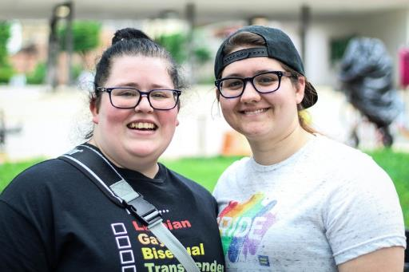

Treatment
- Ensure communities and patients have equitable access to quality information about cervical cancer symptoms and that each cancer patient has tailored information about their diagnosis, intended treatment and planned optimal care pathway.
  - Promote public understanding of cervical cancer signs and symptoms, the role of early detection and the opportunity for cure. Campaigns and activities should be specifically focused on and designed by genderdiverse and sexuality-diverse people and LGBTQ+ and intersex people should be represented in any mass media and resources that are developed. Campaigns, websites and resources should use appropriate language and appropriate imagery (including choice of colours) to represent people with a cervix who are not cisgender women.¹⁸
  - Provide information, consultation and support (for example, queer-friendly services and resources) such that patients and their families/carers fully understand and contribute their own preferences and needs to their individual care pathway.
  - Provide patients with the information, access to financial support and support personnel they need to navigate the health system, including informing them that they can have a person/people of their choice accompanying them whenever needed, as well as provide access to spaces where they feel safe and ensure that they are always addressed correctly. This awareness is particularly important for people with a cervix who are not cisgender women and are required to access care within a “women’s health” environment.
  - Enable incremental improvement by conducting routine patient-related evaluation measures (PREMs) to assess patient satisfaction, feeding results back to shape training and development of personnel, patient information materials and health service systems as appropriate. Ensure sensitively collected information captures patient diversity and experiences according to their sex, gender and sexual orientation. Ensure this information accords to national standards for data collection.

18 Coordinated with actions 2.1 and 5.1

- Develop and implement a road map of coordinated care, with communities of practice, to optimise the delivery of safe, quality care to all patients.
  - Realise a coordinated approach to patient care from diagnosis to survivorship and palliative care that is tailored to local population needs and diversity. This includes identifying and meeting the training and resourcing needs of key professionals (including but not limited to ensuring access to safe services and a supportive workforce for LGBTQ+ and intersex people reflecting sex, gender and identity-sensitive services and care). Consultation with trans men and other gender diverse people to assist with development of training and education of health professionals in trauma-informed care so that people from LGBTQ+ and intersex communities feel safe to access treatment.
  - Establish communities of practice, where multidisciplinary teams oversee processes and standards of care, and take responsibility for actively building relationships within and across jurisdictions. This can enable a level of safety and trust when a patient is required to travel to receive quality care. Tertiary centres should actively nurture relationships with services expert in caring for priority populations (for example, LGBTQ+ and intersex specialised health services).
  - Optimise a hub-and-spoke model ensuring continuity of care for those diagnosed with cervical cancer to bring “quality to patients” where possible (for example palliative care) and “patients to quality” where necessary for highly specialist care (for example brachytherapy). Queer-friendly services are key to ensure that the LGBTQ+ and intersex community feel respected and safe when accessing care. Noting that palliative care services should be integrated into all levels of health care systems including primary care.
  - Identify and leverage quick wins by translating successful service models to new jurisdictions and ensure longer-term solutions that may require policy change or workforce reforms. Consider models aimed at addressing workforce issues, such as building an additional supportive role for gynaecologic nurses. Genuine partnership with priority populations and communities will improve the provision of culturally safe care and enhance access to treatment.
- Drive improvements in cervical cancer management through a data collection framework supporting systematic monitoring and enhancement of the quality of care, in alignment with the Australian Cancer Plan.
  - Enhance and harness the data collected in the National Gynaecological Oncology Registry (NGOR) cervical cancer module to inform continuous improvement in care (equity of access, quality, and safety) based on incidence, stage, and mortality data, key clinical quality indicators, as well as patient reported evaluation and outcome measures (PROMs). Data on patient gender and sexuality should be routinely collected by NGOR to enable monitoring of key clinical quality indicators to ensure equity for gender diverse and sexually diverse people.
  - Conduct annual cervical cancer audits using data from the NSCR, cancer registries and NGOR together with HPV genotype information determined and reported for all cervical cancers
  - Consolidate current clinical guidance and quality standards through developing national guidelines for the management of cervical cancer and utilise the NGOR to monitor adherence.

8.5 PEOPLE WITH DISABILITY: STRATEGIC PRIORITIES AND ACTIONS
Note: italicised words indicate where the action has been tailored for this population.
- Ensure that Australia has access to timely and accurate cervical cancer incidence and mortality data.
  - Review the timeliness of cervical cancer notifications from each of the state and territory cancer registers to the Australian Cancer Database (ACD) and investigate opportunities to accelerate the availability of national cervical cancer data. Aim to have the data for the preceding year available by November 1st of each calendar year.
  - Ensure that this accelerated reporting also includes currently reported stratifications including rates for Aboriginal and Torres Strait Islander people, by remoteness, by socio-economic status and by state and territory.
  - Build on the currently available breakdowns to ensure timely reporting of cancer incidence and mortality for Aboriginal and Torres Strait Islander people in all jurisdictions, people of culturally and linguistically diverse backgrounds, people with disability, people who identify as lesbian, gay, bisexual, transgender, queer, and asexual, people who are intersex, and other priority populations as these data become available.
  - Add cancer registry data into the data assets that are included as enduring linkages in the Multi-Agency Data Integration Project (MADIP) to facilitate this. When cancer data are included in MADIP, consider reporting on individual-level socioeconomic status, rather than area-level measures.

19 Coordinated with actions 5.1 and 8.1

Vaccination
- Optimise the delivery of school-based HPV immunisation programs in all jurisdictions to maximise equity and achieve high coverage for students with disability.
  - Review and revise communication planning materials for students with disability and their communities and provide educational opportunities in both mainstream and special schools to improve adolescent, parent, family and caregiver, and school staff understanding of HPV vaccination and the elimination strategy. This should occur through strong partnerships between health and education to provide an integrated approach to HPV vaccination literacy that spans key learning areas, is supported by a whole-of-school approach, and fosters health literacy.¹⁹
  - Utilise technology to support digital reminders and put clear communication and follow up protocols in place to ensure that the school and the consenting carer are aware when a vaccine dose has been missed and receive clear remedial instructions, including how to access vaccination locally through services that meet the needs of students with disability.
  - Provide in-school vaccination catch up opportunities where possible. Should a single dose vaccination strategy be introduced, ensure that the implementation plan does not reduce opportunities for in-school vaccination given the reduction in required doses; and that the evidence of equal efficacy is communicated clearly to providers and the community.
  - Fund and develop routine program processes that can identify schools with lower coverage and develop tailored solutions to improve HPV vaccination uptake, including working in partnership with disability health services, peak bodies and community.
- Optimise the reach and funding of complementary out-of-school HPV immunisation programs to achieve equity in delivery for all, including people with disability and medically high-risk populations (catch up).
  - Fund and promote catch up of an individual’s allocated dose of HPV vaccination for adults 19 and over in medically higher risk groups, including for people with disability.
  - Fund and promote HPV vaccine catch up strategies with out-of-school adolescents including those with disability, their peak bodies, health services and communities. Ensure equity in availability of catch-up opportunities across jurisdictions and for the most marginalised groups, for example, adolescents in youth detention. Consider alternative community locations and providers, for example, GP clinic settings, Aboriginal Community Controlled Health Organisations, pharmacies, and community events. Develop workforce strategies to expand reach, for example, inclusion of HPV vaccination in the scope of disability service providers and expansion of HPV vaccination nursing workforce to include community outreach.
  - Implement GP and disability service provider education, training and quality improvement activities relating to immunisation that support routine use of the Australian Immunisation Register (AIR) data to check HPV vaccination status for all patients aged 14-19 years, address vaccine hesitancy, and assess decision-making capacity among vaccine recipients for the decision to vaccinate.
- Develop a method to enable annual reporting of HPV vaccination coverage for people with disability and medically high-risk populations to monitor equity in immunisation.
  - Leverage data linkage through the MADIP, to monitor engagement, elimination progress and outcomes for people with disability, using demographic and other variables and a reference group to develop community accepted definitions as to whether a person is identified as with disability within the linked dataset.

Screening and precancer treatment
- Promote cervical screening regularly with the public and strategically with under-screened groups.
  - Undertake regular targeted, tailored campaigns and activities for under-screened groups including campaigns and activities specifically focussed on and co-designed by people with disability, complemented by evidence-based, inclusive population-wide public awareness activities and mass media delivered through appropriate channels²⁰.
  - Work with people with disability, and those who support them, including cervical cancer survivors, and community-controlled organisations who serve these communities, to co-create, design and test best approaches to reach the community, including the content of campaigns and information materials. Ensure information on appointments, reminders, results and follow-up is accessible to people with disability and people who support them. Ensure campaigns are informed by the success and implementation strategies from previous campaigns and formative research, noting that materials may need to enhance community health literacy about HPV and cancer of the cervix.
  - Trial and utilise technology to support digital invitations, reminders, and navigation to follow-up activities for people with screening results that require further investigation. Ensure these technologies are accessible to people with disability and people who support them.
- Increase access to screening, colposcopy and follow-up for people with disability by expanding who can offer these services, and where and how they are offered, to improve reach and uptake.
  - Provide a clear pathway to enable appropriately trained registered nurses, Aboriginal Health Workers and Practitioners, and midwives to independently request and sign the pathology form for a cervical screening test (and be eligible for Medicare reimbursement).
  - Establish a clear national pathway to train and accredit registered nurses and GPs to provide colposcopy.
  - Resource a pilot to scale up point-of-care HPV testing, with links to care, for remote communities.
  - Resource pilots and, where successful, resource scale-up and routine provision of innovative screening models such as peer-led and community-developed services. Work with community-controlled organisations that serve people with disability to develop models, scale up successful models, and share best practice approaches. Provide services that feel and are trustworthy and safe (from appointment through to screening and follow up) and make people aware of what to expect at a screening visit. Consider their needs holistically and deliver services in a way that is integrated with the provision of services to people with disability who have other complex needs and healthcare requirements, and ensures continuity of disability-inclusive care.
20 Coordinated with actions 2.1 and 8.1

- Collect, use, and release data to enable and monitor equity of access to cervical screening and precancer treatment services for people with disability.
  - Routinely report all program indicators stratified by key population demographics, expand reporting to include all priority populations, including people with disability, and introduce routine monitoring of performance against the WHO precancer treatment indicator.
  - Promote the importance of data collection, training all staff to collect demographic data sensitively in order to improve the recording of all demographic fields (Aboriginal and/or Torres Strait Islander status, country of birth, gender), including additional fields not yet captured on the National Cancer Screening Register (NCSR) such as on disability and information that affects clinical management such as immune status. Consult with people with disability, and people who support people with disability, on appropriate ways and opportunities to use data about disability captured on the NCSR or other health systems, such as tailoring routine communication from the NCSP.
  - Enhance clinical information systems in primary health care settings to enable automated uploading for relevant demographic information to integrate with NCSR.
  - Add cancer registry data and screening data from the NCSR into the data assets that are included as enduring linkages in the MADIP which includes data from the National Disability Insurance Scheme (NDIS) and Survey of Disability, Ageing and Carers.
  - Enable clinicians and healthcare services to readily generate reports that can support continuous quality improvement initiatives by identifying patients who are under-screened, and indicating current participation rates to inform efforts that drive engagement.
  - Provide visibility to primary care providers of current waiting times for colposcopy services, so that this can be factored into referrals and improve timeliness of care. Provide information about how and where to find colposcopy services, considering an individual’s physical access needs and any needs for additional support or tailored information (for example Easy English, Braille, pictograms, large-print materials, videos and/or, access to Auslan interpreters and face-to-face conversations) and ensure continuity of disability-inclusive care.
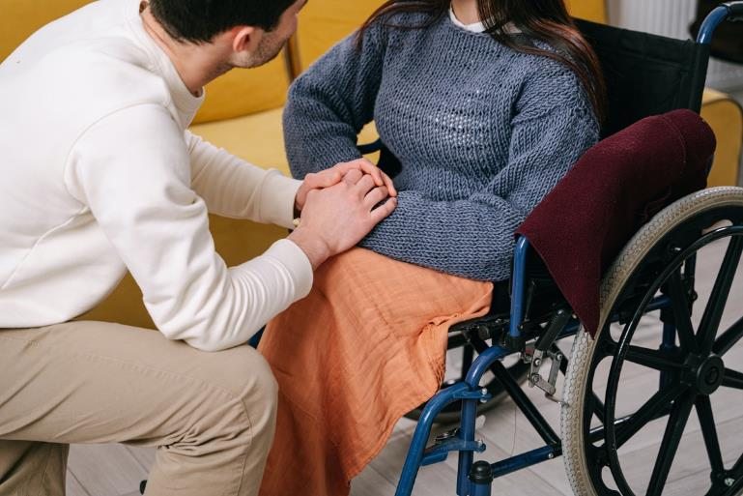

Treatment
- Ensure communities and patients have equitable access to quality information about cervical cancer symptoms and that each cancer patient has tailored information about their diagnosis, intended treatment and planned optimal care pathway.
  - Promote public understanding of cervical cancer signs and symptoms, the role of early detection and the opportunity for elimination, including campaigns and activities specifically focussed on and designed by people with disability.²¹
  - Provide information, consultation, and support such that patients and their families/support people fully understand and contribute their own preferences and needs to their individual care pathway. Particularly accounting for an individual’s physical access needs and any needs for additional support or tailored information (for example, low vision, hearing impairment).
  - Provide patients with the information, access to financial support and support personnel they need to navigate the health system, including informing them that they can have a support person/people/assistance animal as required, accompanying them whenever needed.
  - Enable incremental improvement by conducting routine patient-related evaluation measures (PREMs) to assess patient satisfaction, feeding results back to shape training and development of personnel, patient information materials and health service systems as appropriate. Ensure information collected captures patient diversity and experiences according to their sex, gender and sexual orientation, ethnicity, Aboriginal and Torres Strait Islander and disability status. Ensure this information accords to national standards for data collection.
- Develop and implement a road map of coordinated care, with communities of practice, to optimise the delivery of safe, quality care to all patients.
  - Realise a coordinated approach to patient care from diagnosis to survivorship and palliative care that is tailored to local population needs and diversity. This includes identifying and meeting the training and resourcing needs of key professionals.
  - Establish communities of practice, where multidisciplinary teams oversee processes and standards of care, and take responsibility for actively building relationships within and across jurisdictions. This can enable a level of safety and trust when a patient is required to travel to receive quality care. Tertiary centres should actively nurture relationships with services expert in caring for priority populations (for example, NDIS).
  - Optimise a hub-and-spoke model ensuring continuity of care for those diagnosed with screen-detected cancer and bring “quality to patients” where possible (for example palliative care) and “patients to quality” where necessary for highly specialist care (for example brachytherapy), tailoring the approach to the patient’s disability to ensure quality care is always delivered. Noting that palliative care services should be integrated into all levels of health care systems including primary care.
  - Identify and leverage quick wins by translating successful service models to new jurisdictions and ensure longer-term solutions that may require policy change or workforce reforms. Consider models aimed at addressing workforce issues, such as building an additional supportive role for gynaecologic nurses. Genuine partnership with priority populations and communities will improve the provision of culturally safe care and enhance access to treatment.
21 Coordinated with actions 2.1 and 5.1
- Drive improvements in cervical cancer management through a data collection framework supporting systematic monitoring and enhancement of the quality of care, in alignment with the Australian Cancer Plan.
  - Enhance and harness the data collected in the National Gynaecological Oncology Registry (NGOR) cervical cancer module to inform continuous improvement in care (equity of access, quality, and safety) based on incidence, stage, and mortality data, key clinical quality indicators, as well as patient reported evaluation and outcome measures (PROMs).
  - Conduct annual cervical cancer audits using data from the NSCR, cancer registries and NGOR together with HPV genotype information determined and reported for all cervical cancers.
  - Consolidate current clinical guidance and quality standards through developing national guidelines for the management of cervical cancer and utilise the NGOR to monitor adherence.

8.6 PEOPLE LIVING IN RURAL AND REMOTE AREAS:
STRATEGIC PRIORITIES AND ACTIONS
Note: italicised words indicate where the action has been tailored for this population.
- Ensure that Australia has access to timely and accurate cervical cancer incidence and mortality data.
  - Review the timeliness of cervical cancer notifications from each of the state and territory cancer registers to the Australian Cancer Database (ACD) and investigate opportunities to accelerate the availability of national cervical cancer data. Aiming to have the data available for the preceding year by November 1st of each calendar year.
  - Ensure that this accelerated reporting also includes currently reported stratifications including rates for Aboriginal and Torres Strait Islander people, by remoteness, by socio-economic status and by state and territory.
  - Build on the currently available breakdowns (which includes remoteness area of residence) to ensure timely reporting of cancer incidence and mortality for Aboriginal and Torres Strait Islander people in all jurisdictions, people of culturally and linguistically diverse backgrounds, people with disability, people who identify as lesbian, gay, bisexual, transgender, queer, and asexual, people who are intersex, and other priority populations as these data become available.
  - Add cancer registry data into the data assets that are included as enduring linkages in the Multi-Agency Data Integration Project (MADIP) to facilitate this. When cancer data are included in MADIP, consider reporting on individual-level socioeconomic status, rather than area-level measures.

Vaccination
- Optimise the delivery of school-based HPV immunisation programs in all jurisdictions to maximise equity and achieve high coverage for students living in rural and remote areas.
  - Review and revise communication planning materials for students and families living rural and remote areas and provide educational opportunities in schools to improve adolescent, parent, family and caregiver as well as school staff understanding of HPV vaccination and the elimination strategy. This should occur through strong partnerships between health and education to provide an integrated approach to HPV vaccination literacy that spans key learning areas, is supported by a whole-of-school approach, and fosters health literacy.²²
  - Utilise technology to support digital reminders and put clear communication and follow-up protocols in place to ensure that the school and the consenting carer are aware when a vaccine dose has been missed and receive clear remedial instructions, including how to access vaccination locally through services available in rural and remote areas.
  - Provide in-school vaccination catch up opportunities where possible. Should a single dose vaccination strategy be introduced, ensure that the implementation plan does not reduce opportunities for in-school vaccination given the reduction in required doses; and that the evidence of equal efficacy is communicated clearly to providers and the community.
  - Fund and develop routine program processes that can identify schools with lower coverage and develop tailored solutions to improve HPV vaccination uptake, including working in partnership with rural and remote health services, peak bodies and community.
- Optimise the reach and funding of complementary out-of-school HPV immunisation programs to achieve equity in delivery for all, including people living in rural and remote areas and medically high-risk populations (catch up).
  - Fund and promote catch up of an individual’s allocated dose of HPV vaccination for adults 19 and over in medically higher risk groups, and for people living in rural and remote areas.
  - Fund and promote HPV vaccine catch up strategies with out-of-school adolescents including those living in rural and remote areas, their peak bodies, health services and communities. Ensure equity in availability of catch-up opportunities across jurisdictions and for the most marginalised groups, for example, adolescents in youth detention. Consider alternative community locations and providers, for example, GP clinic settings, Aboriginal Community Controlled Health Organisations, pharmacies, and community events. Develop workforce strategies to expand reach, for example, collaboration with the Royal Flying Doctors Service of Australia.
  - Implement GP and rural and remote health care provider education, training and quality improvement activities relating to immunisation that support routine use of the Australian Immunisation Register (AIR) data to check HPV vaccination status for all patients aged 14-19 years, address vaccine hesitancy, and assess decision making capacity among vaccine recipients for the decision to vaccinate.
.
22 Coordinated with actions 5.1 and 8.1
- Develop a method to enable annual reporting of HPV vaccination coverage for people living in rural and remote areas and medically high-risk populations to monitor equity in immunisation.
  - Leverage data linkage through the MADIP, to monitor engagement, elimination progress and outcomes for priority populations, using demographic and other variables to define priority populations and medically higher risk groups within the linked dataset.
- Promote cervical screening regularly with the public and strategically with under-screened groups.
  - Undertake regular targeted tailored campaigns and activities for under-screened groups including rural and remote communities complemented by evidence-based, inclusive population-wide public awareness activities and mass media delivered through appropriate channels²³.
  - Work with priority communities, including rural and remote communities, including respected members, cervical cancer survivors, and community-controlled organisations who serve these communities, to co-create, design and test best approaches to reach the community, including the content of campaigns and information materials. Ensure campaigns are informed by the success and implementation strategies from previous campaigns and formative research, noting that materials may need to enhance community health literacy about HPV and cancer of the cervix.
  - Trial and utilise technology to support digital invitations, reminders and navigation to follow-up activities for people with screening results that require further investigation.
- Increase access to screening, colposcopy and follow-up in rural and remote areas by expanding who can offer these services, and where and how they are offered, to improve reach and uptake.
  - Provide a clear pathway to enable appropriately trained registered nurses, Aboriginal Health Workers and Practitioners, and midwives to independently request and sign the pathology form for a cervical screening test (and be eligible for Medicare reimbursement).
  - Establish a clear national pathway to train and accredit registered nurses, GPs and Aboriginal Health Practitioners to provide colposcopy.
  - Resource a pilot to scale up point-of-care HPV testing, with links to care, for remote communities (see Screening Case Study 2 (The PREVENT Project) for example).
  - Resource pilots in rural and remote communities and, where successful, resource scale-up and routine provision of innovative screening and follow-up care models such as peer-led and community-developed services, and innovative ways of providing and delivering colposcopy. Work with community-controlled organisations and key healthcare providers in rural and remote regions, such as the Royal Flying Doctors Service, to develop models for screening and follow-up services (for example point of care, mobile, or other approaches), scale up successful models, and share best practice approaches.
23 Coordinated with actions 2.1 and 8.1

- Collect, use, and release data to enable and monitor equity of access to cervical screening and precancer treatment services for people living in rural and remote areas.
  - Routinely report all program indicators stratified by key population demographics, expand reporting to include all priority populations, and introduce routine monitoring of performance against the WHO precancer treatment indicator.
  - Promote the importance of data collection, training all staff to collect demographic data sensitively in order to improve the recording of all demographic fields (Aboriginal and/or Torres Strait Islander status, country of birth, gender), including additional fields not yet captured on the National Cancer Screening Register (NCSR) and information that affects clinical management such as immune status.
  - Enhance clinical information systems in primary health care settings to enable automated uploading for relevant demographic information to integrate with NCSR.
  - Add cancer registry data and screening data from the NCSR into the data assets that are included as enduring linkages in the MADIP.
  - Enable clinicians and healthcare services to readily generate reports that can support continuous quality improvement initiatives by identifying patients who are under-screened and indicate current participation rates to inform efforts that drive engagement.
  - Provide visibility to primary care providers of current waiting times for colposcopy services, so that this can be factored into referrals and improve timeliness of care for people living in rural and remote areas.

Treatment
- Ensure communities and patients have equitable access to quality information about cervical cancer symptoms and that each cancer patient has tailored information about their diagnosis, intended treatment and planned optimal care pathway.
  - Promote public understanding of cervical cancer signs and symptoms, the role of early detection and the opportunity for elimination, including campaigns and activities specifically focussed on and designed by people living in rural and remote areas.²⁴
  - Provide information, consultation and support (for example, utilising the expertise of nurses and allied health professionals) allowing rural and remote patients and their families/carers to fully understand and contribute their own preferences and needs to their individual care pathway.
  - Provide rural and remote patients with the information, access to financial support and support personnel they need to navigate the health system, including informing them that they can have a person/people of their choice accompanying them whenever needed.
  - Enable incremental improvement by conducting routine patient-related evaluation measures (PREMs) to assess patient satisfaction, feeding results back to shape training and development of personnel, patient information materials and health service systems as appropriate. Ensure information collected captures patient diversity and experiences according to their sex, gender and sexual orientation, ethnicity, Aboriginal and Torres Strait Islander, and disability status. Ensure this information accords to national standards for data collection.

24 Coordinated with actions 2.1 and 5.1

- Develop and implement a road map of coordinated care, with communities of practice, to optimise the delivery of safe, quality care to all patients.
  - Realise a coordinated approach to patient care from diagnosis to survivorship and palliative care that is tailored to local population needs and diversity. This includes: identifying and meeting the training and resourcing needs of key professionals (including but not limited to ensuring access to culturally safe services and a supportive workforce for Aboriginal and Torres Strait Islander peoples; inclusive and accessible care for those with disability; in-language culturally relevant resources and provision of care for culturally and linguistically diverse communities and; sex, gender and identity-sensitive services and care for LGBTQ+ people who live in rural and remote areas).
  - Establish communities of practice, where multidisciplinary teams oversee processes and standards of care, and take responsibility for actively building relationships within and across jurisdictions. This can enable a level of safety and trust when a patient is required to travel to receive quality care. Tertiary centres should actively nurture relationships with services expert in caring for priority populations (for example, Aboriginal and Torres Strait Islander Community Controlled Health Organisations) located within rural and remote areas.
  - Optimise a hub-and-spoke model ensuring continuity of care for those diagnosed with cervical cancer to bring “quality to patients” where possible (for example palliative care) and “patients to quality” where necessary for highly specialist care (for example brachytherapy). Noting that palliative care services should be integrated into all levels of health care systems including primary care, especially to those living in rural and remote areas.
  - Identify and leverage quick wins by translating successful service models to new jurisdictions and ensure longer-term solutions that may require policy change or workforce reforms. Consider models aimed at addressing workforce issues, such as building an additional supportive role for gynaecologic nurses. Genuine partnership with priority populations and communities will improve the provision of culturally safe care and enhance access to treatment.
- Drive improvements in cervical cancer management through a data collection framework supporting systematic monitoring and enhancement of the quality of care, in alignment with the Australian Cancer Plan.
  - Enhance and harness the data collected in the National Gynaecological Oncology Registry (NGOR) cervical cancer module to inform continuous improvement in care for rural and remote patients (equity of access, quality, and safety) based on incidence, stage, and mortality data, key clinical quality indicators, as well as patient reported evaluation and outcome measures (PROMs).
  - Conduct annual cervical cancer audits using data from the NSCR, cancer registries and NGOR together with HPV genotype information determined and reported for all cervical cancers
  - Consolidate current clinical guidance and quality standards through developing national guidelines for the management of cervical cancer and utilise the NGOR to monitor adherence.
.

8.7 RELATED DOCUMENTS AND PAPERS
While developing this Strategy, people from priority populations, and in some cases their carers and families, were consulted to provide insights into how the existing health services were – or were not – meeting their needs and what could be done to improve these services.
More information on the consultation process and outcomes can be found in the following documents:
Technical Paper
A full version of the Technical Paper can be accessed here: https://acpcc.org.au/wp-content/uploads/2022/08/ TECHNICAL-PAPER_v1.0_PUBLISH.pdf
Consultation Paper
The full version the Consultation Paper can be accessed here: https://acpcc.org.au/wp-content/ uploads/2022/08/Consultation-Paper_PUBLISH.pdf
Consultation Outcomes Report
An Executive Summary of the consultation findings can be accessed here: https://acpcc.org.au/wp-content/ uploads/2022/12/Consultation-Report-for-the-NationalElimination-Strategy_SUMMARY.pdf

8.8 MORE INFORMATION
Project information, including project governance, governance members, and updates, can be accessed via the project website: https://acpcc.org.au/elimination/

