Self-collection Saves Lives
Cervical Screening Campaign

Sample Social Media Posts
Please copy and paste the social media tiles and content below to share with community members and networks.
Remember to use the hashtag #SelfCollectionSavesLives and tag the Australian Centre for the Prevention of Cervical Cancer (ACPCC).
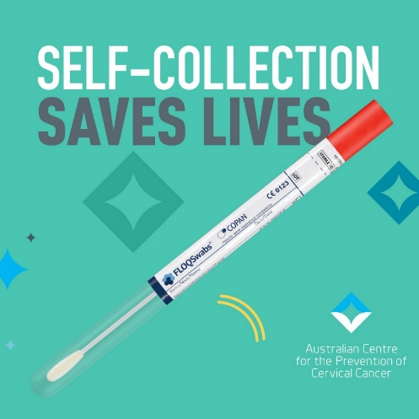 | 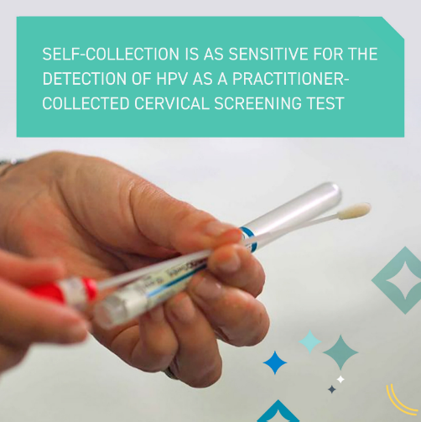 | 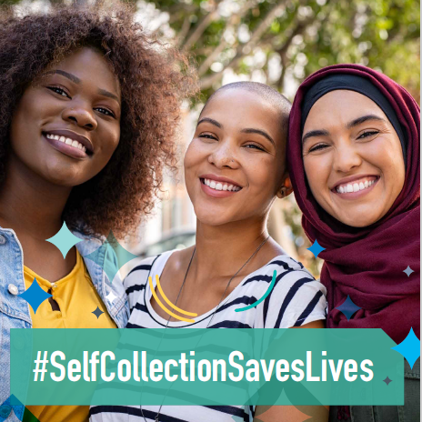
- Did you know, you can offer self-collection to your patients as part of the #NationalCervicalScreeningProgram as a #CervicalScreeningTest? All routine screening participants now have access to this option. For more information visit www.acpcc.org.au/practitioners/
- More than 200 women and people with a cervix die from cervical cancer in Australia each year. Health practitioners can help prevent the majority of cervical cancers by offering HPV self-collection, a more accessible option for patients who are hesitant to have a speculum examination.
- More than half of your patients may be overdue for cervical screening. HPV self-collection is the best tool to help reach your underscreened patients. See more: www.acpcc.org.au/self-collection-campaign/
- ACPCC has instructions on how to take a self-collected HPV test available in 20 languages. To provide your patients with in-language instructions, visit: www.acpcc.org.au/practitioners/resources/
- ACPCC offers cervical screening self-collection training for GPs and nurses with relevant CPD points. Access free education today, including webinars and our in depth, self-paced online self-collection learning module. Visit www.acpcc.org.au/practitioners/education/

Please contact Hannah Saunders hsaunders@acpcc.org.au if you have any questions about the campaign or would like information or material.

