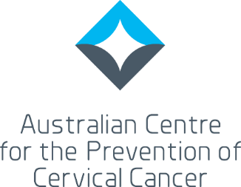
Consultation Outcomes Report: Executive Summary
National Strategy for the Elimination of Cervical Cancer

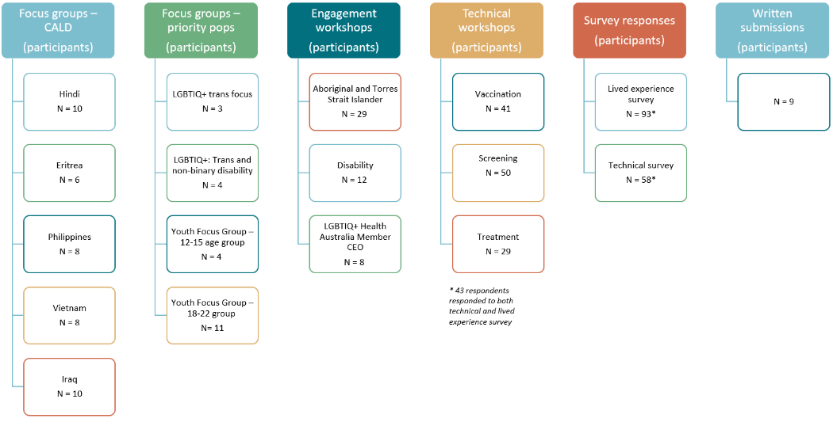
To inform the development of Australia’s national strategy to eliminate cervical cancer as a public health problem, public consultation occurred from 6 May 2022 to 31 July 2022 and involved the following engagement activities.

The University of Melbourne synthesised and analysed the findings, pulling out four major cross cutting themes that were relevant to each of the pillars: vaccination, screening, and treatment, and to all priority groups.
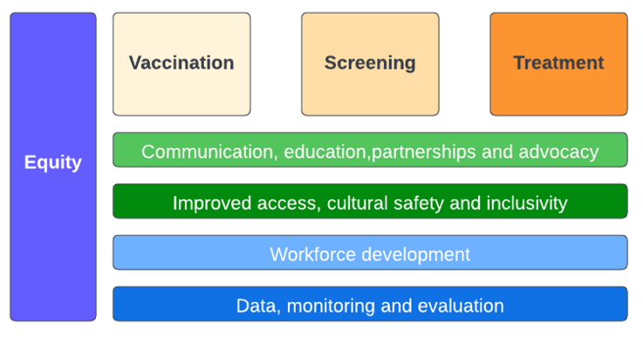
These major cross cutting themes were:
- Communication, partnerships and advocacy
- Improved access, cultural safety and inclusivity
- Workforce development
- Data, monitoring and evaluation

Respondents were supportive of the strategy and are invested in Australia’s efforts to eliminate cervical cancer. The need for equitable, inclusive, safe and appropriate access to care across all populations was emphasised as critical if Australia is to reach elimination for all populations in the country.

CROSS CUTTING THEMES
Most consultation participants spoke of the need to work in partnership with communities to effectively communicate and inform communities about the vision, timeline and goal of cervical cancer elimination, including cervical cancer prevention and control interventions, including vaccination, screening and treatment. Community partnerships were viewed as essential in the development of messages, as well as in the design and delivery of campaigns, vaccination programs and more inclusive screening services.
A strong focus on equity in the consultations highlighted that there is a continual need to improve access, cultural safety and inclusivity across the health system, to facilitate increased participation in vaccination programs, to remove barriers to screening, and to encourage people to seek timely treatment.
This focus on improved cultural safety and inclusivity carries over to the theme of workforce development, with training and education of the workforce required to increase cultural safety, to provide trauma informed care, and to reduce stigma and discrimination that people from priority populations often felt when accessing health care.
Specific workforce reform and development issues are highlighted in the pillars below.
Improvements in data to allow more effective and meaningful monitoring and evaluation should be a priority of the strategy. The incomplete demographic data in the National Cancer Screening Register (NCSR) limits our understanding of which participant groups may require additional support to access screening and early treatment. While there have been improvements made, challenges remain. Colposcopy data remains incomplete. The lack of a clinical quality registry for cervical cancer limits our ability to report against the treatment indicator outlined in the WHO global elimination strategy. Australia needs timely and accurate data on cancer incidence to be able to monitor progress towards elimination.

VACCINATION
Priorities emerging that were relevant to vaccination included the need to renew communication, promotion and awareness activities. There was a perception that increased vaccine hesitancy and fatigue, as a result of the COVID-19 pandemic, had resulted in drops in vaccination rates. Communication campaigns need to be developed with communities to ensure their relevance and impact.
Respondents were highly supportive of the school-based vaccination program but emphasised that education and communication around the program could be improved. Particularly for culturally and linguistically diverse parents, access to more culturally appropriate information in the right language would improve their ability to provide consent. Empowering young people to be active participants in the consent process was also raised. Increasing access to out of school vaccination programs and catch-up vaccination programs was also highlighted as a priority. Considering ways to expand the workforce and availability of the vaccine, stakeholders suggested upskilling Aboriginal Health Workers or Practitioners (AHW/Ps) to be trained immunisers and involving community pharmacists in vaccine delivery. Improved health information systems to allow electronic consent, more efficient reminders and online bookings would also aid program delivery.
Discussion about the potential change to a one-dose vaccination schedule highlighted the need to ensure the changes were properly communicated to the public, to avoid the perception that it was a cost cutting exercise. People raised some concerns that a single dose would reduce the opportunities to reach people with vaccinations.

SCREENING
Similarly, increased promotion and communication around the benefits of screening were thought to be necessary, with suggestions that both mass media and targeted campaigns are needed. Stakeholders were highly supportive of self-collection becoming more available, and the need to raise awareness of this screening option, among both the community and cervical screening providers was emphasised. The development and implementation of community co-designed screening services, that are inclusive and culturally safe, was noted as an important priority.
There was strong advocacy among consultation participants to review Medicare restrictions that limit the ability of registered nurses to order pathology tests related to the National Cervical Screening Program. Further to this, the availability of self-collection should allow the exploration of more flexible models of care aiming to increase reach and equity; following consultation, this may include upskilling Aboriginal Health Practitioners to facilitate cervical screening through self-collection.
Continuing with the theme of workforce development, consultation participants raised the need to develop training and accreditation pathways for colposcopy to include registered nurses and general practitioners (GPs), particularly GPs working in rural/remote settings. With emerging technology to facilitate point of care HPV testing, same day screen and assess models are being trialed in remote Australia, which will further contribute to extending reach.

TREATMENT
Consultation participants felt that it was important to raise community awareness that cervical cancer is preventable, treatable and that no one need die from it. Dispelling negative community perceptions that may exist around cancer treatment was also thought to be a priority.
The need to improve equitable and timely access to diagnosis and care was reiterated. People with lived experience of cervical cancer spoke of challenges with getting a diagnosis, citing a need to upskill GPs in the identification of symptoms and correct referral pathways. The coordination of care once in the tertiary health system was challenging, and resourcing patient navigators or nurses to assist with care coordination was suggested as a potential way to alleviate this burden. Inequities in access to care, particularly an issue for people living in remote and rural Australia, with the additional complexity of coordination, the long periods of time away from home, the added financial burden, were all raised. In addition, the reduced funding, and hence reduced availability of brachytherapy was a critical concern that consultation participants felt required renewed advocacy to address emerging inequity in treatment.
The need to support survivorship in a more holistic way was discussed. Increasing the person-centredness of palliative care by upskilling community nurses and Aboriginal and Torres Strait Islander health workers/practitioners to assist in its provision, will allow more people to receive care at home, or on-country (noting the need to address current workforce shortages).

PRIORITY POPULATIONS
Aboriginal and Torres Strait Islander people
Elimination of cervical cancer for Aboriginal and Torres Strait Islander people is dependent upon access to culturally safe and appropriate services across all three pillars. It was widely acknowledged during the consultation that the Aboriginal health workforce is overburdened. Adequate numbers of clinicians trained to provide culturally safe care to Aboriginal and Torres Strait Islander people should be a priority. Aboriginal Health Workers/Practitioners (AHW/AHP) in the local setting, who can liaise closely with Aboriginal Liaison Officers in the acute or palliative care setting, and/or dedicated patient navigators who are trusted to assist women and people with a cervix across the entire journey, are crucial to successful elimination. The need for investment to achieve this is a strong theme that emerged from the consultations. These strategies need to be underpinned by accurate data about Aboriginal and Torres Strait Islander screening rates and incidence of cervical cancer.

People living with intellectual or physical disability
People with lived experience of a disability highlighted that there is a continual need to educate healthcare providers in the provision of safe services. There was an identified need to provide more training about facilitating the consent process for vaccination and screening, and to address common misconceptions about a lack of sexual activity. More awareness of the benefits of vaccination and screening is needed for parents, carers and support people of people living with disability.
Achieving elimination for people living with disability will require a strengthened focus on community partnerships and co-design to ensure the appropriateness of communication and service delivery. Harnessing enablers, such as self-collection, and delivering them in a safe and trustworthy environment, will be critical in increasing the engagement of people within this population in cervical cancer prevention services.

Culturally and linguistically diverse populations
The strongest theme emerging from the consultations with members of culturally and linguistically diverse communities was the need for more accessible and culturally appropriate information across all three pillars. With many newly arrived people having no experience of cervical cancer prevention programs in their country of origin, the benefits and risks of vaccination and screening need to be clearly communicated. People spoke of the stigma and fear that exists within communities about cancer.
It was raised that consent processes and information provided to parents about school-based vaccination programs could be more culturally appropriate and more accessible in other languages. Community partnerships with organisations working with culturally and linguistically diverse communities can be leveraged to increase awareness of the benefits of the vaccine, maintaining confidence in the safety of the vaccine and potentially play a role in delivering vaccination programs.
Improved cultural awareness among healthcare providers could improve the provision of cervical screening services. Self-collection was supported within the groups, but there was confusion about whether this was something that could be done at home.
Systemic barriers to healthcare, coupled with lower awareness of cervical cancer signs and symptoms, may contribute to later diagnosis of cervical cancer in some culturally and linguistically diverse women and people with a cervix, and these barriers need to be addressed in the strategy.

LGBTIQ+ populations
Achieving elimination for LGBTIQ+ people will require a renewed focus on inclusivity across all three pillars. Making campaigns and NCSP program messaging (including images) more representative of diverse communities and working with services to reduce stigma and discrimination and improve the delivery of trauma informed care, are key priorities. Improvements in service delivery are needed across the health system.
The evolution of the school-based vaccination program to include boys and girls was seen as a positive move for many gender diverse people and people with intersex variations.
Partnerships with community organisations to inform and co-design promotional campaigns and service delivery models for screening have been demonstrated to be successful in engaging people to participate in cervical screening. These partnerships will be essential in achieving elimination for diverse LGBTIQ+ populations in Australia.

Young people
Young people called for more education to improve their awareness of HPV vaccination and screening. There was support for the school-based vaccination program, but people wanted to know more about what the vaccine was, what the side effects were, and what it protected against. Improving education and communication around the vaccine was considered important, as many young people said that they were unsure what the vaccine was when they received it. The out-of-school vaccination options were also valued.
An increased awareness was considered necessary to help to reduce the stigma that is associated with HPV being a sexually transmitted infection. This leads into the need for more education around screening which may alleviate some of the anxiety that may be associated with receiving a HPV positive result.
Young people wanted communication, awareness and education to be available on the platforms that they use.

This report was prepared by the Evaluation and Implementation Science Unit, the University of Melbourne, for the Australian Centre for the Prevention of Cervical Cancer

September 2022

