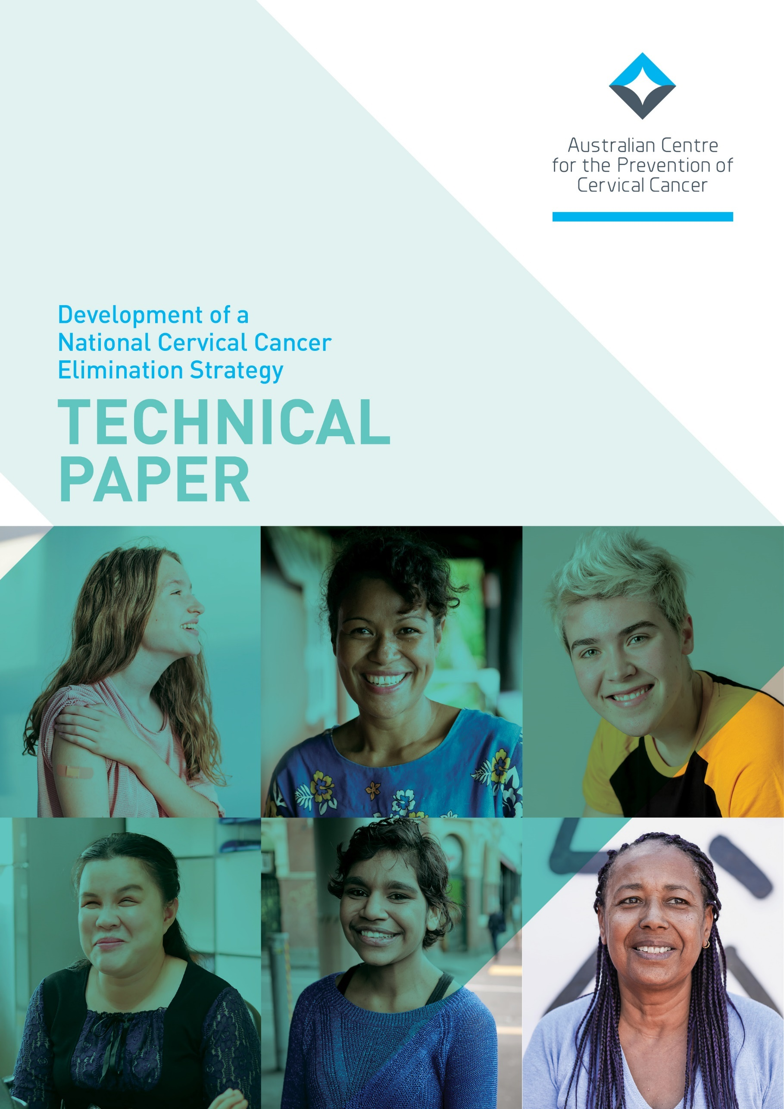

**]**

**© 202**

**© Australian Centre for the Prevention of Cervical Cancer** **(ACN 609 597 408)**  
  
**All Rights Reserved.**

This document is the property of the Australian Centre for the Prevention of Cervical Cancer and may not be copied, transmitted, distributed or reproduced by any means without the written permission of Australian Centre for the Prevention of Cervical Cancer.

Contents

1 EXECUTIVE SUMMARY 5

1.1 Key findings 5

1.1.1 Data issues and gaps 5

1.1.2 Equity issues and gaps 6

1.1.3 Research and policy evidence gaps 7

1.1.4 Assessment of local applicability of WHO targets 8

1.1.5 Assessment of local applicability of WHO recommended strategic actions 9

2 BACKGROUND AND INTRODUCTION 11

2.1 Aims and methods of the Strategic Summary Assessment 11

2.1.1 Purpose 11

2.1.2 Methods 11

2.2 Overview of WHO elimination strategy 13

2.3 Predicted timeline for achieving elimination in Australia 17

2.4 Cervical cancer prevention and control in Australia: Current status 18

2.4.1 Overview of the National HPV Vaccination Program 18

2.4.2 Overview of the National Cervical Screening Program 21

2.4.3 Overview of cervical cancer treatment in Australia 24

2.5 Overview of relevant existing national targets and strategies 25

3 FINDINGS AND ANALYSIS 26

3.1 Disease outcomes 26

3.1.1 Cervical cancer incidence 26

3.1.2 Cervical cancer mortality 29

3.1.3 Cervical precancer detection rate 30

3.1.4 HPV infection prevalence 32

3.1.5 Current research, policy and health system issues relating to monitoring disease outcome indicators 33

3.1.6 Key issues for strategy development identified from disease outcome indicator review 35

3.2 Vaccination indicators 37

3.2.1 HPV vaccination coverage: definition 37

3.2.2 HPV vaccine completion 37

3.2.3 HPV vaccine initiation 42

3.2.4 Australian literature: HPV vaccination program implementation 44

3.2.5 Key issues for strategy development identified from vaccination review 49

3.3 Screening and precancer treatment indicators 53

3.3.1 Screening participation (WHO indicator) 53

3.3.2 Screening participation (Australian program) 54

3.3.3 Attendance for follow-up tests (surveillance and colposcopy) 58

3.3.4 High-grade cervical disease treatment rates 60

3.3.5 Current research, policy and health system issues: Overview of key literature …… 61

3.3.6 Key issues for strategy development identified from screening review 69

3.4 Invasive cancer treatment and palliative care indicators 75

3.4.1 Cervical cancer survival 75

3.4.2 Cervical cancer treatment rates (WHO indicator) 76

3.4.3 Appropriateness of care 82

3.4.4 Current research, policy and health system issues: overview of key literature 86

3.4.5 Key issues for strategy development identified from cancer treatment review 88

3.5 Health system enablers 92

3.5.1 Review of local applicability of WHO recommended priority actions to strengthen health systems 92

3.6 Partnerships, advocacy and communications 95

3.6.1 Partnerships 95

3.6.2 Multisectoral collaboration 95

3.6.3 Advocacy and communication 95

3.6.4 Review of local applicability of WHO perspective on partnerships, advocacy and communication 96

3.7 Surveillance, monitoring and evaluation 97

3.7.1 Review of local applicability of WHO recommendations and strategic actions for monitoring and evaluation 99

4 SYNTHESIS 100

4.1 Strategic summary of data issues and gaps 100

4.1.1 Key data issues arising across the elimination pillars 100

4.2 Strategic summary of equity issues and gaps 101

4.2.1 Key equity issues arising across the elimination pillars 101

4.3 Strategic summary of research and policy issues and gaps 102

4.3.1 Key research and policy issues arising across the elimination pillars 102

5 APPENDICES 103

5.1 Appendix A: National Cervical Screening Program Pathway 104

5.2 Appendix B: Alignment to existing national targets and strategies 105

6 REFERENCES 112

7 ABBREVIATIONS 124

8 LIST OF TABLES 126

9 LIST OF BOXES 126

10 LIST OF FIGURES 127

# EXECUTIVE SUMMARY

The Australian Centre for the Prevention of Cervical Cancer has undertaken a strategic analysis of data, relevant research and current practice and policy related to cervical cancer elimination in the Australian context.

Forming part of the development of Australia’s National Cervical Cancer Elimination Strategy, this analysis has been framed:

* by an overarching equity lens
* by considering available data to report against 12 elimination indicators as first proposed by the National Health and Medical Research Council (NHMRC) Centre for Research Excellence in Cervical Cancer Control in their 2021 Cervical Cancer Elimination Report (1)
* by considering the three pillars of vaccination, screening and treatment and related recommended global strategic actions of the World Health Organization (WHO) global strategy to accelerate the elimination of cervical cancer as a public health problem (2).

This technical paper is accompanied by a consultation paper and a series of survey questions for submission of responses to inform the draft National Cervical Cancer Elimination Strategy. It can be found here: <https://acpcc.org.au/elimination/get-involved/>

## Key findings

### Data issues and gaps

**Timely monitoring**

Timely monitoring of the overall elimination target of a cervical cancer incidence less than four per 100,000 (to know when elimination has been reached) will be a major challenge, because national cancer incidence data lag by several years.

In addition, Australia is unable to report national stage distribution data or stage-specific survival for cervical cancer, as stage is not collected nationally.

**Deficiencies in priority populations**

There is a marked deficiency across vaccination, screening and treatment programs, indicators and outcomes in data for priority populations, including Aboriginal and Torres Strait Islander people, people living with a disability, medically higher-risk groups, refugees, CALD communities and LGBTQI+ people.

**Lack of precancer treatment data**

There is no data to assess the proportion of people who receive treatment for screen-detected cervical precancer, which is a WHO elimination strategy indicator.

**Lack of invasive cervical cancer treatment data**

There is no data to assess the proportion of patients with invasive cervical cancer who receive treatment and care (a WHO elimination strategy indicator) nor the quality of care and whether it is compliant with the optimal care pathway.

Sparse data was located identifying the patients who do not currently receive treatment or appropriate care in Australia and why.

### Equity issues and gaps

**Disparities**

* Higher rates of cervical cancer incidence and mortality are experienced by Aboriginal and Torres Strait Islander people, people living in very remote areas, people living in lower socioeconomic areas and people living in the Northern Territory.
* There is disparity in vaccine course completion for Aboriginal and Torres Strait Islander adolescents, and people residing in remote areas of lower socioeconomic status. Disparities are greatest for Indigenous males. Disparities are much less marked for one dose receipt.
* Some evidence suggests additional barriers to vaccination are experienced by some CALD communities, students with a disability and students in smaller schools.

**Low screening participation**

* Program data shows lower screening participation for residents of lower SES areas, residents of more remote areas and young women.
* Pre-renewal research data demonstrated markedly lower participation in screening for Indigenous women. Additional barriers faced by Indigenous people included lack of access to culturally safe services.
* Limited data suggest lower screening participation and differing barriers to participation for some CALD groups, for people living with a disability and for LGBTQI+ people. There is no data on intersectionality of these groups.

**Follow up**

* Little is known about how intensive cervical screening and follow up is recommended to, and understood and accepted by, the medically higher risk groups (diverse patient groups facing differing health issues).
* Rates of follow up after a positive screening test were lower for Aboriginal and Torres Strait Islander people and people residing in lower SES areas. Rates varied by remoteness.

**Treatment and care**

* Little data was identified on equity in cancer treatment and care. The available data indicated structural and cultural barriers to quality care for Aboriginal and Torres Strait Islander people, including racism.

### Research and policy evidence gaps

**Relating to Disease Outcome Indicators**

**(cervical cancer incidence, mortality, precancer rate and HPV prevalence)**

* **Routine monitoring for priority groups:** Determining how Australia can best monitor relevant disease indicators (incidence, mortality, precancer rates and HPV prevalence) for: people with a disability, LGBTQI+ people, refugees medically higher risk groups, CALD communities, other priority populations to ensure equity of outcomes
* **Routine monitoring for Aboriginal and Torres Strait Islander people:** Identify solutions to correct longstanding known and continuing deficits in reporting program indicators and outcomes for Aboriginal and Torres Strait Islander people in the NCSP and cancer registries, given that are they are known to perpetuate inequities by preventing any ability to measure them and act.
* **Overcoming existing equity gaps:** Determine how the cervical cancer incidence and mortality gap for Aboriginal and Torres Strait Islander people, people living in very remote areas, the most socioeconomically disadvantaged and in the Northern Territory can be most rapidly and effectively closed.

**Relating to Vaccination**

* **Partnerships between education and health:** Optimising existing partnerships between the education and health sectors to support high HPV vaccine coverage for all students
* **Outreach and primary care strategies:** Optimising outreach and primary care strategies to reach and catch up out of school or post school cohort age students
* **One-dose HPV vaccine schedule:** Identifying whether the available evidence supports the effectiveness and cost-effectiveness of a one dose HPV vaccine schedule in Australia.
* **Funded, targeted vaccination:** Identifying the contribution that funded, targeted vaccination for medically high-risk groups or other priority populations aged over 19 could make towards equitable elimination
* **Parental reasons for decline:** Understanding and addressing the reasons why some parents or guardians decline or do not consent to the HPV vaccine for their child when offered it in the school-program
* **Supporting adolescents with a disability:** Understanding how vaccination programs can best support the needs of adolescents with a disability in both mainstream and special schools
* **COVID vaccination program learnings:** Leveraging learnings and new ways of working from COVID vaccination programs to improve the efficiency and reach of HPV vaccination
* **Routine monitoring for priority groups:** Identifying how coverage of HPV vaccines can be routinely monitored for priority and higher risk groups.

**Relating to Screening and Precancer treatment**

* **Routine monitoring for priority groups:** Best methods to measure, and then monitor, screening and precancer treatment-related program and elimination indicators for priority and diverse populations
* **Self-collection:** Optimal implementation of self-collection to overcome current barriers to screening participation across diverse communities
* **Precancer diagnosis and treatment**
  + Methods for monitoring the precancer treatment rate in Australia
  + Understanding and addressing barriers to accepting and receiving further investigations and treatment after a positive screening test
* **NCSP indicators:** Consider including indicators that routinely monitor precancer treatment rates and the proportion of participants completing test of cure
* **Integrated software systems and reminders**
  + Methods to better integrate the use of current digital technologies for screneing histories and reminders
  + Methods to improve invitations/reminders and their delivery – for example: tailored messages, text message and more use of social media platforms to deliver concurrent education
* **Diagnostic assessment:** Methods to ensure people and healthcare providers are aware of the symptoms of cervical cancer and that people feel safe and supported accessing appropriate testing and investigation.

**Relating to Cancer Treatment and Care**

* **Receipt of treatment and care**
  + Methods to assess and monitor the proportion of patients receiving treatment for cervical cancer in Australia
  + Methods to determine whether care received is optimal care and is culturally safe
  + Methods to identify what the current barriers to receiving quality care are.
* **Routine monitoring for priority groups:** Best methods to measure, and then monitor, cancer treatment-related elimination indicators for priority and diverse populations

### Assessment of local applicability of WHO targets

**Elimination**

Consideration should be given to Australia’s explicit endorsement of the global elimination target (less than four per 100,000) as applicable and appropriate for *all* Australians, including groups known or suspected to currently be at higher risk of developing cervical cancer.

**Vaccination**

The strategy should seek to understand if the global target of 90% completed course coverage for girls (by age 15) is applicable to Australia, given we have a both-sex vaccination program.

**Screening**

The WHO indicator relating to twice-lifetime cervical screening does not directly reflect screening recommendations in Australia; however, Australia has not yet met this target. This is partly because HPV screening has not been available for long enough in Australia.

While Australia may wish to adopt a more ambitious target than that set by WHO, the WHO target could be seen as a minimum that must be met for all groups in Australia. Of note, the WHO strategy requires scaling up beyond 70% twice in a lifetime to over 90% beyond 2030.

**Treatment**

The WHO target is that90% of women with invasive cancer are managed. In developing the national strategy, explicit consideration of the adequacy of the WHO target in the Australian setting is required.

Is this target too low? Should quality and adequacy of care be included in the stated target?

### Assessment of local applicability of WHO recommended strategic actions

The WHO Strategy to accelerate the elimination of cervical cancer is intended for the global context, including low- and middle-income countries. The analysis found variable alignment with, but useful guidance from, the WHO strategic actions outlined in the global strategy.

**Vaccination**

Strategic actions to ensure vaccine supply, improve coverage, and improve communication and social mobilisation are consistent with existing priorities under Australia’s National Immunisation Strategy.

The recommended strategic action to ‘Innovate to improve efficiency of vaccine delivery’ urges countries to ensure that they have timely processes to consider new evidence and amend current recommendations.

**Screening and pre-cancer treatment**

Strategic actions to create an enabling and accessible screening environment, and integration into primary care are applicable.

Promotion of a screen and treat approach is not appropriate but a screen and assess approach should be considered in remote areas utilising point of care HPV testing.

Actions to ensure supply of tests and treatment devices and strengthen pathology services can be adapted to focus on maintaining these with a focus on quality.

**Cancer treatment and care**

Two of the nine strategic actions require adaptation to include *maintenance* of surgical capacity and pathology services rather than their expansion and strengthening.

The action to implement cervical cancer management guidelines requires Australia to consider whether a consolidated national resource is required.

Other strategic actions to streamline care pathways, integrate palliative care, optimise the health care workforce, reduce cancer stigmatisation and provide comprehensive support are all critical and should align with the forthcoming National Cancer Strategy.

Improving access to radiotherapy and chemotherapy is applicable and necessary for Australians residing further from major centres.

**Monitoring and evaluation**

All five strategic actions are applicable in Australia and cover:

* governance and accountability of programs
* the setting of milestones, targets and indicators for elimination
* improvement of cancer registries (with timeliness and ability to monitor stage and treatment challenges locally)
* tracking of patients through the continuum of care
* working towards disaggregation of data by equity stratifiers.

WHO’s Elimination Strategy also includes nine priority actions to strengthen health systems, all of which are applicable in Australia and aligned with many existing strategies. These include:

* strengthening primary care centred models of care
* strengthening the primary care workforce
* improving access to medications
* supporting quality in health care and digital innovation,
* reducing cancer stigmatisation
* data systems for monitoring and evaluation.

Australia should ensure it considers the priority action to ensure ‘Universal health coverage and protection from catastrophic costs’ given the extent of gap payments required in both the public and private health care systems and documentation of a rising cost burden for cancer patients.

Similarly, the priority action to ‘Engage with private sector providers’ is important within the Australian health care context, given that private providers may be less likely to provide comprehensive cancer services. (3)

**Please note: Throughout this report we often use the term ‘women’ to refer to people eligible for or attending cervical screening or experiencing cervical cancer. However, we respectfully acknowledge that some people with a cervix do not identify as women and are equally impacted by the risk of cervical cancer**.

# BACKGROUND AND INTRODUCTION

## Aims and methods of the Strategic Summary Assessment

### Purpose

This analysis aims to provide a strategic overview of data and relevant research, and current practice and policy, to inform the development of Australia’s National Cervical Cancer Elimination Strategy.

This analysis also notes the strategic actions recommended in the overarching WHO global strategy for the acceleration of the elimination of cervical cancer as a public health problem (2) so that their applicability can be considered in the Australian context.

It is intended to provide a resource to interested parties being consulted as part of the strategy development. The anticipated audience includes policy makers, researchers and academics, health professionals, non-government organisations, advocates and consumers.

### Methods

We reviewed and analysed available data against the 11 indicators proposed by the NHMRC Centre of Research Excellence in Cervical Cancer Control in its inaugural 2021 Elimination Progress Report (1).

Data has been updated where available through formal data requests made to the Australian Department of Health as required (for NCSR and AIR data). An additional 12th indicator, survival, has been added.

The indicators were developed to inform and monitor Australia’s status and progress towards the elimination of cervical cancer as a public health problem. They are outlined in Table 1.

In addition, we reviewed published and grey literature to identify studies and reports that:

* + provide supplementary data about the indicators
  + document key implementation issues in Australia across the three strategy pillars of HPV vaccination, cervical screening and treatment.

For cervical cancer incidence and mortality, rates were age-standardised to the world population (female) 2015 to allow comparison with other countries and the global rate.

This means that these rates are not necessarily consistent with rates published routinely in Australia. Australian rates present either crude rates or rates age-standardised to the Australian population.

Using the world population for age standardisation can impact on determination of when elimination is reached (likely favourably). This is because the world population has a younger age structure than the Australian population.

Table 1. Cervical cancer elimination progress indicators, Australia.

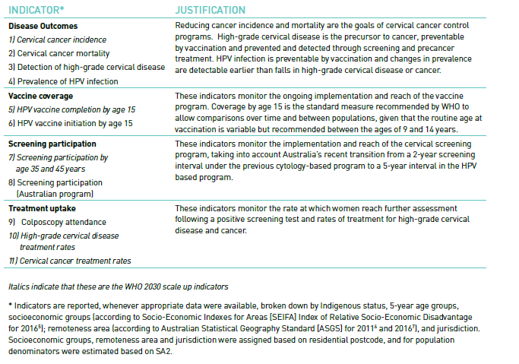

Source: NHMRC Centre of Research Excellence in Cervical Cancer Control. 2021 Cervical Cancer Elimination Progress Report: Australia’s progress towards the elimination of cervical cancer as a public health problem. (1)

## Overview of WHO elimination strategy

**In November 2020, the WHO formally launched the global strategy to accelerate the elimination of cervical cancer as a public health problem (2).**

**Australia – which has a history of global leadership in cervical cancer control programs, technology and research – led the way by sponsoring a successful resolution at the 73rd World Health Assembly to adopt the strategy.**

**The adoption of the global strategy means that, for the first time ever, the world has committed to eliminate a cancer as a public health problem. This goal will be achieved when the incidence rate of cervical cancer falls to fewer than four per 100,000 in every country.**

**As shown in Figure 1, elimination as a public health problem has a specific consensus definition: Public health actions result in the meeting of an agreed target, but ongoing activities are required to maintain elimination.**

**This is different to the eradication of a disease (for example, smallpox), when prevention and control activities can cease once eradication is achieved.**

Figure 1. Continuum of control, elimination and eradication.

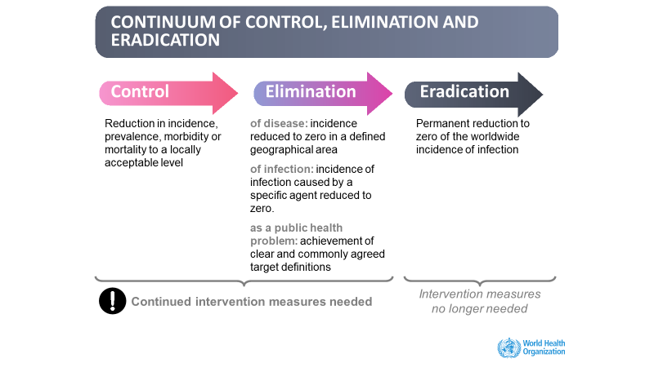

Source: WHO WPRO regional consultation on the elimination of cervical cancer

**The path to elimination is possible because of advances in the understanding of cervical cancer as a preventable cancer caused by oncogenic human papillomavirus (HPV).**

**It is also made possible by modern technology that can be implemented at the population level enabling:**

* **primary prevention through HPV vaccination**
* **more effective and accessible secondary prevention through primary HPV cervical screening**
* **effective treatment modalities for cervical precancer and early-stage invasive cancer.**

**Under the WHO strategy, countries are invited to commit to achieving scale-up coverage targets by 2030 through the implementation of strategies for primary and secondary prevention in the context of comprehensive cancer treatment.**

**These so-called 90/70/90 targets are:**

* 90% of girls to be fully vaccinated with the HPV vaccine by age 15
* 70% of women to be screened by age 35 and again by age 45 using a high precision test (such as an HPV PCR-based test)
* 90% of women identified with cervical disease to receive treatment for precancerous lesions or invasive cancer.

The elimination strategy components, and the scale up targets, have been defined based on consensus modelling undertaken by three international modelling groups.

The modelling informed the feasibility of global elimination through predicting the optimal combination of vaccine coverage for long term HPV control and screening and treatment to prevent and control cervical cancer and precancer in cohorts already infected with oncogenic HPV globally.

HPV is a common and usually asymptomatic infection that is spread through sexual activity. The conceptual model is shown in Figure 2.

The predicted outcomes over time utilising just vaccination, vaccination and once per lifetime screening, or vaccination and twice per lifetime screening are shown in Figure 3.

As seen in Figure 3, the addition of screening accelerates the time to achieve elimination by preventing additional cases in the short-medium term. Vaccination and twice per lifetime screening was estimated to avert 78.1 million cervical cancer cases in these 78 Low and Low Middle-Income Countries (LMICs) through to 2120 (4).

The 90-70-90 scale-up targets are interim targets to kick start and accelerate all countries towards elimination. The modelling assumes ongoing improvements in screening coverage, reaching 90% from 2045 onwards.

Figure 2. Conceptual framework of cervical cancer elimination.

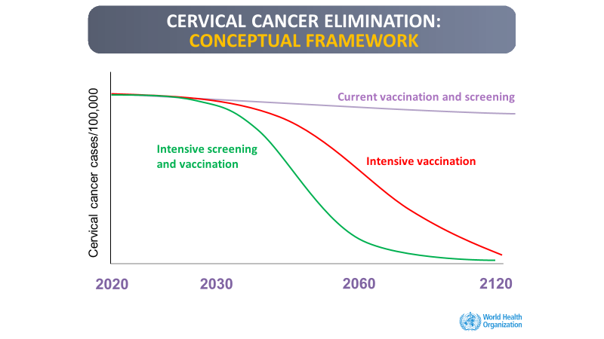

Source: WHO WPRO regional consultation on the elimination of cervical cancer.

Figure 3. Dynamics of cervical cancer incidence after HPV vaccination and cervical screening.

Source: Brisson M, Kim JJ, Canfell K et al. Lancet 2020; 395: 575–90.(4)

## Predicted timeline for achieving elimination in Australia

An important modelling study by Hall et al suggested that cervical cancer could be considered as eliminated as a public health problem in Australia as early as 2030 (5) if high-coverage vaccination and screening is maintained, using an elimination threshold of four new cases per 100 000 women annually.

However, screening and vaccination initiatives would need to be maintained thereafter to maintain exceptionally low cervical cancer incidence and mortality rates. The initial peak in cancer diagnoses in Figure 4 is due to the increased sensitivity of the HPV test.

The HPV test will identify more prevalent cancers and bring forward (downstage) their diagnosis. The peak was predicted following the implementation of HPV screening in Australia.

Cancer incidence data for this period (2018 onwards) is not yet available. Notably, there is no corresponding increase in mortality due to these earlier diagnoses of existing cases.

Figure 4. The predicted (A) age-standardised annual incidence of invasive cervical cancer and (B) associated mortality.

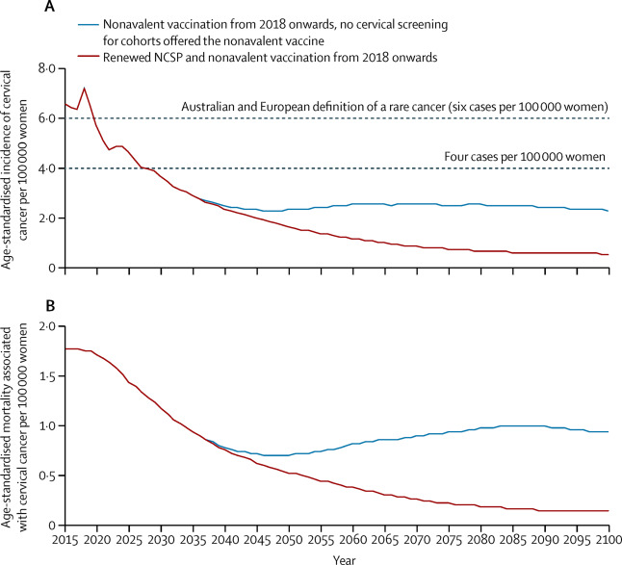

Source: Hall MT, Simms KT, Lew JB, et al. Lancet Public Health. 2019;4(1):e19-e27. (4)

## Cervical cancer prevention and control in Australia: Current status

### Overview of the National HPV Vaccination Program

Box 1. Overview of the National HPV Vaccination Program

|  |
| --- |
| * Australia was the first country in the world to introduce a national HPV vaccination program in 2007 * In 2013, males were included national HPV vaccination program, with a two-year catch-up program for boys to age 15. * In 2017, provision of free catch up through to age 19 through primary care commenced, in line with other NIP vaccines. * As of 2018, the program offers females and males a two-dose schedule (0,6-12 months) of nonavalent HPV vaccine that protects against HPV types 16, 18, 6, 11, 31, 33, 45, 52 and 58. * The vaccine has been highly effective in Australia, with population-level reductions in HPV prevalence and cervical precancers. * The vaccine is safe, using both routine passive and active surveillance, and coverage is continuing to increase year on year. |

#### **Initial roll out and catch-up program**

Australia commenced its National HPV Vaccination Program in 2007 using the quadrivalent HPV vaccine (4vHPV) in a three-dose schedule (0,1*–*2,6 months) for females aged 12*–*26. The school-based program began in April, and the primary care program began in July.

The 4vHPV vaccine (trade name Gardasil) prevents infection with four HPV types:

* **Types 16 and 18** – the two most oncogenic types responsible for around 70% of cervical cancers globally (and around 80% in Australia) (6)
* **Types 6 and 11** – which cause over 90% of genital warts.

Australia was the first country to introduce a funded national HPV vaccination program. It was, and remains, one of the largest funded catch-up programs in the world.

The National HPV Vaccination Program Register (NHVPR) was established by legislation to support the program in the following ways:

* recording details of doses administered
* supporting completion of HPV vaccine courses through program management reports and reminders
* monitoring coverage
* maintaining a long-term record of vaccines administered to support ongoing program evaluation (7).

Coverage estimates for the initial 12 to 26 year old catch-up cohorts (vaccine eligible 2007*–*2009) from the NHVPR (as at 2011) are shown in Figure 5. Note that reporting to the register from primary care was incomplete, with estimates of 5, 10 and 15% under reporting in women aged 18*–*26 for doses 1, 2 and 3 respectively (8).

Figure 5. National female quadrivalent HPV vaccine coverage by dose number, initial program cohorts aged 12-26 in 2007

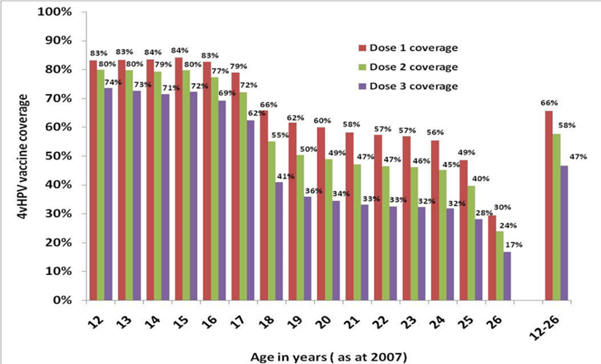

Source: NHVPR 2011.

#### Evolution of the program

Following the catch-up program, routine school-based vaccination for a single cohort of girls per year continued (usual age 12*–*13, delivered in the first year of high school but jurisdiction dependent).

In 2013, the vaccination of males was added, with a two-year catch-up program for boys to age 15. In July 2017, provision of free catch up through to age 19 through primary care commenced, in line with other NIP vaccines (9).

In 2018, the program changed to offer females and males in the targeted cohort a two-dose schedule (0, 6*–*12 months) of nonavalent HPV vaccine (9vHPV) (10).

The 9vHPV vaccine (tradename Gardasil 9) protects against the same types of HPV as the 4vHPV, with the addition of five further oncogenic types (types 31, 33, 45, 52 and 58).

These five types are the next five most detected types in cervical cancer. Those who are immunocompromised, or aged 15 and over at first vaccine dose, still require three doses to complete the course.

At the end of 2018, HPV vaccination data was migrated from the NHVPR to the Australian Immunisation Register (AIR). The AIR is a whole of life extension of the former Australian Childhood Immunisation Register.

HPV vaccination coverage data are now reported by the National Centre for Immunisation Research and Surveillance (NCIRS) in its annual immunisation coverage report (11).

#### Program evaluations

NCIRS conducted two evaluations of the National HPV Vaccination Program in 2014 and 2021 (12,13).

Both evaluations concluded that the vaccine has been highly effective in Australia with population-level reductions in:

* HPV prevalence
* genital warts
* cervical precancers
* juvenile onset recurrent respiratory papillomatosis (a rare, potentially severe condition of childhood caused by HPV types 6 and 11).

The vaccine has been demonstrated to be safe, using both routine passive and active surveillance. Coverage is continuing to increase year on year in the routine cohorts.

### Overview of the National Cervical Screening Program

Box 2. Overview of the National Cervical Screening Program

|  |
| --- |
| * The NCSP was established in 1991, delivered by primary care. Two-yearly cervical cytology screening (Pap testing) for women aged 20*–*69 through until December 2017 has halved incidence and mortality from cervical cancer in Australia. * Since December 2017, the NCSP changed to a primary HPV screening program for ages 25 to 69, with exit testing at age 70*–*74. Partial genotyping and reflex liquid-based cytology is now used for triage of HPV positive women. This renewed program is predicted to decrease cervical cancer incidence and mortality by a further 20*–*30%. * The National Cancer Screening Register (NCSR) supports the NCSP by utilising Medicare enrolment data to:   + send invitations to participants   + remind people who are overdue for screening   + support rescreening and follow-up in screening participants in whom HPV has been detected but where appropriate management has not yet been reported. * Colposcopy reporting is now mandatory. * An imminent change to self-collection policy will provide this option to all screening participants from July 2022. |

#### Cytology-based screening 1991-2017

Australia has a longstanding and successful National Cervical Screening Program, which was established in 1991 by the Australian Government in partnership with state and territory governments. The program was originally called The Organised Approach for the Prevention of Cervical Cancer.

The program, delivered by primary care, halved the incidence and mortality from cervical cancer in Australia through second yearly cervical cytology screening (Pap testing) for women aged 20*–*69 until December 2017.

This result was achieved through robust program infrastructure, including:

* eight jurisdictional Pap test registers providing support to participants, clinicians and laboratories and serving as a safety-net function
* quality standards for laboratories (both public and private)
* annually reported national program indicators (compiled from the registers then reported by the Australian Institute of Health and Welfare (AIHW))
* national and jurisdictional communication campaigns and implementation strategies to support participation.

Screen-positive women were referred for further assessment and treatment as indicated to gynaecologists in either the public or private sector following clinical guidelines.

The guidelines were released in 1994, titled Screening to Prevent Cervical Cancer: Guidelines for the Management of Women with Screen Detected Abnormalities. They were then updated in 2006, titled NHMRC Guidelines for the Management of Asymptomatic Women with Screen Detected Abnormalities.

Cervical screening was and is rebatable under Medicare. However, there may be out-of-pocket costs for both screening (pathology and primary care consultation) and follow-up care.

#### HPV primary screening

A review of the NCSP commenced in 2011, considering:

* updates in knowledge about test technologies
* the optimal screening age range and interval
* HPV vaccination.

HPV vaccination would reduce cervical cancer risk in younger birth cohorts age-eligible for vaccination and have implications for the positive predictive value of the existing program.

In 2014, a policy change was announced to transition to five-yearly primary HPV screening, with partial genotyping for HPV16/18 and liquid-based cytology triage for non-16/18 HPV types. The new screening would start at age 25 with an exit test for women between the ages of 70*–*74.

Following a comprehensive evidence review and extensive Australian-specific modelling, Australia transitioned its cervical screening program to the new primary HPV screening program in December 2017. The program was suitable for both vaccinated and unvaccinated women.

The screening interval changed to five years, based on the higher sensitivity and negative predictive value of HPV nucleic acid testing (NAT) screening. The age range moved to 25*–*69, with exit testing at age 70*–*74.

There was limited evidence of effectiveness of cervical screening below the age of 25 and evidence that an exit HPV test at 70*–*74 would cost-effectively increase program impact (14).

The program is now predicted to decrease cervical cancer incidence and mortality by a further 20*–*30%.

The screening pathway is shown in Appendix A. Most participants (over 90%) test HPV negative and rescreen in five years. Participants who test positive for HPV16 or HPV18, or who test positive for other HPV types but have high-grade cytology, are referred directly for colposcopy.

Those who test positive for non1618 HPV with no cytological abnormality, or with only low-grade changes, repeat the test in 12 months to assess clearance.

Initially all participants with a repeat positive HPV test at 12 months were referred to colposcopy. However, low disease detection rates in this group resulted in revision of clinical guidelines. Now, most participants have a further repeat test after another 12 months before referral to colposcopy (15). Colposcopy capacity was problematic during the initial transition of the program. All participants were still due in the first two years of the new five-year interval and tested with a more sensitive test, resulting in high referral rates to colposcopy.

A new NCSR supports the updated program through active invitations for eligible women to join the program and re-attend for tests when they are due. The NCSR also provides a safety net reminder function for those who are overdue.

Before the NCSR, people were enrolled on the jurisdictional registers when they had their first cytology screening test – unless they opted out.

In contrast, Medicare enrolees are automatically enrolled on the National Cancer Screening Register. It acts as a whole-of-population register and, for the first time, provides potential line of sight of those who have never been screened.

The program has updated national indicators, clinical guidelines and laboratory guidelines and standards for HPV testing. Colposcopy reporting is now mandatory.

Annual reports against national indicators are published by the AIHW using NCSR data.

Self-collection (the option to take one’s own vaginal sample for HPV testing instead of a clinician collecting a cervical sample using a speculum) became available. Self-collection uses a clinician-supported model for under and never screened people aged 30 and over as part of the program.

Implementation and uptake have been hampered by:

* the regulatory requirement for laboratories to gain their own approval to undertake HPV testing on self-collected specimens
* difficulties determining participant eligibility
* limited promotion.

Self-collection is as accurate as clinician collection for the detection of underlying cervical precancer when a PCR based HPV screening assay is used and is known to improve screening participation in under screened groups (16).

An imminent policy change will provide this option to all screening participants from July 2022.

### Overview of cervical cancer treatment in Australia

Box 3. Overview of cervical cancer treatment in Australia

|  |
| --- |
| Australia has no official national clinical guidelines for cervical cancer treatment. However, the Cancer Institute NSW operates the eviQ program.  This program produces nationally endorsed evidence-based cancer treatment information in Australia. It is embedded into clinical practice, policy and oncology information systems (OMIS) across the country.  The optimal care pathway for women with cervical cancer was released in January 2020. The pathway guides healthcare practitioners in providing patient-centred, optimal cancer care at each step of the cancer prevention to treatment pathway. |

#### Optimal care pathway for women with cervical cancer

The optimal care pathways describe a model of cancer care that puts the patient at the centre of care decisions. They define a national standard of high-quality cancer care that all Australians should expect (17).

Optimal care pathways aim to improve patient outcomes through:

* promoting quality cancer care
* ensuring that all people diagnosed with cancer receive the best care, irrespective of where they live or receive cancer treatment.

The optimal care pathways are endorsed by:

* Cancer Australia
* the former National Cancer Expert Reference Group (a committee that reported to the former Australian Health Ministers Advisory Committee and Cancer Council Australia, through this committee, to the former Council of Australian Governments Health Council)
* all states and territories.

The optimal care pathways have Australia-wide acceptance and government support. They are being implemented nationally.

The first edition of the optimal care pathway for women with cervical cancer (18) was released in January 2020. The pathway describes the optimal cancer care that should be provided at each step:

* + Step 1: Prevention and early detection
  + Step 2: Presentation, initial investigations and referral
  + Step 3: Diagnosis, staging and treatment planning
  + Step 4: Treatment
  + Step 5: Care after initial treatment and recovery
  + Step 6: Managing recurrent, residual or metastatic disease
  + Step 7: End-of-life care

The pathway includes all squamous cell, glandular (adeno) and mixed-cell cervical carcinomas.

#### Other treatment guidelines

Australia has no official national clinical guidelines for cervical cancer treatment. However, the Cancer Institute NSW operates the eviQ program, which produces nationally endorsed evidence-based cancer treatment information in Australia.

This program is embedded into clinical practice, policy and OMIS across the country. The eviQ program includes treatment protocols for cervical cancer across radiation oncology (19) and medical oncology (20).

There are NSW (2019) and SA (2011) guidelines in place for gynaecological cancers (21, 22). There is also the Gynaecology Oncology Radiation Oncology Collaborative (GOROC) Position Paper on Image Guided Brachytherapy (IGBT) for Cervical Cancer (23).

Cancer Australia published a systematic review of evidence for treatment for stage IB2 cervical cancer in 2015 (24). Australia’s National Framework for Gynaecological Cancer Control was published in 2016. (25) It superseded the 2011 national gynaecological cancers service delivery and resource framework.

The Tripartite National Strategic Plan for Radiation Oncology 2012*–*2022 includes key strategies for a well-resourced, planned and research-informed sector. The plan aims to enable equitable access to quality radiation oncology services for all patients, including those in regional and remote areas and Aboriginal and Torres Strait Islander patients (26).

## Overview of relevant existing national targets and strategies

There are several existing national strategies with related targets and elements that align with the cervical cancer elimination agenda. These strategies may be considered in developing the National Elimination Strategy. A summary table can be found in Appendix B.

# FINDINGS AND ANALYSIS

## Disease outcomes

### Cervical cancer incidence

The goal to achieve elimination of cervical cancer as a public health problem is to reach an incidence rate of less than four per 100,000. The most recently available national data for the period 2012*–*2016 are presented below in Figure 6.

These data are categorised by socioeconomic status, remoteness and Indigenous status (for the four jurisdictions with adequate data quality). They are also adjusted to world standard female population 2015 for international comparability.

The overall age-adjusted national incidence was 6.3 per 100,000.

Aboriginal and Torres Strait Islander people had more than twice the incidence of other Australians in the states and territories with adequate reporting of Indigenous status for inclusion. A gradient was observed by socioeconomic status (incidence 5.3 and 7.7 per 100,000 for the least and most disadvantaged quintiles respectively and by remoteness, with those residing in very remote areas having the highest incidence.

Incidence was lowest in Victoria (5.6 per 100,000) and highest in Tasmania (8.0 per 100,000).

Further inequity is reflected in the lack of national data assessing incidence for:

* culturally and linguistically diverse population groups
* those living with a disability
* those in medical high-risk groups (for example, living with HIV or immunosuppressed)
* LGBTQI+ populations.

Figure 6. National cervical cancer incidence per 100,000 women, by Indigenous status*, socioeconomic status and remoteness, Australia 2012–2016.

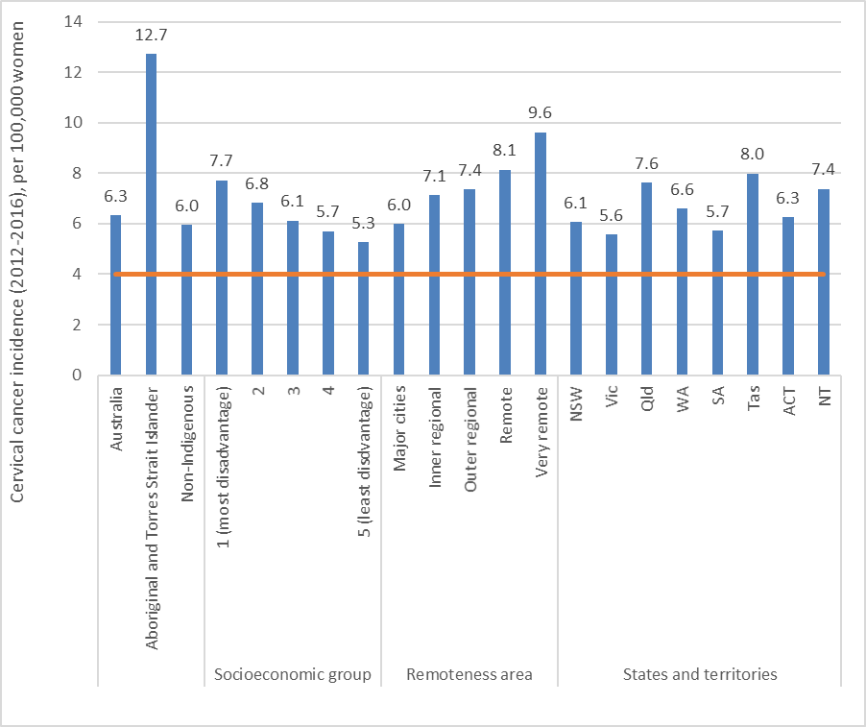

Source data: National Cancer Database. Age-standardised using WHO elimination methodology (World 2015 female population, all ages). *Data for Aboriginal and Torres Strait Islander women are from NSW, Qld, NT and WA, only.

Two recent analyses have compared cervical cancer incidence rates by country or region of birth. Based on an ad hoc analysis of national data for the period 2005*–*2014 (27), cervical cancer incidence rates were higher than those of Australian-born women among women born in New Zealand, the Philippines, Polynesia and Eastern Europe (Figure 7).

In Victoria in the period 2009*–*2018, cervical cancer incidence rates were higher than the rate experienced by Australian- and New Zealand-born women among women born in areas of the Pacific, the UK or Ireland, North-East Asia and areas of Europe outside Southern Europe (Figure 8) (28).

Figure 7. Adjusted incidence rate ratio and 95% confidence intervals for cervical cancer diagnosed in Australia in 2005–2014 relative to Australian-born (A) by country of birth and (B) by region of birth.

Adjusted for age group at diagnosis, and year of diagnosis in a negative binomial regression model with Australian-born population as a reference. (27)

Figure 8. Age-standardised incidence rates (with 95% confidence intervals) by country of birth for invasive cervical cancer in Victoria, 2009–2018.

*Source: Victorian Cancer Registry (28)*

### Cervical cancer mortality

Reducing premature mortality from cervical cancer is the overarching aim of the WHO elimination strategy. Cervical cancer mortality has, therefore, been identified as a key impact indicator.

Cervical cancer mortality will capture two things that will not be reflected in cervical cancer incidence rates:

* downstaging (due to screening)
* the WHO target of treating 90% of women diagnosed with cervical cancer.

In Australia in 2019, there were 231 deaths from cervical cancer. Figure 9 depicts cervical cancer mortality for the period 2015-2019 stratified by Indigenous status, socioeconomic status, remoteness and jurisdiction. Cervical cancer mortality, standardised to the world population 2015, was 1.4 per 100,000 women in 2015*–*2019.

There was some variation in mortality across the population, including higher rates for Indigenous women (x3.8), women living in very remote areas (x3.7) and women in the NT (x2.7). There was also a clear socioeconomic gradient (Figure 9).

Figure 9. Cervical cancer mortality per 100,000 women, Australia, 2015-2019.

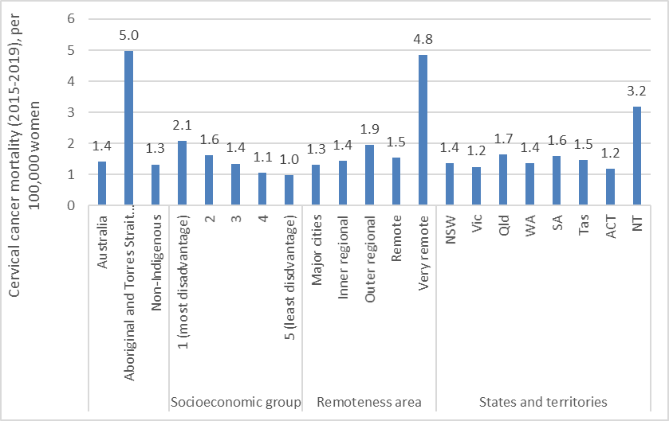

Source data: National Cancer Database. Derived from Australian Institute of Health and Welfare 2021. National Cervical Screening Program monitoring report 2021. Cancer series 134. Cat. no. CAN 141. Canberra: AIHW. (29) Age-standardised using WHO elimination methodology (World 2015 female population, all ages). *Data for Aboriginal and Torres Strait Islander women are from NSW, Qld, NT and WA, only

### Cervical precancer detection rate

Cervical screening aims to detect specific types of cervical disease, known as high-grade cervical intraepithelial neoplasia (CIN2+, meaning grade 2 or worse), that are the precursors of cervical cancer. Women with cervical disease detected through screening can then have treatment to prevent progression to cancer.

This indicator measures the proportion of women screened who are found to have high-grade disease as defined by a positive result on biopsy.

It is determined by:

* the underlying proportion with high-grade disease in the screened population (
* the accuracy of the screening method used
* the subsequent diagnostic steps and follow up undertaken with women found positive on the screening method
* the completeness of histopathology reporting.

The underlying proportion with high-grade disease in the screened population will reduce as HPV vaccinated cohorts become a greater proportion of the screening age range. It will also vary depending on the underlying risk profile of those attending screening at any point in time.

Time trends in detection of high-grade disease in screened women demonstrate the impact of HPV vaccination on reducing disease prevalence in Australia to the end of the cytology-based screening program, based on data to June 2017 (Figure 10).

Large falls in rates of disease detection (rate of biopsy proven disease per 1,000 people screened) in the youngest screening age group commenced shortly after the vaccination program commenced in 2007.

This was followed by declines in women aged 20*–*24, who previously had the highest rates of disease, then declines commencing in women aged 25*–*29.

Figure 10. Cervical precancer rate per 1,000 women screened, 2004–2017, Australia.

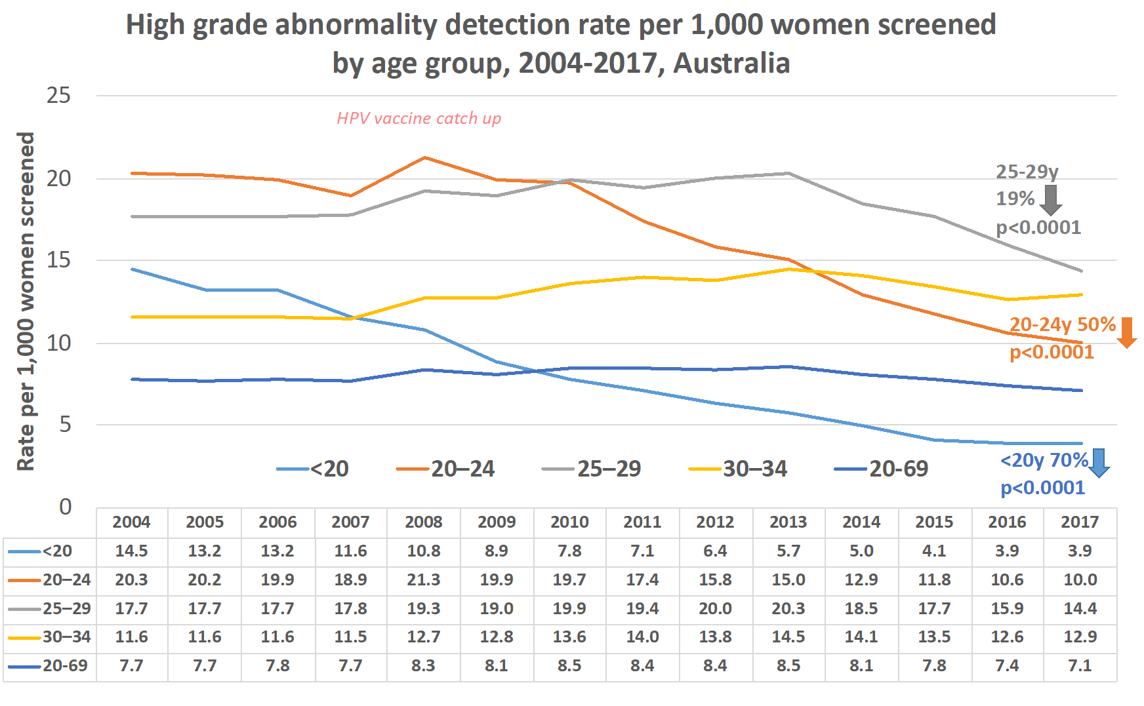

Source: AIHW 2020 Cervical screening in Australia report. (30)

Figure 11 shows the estimated rates of biopsy proven high grade disease per 1,000 people screened following the adoption of HPV screening in December 2017 for the years 2018*–*2020. The screening program now screens women from the age of 25 and the overall screening age range is now 25-74.

Data for 2018 should be interpreted with caution due to incomplete reporting to the register in this period. Data were not available by Indigenous status, socioeconomic status, remoteness, country of birth or language spoken at home.

The increase in rates overall from 2018 likely reflects the increased sensitivity of HPV screening for detecting precancers relative to cytology.

The increased rate in 2020 is likely to reflect that those screened in 2020 are overdue for screening (late or never attenders) by definition. They will therefore have a higher risk of underlying disease, as all regular screeners under the former two-year interval should have screened by the end of 2019.

The number of screening participants was also considerably lower in 2020 (one million as opposed to 1.9 million in 2019).

Despite the difficulties assessing trends over time, it is interesting that the rate of disease detection in women aged 25*–*29 was lower in 2020 than in those aged 30*–*34 for the first time – especially given the change in test and screening characteristics.

This result may suggest increasing vaccine impact in those aged 25*–*29 as more women vaccinated prior to exposure to HPV age into this group over time.

Figure 11. Cervical precancer rate per 1,000 women screened, 2006–2020, Australia.

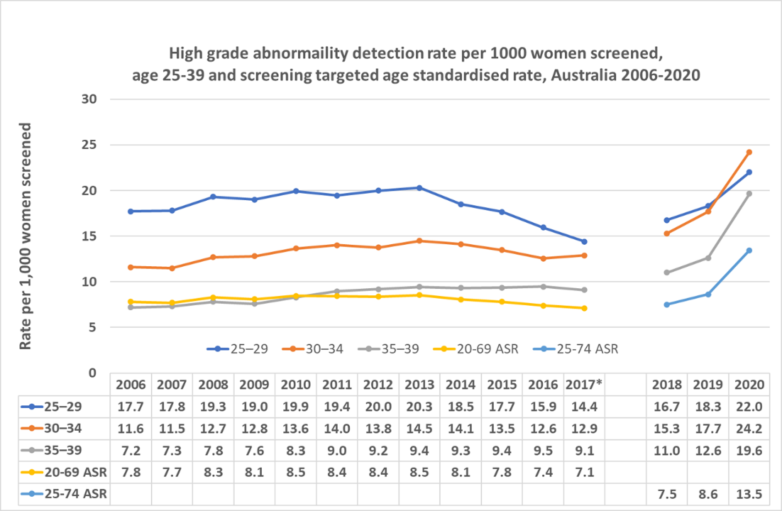

Source data: AIHW 2021 National Cervical Screening Program monitoring report. (29)

### HPV infection prevalence

Eliminating cervical cancer depends upon reducing the prevalence of oncogenic HPV types through HPV vaccination. Monitoring infection prevalence, where feasible, measures the extent to which this reduction is being achieved and sustained over time.

Figure 12 depicts HPV positivity among screening women aged 25-74 years in 2019 stratified by socioeconomic status, remoteness and jurisdiction. In 2019, 2% of screening tests among women aged 25*–*74 were positive for HPV16 or HPV18. These are the most oncogenic HPV types and are prevented by both the quadrivalent and the recent nonavalent HPV vaccines.

Positivity was low across all socioeconomic groups, remoteness areas and jurisdictions (being highest in the NT at 2.6%) (and age groups – data not shown). (Figure 12)

Positivity for oncogenic HPV types other than HPV16 or 18 was 6.5%. There was higher positivity for women living in very remote areas (7.8%) and women living in the Northern Territory (8.7%) (and younger women as well established - data not shown) (Figure 12). Detection by Indigenous status, country of birth or language spoken (or for other priority populations) was not available.

Figure 12. Oncogenic HPV positivity amongst screening women aged 25–74, Australia, 2019

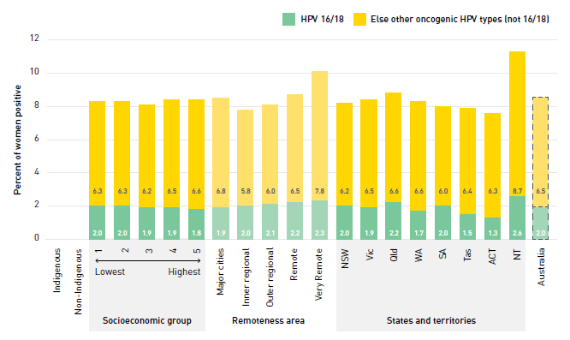

Source: NHMRC Centre of Research Excellence in Cervical Cancer Control. 2021 Cervical Cancer Elimination Progress Report: Australia’s progress towards the elimination of cervical cancer as a public health problem. (1)

### Current research, policy and health system issues relating to monitoring disease outcome indicators

#### Cancer data

Australia has high-quality cancer registers with data collated nationally for regular reporting by the AIHW. This means that national data become available dependent upon the slowest register to complete their data for a given year (currently NSW). National data are currently lagged by several years, making timely reporting of trends in incidence, such as that required to determine elimination, problematic.

National cancer mortality data from the national death index, collated from jurisdictional births, deaths and marriage registers, are currently timelier than cancer incidence data.

Because cervical cancer is already relatively uncommon, understanding incidence and mortality in subpopulations is difficult using single jurisdictional registry data alone due to a lack of power.

Quality of data for Indigenous identification and country of birth is likely to be variable across registers. It is notable that some cancer registers are still unable to contribute data for incidence for Indigenous women due to lack of completeness and quality.

#### Precancer data

As noted above, completeness of histopathology data may have an impact on the apparent precancer detection rate. There is particular concern around 2018 as the first year of the new program and register.

The changing profile and number of women being screened through the new five-year interval will also mean that year on year differences in precancer detection rates become more difficult to interpret.

Interpretation of the indicator is also complex. A declining rate of disease detection can indicate that the vaccine program is working. However, a higher rate of detection means more women at risk have been effectively engaged in screening and identified for treatment to prevent cancer.

An additional advantage of the new national register is that precancer rates will be available by CIN3/AIS (the highest grade and true precancers) rather than just for the CIN2+ group. This was a previous limitation, as not all jurisdictional registers coded to the level of CIN3.

In theory, the register can now provide data for Indigenous Australians, but such data have not been released routinely at this time due to quality and completeness issues. Similarly, the register has the capacity to record and report by country of birth and language spoken at home, but these data are currently very incomplete.

Linkage studies in the pre-HPV screening era and an analysis of Victorian registry data (ACPCC, unpublished data) demonstrated that Aboriginal and Torres Strait Islander people participating in screening do have higher rates of precancer detected than other Australians (31, 32).

#### HPV vaccine impact data

Previous studies and a national AIHW data linkage have informed estimates of HPV vaccine effectiveness against precancer in Australia, including estimates of the effectiveness of just one dose (33-37).

Integration of HPV vaccine history into the NCSR would facilitate regular timely analyses of vaccine effectiveness and impact studies to document progress over time. It would also help identify whether rates are not declining as expected in some populations, without the need for ad-hoc and time lagged research-based data linkage studies.

Monitoring vaccine impact through measuring HPV prevalence in the population has been facilitated by the introduction of HPV-based screening (38).

Before this, consent-based HPV surveillance was undertaken. It clearly demonstrated the major direct and herd protection effects of vaccination in Australia in reducing oncogenic HPV prevalence, including for Aboriginal and Torres Strait Islander people and in males as well as females (39-44).

An important aim for ongoing HPV surveillance will be to monitor the anticipated decline in the additional five oncogenic types following the introduction of 9vHPV vaccination. Monitoring will ensure vaccine effectiveness and identify any populations with inequitable rates of protection.

Currently, only some screening HPV assays provide discrimination of individual or subgroups of HPV types. However, it will be important to ensure that the register can easily extract and report by these types as more tests enter the market and given the emerging possibility that further genotyping may be utilised for triage (45).

The targeted cohorts (age 12 in 2018) will not reach screening age (25 years) until 2031. Earlier surveillance is planned through HPV typing of routinely collected Chlamydia screening samples from young women (46).

Australia has an HPV surveillance plan (2013), which is due for updating (47). The plan should now consider the value of investing in routine systems for monitoring Australia’s progress and maintenance of cervical cancer elimination across the population through HPV typing of precancers and cancers.

### Key issues for strategy development identified from disease outcome indicator review

From the disease outcome indicator review, the key issues for strategy development are as follows.

1. **Data issues and gaps**

There is a lack of:

* Timeliness of cancer incidence data
* National reporting of cancer incidence by Indigenous status or ethnicity
* National registry reporting of HPV prevalence or precancer by Indigenous status or ethnicity or for other populations of interest.

In addition:

* HPV vaccination status is still not integrated into NCSR
* We need to understand and monitor completeness of NCSR data (histopathology)
* We need to ensure the NCSR can report by single HPV genotype prevalence into the future.

1. **Equity issues and gaps**

The equity issues and gaps include the following:

* Lack of national reporting of cancer incidence by Indigenous status or for CALD populations
* Higher rates of cancer incidence and mortality for jurisdictions with data available and mortality for Aboriginal and Torres Strait Islander people
* Higher rates of cancer incidence and mortality for people living in very remote areas, lower socioeconomic areas and for those living in the NT
* Lack of national registry reporting of HPV prevalence or precancer by Indigenous status or ethnicity
* Lack of cervical cancer incidence, HPV prevalence or precancer data for medically high risk (immunosuppressed or immune compromised, including people living with HIV), LGBTQI+ and those living with a disability

1. **Research and policy evidence gaps**

The research and policy evidence gaps include the following:

* Determining how Australia can assess current incidence, mortality, precancer rates and HPV prevalence for priority populations and CALD communities.
  + Should these data be assessed intensively periodically for intermittent monitoring of progress OR
  + Should systems be designed to routinely collect and report on these data?
  + Specifically, the use of Commonwealth-led integrated data sets, such as through the Multi-Agency Data Integration Project (48), should be considered as a way to provide baseline and ongoing regular data to identify populations who are under screened, under vaccinated and overrepresented in cervical cancer incidence and mortality statistics and inform the elimination of cervical cancer in Australia.
* Identify solutions to correct longstanding known and continuing deficits in reporting program indicators and outcomes for Aboriginal and Torres Strait Islander people in the NCSP and cancer registries, given that are they are known to perpetuate inequities by preventing any ability to measure them and act.
* Determine how the cervical cancer incidence and mortality gap for Aboriginal and Torres Strait Islander people, people living in very remote areas, the most socioeconomically disadvantaged and in the Northern Territory can be most rapidly and effectively closed.

1. **Assessment of local applicability of WHO incidence target**

Consideration should be given to Australia’s explicit endorsement of the global elimination target (less than four per 100,000) as applicable and appropriate for *all Australians*, including groups known or suspected to currently be at higher risk of developing cervical cancer.

## Vaccination indicators

Providing high coverage, equitable HPV vaccination programs is one of the three key pillars of the WHO global strategy to accelerate the elimination of cervical cancer as a public health problem.

Australia’s National Elimination Strategy will need to identify and address any barriers to equitably delivering and monitoring an effective HPV vaccination program in Australia.

### HPV vaccination coverage: definition

HPV vaccination coverage is routinely reported at age 15. This is in line with WHO recommendations to accommodate varying ages of routine vaccination at the country level. WHO recommends routine vaccination of girls at age nine to 14.

Dose 1 coverage represents the proportion of eligible adolescents who initiate the course. Completed course coverage represents the proportion of adolescents who receive the required number of doses, whether this be three doses (0,1*–*2, 6 months) or two doses (0,6*–*12 months) validly spaced (not too close together).

The proportion of adolescents on the two-dose schedule has increased over time in Australia, with all adolescents on this schedule in the 2020 15-year-old cohort.

### HPV vaccine completion

The WHO scale up target for vaccination for the Elimination Strategy is that, by 2030, 90% of girls aged 15 are fully HPV vaccinated.

National data from the AIR indicate that, for the 2020 15-year-old cohort (year of birth 2005), 80.5% of girls were fully vaccinated against HPV. Figure 13 presents HPV vaccine completion coverage data for 15-year-old girls in 2020 by stratified by Indigenous status, socioeconomic status, remoteness and jurisdiction.

Completion coverage was lower for:

* Indigenous girls (5.9% lower)
* those in remote areas (5.9% lower than in regional areas)
* those residing in areas in the lowest socioeconomic quintile (4.2% lower compared to the highest quintile)

Coverage was variable by jurisdiction of residence ranging from 76.7% in Queensland to 83.6% in the ACT.

Figure 13. National female HPV vaccine completed course coverage at age 15, 2020 cohort (2005 birth cohort)

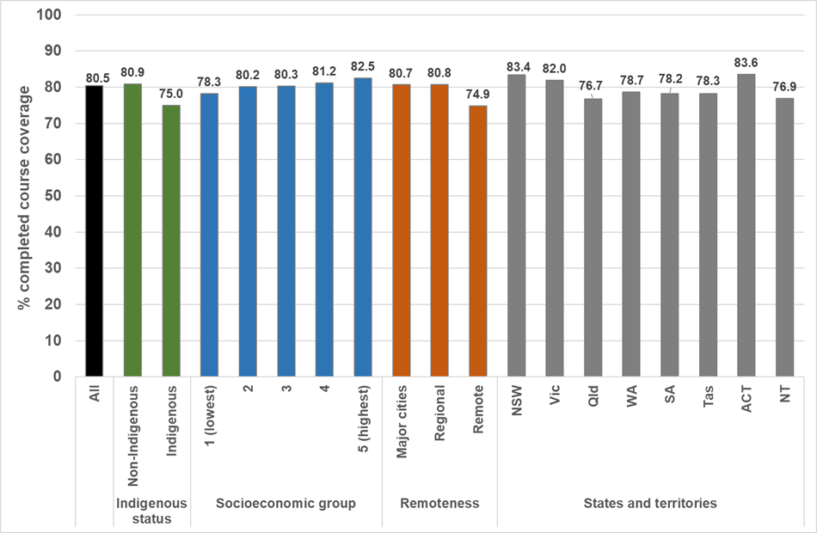

Source: AIR via NCIRS.

HPV vaccination of males is not part of the WHO strategy for the elimination of cervical cancer due to:

* lack of cost-effectiveness compared to female only vaccination (49)
* modelling indicating that it would not significantly impact long term outcomes whilst requiring twice as many doses (4)
* current costs
* global shortage of supply.

However, Australia already has a both-sex HPV vaccination program.

Modelling suggests that local elimination of targeted HPV types can be achieved (50) over a 70-year time horizon at:

* coverage rates over 80% in a both-sex vaccination program, or
* coverage over 90% in a single-sex vaccination program.

Figure 14 presents national data from the AIR for the 2020 male 15 year old cohort (year of birth 2005) stratified by Indigenous status, socioeconomic status, remoteness and jurisdiction. In 2020, 76.5% of boys were fully vaccinated against HPV.

As with girls, but with more pronounced gradients, completion coverage was lower for:

* Indigenous boys than non-Indigenous boys (by 10.2%)
* those in remote areas (7.7% lower than major cities)
* those residing in areas in the lowest socioeconomic quintile (6.5% lower than in the highest quintile).

Coverage was variable by jurisdiction of residence (from 70.0% in the NT to 80.6% in NSW).

Figure 14. National male HPV vaccine completed course coverage at age 15, 2020 cohort (2005 birth cohort)

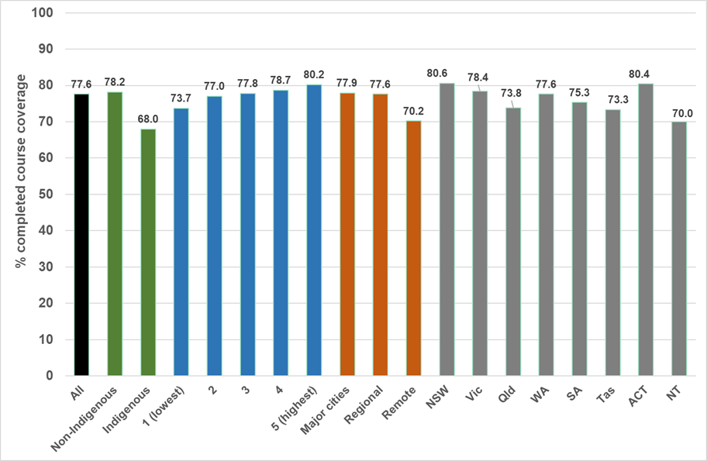

Source: AIR via NCIRS.

Figure 15 provides further detail of HPV completion coverage data in 2020 by Indigenous status and sex, stratified by socioeconomic status, remoteness and jurisdiction. The data indicate wide ranges in coverage by these parameters ranging from a low of 47.5% coverage for Indigenous boys in SA to a high of 83.9% amongst non-Indigenous girls in the ACT.

Figure 15. National HPV vaccine completed course coverage at age 15 years, 2020 cohort (2005 birth cohort) by sex and Indigenous status stratified by socioeconomic status, remoteness and jurisdiction.

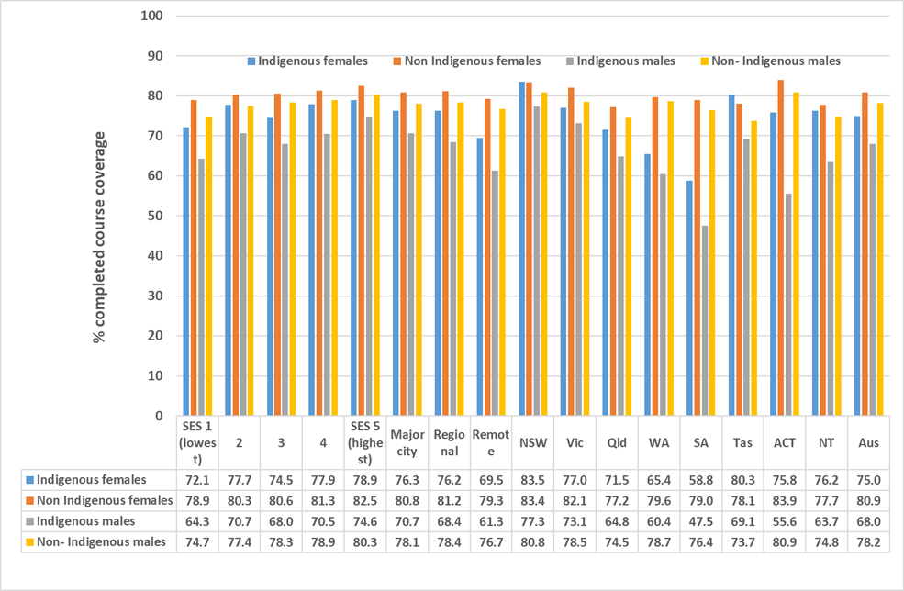

Source: AIR via NCIRS.

#### Trends in completed course coverage over time

As noted previously, HPV vaccine completed course coverage has gradually improved over time since the commencement of the program in 2007 through to 2015 (51).

Figure 16 shows further improvement over time between 2016–2020 for all adolescents, both Indigenous and non-Indigenous males and females. More marked improvements have been noted in recent years for Indigenous students.

COVID impacts on vaccination are not seen in the 15-year-old 2020 cohort but can be observed in the lower rates of HPV vaccine initiation in 2020. There were 17,300 fewer first doses in girls aged 11 to under 15 years and 18,600 fewer first doses in boys than in 2019.

There was a noticeable decline in second dose receipt within the same calendar year for those who initiated HPV vaccine in 2020.

The percentage of girls aged 11 to under 15 years who received a second dose of HPV vaccine in the same year they received dose 1 fell 11.5% from 86.2% in 2019 to 74.7% in 2020.

The reduction observed among Indigenous girls was from 70.2% in 2019 to 61.3% in 2020.

The percentage of boys aged 11 to under 15 years who received a second dose of HPV vaccine in the same year they received dose 1 fell 11.7% from 84.3% in 2019 to 72.6% in 2020.

The reduction observed among Indigenous boys was from 64.4% in 2019 to 58.3% in 2020 (11).

Figure 16. National HPV vaccine completed course coverage at age 15, 2016-2020 by sex and Indigenous status.

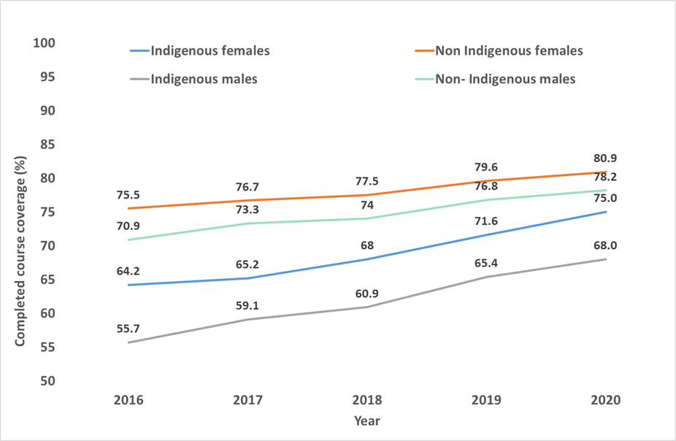

Source: AIR via NCIRS.

### HPV vaccine initiation

Monitoring of the uptake of the first dose of HPV vaccine provides additional information about the vaccine’s reach and acceptability. Barriers to course completion (receipt of second and/or third doses) may be different to those which prevent initial vaccine acceptance and receipt.

An additional reason for monitoring the receipt of at least one dose is the accumulating evidence suggesting that one dose may be sufficient to provide protection against HPV infection and disease (34, 52, 53).

Figure 17 shows dose 1 HPV vaccine coverage amongst children aged 15 in 2020 stratified by Indigenous status, socioeconomic status, remoteness and jurisdiction.

National coverage for the whole cohort (both sexes) was 85.7%. Female coverage was 86.6% and was higher in Indigenous girls (87.8%) than non-Indigenous girls (86.6%).

Male coverage was 84.9% with minimal difference between Indigenous (83%) and non-Indigenous boys (85%). Far smaller differences were seen by socioeconomic status, remoteness or jurisdiction than observed for completed course coverage in both girls and boys.

Figure 17. National HPV vaccine dose 1 coverage at age 15 by sex and Indigenous status, socioeconomic status, remoteness and jurisdiction.

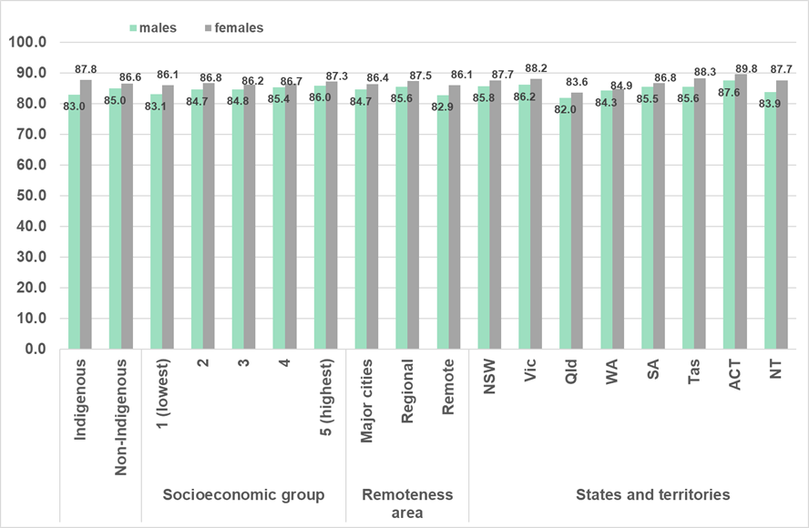

Source: AIR via NCIRS.

Figure 18 provides further detail of HPV initiation coverage data in 2020 by Indigenous status and sex stratified by socioeconomic status, remoteness and jurisdiction. Dose 1 coverage estimates for Indigenous males were just below 80% in two jurisdictions (ACT and WA) and lower in one (SA 69.3%).

Figure 18. National HPV vaccine dose 1 coverage at age 15, 2020 cohort (2005 birth cohort) by sex and Indigenous status stratified by socioeconomic status, remoteness and jurisdiction.

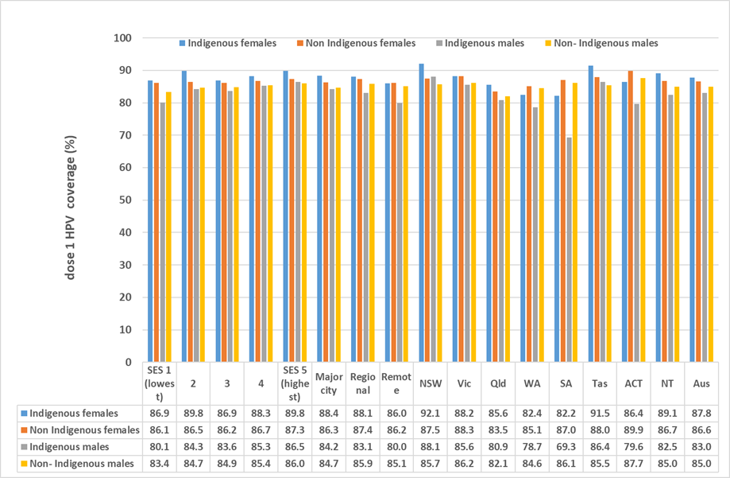

Source: AIR via NCIRS.

#### Trends in dose 1 coverage over time

Figure 19 shows improvement over time between 2016 and 2020 for all adolescents, including both Indigenous and non-Indigenous and children. Dose 1 coverage in Indigenous girls is higher than for other groups since 2018.

Figure 19. National HPV vaccine dose 1 coverage at age 15, 2016-2020 by sex and Indigenous status.

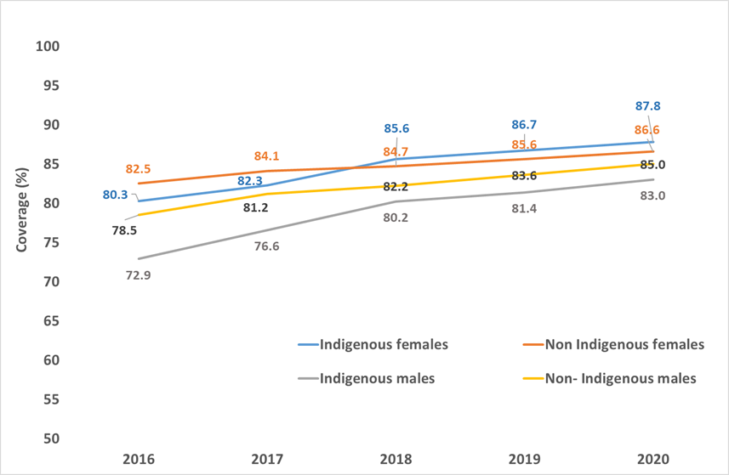

Source: AIR via NCIRS.

### Australian literature: HPV vaccination program implementation

This section provides an overview of key studies describing the effectiveness of implementation of HPV vaccination programs in Australia. It also identifies barriers and facilitators to improving HPV vaccination coverage.

#### School- based programs

**Reasons for non-completion**

Two surveys of parents aimed to establish the reasons for non-completion of the HPV vaccine course in school programs. The surveys were conducted in South Australia in 2010 and earlier (54) and in Northern NSW in 2010 (55).

The surveys identified that the main reasons for non-completion were:

* school absences
* parents being unaware that the course was not complete
* parents being unaware that they could complete the course at a general practitioner (GP)
* logistical barriers.

**Barriers to HPV vaccination uptake**

Selvey et al evaluated barriers to HPV vaccination uptake in WA schools in 2016*–*2018 (56). They used an online survey of 82 school program coordinators, focus groups with students (n=10) and interviews with parents (n=22) from low-coverage schools.

As shown in Table 2, school coordinators reported that schools with lower coverage had more problems with consent form return, parental literacy, language and religious concerns in parents.

Schools with low coverage were significantly more likely to report that difficulty contacting parents was a barrier to immunisation. Parents had mixed views on paper- based consent forms compared to email or electronic consent forms.

Interestingly, over one quarter of parents did not know if their child had completed the vaccine course. The authors recommended multifaceted strategies to improve coverage in low-coverage schools. They suggested a focus on consent form return and intensive follow up of students who missed doses.

Table 2. School-based coordinators’ perceptions of reasons for parents not consenting by tertile of school coverage.

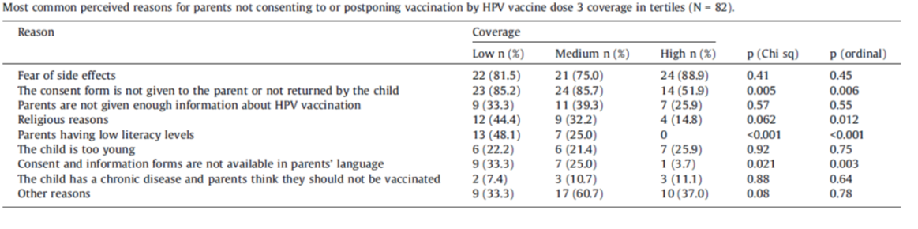

*Source: Selvey et al 2020. (56)*

**School-level factors associated with HPV vaccination initiation and completion**

A linked ecological level data analysis between schools’ data and 2016 school-level HPV vaccination coverage data in NSW, WA and Tasmania identified school-level factors associated with HPV vaccination initiation and completion (57).

All school characteristics examined were associated with vaccination coverage.

The factors most strongly associated with lower initiation (OR>4.0 in females) were:

* small school size
* location in Tasmania
* special needs schools.

The factors most strongly associated with lower completion were:

* remote location
* location in Tasmania or WA
* small school size
* coeducational school
* a higher proportion of Indigenous enrolments.

A further analysis from the same study identified that 24% of schools had diphtheria-tetanus-pertussis booster vaccine coverage more than 5% higher than HPV vaccine coverage.

Significant predictors were remote schools and major city schools, small schools, higher socioeconomic status and lower language-other-than-English enrolments (58). The authors suggested the findings could be indicative of HPV vaccine-specific hesitancy.

**Factors associated with lower school-based coverage**

Mak et al identified factors associated with lower school-based immunisation coverage in WA in 2009*–*2010 (59). HPV course completion rates were higher in Catholic schools than in government or independent schools. Rates were lower in schools in the most disadvantaged and remote areas.

A series of qualitative studies examined the experience of HPV vaccination at school from adolescent, parent and utilised perspectives in NSW in the initial years of the program.

These studies documented:

* the complexity of the vaccination preparation and implementation processes (60)
* fear and distress amongst adolescent girls around the vaccination process (61)
* low levels of student and parent knowledge about HPV and the vaccine (62).

Decision making about HPV vaccination was determined by existing world views, attitudes and experiences. Decision making had variable adolescent involvement.

Parents could be grouped into both active and passive decision makers (63).

**Uptake of adolescent school-based immunisations among students with a disability**

O’Neill et al described uptake of adolescent school-based immunisations among students with a disability in 28 special schools in 2017 in Victoria (64).Coverage of dose 1 HPV vaccine was 67% in females and 66% in males.

Dose 3 coverage was approximately 40% for females and 43% for males, although missing data limits the accuracy of these estimates.

The main reasons for missed immunisations were:

* absence from school
* lack of consent
* inability to immunise due to the student’s behaviour
* anxiety.

**Interviews about HPV vaccination with mothers of Arabic Muslim background**

Netfa et al undertook interviews about HPV vaccination for their children with 15 mothers of Arabic Muslim background in Western Sydney in 2018*–*2019 (65).

Five key themes emerged from the interviews:

* lack of awareness and knowledge of HPV and HPV vaccination
* awareness and understanding of the government vaccination information sheet; (including lack of receipt and need for Arabic version)
* parents’ preferences for information provision (prefer in language and opportunity for discussion)
* the role of parents’ religious beliefs in forming attitudes about HPV vaccination (including need to be halal, attitudes to sex, differing attitudes by child’s gender, fatalism)
* lost opportunities to educate parents about HPV vaccination during GP visits.

The researchers concluded: “There is a need to address language, cultural and communication barriers in order to improve the awareness and acceptability of the HPV vaccine among the Arabic community in Australia.”

**Interviews with parents of HPV vaccine-eligible students**

Davies et al interviewed 22 parents of HPV vaccine-eligible students in WA and SA (2013*–*2015). The parents had positive attitudes to school-based programs related to trust, peer support for students and convenience. However, parents had limited knowledge about HPV and the vaccine plus a desire for in-school education for their adolescents (66).

#### Beyond school populations

**Catch-up status in refugees and asylum seeker**

Nyanchoga et al reviewed electronic health records to identify catch-up immunisation status in refugees and asylum seekers in a southeast Queensland clinic in 2015*––*2018 (67). Only 7.8% had a record of HPV vaccination.

Significant predictors of under-immunisation across all vaccines were younger age, earlier arrival in Australia (pre-2015) and being a refugee rather than an asylum seeker.

**Trans and gender diverse Australian people**

In a study of 537 trans and gender diverse Australian people, 41% reported having received HPV vaccination (68). 60.7% were aged between 18*–*24 and 20.5% were aged 25*–*34.

In a cross section 2018 survey, just 5.8% of 34 women and trans people living with HIV reported HPV vaccination (69), despite HPV vaccination being recommended for all people living with HIV.

#### NCIRS HPV Vaccine Program Evaluation findings

In the NCIRS HPV Vaccination Program Evaluation Report 2021 (12), 42 key stakeholders were interviewed, and 1513 stakeholders were surveyed.

Stakeholders were predominantly:

* immunisation providers
* GPs
* practice nurses
* school-based nurse immunisers
* Aboriginal and Torres Strait Health Workers
* sexual health physicians
* cervical screening managers.

The report aimed to assess:

* stakeholder perspectives on the impact of the National HPV Vaccination Program
* factors that could positively or negatively influence program outcomes and impacts.

Almost all stakeholders believed that 90% coverage by 2030 was possible in Australia. However, stakeholders believed that we would need increased effort and support for the program plus the development of additional strategies.

Stakeholders thought that the major barriers to higher coverage in the school program were absenteeism and consent form return.

Reported enablers of consent form return were:

* school immunisation teams having access to parent contact details and resources or capacity to conduct follow up of unreturned forms
* appropriate consent forms and information for population subgroups with different languages and levels of literacy
* education for students
* supportive school staff

From the program evaluation, recommendations to optimise HPV vaccination in Australia included the following:

* **Consent forms** – electronic or both options
* **Information and education for adolescents and parents** – enhanced, dedicated and targeted resources, in-school education, videos and media campaigns, and resources for Aboriginal and CALD populations
* **Catch up opportunities** – expand school health care clinics and school nurse roles, more catch up at school, community outreach for schools with high absenteeism, targeted catch up in low-coverage areas, out of home care program services
* **Provider education** – on generating AIR catch up lists, campaign to raise GP awareness about checking status, how to counsel vaccine hesitant
* **Data quality and reporting** – provision of timely school level coverage data
* **Research to inform interventions** – data linkage to identify gaps, local research and interventions for low coverage, 1 dose data, community attitude surveys
* **Funding and support** – to remote areas for vaccination of high-risk groups and for evaluation of school programs
* **Program and policy** – enhance ability for schools to share class lists with parent details with immunisers, support the needs of students in special schools, target marginalised students with tailored strategies.

#### Interventions to increase HPV vaccine coverage

**Impact on student knowledge, psychosocial outcomes and vaccine coverage**

Skinner et al undertook a cluster randomised controlled trial in 40 schools in WA and SA (2013*–*2015) of education, decisional support and logistical strategies to assess impact on student knowledge, psychosocial outcomes and vaccine coverage (70).

Adolescents in intervention schools had significantly greater HPV vaccine knowledge when measured prior to dose 1 and prior to dose 3. However, there was no difference in vaccination coverage between intervention and control schools with the logistical intervention not implemented as intended (71).

There were small but significant increases in adolescent decision-making involvement, vaccine related confidence and reduced vaccine related fear and anxiety (66).

**The impact of SMS reminders**

Tull et al evaluated the impact of SMS reminders in a randomised trial on uptake of HPV vaccination in Year 7 students in 31 schools in Victoria in 2016. (72) They found a small but significant increase in uptake following either a motivational or self-regulatory SMS.

However, the study only included parents who had already consented for their adolescent to receive HPV vaccination at school.

**Strategies to increase consent form return rate**

Mak et al assessed the impact of four strategies to increase consent form return rate in the school-based program in WA in 2009. The principals of the schools selected the strategies (73).

The strategies were:

* standard reminder letters
* phone calls
* resending consent packs to parents
* school incentives, such as education gift vouchers or movie passes, if the school’s return rate was more than 90%.

The only strategy that improved consent rates was resending consent packs to parents (OR 1.76). This was noted after adjusting for demographic predictors of consent form return, such as younger student age, female students, independent school type, medium level disadvantage and school vaccination provider.

### Key issues for strategy development identified from vaccination review

From the vaccination review, the key issues for strategy development are as follows.

1. **Data issues and gaps**

There is a lack of clarity on:

* HPV coverage estimates for priority populations or higher risk groups
* whether current school coverage estimates are readily available to support local initiatives.

1. **Equity issues and gaps**

The equity issues and gaps include the following:

* **Disparity in vaccine course completion**: Disparities exist for Aboriginal and Torres Strait Islander adolescents, for those residing in remote areas, of lower socioeconomic status, with disparities greatest for Indigenous boys (disparities are much less marked for one dose receipt)
* **Additional barriers to vaccination**: Sparse descriptive and coverage data suggests there are barriers experienced by some CALD communities, students with a disability and students in smaller schools
* **Access issues**: Ensuring that adolescents who were not vaccinated at school because of parental wishes who wish to receive the vaccine are able to access it, with providers assessing competence as mature minors (Gillick competence) where required.

1. **Research and policy evidence gaps**

The research and policy evidence gaps include the following:

* **Partnerships between education and health:** Optimising existing partnerships between the education and health sectors to support high HPV vaccine coverage for all students
* **Outreach and primary care strategies:** Optimising outreach and primary care strategies to reach and catch up out of school or post school cohort age students
* **One-dose HPV vaccine schedule:** Identifying whether the available evidence supports the effectiveness and cost-effectiveness of a one dose HPV vaccine schedule in Australia. What type of strategies could be delivered to extend reach to all if a one dose schedule is approved for use in Australia?
* **Funded, targeted vaccination:** Identifying the contribution that funded, targeted vaccination for medically high-risk groups or other priority populations aged over 19 could make towards equitable elimination
* **Parental reasons for decline:** Understanding and addressing the reasons why some parents or guardians decline or do not consent to the HPV vaccine for their child when offered it in the school-program
* **Supporting adolescents with a disability:** Understanding how vaccination programs can best support the needs of adolescents with a disability in both mainstream and special schools
* **COVID vaccination program learnings:** Leveraging learnings and new ways of working from COVID vaccination programs to improve the efficiency and reach of HPV vaccination
* **Routine monitoring for priority groups:** identifying how coverage of HPV vaccines can be routinely monitored for priority and higher risk groups. Options could include:
  + The routine regular use of integrated linked data sets (eg MADIP)
  + Expansion of AIR to include relevant data fields (through school consent forms, primary care or Medicare enrolment data)

1. **Assessment of local applicability of WHO vaccine coverage target**

The WHO’s vaccine coverage target is a 90% completed course coverage for girls (by age 15).

* Is the global target applicable to Australia, given we have a both-sex vaccination program?
* Should Australia have a strategy-based vaccination target?

Note that the National Preventive Health Strategy 2021*–*2030 includes the HPV vaccination target of at least 85% coverage by 2030.

1. **Assessment of local applicability of WHO-recommended strategic actions**

The WHO global strategy to accelerate the elimination of cervical cancer as a public health problem (2) includes four strategic actions to achieve 90% coverage for HPV vaccination of girls.

Australia’s national strategy should consider the applicability of these actions and the actions that are required locally. These are described in Table 3 and 4 below.

Table 3. WHO Strategic actions to achieve 90% coverage of HPV vaccination.

Table 4. Alignment between WHO Strategic Actions and National Immunisation Strategy.

|  |  |
| --- | --- |
| WHO Strategic Action | Aligns with |
| Strategic Action 1: Secure sufficient and affordable HPV vaccines | **National Immunisation Strategy strategic priority 3:** Ensure secure vaccine supply and efficient use of vaccines for the NIP (74) |
| Strategic Action 2: Increase the quality and coverage of vaccination | **National Immunisation Strategy strategic priority 1:** Improve immunisation coverage  The two notable key actions under that priority include:   * Implement strategies to improve and better understand adolescent immunisation coverage * Improve coverage for population groups at higher risk |
| Strategic Action 3: Improve communication and social mobilisation | **National Immunisation Strategy strategic priority 5:** Maintain and ensure community confidence in the NIP through effective communication strategies |
| Strategic Action 4: Innovate to improve efficiency of vaccine delivery | **Does not clearly align with any National Immunisation Strategy priorities**, **however it is closest to strategic priority 2:** Ensure effective governance of the NIP  (This strategic action refers to timely processes to consider new evidence and update schedules and programs when new evidence is generated, such as for one dose schedules.) |

## Screening and precancer treatment indicators

Providing high quality, effective cervical screening and precancer treatment is one of the three key pillars of the WHO global strategy to accelerate the elimination of cervical cancer as a public health problem (2).

Australia’s National Elimination Strategy should identify and address barriers to delivering and monitoring cervical screening and precancer treatment equitably across Australia.

### Screening participation (WHO indicator)

The WHO screening indicator measures performance compared to the target, which is that women be screened with a high-performance test (currently, an HPV test) at least once by age 35 and at least twice by age 45.

Australia is still in its first round (first five years) of HPV screening. Therefore, HPV screening has not been available in Australia long enough for women to have had two adequately spaced HPV tests by age 45.

An interim measure, as used in Figure 20 below, reports on the proportion of women who have had at least one HPV test by age 45 and had at least one prior Pap test (with at least two years spacing between the tests).

Figure 20 summarise the proportion of Australian women aged 35 and 45 in 2019 who had been screened with an HPV test (and a previous Pap for those aged 45) stratified by socioeconomic status, remoteness and jurisdiction. In 2019, 54.9% of women aged 35 had been screened at least once and 54.9% of women aged 45 had been screened twice as defined above.

In most areas of Australia, 50-60% of women had been screened once by age 35, with women in very remote areas the only group with below 50% participation (49%).

For two screens by age 45 there was greater variability, with below 50% participation for women in outer regional, remote and very remote areas and in the NT.

Women residing in areas in the highest socioeconomic quintile and those residing in Tasmania were the only groups with over 60% participation. Data were not available by Indigenous status.

Figure 20. Percentage of eligible women aged 35 with at least one primary HPV test and aged 45 with at least one primary HPV test plus one earlier screening test, as of 31 December 2019.

Measure for two tests by age 45 is interim, because HPV testing has not been available in Australia long enough for women to have had two sufficiently spaced tests by age 45.

Source: NHMRC Centre of Research Excellence in Cervical Cancer Control. 2021 Cervical Cancer Elimination Progress Report: Australia’s progress towards the elimination of cervical cancer as a public health problem. (1)

### Screening participation (Australian program)

Participation in screening as recommended in Australia is also presented.

The number of women who are up-to-date should increase over the first five years of the new program (Figure 21), as additional people attend but no screening participants become due for five-yearly screening until December 2022.

Being up-to-date means receiving an HPV test in the previous five years, according to the recommendations in the HPV program.

As seen in Figure 21, the observed participation has been slightly below that anticipated based on projections from historical data.

Participation reached 62.6% up to date in 2020 in eligible women aged 25*–*74 (and 64.5% in the 25*–*69 year age range, which was included in both the cytology and HPV program).

As seen in Figure 22, the proportion of up-to-date people varies substantially by age. The proportion is lowest in the oldest group (aged 70-74), who are now due for exit testing, potentially as women in this age group may have previously exited the cytology-based program.

Figure 21. Percentage* of eligible women (aged 25–69) up to date with screening by the end of calendar year – observed versus expected.

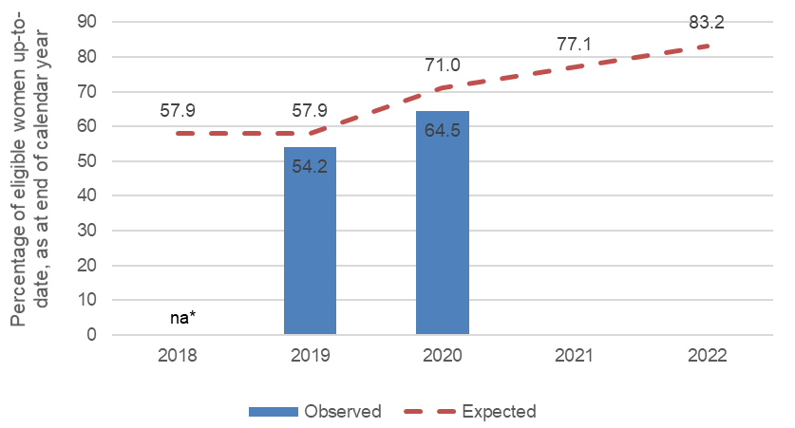

*Age-standardised to 2001 Aust population, 25–69. 25–69 used as this age range is common to both the previous cytology program and current HPV program.

Source data: Observed = AIHW 2021 National Cervical Screening Program monitoring report 2021. (29) Coverage by age. Expected = AIHW 2018 Cervical Screening in Australia 2018. Expected rates for 2018 and 2019 (women attending for screening within the previous two years, given a two-year repeat recommendation) are based on two-year participation (2015-2016). The expected rate in 2020 (women attending within the previous three years, given a two-year repeat recommendation) is based on participation in the three-year period 2014–16, and in 2022 (women attending within the previous five years, given a two-year repeat recommendation) is based on participation in the five-year period 2012–2016. Expected participation in 2021 was set to the mid-point of the expected rates for 2020 and 2022.

Figure 22. Percentage of women (aged 25–74) up to date with screening at the end of 2019 and 2020 by age group.

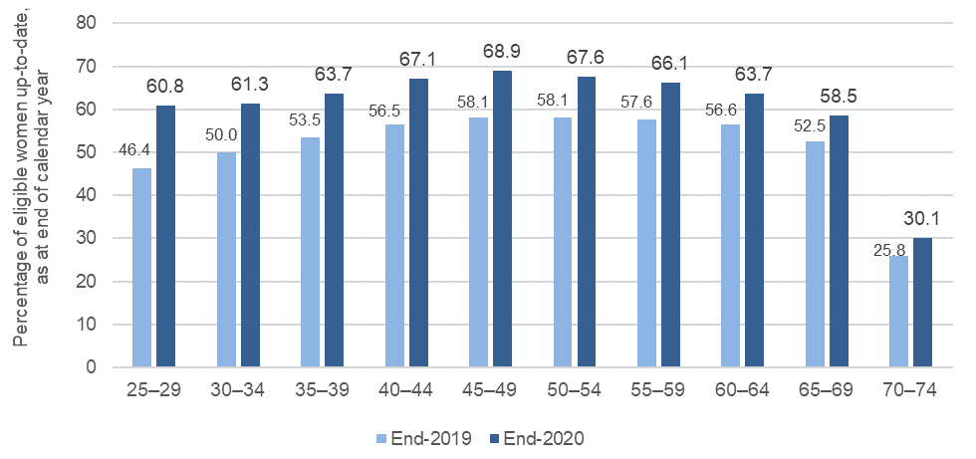

Source data: AIHW 2021 National Cervical Screening Program monitoring report 2021. (29) Coverage by age.

#### Screening participation – equity

Figure 23 summarises the proportion of Australian women aged 25-69 in 2019 and 2020 who were up to date with screening, stratified by socioeconomic status, remoteness and jurisdiction. There was variability in the proportion of people up to date by remoteness (lowest in very remote areas in 2020 at 51.8%). In 2020, there was a marked gradient of over 10% difference between the highest (69.0%) and lowest (56.0%) socioeconomic quintiles. There was less variation by jurisdiction ranging from 61.0% up to date in the Northern Territory to 67.0% in South Australia. Data are not available by Indigenous status, country of birth or language spoken other than English.

Figure 23. Percentage of women (aged 25–69) up to date with screening as at the end of 2019 and 2020 by area of residence and socioeconomic status.

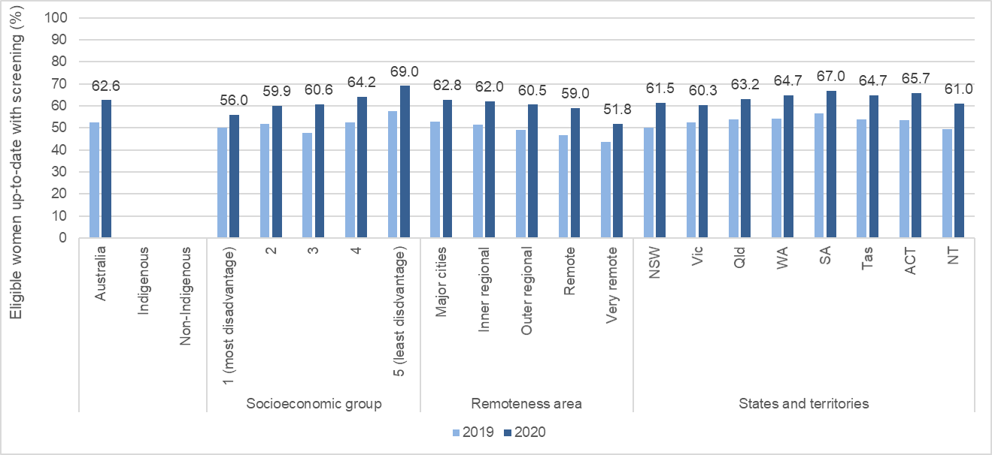

Data labels are for 2020. Source data: 2019 = C4 Elimination report 2021 (1); 2020 = AIHW 2021 National Cervical Screening Program monitoring report 2021. (29) Coverage 2019-2020

#### Trends in screening coverage over time

Screening participation among women aged 25*–*69 has declined over time, from a peak of 64.9% in 1999, to 53.8% in 2019 (Figure 24). This age group was selected as it has been consistently eligible for screening since 1991.

Figure 24. Percentage of eligible women aged 25–69 with a test within the appropriate screening interval as at the end of the calendar year (age-standardised, Australia 2001 population).

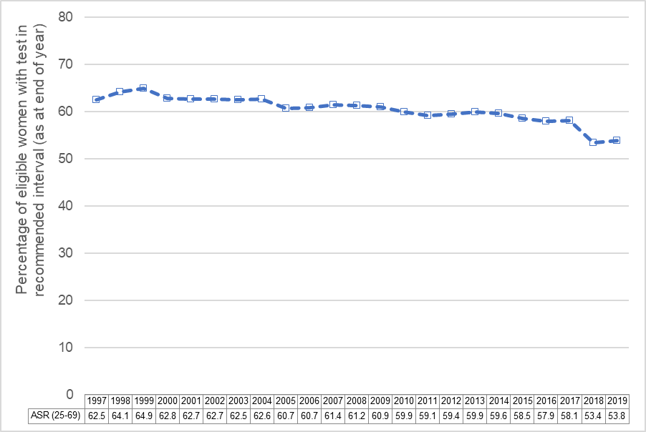

Results for 1997 to 2017 are a Pap test in the previous two years. Results for 2018 are a Pap test or an HPV test in the previous two years. Results for 2019 are an HPV test in 2018 or 2019. Results for 2017 are extrapolated from results for Jan 2016 to Jun 2017 only.

Trends in screening participation over time have varied by age (Figure 25).

Between 1997*–*2019, participation increased by five to 10 percentage points for women aged 60*–*64 and 65*–*69 (who initially had the lowest screening participation).

Participation strongly decreased by close to 20 percentage points among women aged 25*–*29 and 30*–*34 (who now have the lowest screening participation).

Smaller declines of around five to 10 percentage points have occurred since 1997 among other age groups.

Figure 25. Trends in the percentage of eligible women with a test in the recommended screening interval as at the end of the calendar year, by age.

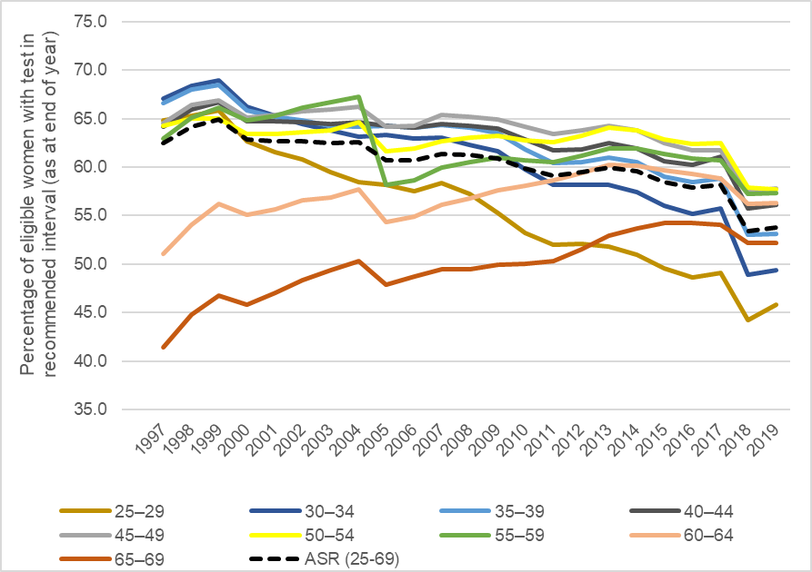

### Attendance for follow-up tests (surveillance and colposcopy)

Women classified as intermediate risk at their initial screening test in 2018 and 2019 were recommended to return for a repeat test in 12 months.

Overall, the proportion of women who had attended for their repeat test between nine and 15 months later was 57.2% among those classified as intermediate risk in 2018, and 58.1% among those classified as intermediate risk in 2019. (29,30) An analysis of data from the NCSR suggests that this proportion varies by remoteness of residence and area-level socioeconomic status (Daffodil Centre, unpublished data).

Among those classified as higher risk (recommended to attend colposcopy), the proportion who had attended colposcopy within three months of referral was 60.8% and 55.6% among those classified as higher risk in 2018 and 2019, respectively. (29, 30)

As shown in Figure 26, among those classified as higher risk in 2018, the proportion seen at colposcopy tended to be:

* higher for those referred due to their baseline test (HPV 16/18 detected or non-16/18 detected with high-grade cytology) than those referred at 12 months (initially classified as intermediate risk with HPV detected at 12 months)
* lower among those living in remote and very remote areas
* lower among those living in the most disadvantaged areas (lowest socioeconomic group)
* much lower for those living in the Northern Territory
* higher for those with possible high grade or worse cytology (15)
* higher for women with HPV 16/18 compared to those with HPV non-16/18 and the same cytology result (15)

Figure 26. Percentage of higher risk women with colposcopy, by referral indication, socioeconomic quintile, remoteness, and jurisdiction, among women aged 25-74 years referred to colposcopy in 2018

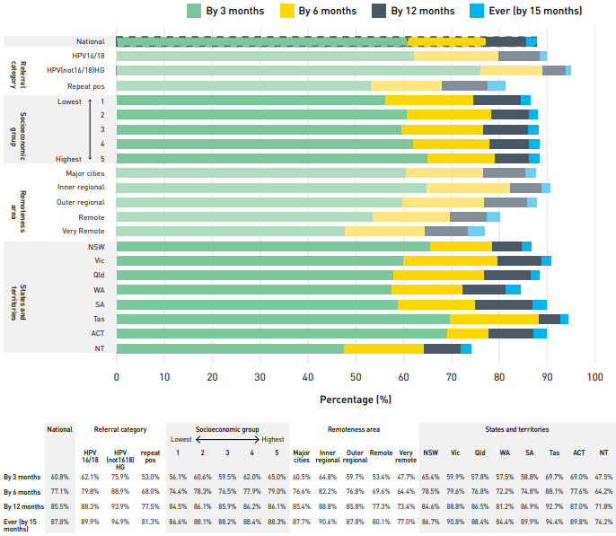

Ref: 2021 C4 Elimination report (1)

### High-grade cervical disease treatment rates

Precancer treatment rates are not routinely published as an indicator within the NCSP. No published or routinely reported data were available, and no relevant data were identified in the Australian peer reviewed or grey literature.

After treatment of high-grade cervical disease (HSIL CIN2/3), both the former cytology-based program (from 2005) and the current HPV based screening program require a test of cure (TOC) to be completed.

A TOC consists of a co-test (LBC and HPV test) performed at 12 months after treatment, and annually thereafter, until a negative co-test is received on two consecutive occasions.

Completion of a TOC indicates that:

* the participant’s lesion has been successfully treated
* their risk of further HSIL or invasive cervical cancer is low
* they can return to routine screening.

The completion rates for TOCs are not routinely monitored or published as an indicator within the NCSP. However, two research studies indicate that compliance with TOC in Australia has been sub-optimal (75, 76). This means that some participants may remain at elevated risk of HSIL or cervical cancer, despite treatment.

**TOC compliance evaluation**

Using state screening, hospital and death registry data, Munro et al evaluated TOC compliance for over 5000 participants in Western Australia treated between 2006 (the year in which the pathway was introduced) and 2010 followed up for at least 27 months (75).

Over one third (37%) of women did not commence the TOC pathway and 38% of women entered the pathway later than recommended.

Commencement of TOC was associated with:

* **age** – it was more likely for those aged over 35; OR 1.3
* **year of treatment** – it was more likely with each subsequent year after the change was introduced
* **area-level socioeconomic status** – OR 0.7 for most disadvantaged compared to most advantaged quintile.

Just 18.5% of the total cohort completed a TOC. Of those within the cohort who commenced the TOC pathway during the study period, 29% completed it by study end.

**Patients who received excisional treatment**

Tan et al conducted a review of data from the Victorian Cervical Screening Registry of 8478 screening participants who received excisional treatment between 2007*–*2011, with follow up data through to April 2015 (76).

While 27% of participants completed TOC, 28% had no HPV tests and 25% had only one.

These studies were undertaken during the cytology-based program, and providers may now be more familiar with the requirements for test of cure. However, there is no available data to indicate that TOC compliance has increased or is timely and equitable.

### Current research, policy and health system issues: Overview of key literature

#### Aboriginal and Torres Strait Islander people

There are no current or previous national data on screening participation by Aboriginal and Torres Strait Islander women. This is primarily because

* Aboriginal and Torres Strait Islander status was not recorded routinely on pathology forms (the primary source of data for previous jurisdictional cervical screening registers)
* recording of Indigenous status on the NCSR is incomplete.

The renewal of the NCSP provided an opportunity to correct this situation. However, this continues to be a challenge. A coordinated strategy involving primary health care, pathology practices, primary care IT providers, Indigenous communities, other stakeholders and the NCSR is required.

In December 2020, 38.3% of the Aboriginal and Torres Strait Islander women who were regular clients of these services had a cervical screening test in the previous five years (29). This data comes from national data from primary healthcare organisations funded by the Department of Health to provide services to Aboriginal and Torres Strait Islander people.

However, these records may not capture screening visits if clients had undergone screening outside their usual primary healthcare organisation.

Aboriginal and Torres Strait Islander women were substantially less likely to have attended within the previous two, three or five years than non-Indigenous women in the two-yearly cytology program. This is according to ad hoc linkage studies of data in Queensland (77) and NSW (78).

In Queensland, the number of Indigenous women who had been screened was consistently at least 20 percentage points lower than the corresponding rate in non-Indigenous women over two-year periods between 2000*–*2011.

The absolute difference increased to at least 25 percentage points over three-year periods and to just under 30 percentage points over five-year periods between 2000*–*2011(77).

In NSW, the number of Indigenous women who had been screened was consistently less than half of the corresponding rate in non-Indigenous women over two, three and five-year periods between 2009*–*2013, with a difference of more than 30 percentage points (78).

Multiple factors may reduce Indigenous women’s participation in cervical screening, such as:

* lack of knowledge about the screening process
* confusion about cervical screening
* fear of the invasive speculum procedure and results
* preference for a female practitioner to take the sample whilst still maintaining privacy within health services (many Aboriginal and Torres Strait Islander people view cervical screening as women’s business)
* a lack of culturally safe services, resources and support (79).

Additionally, as articulated by Whop et al (80): “For Aboriginal and Torres Strait Islander communities, the term shame has a particular meaning, which is distinct from Western conceptions of the emotion.

Shame may be experienced when a person behaves in a way that violates collectivist, cultural or spiritual norms or is singled out – either positively or negatively (81). Cervical screening is seen as a private and intimate procedure, causing feelings of shame among some women.”

These barriers occur in the context of ongoing colonial control and subjugation and experiences of racism in healthcare settings (82).

Several published studies have identified barriers to conventional cervical screening and recommended strategies. However, few have implemented strategies that increased cervical screening participation amongst Aboriginal and Torres Strait Islander women.

For those that did, there were modest increases in participation, ranging from 9.1%-27%. Strategies focused on education and health promotion, staff development to improve clinical skills, invitations for screening, and call and re-call systems (83-85).

The introduction of self-collection as an option for screening has also been examined in several research studies including Aboriginal and Torres Strait Islander women.

Self-collection has:

* been shown to be acceptable to many
* increased participation in women who would otherwise not have screened
* helped overcome some of the barriers to screening
* provided increased agency and control in relation to the screening experience (80, 86-88).

#### CALD communities

Country of birth was not routinely recorded on the previous state-based screening registers. Therefore, national or population-based screening participation data by country of birth is not available for the previous cytology screening program.

Country of birth is recorded on the NCSR but is incomplete, being unpopulated for 67% of people aged 25-74 who had an HPV test in 2018*–*2020.

Main language other an English spoken at home was similarly incomplete for 86% of 2018*–*2020 screening participants (29).

However, the following patterns have emerged from smaller studies of screening participation among migrants:

* **Migrant women:** 1*–*16% lower screening rates among migrant women compared with Australian-born women, with participation of South Asian women being significantly lower (89).
* **Non-refugee African women**:These women (in Brisbane) were more likely to have screened than refugee women (73.6% versus 61.8%); immigration status was not a predictor of screening, and screening participation was predicated by work arrangements, parity, healthcare visits, knowledge and perceived susceptibility to cervical cancer (90)
* **South Asian women**: Bangladeshi, Indian, Pakistani, Sri Lankan, Bhutanese, Maldivian and Nepali populations had poorer knowledge of cancer and cancer prevention and experienced more barriers to screening (91). Barriers for South Asian women in Queensland included lack of knowledge, lack of familarity with preventive health, health care system factors, practical constraints and sociocultural beliefs (92). GPs were identified as important gatekeepers to support screening behaviours (93).
* **Arabic-speaking refugee women**: In Melbourne, these women had limited awareness of cervical screening (94)
* **Bhutanese refugee women**: Barriers for Bhutanese refugee women include cultural influences and norms, poor knowledge of health services and health systems, and poor practice by health professionals (95)
* **Women born in Muslim countries:** These women, as well as women born in some non-Muslim countries, had lower odds of participation in cervical screening than Australian born women (96).

An unpublished analysis of 2014*–*2015 National Health Survey data identified four country of birth and language groups that were consistently under screened across all screening programs.

These included:

* Chinese-born Mandarin speakers
* Indian-born Hindi speakers
* Philippines-born Tagalog speakers
* Iraq- and Syrian-born Arabic speakers (97).

Once they entered the program, women born in North Africa and the Middle East were just as likely to re-screen as Australian women.

An unpublished analysis of data from the NSW Pap Test Register for women enrolled in the large cohort study called 45 and up also identified lower screening participation compared to Australian-born women for women born in Asia and the Middle East.

This study additionally identified that women born in New Zealand and Oceania were also significantly under screened compared to Australian-born women (98).

While screening participation increased with time lived in Australia, most groups of immigrant women remained significantly under screened – even after 20 years or more living in Australia compared to Australian-born women.

#### LGBTQI+ communities

There are no routine national data on screening participation among LGBTQI+ communities.

However, the following observations have emerged from smaller studies of issues relating to cervical screening and cervical cancer among LGBTQI+ people in Australia and overseas.

**Screening was not universally recommended to trans and gender-diverse people**

A national Australian survey in 2018*–*2019 with 196 trans and gender-diverse people found almost half (44.6%) had never had a healthcare provider recommend cervical cancer screening to them.

Around half (48.0%) had never participated, with 21.9% reporting that they are regular screeners. More than a quarter (27.5%) of people who had screening had an abnormal result.

The most common reason for not participating in screening was that it is was emotionally traumatic (55.3%). Around 38% of patients were unable to find a healthcare provider with whom they were comfortable (99).

**A significant proportion of transgender men retain their cervix**

A review of cervical cancer prevention in transgender men showed a significant proportion retain their cervix, are at risk of acquiring HPV and have personal and structural barriers to accessing cervical screening (100).

**Cervical cancer screening was not universally associated with dysphoria**

A systematic narrative review of 27 studies identified that cervical cancer screening was not universally associated with dysphoria among gender minorities assigned female at birth. The review recommended that providers explore patient preference and avoid making assumptions (101).

**Care is required within the context of a nonbinary approach**

A review of barriers to screening for transgender men (which included data from 15 relevant studies from the US, Canada and UK) identified the need for healthcare services to provide care within the context of a nonbinary approach to gender identity and health (102).

**Barriers to cervical cancer screening experienced by lesbian women**

Key barriers to cervical cancer screening experienced by lesbian women were:

* lack of opportunistic screening
* fear of penetration
* encountering heterosexism and discrimination (103).

#### Medically higher-risk people

People living with conditions that impair immune function related to control of HPV infections are at greater risk of precancer and cancer of the cervix.

This includes people with:

* HIV
* primary immunodeficiency
* post-transplant immunosuppressive therapies
* autoimmune conditions, such as rheumatoid arthritis or multiple sclerosis.

As well as an all-age recommendation for HPV vaccination for these groups, Australian guidelines recommend more frequent screening and more intensive follow up for these groups:

* three-yearly rather than five-yearly HPV screening (previously annually rather than two-yearly under the cytology program)
* colposcopy referral for any HPV detection (104).

Low participation in cervical screening by HIV-positive women and transplant recipients has been reported in some international studies (105-107).

No national data are available on rates of screening or follow up in medically higher risk groups in Australia, with the following data located in the Australian literature.

In a cross sectional 2018 survey of women and trans and gender diverse people assigned female at birth:

* all 48 HIV-positive respondents reported having had a Pap test
* 63% of the HIV-positive respondents reported having had an abnormal test
* of 19 non-HIV positive but immunocompromised participants, 10% had never had cervical screening (69).

In a survey of 186 female Allogeneic Blood and Marrow Transplant (BMT) survivors (transplanted 2000*–*2012) at least one year since transplant in NSW:

* 36% had not had Pap test since transplantation
* 75% of those who had a Pap test had been screened within the last two years
* younger women were more likely to have had a screen
* those less than two years since transplant were less likely to have screened
* 30% of women believed that screening was not necessary, with other barriers reported including lack of time and cost
* nearly half of women (46%) reported that they had not been advised to screen by their treating team (108).

A 2018 survey of 69 female post-liver transplant patients in Melbourne found that 80% reported up to date cervical screening (109).

A 2007 Australia-wide survey of 131 nephrologists found that 86% recommended one to two-yearly cervical screening to their patients with chronic kidney disease (110).

#### People living with a disability

There are no national data reporting cervical screening participation amongst people living with a disability and limited recent Australian literature identified the following.

**Screening in people with an intellectual disability**

In a 2013 survey of 653 people with an intellectual disability in Victoria (43% female), rates of cervical screening were lower than those reported in the general population (111).

Of those aged 18 to 39, 17.4% reported a Pap test in the previous two years (compared to 83.7% in the Victorian Health Survey 2012) as did 13.8% of those aged 40 to 59 (compared to 75.9%).

The estimated proportion for women aged 60 and older was 27.1% (compared to 42.1%), although the sample size was small.

**Barriers to cervical screening amongst women living with a physical disability**

Ramajan et al undertook an integrative literature review (of publications 2001*–*2013) to identify barriers to cervical screening amongst women living with a physical disability (112).

These barriers have been classified into:

* physical, environmental and architectural barriers
* sociodemographic disadvantages
* communication barriers.

Whilst most literature identified was international, they considered its applicability in the Australian setting. They noted that many known sociodemographic barriers to health care access and screening impact people with a disability disproportionately due to a higher prevalence of these characteristics.

The three main issues identified from the literature relating to screening for women with a disability were:

* **health insurance** – predominantly from US literature
* **healthcare workers** – attitudes, level of knowledge and understanding of disability, stereotypes and social misconceptions
* **physical barriers** – built environment and hazards with examination tables.

**The experience of Pap testing in 60 women aged 26-59 with a disability**

Qualitative research by Johnson et al (2006) into the experience of Pap testing in 60 women aged 26*–*59 with a disability (physical, psychiatric, intellectual or sensory) found that none of the participants viewed cervical screening as a positive experience (113).

The researchers identified three key themes in how the women viewed cervical screening:

* **Feelings around cervical screening were often intertwined with negative views about themselves as women**: These feelings related to their disability and its negative impacts on their lives (for example, inability to bear children or marital breakdown after acquiring a disability)
* **Privacy and control concerns**: Some women felt that their inner body was the only private part of themselves left and thus screening was an invasion
* **Sexuality and sexual abuse concerns**: For some women, screening reinforced to them their own lack of a sexual life, whereas for others it raised the issue of societal expectations that they would not have a sexual life; for women who had experienced sexual abuse, the screening procedure and the feeling of powerlessness were reminders of these experiences.

**The Australian nurse experience of providing screening to women with a physical disability**

Halcomb et al (2019) surveyed 178 Australian general practice nurses regarding their experiences of providing screening to women with a physical disability (114).

Most (more than 70%) of practices had strategies to assist with physical access (such as ramps, accessible toilets and consultation rooms, disabled parking). One third had record systems in place to clearly identify women with a disability when inviting them into screening.

About two thirds of participants reported having strategies and facilities to assist women with a disability to screen, including:

* adjustable examination tables
* nurse chaperones
* assistance with dressing and getting onto the examination table
* longer appointment times
* visual aids
* home visits.

When describing providing screening to women with additional needs in the last month, strategies described were either:

* **practical assistance to facilitate screening** – such as longer appointment types, emotional support, enlisting carers to assist, physical assistance with dressing or the use of electric beds or footstools
* **modifying positions and technique for comfort** – such as using the left lateral position, supporting with pillows and using the floor rather than a bed.

#### Barriers to, and enablers of, screening

Key barriers and enablers of cervical screening found in the Australian literature (97, 98, 115*–*117) are summarised in Table 5 and Table 6 below.

Table 5. Summary of barriers to screening participation.

|  |
| --- |
| Barriers to cervical screening |
| * Lack of access, including remoteness, transport, hours (not available at a convenient time), cost * Fear, shame, embarrassment * Low awareness of screening, benefits and cervical cancer risk * Language barriers * Distrust of health care services – for example, due to racism, discrimination, stigma * Lack of services that feel safe (culturally, or for LGBTQI+ people) * Cultural beliefs about cancer (fatalism, stigma) * Pain or discomfort with the speculum exam * Lack of appropriately tailored information – for example, translations without consideration of culturally appropriate messages * Negative previous experiences with screening or health services * Lack of saliency – for example, other health issues that are more urgent * Not sick – only seeking healthcare when symptomatic * Previous trauma, including sexual trauma * Lack of data – inhibits recall, opportunistic offers (if the healthcare provider could see the person was due or overdue), monitoring and accountability * Cultural beliefs about women’s bodies – sacredness, modesty |

Table 6. Summary of enablers to screening participation.

|  |
| --- |
| Enablers of cervical screening – what works? |
| * Reducing logistical barriers (including flexibility) * Self-collection * Trusted providers * Data reminders, monitoring and accountability * Female providers * Community engagement, including community-based education * Culturally safe care * Support person along the full pathway * Locally devised solutions * Learn from people who screen who belong to communities who tend to be under screened – the motivation and factors that led to them screening * Communication that emphasises screening as important to enable the person to continue to care for and participate in their community * Communication that promotes screening as an investment to prevent future disease, and detecting disease earlier to prevent bigger problems in future (positive messages) * Primary healthcare engagement with continuous quality improvement * Reminders and invitations * Awareness campaigns * Healthcare provider recommendations, such as opportunistic offers when people attend for other reasons * Talking about screening – normalising screening among peers and in community |

From July 2022, participants can choose screening using either a clinician-collected or self-collected sample.

This has been widely found to be a key enabler of screening (16,118) and has the potential to address or reduce some known barriers.

Self-collection at the time of a clinic visit is preferred, but self-collection can be done anywhere the healthcare professional ordering the test considers appropriate.

The flexibility provided by self-collection may enable approaches tailored to specific communities (for example outreach) or areas (such as remote or very remote areas).

Self-collection also includes non-speculum collection of a lower vaginal swab by a clinician. This has been found to be more acceptable than self-collection in some culturally and linguistically diverse communities in England (119).

### Key issues for strategy development identified from screening review

From the screening review, the key issues for strategy development are as follows.

1. **Data issues and gaps**

There is a current lack of precancer treatment data to inform the 90% treatment indicator. The data:

* will rely on completeness of histopathology reporting, colposcopy reporting and supplementation with Medicare item numbers
* needs full assessment of quality, completeness and accuracy, and development of an ongoing reporting mechanism

There is a lack of reporting on screening program indicators by Indigenous status, CALD status, for those with a disability, by gender, for medically high risk.

**Aboriginal and Torres Strait Islander people**

Indigenous status is around 70% complete, preventing participation reporting; however, other indicators could feasibly be reported with cautious interpretation.

**Measures of cultural and linguistic diversity**

* Country of birth does not completely capture cultural and linguistic diversity
* Country of birth does not capture aspects important to communication, such as proficiency in English or cultural beliefs
* Country of birth and language spoken at home are fields within the NCSR but are extremely incomplete
* Difficulty speaking English and interpreter-required information is recorded on the NCSR for bowel only (completeness and sensitivity of this measure is unknown; it is presumably unavailable for people aged under 50 who are not eligible for bowel screening)
* Other Census measures of cultural diversity which are not on the NCSR include Australian citizenship, year of arrival in Australia, country of birth of parents, proficiency in spoken English, ancestry and religious affiliation.

**Gender versus sex**

Gender is recorded on NSCR, but accuracy is unknown. Population by identified gender is not recorded on the Census, meaning a population denominator is not available to estimate screening participation.

**Measures of disability**

Some measures are recorded on the NCSR for bowel only; the focus is mainly on disabilities that could affect a call (deaf or mute); it is presumably unavailable for people aged under 50 who are not eligible for bowel screening.

Personal representative is available for cervix but is likely not overly sensitive or specific.

**Medically high risk**

There is uncertainty regarding the NCSR’s ability to clearly identify those who are medically high risk, and on three yearly screening interval and medically high-risk pathway, and to report outcomes for this group.

1. **Equity issues and gaps**

The equity issues and gaps include the following:

* Lower participation for residents of lower SES areas, more remote area residents and young women, according to program data
* Variable participation by jurisdiction, according to program data
* Lower participation in screening for Indigenous women, according to pre-renewal research data
* Additional barriers faced by Indigenous people include lack of access to culturally safe services, racism and feelings of shame for some women
* Lower participation and differing barriers to participation for some CALD groups, for those living with a disability and for LGBTQI+ people, with no data on intersectionality of these groups

Little is known about how more intensive cervical screening and follow up is recommended to, and understood and accepted by, the medically higher risk groups (diverse patient groups facing differing health issues).

Rates of follow up after a positive screening test vary by Indigenous status, remoteness and socioeconomic status.

1. **Research and policy evidence gaps**

The research and policy evidence gaps include the following:

* Best methods to measure, and then monitor, screening and precancer treatment-related program and elimination indicators for priority and diverse populations
* Optimal implementation of self-collection to overcome current barriers to screening participation across diverse communities
* Methods for monitoring the precancer treatment rate in Australia and understanding and addressing barriers to accepting and receiving further investigations and treatment after a positive screening test
* Consideration of whether the NCSP indicators should include indicators that routinely monitor precancer treatment rates and the proportion of participants completing test of cure
* Methods to better utilise and embed the use of current digital technologies to make screening histories and reminders from the registry integrated into medical software used by providers and improve reach to participants

In addition, invitations and reminders could be improved or delivered in a better way, for example:

* moving beyond translations to use more tailored messages for Aboriginal and Torres Strait Islander or CALD communities
* using text messages
* providing a choice of delivery mode rather than paper-based mail
* using more social media or other technology platforms to deliver education.

Consideration also needs to be given to those who require diagnostic assessment rather than screening due to the presence of symptoms.

For example, people and healthcare providers need to be aware of the symptoms of cervical cancer. They also need to feel safe and supported accessing appropriate testing and investigation.

1. **Assessment of local applicability of WHO screening and treatment targets**

The WHO indicator relating to twice-lifetime cervical screening does not directly reflect screening recommendations in Australia. It may, therefore, seem like an easy target. Yet Australia has not yet met this target.

This is partly because HPV screening has not been available for long enough in Australia. While Australia may wish to adopt a more ambitious target than that set by WHO, the WHO target could be seen as a minimum that must be met for all groups in Australia.

Of note, the WHO strategy requires scaling up beyond 70% twice in a lifetime to over 90% beyond 2030.

The strategic actions recommended in the WHO strategy to achieve the targets for screening participation and precancer treatment are in Table 7.

Table 7. Strategic actions to achieve 70% coverage for screening and 90% treatment of precancerous lesions identified in the WHO strategy.

In the Australian context, these strategic actions could be adapted as follows.

1. **Understand barriers to accessing services and create an enabling environment**

Increase public understanding of how cervical screening can help prevent cervical cancer and what is involved in screening.

Draw on the example of actions successfully undertaken with pre-exposure prophylaxis (PrEP).

Consider aspects relating to workforce – both for screening and colposcopy. Self-collection may enable a wider workforce to be involved in promoting and offering screening, under the supervision of a healthcare professional.

The cytology workforce is aging and likely to decline in numbers over time. The renewal led to a reduced demand for cytologists.

However, the fluctuating demand for LBC tests, due to the transition from two-yearly Pap tests to 5-yearly screening, means that attention will need to be paid to workforce as we approach projected peaks every five years.

Strategies to retain cytologists between these peaks will need to be considered, along with continuing to train recent medical laboratory science graduates in cytology, albeit at smaller numbers than before renewal.

Other countries train nurse colposcopists or GP colposcopists, and there are some trained professionals working in this capacity in Australia. However, training is not available in Australia. As a result, there are only a small number of nurse colposcopists, limiting their potential to address unmet demand for colposcopy.

1. **Integrate screening and treatment services into the primary care package**

Support the use of community-based healthcare settings and population-specific settings including Aboriginal Medical Services that provide holistic care.

Peer-based, nurse-led services can be successful, more accessible and safer for disengaged or priority populations (for example, the Check Out clinic for LGBTQI+ run by FPNSW and ACON).

The current requirement that a cervical screening test pathology request be signed by a health care professional with a Medicare provider number should be reviewed.

This requirement is a likely barrier to creating systems that support higher participation in cervical screening for groups who have strong engagement with alternative primary health care providers such as accredited screening nurses.

In particular, self-collection could be readily supported by bilingual health care workers and Aboriginal and Torres Strait Islander Health Care Workers.

1. **Promote a screen and treat approach – replace with screen and assess approach in remote areas**

This approach is recommended in LMIC settings, where follow up of women who screen positive may be highly problematic, meaning that a degree of over treatment outweighs the harms of failure to treat those who require it.

This approach is not considered appropriate in Australia where we have the resources to ensure that all people can receive the same standard of care.

In remote areas, follow up can be difficult and resource intensive, and there is likely to be a role for a screen and same day assessment approach. This can be facilitated by point of care HPV tests, which have equivalent sensitivity for HPV and can be performed in about an hour.

This makes immediate further clinical assessment of those who screen positive for HPV (collection of cytology specimen for self-collected specimens or potentially colposcopic assessment) feasible.

Treatment would still require results of cytology, colposcopy and histopathology assessment as indicated. However, same day screening and assessment could reduce the number of visits and need to travel to two instead of three.

1. ***Maintain* an affordable supply of quality assured, high performance screening tests and treatment devices**

Consider how regulation of suitable HPV tests that can be used on self-collected samples could be streamlined. This should include point-of-care HPV tests that can support suitable models of care in remote settings.

1. ***Maintain* strong laboratory capacity and quality assurance programmes**

These are in place in Australia, so maintaining quality and capacity are key.

## Invasive cancer treatment and palliative care indicators

Providing high coverage, high quality, timely, affordable and effective cervical cancer treatment and care is one of the three key pillars of the WHO global strategy to accelerate the elimination of cervical cancer as a public health problem (2).

Australia’s National Elimination Strategy will need to identify and address any barriers to delivering and monitoring treatment and care equitably to people diagnosed with cervical cancer.

### Cervical cancer survival

Survival data may help to identify gaps in the adequacy of access to, and completion of, effective treatment and early diagnosis. National data for the most recently available five-year period 2013*–*2017 is shown below in Figure 27.

The data show a five-year relative survival rate of 74%. Survival is not available by stage, as this information is not nationally reported. For 2012*–*2016, five-year relative survival was lower for Indigenous Australians than Non-Indigenous Australians (58% compared to 73%).

Observed five-year survival varied by remoteness and was lowest in remote areas (at 66.7%), although confidence intervals overlapped with major cities (73.0%), inner regional (69.5%) and outer regional (67.2%) areas (very remote not published).

Observed five-year survival also varied by area level socioeconomic status. It was significantly lower in the most disadvantaged quintile at 64.7% (Quintile 2 68.2%, Quintile 3 71.9%, Quintile 4 77.8%, Quintile 5 (most advantaged) 78.9% (Source: Australian Cancer Database) (120).

Figure 27. Five -year relative survival for cervical cancer, 1988–1992 to 2013–2017

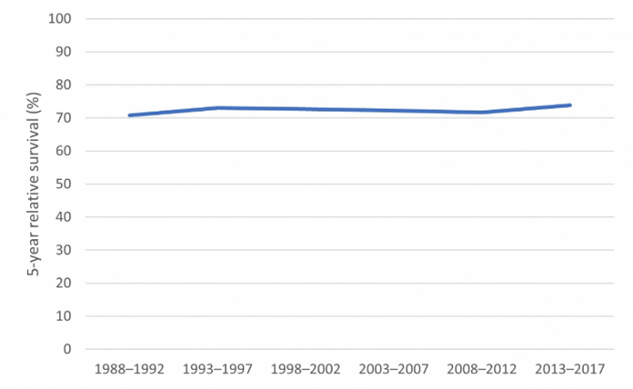

Source: Australian Cancer Database. (120)

### Cervical cancer treatment rates (WHO indicator)

#### Proportion of people with cervical cancer who are managed

The WHO scale up target for the treatment pillar is that, by 2030, 90% of women with invasive cervical cancer are managed.

No national data were identified that provide information as to whether this target is currently being met in Australia*.* Australia’s national cancer database does not contain staging or treatment data.

National level activity data for radiotherapy 2013*–*2015 and systemic therapy 2012*–*2016 as measured through MBS and PBS data respectively. These data are available for all cancers, but not for individual cancer types, as part of the National Cancer Control Indicators (121).

These are reported as numbers and not as rates for patients with cancer. Similarly, surgical activity data using hospital separations 2010*–*2015 are only available for the top 5 incident cancers (122).

The AIHW regular report, Cancer in Australia, includes a section on treatment. However, it only provides data for individual cancer types when they are one of the most common cancers for that type of treatment (123).

In the 2021 report, cervical cancer was the third most common principal diagnosis in females for hospitalisations where radiotherapy was performed (n=437 in 2019*–*2020).

Cervical cancer was also the most common additional diagnosis in females for hospitalisations where a radiotherapy session was the principal diagnosis (n=363).

The AIHW publishes regular reports on radiotherapy activity in Australia, including:

* waiting times by area of residence
* socioeconomic status
* sex
* age group
* jurisdiction and sector,
* treatment intent
* the top 10 principal diagnoses, not available for cervical cancer separately (124).

The AIHW publish regular comprehensive reports on palliative care use in Australia but does not describe patterns of use for gynaecological cancers or cervical cancer specifically (125).

However, data reporting rates of receipt of treatment for cervical cancer were located for Queensland and Victoria. Data were also located from an analysis of data from four major hospitals in South Australia.

#### Queensland data

State-level data from the Queensland Cancer Quality Index for the period 2003*–*2017 are available (126). The Cancer Quality Index was developed to track progress in delivering safe, quality cancer care within health care services using state-level linked data (127, 128).

The linked data are housed in the Queensland Oncology Repository (QOR), which compiles and collates data from a range of source systems, including:

* the Queensland Cancer Register
* private and public hospital admissions data
* death data
* treatment systems
* public and private pathology
* hospital clinical data systems
* QOOL (129).

Age-adjusted cervical cancer treatment rates (defined as at least one of major resection, radiotherapy or chemotherapy) were stable over time at 90% in rural and remote areas. These treatment rates and rose over time in regional and metropolitan areas to 96% and 95% respectively in the period 2013*–*2017 (Table 8).

Treatment rates were stable over time for surgery and radiotherapy, and they rose for systemic therapy (chemotherapy).

The proportion of cervical cancer patients receiving multidisciplinary team (MDT) review rose considerably over time. It’s worth noting that this is likely underreported, as reporting relies on the presence of MDT software.

The number of patients receiving treatment within 30 days of diagnosis fell over time to 29% in the 2013–2017 period.

In the 2013–2017 period, there was a large disparity in the proportion of patients receiving treatment within 30 days by use of private health care (22% public patient compared with 45% private patients; p<0.001).

There were non-statistically significant differences by remoteness (33% for rural and remote versus 29% for regional and metro) or older age (29% aged under 75 versus 35% aged 75 and over).

The rate of treatment within 30 days was 36% for all Indigenous patients, compared to 21% and 45% for non-Indigenous patients treated in public and private hospitals respectively (p<0.05 for difference with non-Indigenous patients in public hospitals).

Whilst timeliness was poorest for the most disadvantaged group, there was no significant trend in the proportion of patients treated within 30 days by socioeconomic status:

* 19% disadvantaged (SEIFA 1–2)
* 29% middle (SEIFA3–8)
* 24% affluent (SEIFA9–10).

The age adjusted 90-day mortality rate in 2013–2017 post major resection was 1.4%.

Table 8. Selected Queensland Cancer Quality Index metrics for cervical cancer, 2003-2017.

|  |  |  |  |
| --- | --- | --- | --- |
|  | 2003-2007 | 2008-2012 | 2013-2017 |
| % receiving treatment* | Rural & remote 90%  Regional 88%  Metro 93% | Rural & remote 90%  Regional 92%  Metro 93% | Rural & remote 90%  Regional 96%  Metro 95% |
| Receiving major resection | 143 (19%) | 214 (24%) | 236 (23%) |
| IV systemic therapy | 252 (31%) | 344 (40%) | 450 (47%) |
| Radiotherapy | 397 (49%) | 449 (51%) | 484 (51%) |
| MDT | 5 (1%) | 149 (17%) | 114 (12%) |
| Mortality post major resection+  In hospital  30 days  90 days  1 year survival  2-year survival | 0%  0.7%  0.6%  97%  93% | 0%  0%  0%  99%  95% | 0%  0.4%  1.4%  96%  92% |
| Timeliness – % receiving treatment within 30 days  of diagnosis | Age <75 40%  Age 75+ 47%    Indigenous 24%  Non-Indigenous  Public 35%  Private 53%    All 40%  Public 34%  Private 54%    Rural & remote 35%  Regional -%  Metro 43%    Disadvantaged 41%  Middle 37%  Affluent 56% | Age<75 31%  Age75+ 37%    Indigenous 25%  Non-Indigenous  Public 22%  Private 54%    All 32%  Public 22%  Private 54%    Rural & remote 26%  Regional 33%  Metro 33%    Disadvantaged 26%  Middle 32%  Affluent 46% | Age<75 29%  Age75+ 25%    Indigenous 36%  Non-Indigenous  Public 21%  Private 45%    All 29%  Public 22%  Private 45%    Rural & remote 33%  Regional 29%  Metro 29%    Disadvantaged 19%  Middle 29%  Affluent 24% |

+rate adjusted for age and sex *Treatment = major surgery, radiotherapy, or chemotherapy. Source: (126)

#### Victorian data

The Victorian Cancer Quality Index provides state-wide information on the utilisation, timeliness and outcome of surgery, radiation therapy and systemic therapy for Victorians with cancer.

Cancers included in the index include breast, colorectal, gynaecological, hepatobiliary, lung, upper gastrointestinal and urological cancers (130).

The index is modelled on the Queensland reporting which enables comparisons between cancer care in Victoria and Queensland.

Data is similarly derived from linkage between:

* the Victorian Cancer Registry (VCR)
* Victorian Admitted Episodes Dataset (VAED)
* the Victorian Radiotherapy Minimum Data Set (VRMDS)
* the Victorian Death Index.

In the period 2012–2015, rates of cervical cancer treatment (defined, as previously, as one or more of major resection, radiotherapy and chemotherapy) were:

* 78% in remote and outer regional areas
* 86% in inner regional
* 79% in metro areas.

It is unclear why apparent treatment rates are substantially lower than treatment rates reported from Queensland using the same method.

Potentially, this could relate to completeness of data linkage or completeness of the source data. However, rates for each type of treatment are similar to Queensland, as explained below.

In the most recent reporting period (2012–2015) compared to the previous (2008–2011), rates of major resection for cervical cancer and chemotherapy were stable (at 42% and 40%). Just under half of patients (47%) received radiotherapy. No radiotherapy data available for the period 2008–2011.

These rates were all highly comparable to Queensland rates.

The disparity in timeliness of treatment by private patient status in Queensland was also clearly apparent in Victoria, where 23% of patients were treated within 30 days of diagnosis in 2012–2015 (18% of public patients compared with 46% of private patients).

There were minor variations by remoteness (27%, 19%, 24% for remote and outer regional, inner regional and metro) and age (21% under 75 versus 28% aged 75 and over).

No data by Indigenous status was available due to small numbers. The 90-day mortality rate in 2012–2015 post major resection was 0%.

#### South Australian data

Roder et al (2018) noted that in Australia: “Treatment and risk-adjusted survival data [for cervical cancer] are ... lacking in most local clinical settings, which reduces opportunities for the evaluation of local uptake of recommended protocols and survival monitoring,” (131).

The study utilised data from the South Australian Clinical Cancer Registry from four major public hospitals in South Australia to assess time trends and differences in:

* clinical management of cervical cancer
* disease-specific survival by socio-demographic and tumour characteristics (such as histology type, stage and grade).

The study analysed data from 1,274 patients with cervical cancer between 1984–2012.

Over the period, 96.3% of patients received treatment for their cancer. Stage distribution demonstrated the impact of the national cervical screening program:

* 52% diagnosed at Stage I (16% IA and 36% IB)
* 23% at Stage II (6% IIA, 17% IIB)
* 16% at Stage III (6% IIIA, 10% IIIB)
* 10% at Stage IV
* 20 cases (1.6%) of unknown stage were excluded.

The proportion receiving treatment varied by age and was lowest for those aged over 80 at 77.1%. Additionally, 82.5% of stage IV patients received treatment.

Receipt of treatment did not vary by histological subtype, sociodemographic factors, area-level socioeconomic status, remoteness of residence or Local Health Network.

Treatment combinations were:

* no treatment (3.7%)
* surgery only (37.6%)
* radiotherapy only (24.7%)
* surgery and radiotherapy (13.3%)
* radiotherapy and systemic therapy (12.2%)
* surgery, radiotherapy and systemic therapy (6.5%)
* surgery and systemic therapy (1.6%)
* systemic therapy only (0.3%).

The percentage of radiotherapy treatments accompanied by systemic therapy increased over time from 18% in 1984–99 to 82% in 2000–2012 (p<0.001).

##### Surgical treatments

Surgical treatment included fertility sparing options. 59% of patients received surgical treatment. This proportion declined significantly with:

* increasing age (86% of those aged over 40, 16.5% aged 80+)
* more advanced stage
* squamous compared to adenocarcinoma or adenosquamous histological subtype.

The likelihood of a hysterectomy rather than more conservative surgery increased with age, and a trend towards more conservative surgery was observed over time. Sociodemographic factors were not associated with likelihood of surgery in adjusted analyses.

##### Radiotherapy

57% of patients received radiotherapy, with this proportion increasing with age through to age 79. Then number of people receiving radiotherapy varied markedly by stage and was:

* highest for stages IIIA and IIIB at 96% each
* lowest for stage I (IA 7%, IB 35%)
* more commonly used for patients with squamous cancers than other types.

Sociodemographic factors were not associated with the likelihood of radiotherapy in adjusted analyses. Radiotherapy was more likely to be used in combination with systemic therapy, rather than a combination with surgery, over time.

##### Systemic therapy

21% of patients received systemic therapy. 91% of patients receiving systemic therapy received it in combination with radiotherapy. Use increased over time, was more common for adenocarcinomas and was less common for differentiated tumours.

Those aged 50–59 were most likely to receive systemic therapy (29%). Usage decreased above this age and it was most used with Stage IIIB disease (45%).

Socioeconomic status was not associated with receipt of systemic therapy. Those living in remote areas were less likely to receive this treatment (OR 0.34 0.14, 0.83) compared with those living in high accessibility areas.

### Appropriateness of care

There is no national or state-level data describing appropriateness of cervical cancer treatment or compliance with the Optimal Care Pathway for Cervical Cancer, first published in January 2020 (18).

Four studies, each identifying treatment patterns over a decade ago, are summarised below.

**Observed versus optimal treatment rates**

A study of 385 women undergoing first treatment for cervical cancer, between 1999–2008 at the Royal Women’s Hospital (RWH) Melbourne, compared observed treatment rates with modelled optimal treatment rates (132).

Optimal treatment was based on guidelines synthesised from local recommendations and international guidelines.

As shown in Table 9, rates of surgery matched those predicted as the optimal rate. However, rates of radiotherapy, chemotherapy and chemoradiotherapy were lower than predicted as optimal.

**Factors associated with receiving suboptimal care**

Whop et al (2017) examined 105 women diagnosed with cervical cancer receiving care in public hospitals in Queensland between January 1998 and December 2004.

The researchers wanted to determine if being Indigenous and other factors were associated with receiving suboptimal care, based on local clinical guidelines (133).

Indigenous women had seven times the odds of receiving suboptimal care than non-Indigenous women (stage adjusted OR 5.7, 95% CI 1.2–27.3) (as seen in Figure 28).

Table 9. The estimated percentage of patients with cervical cancer who should receive each treatment type according to the guidelines, compared with the observed rates from a pattern of care study at the Royal Women’s Hospital, Melbourne in 1999–2008.

|  |  |  |  |  |  |  |  |  |
| --- | --- | --- | --- | --- | --- | --- | --- | --- |
| FIGO stage1 | Baseline % (95% credible interval) | | | | | | | |
|  | Surgery | | Radiotherapy | | Chemotherapy | | Chemo-radiotherapy | |
|  | Optimal rates | Observed rates | Optimal rates | Observed rates | Optimal rates | Observed rates | Optimal rates | Observed rates |
| Overall | 63 (61–64) | 63 (60–65) | 52 (53–56) | 49 (46–52) | 36 (35–38) | 27 (24–30) | 36 (35–38) | 25 (21–28) |
| IA1 | 98 (96–100) | 99 (95–100) | 2 (1–6) | 1 (0–5) | 0 (0–0) | 0 (0–0) | 0 (0–0) | 0 (0–0) |
| IA2 | 100 (95–100) | 100 (95–100) | 0 (1–6) | 0 (0–5) | 0 (0–0) | 0 (0–0) | 0 (0–0) | 0 (0–0) |
| IB-IIA (Overall) | 81 (79–85) | 77 (72–81) | 52 (51–58) | 52 (47–57) | 19 (17–23) | 22 (18–28) | 19 (17–23) | 20 (16–25) |
| IB-IIA (<4 cm) | 100 (99–100) | 89 (85–92) | 35 (34–40) | 40 (36–46) | 0 (0–0) | 13 (10–18) | 0 (0–0) | 11 (8–15) |
| IB-IIA (>4 cm) | 28 (27–34) | 43 (35–50) | 100 (100–100) | 84 (74–90) | 72 (68–75) | 48 (36–58) | 72 (68–75) | 48 (36–58) |
| IIB-IVA | 0 (0–0) | 9 (7–11) | 100 (100–100) | 87 (84–91) | 100 (97–99) | 60 (50–69) | 100 (97–99) | 56 (45–66) |
| IVB | 0 (0–0) | 0 (0–0) | 100 (100–100) | 80 (30–98) | 50 (50–50) | 40 (15–49) | 50 (50–50) | 40 (15–49) |

Source: Kang et al 2015. (132)

1 FIGO (International Federation of Gynaecology and Obstetrics) stage refers to how far a cancer has spread at diagnosis. Stage I cancers are confined to the cervix, stage 2 extend beyond the cervix but not into the pelvic wall, stage 3 into the pelvic wall and stage 4 beyond the pelvis.

Figure 28. Percentage of women who received suboptimal care in 105 women diagnosed with cervical cancer in Queensland between January 1998 and December 2004.

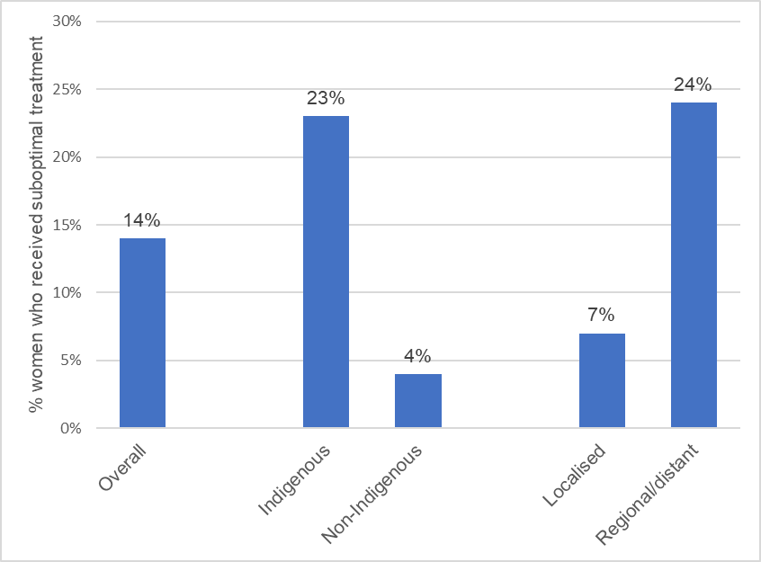

Source: Whop et al 2017. (133)

**Stage IB1-IVA patients treated with combined chemotherapy**

Lim et al (2012) conducted a retrospective review using patient files of 69 patients with Stage IB1-IVA cervical cancer treated with combined chemoradiotherapy in Western Australia between 2005–2008. (134)

Median age was 48 years, with patients aged 24–81. Whilst all patients completed external-beam radiotherapy, only 43% of patients completed the planned course of brachytherapy.

33% of patients received one dose of brachytherapy but did not complete the course, with the main reason being an inability to meet normal tissue dose constraints.

Sixteen patients (23.2%) did not have brachytherapy: 12 were unable to have the brachytherapy applicator inserted, two could not meet dose constraints, one had medical comorbidities and one refused.

They went on to have a CT-planned external beam radiotherapy boost. All patients received chemotherapy but 4% received only four cycles.

Prognostic factors for relapse and death included nodal involvement and pre-treatment haemoglobin but also treatment time more than eight weeks was associated with increased risk of relapse (50% versus 19%) adjHR, 8.2; 95% CI, 1.4–47; p = 0.02) but not death in adjusted analyses (36% versus 19%; (adjHR,2.7; 95% CI, 0.50–14; p = 0.2).

Those who failed to complete brachytherapy also had an increased risk of death (33% versus 23%; adjHR, 5.8; 95% CI,1.1–31; p = 0.04).

**Adherence to clinical practice guidelines**

Chiew et al (2017) reviewed data held in a Clinical Cancer Registry for 208 cervical cancer patients treated in southwest and central Sydney between July 2005 and December 2011 (135).

The researchers assessed adherence to 10 widely accepted Clinical Practice Guidelines (CPGs) that are consistent in the literature and international guidelines (Table 10).

Mean age at diagnosis was 53 and 48% of patients were overseas born.

Adherence to individual CPGs was higher for chemotherapy (97%) and for surgery (74-83%), but more variable for radiotherapy (47–100%).

There were 133 (64%) patients with sufficient data available to assess overall care and of these 54% received overall guideline adherent care.

In an adjusted logistic regression model, guideline-adherent care was greater for stage I and II patients (OR 5.5; 95% CI, 1.9–16).

Guideline-adherent care was not significantly associated with age, lower versus higher socioeconomic status, distance to treatment or being born overseas.

Guideline-adherent care was also associated with survival for stage I and II patients with a five-year cancer-specific survival of 93.7% versus 69.7% (Figure 29) and with a lower risk of death for stage I and II patients in a Cox regression model (HR = 0.22; 95% CI,0.07–0.75).

Table 10. Adherence to Clinical Practice Guidelines amongst 208 cervical cancer patients, Sydney 2005–2011.

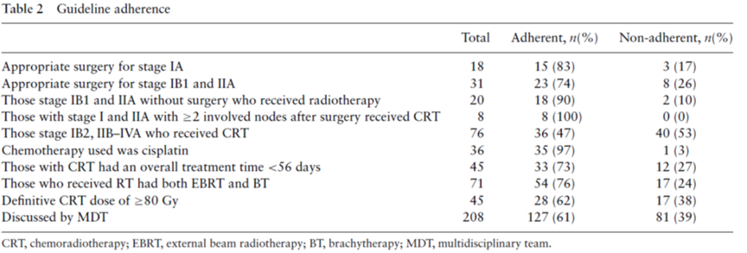

Source: Chiew et al 2017. (135)

Figure 29. Survival analysis for FIGO stage I and II disease by receipt of guideline adherent care (n = 106, 15 cancer-related deaths, 91 censored).



Source: Chiew et al 2017 (135)

### Current research, policy and health system issues: overview of key literature

A 2009 study of GP referral practices for patients with symptoms of gynaecological cancers, using patient vignettes, found that most patients (90%) with a high probability of cervical cancer were referred to a gynaecologist rather than a gynaecological oncologist (gynae oncologist).

Significant variations existed for rural compared to metropolitan GPs in access to both public and private gynae oncologists and to gynae oncologists attending an MDT (136).

Marcusson-Rababi et al (2019) undertook a in depth qualitative study of eight Indigenous gynaecological cancer patients (aged 33–68) referred to a tertiary hospital for care in Queensland in 2016–2017 and 18 of their cancer care providers (137).

The study identified that: “The Indigenous women in the study faced substantial challenges associated with late referral, misdiagnosis, miscommunication, lack of information, logistical challenges in accessing treatment and services, background life crises, and cultural insensitivities in the system.”

Recommendations arising are given in Box 4.

Box 4. Recommendations to improve gynaecological cancer services to better meet the needs of Indigenous women in Queensland.

|  |
| --- |
| **Recommendations for cancer care professionals**   * Increase cross-cultural communication training * Be sensitive to patients’ feelings when communicating diagnosis and prognosis * Be compassionate and take a whole-of-person approach in your treatment of patients * Be proactive in offering counselling services to patients * Be aware of cultural values and preferences when providing cancer care * Participate in cultural awareness training * Empower patients to be active decision-makers in their cancer treatment * Be aware of logistic challenges facing patients in engaging with cancer treatment     **Recommendations for cancer care services**   * Ensure patients understand their diagnosis, the nature of treatments and their treatment options * Produce and make available culturally appropriate patient education resources * Improve access to Indigenous interpreters * Make access to allied health support more flexible and convenient for patients * Employ more Indigenous Liaison Officers * Employ more Indigenous staff across the service * Allow escorts and support persons to accompany patients to tests and procedures * Engage social work services more for Indigenous patients * Offer more transport assistance for local patients * Offer more assistance for patients to attend appointments and clinics * Be aware of socio-economic status of patients and the costs associated with accessing treatment     **System-wide recommendations**   * Provide greater training for GPs in cancer identification * Facilitate more timely referral processes * Provide patient navigator programs * Prioritise development of cancer services in regional areas |

Source: Marcusson-Rababi et al 2019 (137)

Beesley et al (2020) surveyed 64 health professionals providing gynaecological cancer care across Australia in 2017 and interviewed a further eight (138).

The online survey collected:

* demographic information, such as location, type of service they work in, their role, years of experience
* respondents’ current practice of needs assessment of women with gynaecological cancer and their caregivers
* service-level process and protocols
* questions about enablers and barriers to the provision of supportive care.

Responses were assessed against a best-practice service delivery framework compiled from review of recommended practices. No responders reported meeting all 12 best practice criteria, and 39% met none of the criteria.

According to the researchers: “Respondents generally rated needs assessment for potentially vulnerable populations as being poor to average, with mean scores of assessment among women from rural and remote locations being the poorest, followed by Aboriginal and Torres Strait Islander women, culturally and linguistically diverse women, refugee women, lesbian, gay, bisexual, transgender, and/or intersex people, women with pre-existing mental health disorders, and women from other vulnerable groups (sexual abuse victims, frail aged, young adults).”

The most important enabler to provision of care reported was having sufficient time to discuss issues with patients.

The most important barriers to care for women with gynaecological cancer and their caregivers were:

* lack of time to discuss issues
* workforce
* availability of psycho-oncology and allied health professionals
* availability of specific gynaecological cancer services
* protocols for needs assessment.

Although not specific to cervical cancer, a qualitive study interviewed 25 NSW GPs in 2017–2018 to understand their perception of barriers and enablers to the provision of palliative care (139).

Patients reported “struggling with the complexity of palliative care and system-related barriers to optimal care provision.”

Suggested strategies included:

* adequately managing time pressure
* facilitating multidisciplinary teamwork
* fostering the uptake of guidelines
* further education on palliative care
* using non-government organisations (NGOs).

### Key issues for strategy development identified from cancer treatment review

From the cancer treatment review, the key issues for strategy development are as follows.

1. **Data issues and gaps**

There is no national data currently available that can identify and monitor the proportion of patients who receive treatment and care for cervical cancer nor the quality of care and whether it is compliant with the optimal care pathway.

Sparse data was located identifying which patients do not currently receive treatment and appropriate care in Australia and why.

* How can these data best be collected whilst recognising patient privacy issues?
* Can qualitative research complement systems be established for overall indicator monitoring?

There is a lack of national stage distribution data or stage specific survival data.

* Is local clinical cancer registry data or state-based data sufficient and if not, how can national data collection be facilitated?

1. **Equity issues and gaps**

There is a lack of data identified on equity in treatment. The available data indicates structural and cultural barriers to quality care for Aboriginal and Torres Strait Islander patients including racism.

Methods need to be identified to best collect data to record and monitor treatment occurrence and experiences for patients of different backgrounds.

1. **Research and policy evidence gaps**

Development and implementation of methods to assess whether patients are currently experiencing appropriate, culturally safe treatment and optimal care for cervical cancer in Australia and identify what the current barriers to receiving such care are.

Options for consideration and assessment of data to develop such methods include:

* the creation and maintenance of a national linked data set or compilation of state-linked data considering
  + whether underlying data elements are available
  + whether data quality and timeliness are adequate
* use of the National Gynae-Oncology Register (<https://ngor.org.au/>) and if so in what time frame, with the cervical cancer module upcoming
* sentinel surveillance through local clinical cancer registries or tertiary centres
  + need to identify any important groups who would be missed in such a strategy
* whether the optimal cancer care pathway should have an implementation strategy, with recommended indicators that are locally monitored and then collated.

Under the National Cancer Control Indicators for Psychosocial Care, instruments and state-based data exist for monitoring of patient experience (see <https://ncci.canceraustralia.gov.au/psychosocial-care/patient-experience>).

There is a need to consider:

* whether existing instruments and data systems could be used to focus on gynaecological cancer care and cervical cancer care in particular
* whether progress is being made towards national reporting

1. **Assessment of local applicability of WHO treatment target**

In developing the national strategy, we need to consider the adequacy of the WHO target (90% of women with invasive cancer are managed) in the Australian setting.

* Is this target too low?
* Should quality and adequacy of care be included in the stated target?

Note the need to establish appropriate systems to measure and monitor performance against this target.

1. **Assessment of local applicability of WHO recommended strategic actions**

The WHO global strategy to accelerate the elimination of cervical cancer as a public health problem includes nine strategic actions to achieve 90% treatment and care for

cervical cancer cases (2).

Australia’s National Strategy should consider the applicability of these actions and what actions are required locally. These are described in Table 11 below.

As identified in section 3.4.5, Australia has no official national clinical guidelines for cervical cancer treatment.

As such, the strategy should consider whether one is necessary, given other existing resources such as eviQ and the optimal care pathway.

Australia has existing high-quality pathology services and surgical capacity, and the strategy should ensure these are recognised as fundamental to success and maintained.

Further strengthening and integration of palliative care services in Australia is part of the National Palliative Care Strategy.

The elimination strategy is likely to be supported by the upcoming National Cancer Strategy in relation to the other listed strategic actions and their alignment. Shared objectives and actions should be reviewed once this is finalised.

As brachytherapy is part of some cervical cancer treatment regimens and is only available at specialised radiotherapy centres, access to radiotherapy and chemotherapy is most likely to be most problematic for patients from remote areas.

Table 11. WHO strategic actions to achieve 90% treatment and care for cervical cancer cases

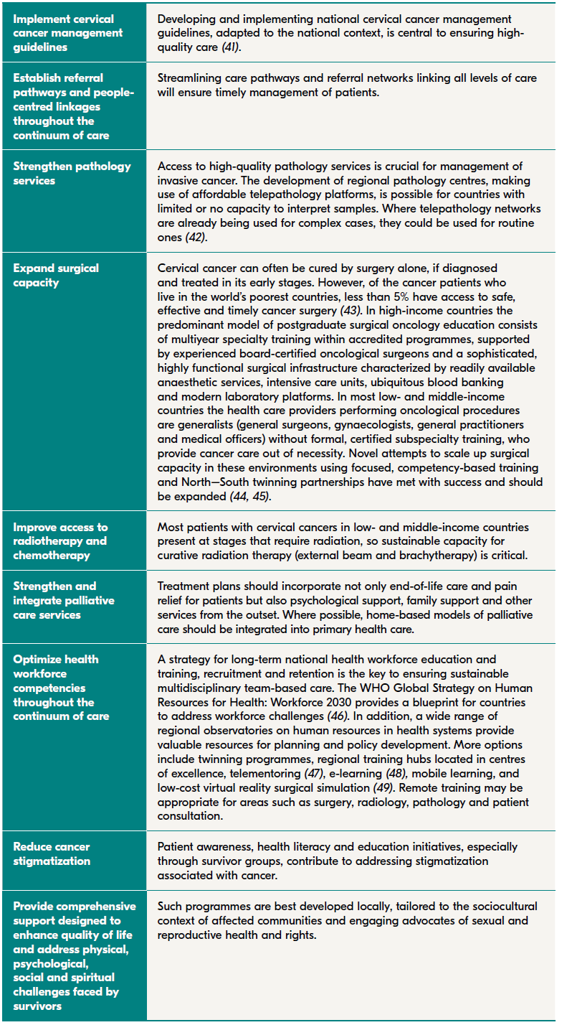

## Health system enablers

The WHO global strategy to accelerate the elimination of cervical cancer as a public health problememphasises the importance of primary care as the preferred entry point for cervical cancer prevention initiatives.

The strategy notes: “Cervical cancer programs should be situated within a holistic approach to health systems that is people centred and responsive to the needs of women across the life course.” (2)

The strategy recommends integration of cervical cancer services rather than siloing within individual health programs.

### Review of local applicability of WHO recommended priority actions to strengthen health systems

Table 12 shows the WHO strategy’s nine priority actions to strengthen health systems.

These should be considered in the local context when developing Australia’s elimination strategy.

Many of these actions align with elements of existing Australian national strategies, activities or known areas requiring action, as detailed below.

**Reinforce primary health care-oriented models of care**

* Australia’s Primary Health Care 10-Year Plan 2022–2032 (140).
* A national nursing strategy is under development (141).

**Invest in the primary health care workforce**

* Australia’s Primary Health Care 10-Year Plan 2022–2032.
* Aboriginal and Torres Strait Islander Health Curriculum Framework.
* National Medical Workforce Strategy 2021–2031, especially Priority 4: Build the generalist capability of the medical workforce (142).

**Improve access to medicines and other health products**

* Ongoing reforms as part of the Australian Government Response to the Review of Medicines and Medical Devices Regulation (MMDR) in September 2016, including streamlining of regulatory approvals (143)

**Reduce cancer stigmatisation**

* Australia has high-profile cancer councils, which undertake a range of patient support, education and advocacy functions, as well as support groups for patients and carers.

Table 12. WHO strategy’s nine priority actions to strengthen health systems

**Engage with private sector providers**

* Cancer services are available across both the public and private health care sectors in Australia.
* However, a 2016 survey found that for-profit providers were significantly less likely to provide comprehensive cancer services. Providers identified that, across all geographical regions, the most pressing service gaps related to supportive care or survivorship services (3).

**Universal health coverage and protection from catastrophic costs**

* Medicare provides free or lower cost access to medical services by doctors, specialists and other health professionals, hospital treatments and prescription medicines.
* Many Australians also have private health insurance (44% had private hospital cover at June 2019), which frequently requires out-of-pocket gap payments when used (144).
* Out-of-pocket gap payments make up 17% of total expenditure on health care in Australia, which is above the OECD average (145).
* Cancer patients may experience high financial burdens from such costs (146, 147)
* A 2018 survey of people living with cancer in Australia found that over a quarter had incurred costs of more than $10,000 over the previous two years, and one in six reporting that the costs had a significant impact on their lives (148).
* There is evidence that out-of-pocket costs vary widely and are increasing over time (149, 150).

**Innovation and digital technologies for health**

* Australia’s National Digital Health Strategy is due to be renewed in 2022 (151).

**Systems for improving the quality of health care**

* The Australian Commission on Health and Safety provides leadership to improve the safety and quality of health care in Australia.
* Australia has eight National Safety and Quality Health Service Standards which health services are assessed against and must comply with to become accredited (152).
* Service standards include public and private hospitals, day procedure hospitals, private dental practices, transport and community health services.

**Data systems, monitoring and evaluation**

* As outlined in this report, Australia has high-quality cancer registers, a national cancer screening register and a national immunisation register – all of which provide important data for monitoring elimination efforts.
* Gaps for timely monitoring of progress towards elimination across the three elimination pillars remain.
* Gaps for monitoring the equity of elimination efforts for all population groups will need to be addressed in the national strategy.
* Australia’s HPV surveillance strategy is due for updating (47).

## Partnerships, advocacy and communications

### Partnerships

The WHO strategy will be implemented with the aid of high-level global partnerships coordinated by WHO including global institutions, development partners, and multilateral and bilateral entities.

Partnerships with academic institutions and professional associations are needed to support capacity building, skill transfer and strengthening of existing relationships between countries of differing resource levels.

Uptake of services at the local level will depend upon successful partnerships with a wide range of local networks, women’s groups, NGOs and civil society. Innovative ways to find these partnerships are required.

### Multisectoral collaboration

WHO emphasises the need to work beyond the health sector to achieve a shared vision of the elimination targets.

Strong government leadership is required to engage health, education, finance and labour portfolios to*:* “Work closely with women, communities, civil society, young people, the media, the private sector, development partners, health professionals’ associations, patients’ groups and other stakeholders to achieve cervical cancer targets.” (2)

In line with the sustainable development goals, the importance of cross-sectoral regional and international partnerships is also emphasised to support the human rights of girls and women.

Between-country regional partnerships should support knowledge exchange and skills building.

### Advocacy and communication

Globally advocacy efforts are centred around securing health financing, prioritising the health of girls and women and reinforcing the connection between health and development.

At the national and local levels, governments should create enabling environments for demand creation to reduce barriers to care led by NGOs, civil society and consumer groups.

Digital communication and social media have enhanced the speed and scope of communication to consumers.

The strategy requires: “Agile and responsive systems that are able to drive comprehensive, robust and proactive communication to promote the uptake of appropriate interventions, to counter misinformation, and to address vaccine hesitancy and the rising anti-vaccine movement.” (2)

Culturally relevant and context-specific nationally consistent content should support communication and advocacy for cervical cancer elimination at all levels of the health system.

The strategy recommends the strategic use of media platforms, opinion leaders, influencers, traditional and faith leaders, and patient advocates to increase access to information.

### Review of local applicability of WHO perspective on partnerships, advocacy and communication

To best implement an evidence-informed strategy for Australia, partnerships will be necessary between:

* government
* NGOs
* academic institutions
* professional associations
* peak bodies
* consumer organisations
* the health sector (including for-profit organisations)
* local networks.

Input from these bodies and from civil society in developing the strategy is also important.

Collaboration and strong partnerships beyond the health sector, and into the region, would best support the effective development and implementation of the strategy.

Such partnerships would ensure Australia’s expertise and experience in cervical cancer prevention and control supports neighbouring countries’ work towards control and elimination.

Communication within the health system, and advocacy and communication across the community, will be important to promote the visibility and ownership of the national strategy across professional groups, the health sector and the community.

Reaching harder to reach populations, including those with differing barriers to participation in screening, vaccination and treatment, will require specific, evidence informed and tailored communication strategies.

Ongoing vigilance is required in relation to antivaccination misinformation regarding HPV vaccination programs.

## Surveillance, monitoring and evaluation

The final section of the WHO strategy makes recommendations around the importance of monitoring and evaluation of the strategy.

The WHO strategy notes: “It is fundamental that robust surveillance and monitoring systems are developed at the national or subnational level, both to determine the baseline and to monitor and evaluate the impact of the broad interventions and activities implemented as part of the cervical cancer elimination strategy.” (2)

The strategy distinguishes data collection through population-based surveillance versus program monitoring. A proposed framework is given in Figure 30.

Figure 30. WHO surveillance and monitoring for the elimination initiative

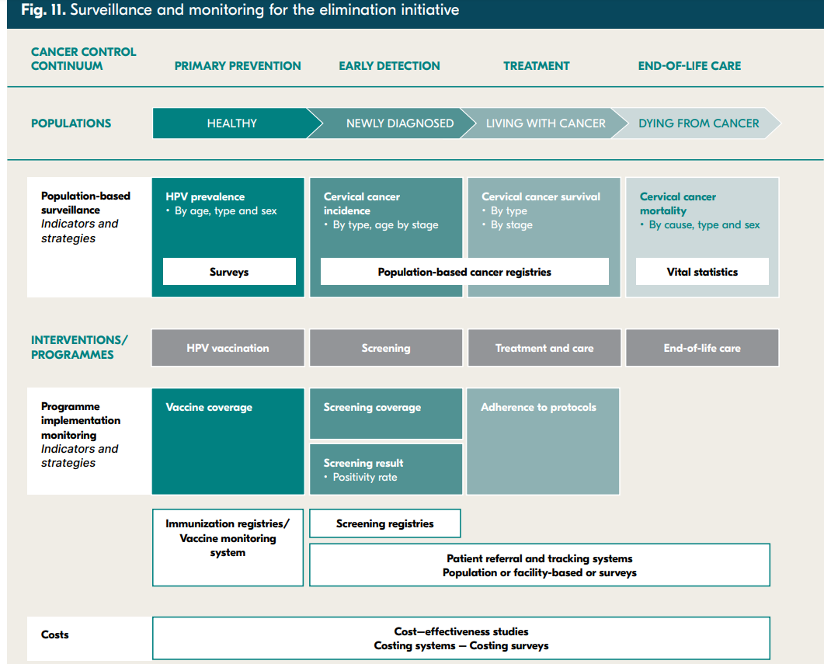

Three indicators are considered essential to be determined using population-based surveillance:

* cervical cancer incidence
* cervical cancer survival
* cervical cancer mortality.

These should be supplemented where possible with HPV prevalence monitoring. The strategy notes the fundamental importance of population-based cancer registries and vital registration.

Program monitoring is required to monitor the quality and coverage of the implemented strategies.

Program monitoring is challenging, due to the complexities of:

* monitoring primary through to tertiary prevention measures
* tracking individuals across the continuum of care using information systems.

The WHO recommends the following key indicators:

**Performance indicators**

* HPV vaccination coverage by age at vaccination and number of doses
* Screening rate of women aged 30–49: Percentage of women who screened for the first time in the previous 12-month period
* Positivity rate: Percentage of screened women aged 30–49 with a positive screening test in the previous 12-month period
* Treatment rate: Percentage of screening test-positive women receiving treatment in the previous 12-month period

**Result indicator**

* Coverage rate: Percentage of women aged 30–49 who have been screened with a high-performance test at least once between ages 30–49 and the percentage screened at least twice

**Impact indicators**

* Cervical cancer age-specific incidence
* Cervical cancer age-specific mortality

### Review of local applicability of WHO recommendations and strategic actions for monitoring and evaluation

As outlined in the earlier sections of this report, Australia’s current elimination strategy indicators (as developed by the NHMRC CRE for Cervical Cancer Control) incorporate the recommended WHO indicators. (1)

Australia’s elimination strategy indicators also go beyond WHO indicators by adding:

* the additional indicators of precancer detection rate (rather than screening positivity rate alone)
* participation measures specific to Australia’s screening program
* an additional measure relating to diagnostic assessment (proportion of women who attend colposcopy and its timeliness).

However, as noted in earlier sections of the report:

* there are no data available to report against some of the indicators, most notably the WHO indicators of precancer and cancer treatment rates
* there is a lack of data available to report many indicators by important subpopulations of interest to determine equity in effective delivery of programs and outcomes.

The WHO strategic actions for monitoring and evaluation, listed below, need to be considered and incorporated into the development of Australia’s elimination strategy.

1. Strengthen governance and accountability of programmes related to cervical cancer and conduct regular reviews to help ensure that national strategies, plans and resource allocations reflect actual country needs.
2. Set country-specific targets, milestones and indicators for monitoring and evaluating the national cervical cancer elimination programme – data on progress towards these objectives should be used to regularly report on the impact of the various interventions being carried out in a country and adjust programme interventions as necessary.
3. Develop or improve population-based cancer registries to inform national cervical cancer elimination programmes and help to track progress towards the goal of elimination.
4. Track patients throughout the continuum of services to ensure that women and girls in need are being successfully treated.
5. Work towards disaggregation of data by equity stratifiers to enable detection of differences across population segments and set equity-oriented targets.

# SYNTHESIS

This analysis has assessed the current situation in relation to cervical cancer prevention and control activities and outcomes in Australia. Available Australian data has been reviewed against elimination indicators, supplemented with currently available research and policy evidence.

The analysis explicitly considered the three elimination pillars, alongside the strategic actions recommended as part of the WHO global elimination strategy.

Strengths and gaps in our current prevention programs and treatment systems, and our ability to measure and monitor these, have been identified.

Identifying these strengths and gaps informs the scope of issues and specific policy questions to be considered during the development of Australia’s national elimination strategy.

## Strategic summary of data issues and gaps

The most significant data challenge identified for each pillar include:

* **Overall strategy and outcome indicators:** Lack of timeliness in national cancer data to inform the monitoring of the elimination target (incidence less than 4 per 100,000)
* **Vaccination pillar:** Lack of national immunisation coverage data for subpopulations of interest, with the notable exception of Aboriginal and Torres Strait Islander people
* **Screening and precancer treatment pillar**: Lack of any data on precancer treatment rates
* **Treatment pillar:** Lack of national data on cervical cancer treatment rates.

### Key data issues arising across the elimination pillars

The analysis identified a lack of national data across the vaccination, screening and treatment pillars for populations of interest to ensure equity in access, participation and outcomes.

These groups include people living with a disability, culturally and linguistically diverse populations, LGBTQI+ people, and people at higher medical risk from HPV.

No data was available for particularly vulnerable population groups, such as refugees, prisoners or people experiencing homelessness.

With the notable exception of vaccination data, there was a lack of national data to report program indicators or outcomes for Aboriginal and Torres Strait Islander people.

This is despite many years of advocacy, investigation into and proposal of solutions to address this critical data gap.

## Strategic summary of equity issues and gaps

The most significant equity challenges identified for each pillar include:

* **Overall strategy and outcome indicators:** Aboriginal and Torres Strait Islander women have 3.5 times the mortality rate from cervical cancer as other Australians, as estimated from subnational data (noting reporting of Indigenous status is not of sufficient quality in the remaining three jurisdictions)
* **Vaccination pillar:** Recognising that Australia has a both-sex vaccination program, Indigenous males have persistently lower coverage with a completed HPV vaccination course than non-Indigenous males, and Indigenous and non-Indigenous females
* **Screening and precancer treatment pillar**: Available research data (no national or subnational program data are available) consistently suggest substantially lower screening participation amongst Aboriginal and Torres Strait Islander people.
* **Treatment pillar:** Available data suggest that there are structural and cultural barriers to quality care for Aboriginal and Torres Strait Islander patients, including racism.

### Key equity issues arising across the elimination pillars

The major challenge to identifying equity gaps across the pillars and outcome measures was the lack of data.

Data is lacking to assess the participation, outcomes and experiences of population subgroups, including people living with a disability, culturally and linguistically diverse populations, LGBTQI+ people, and people at higher medical risk from HPV.

Available data across all pillars suggests inequity across programs and services for Aboriginal and Torres Strait Islander people.

## Strategic summary of research and policy issues and gaps

The most significant research and policy questions identified for each pillar include:

* **Overall strategy and outcome indicators:** How can the cervical cancer incidence and mortality gap for Aboriginal and Torres Strait Islander people, people living in very remote areas, the most socioeconomically disadvantaged and in the Northern Territory be most rapidly and effectively closed?
* **Vaccination pillar:** Is available evidence sufficient to support the effectiveness and cost-effectiveness of a one-dose HPV vaccine schedule in Australia?
* **Screening and precancer treatment pillar**: How can we monitor the precancer treatment rate in Australia and understand and address barriers to accepting and receiving further investigations and treatment after a positive screening test?
* **Treatment pillar:** How can we assess whether patients are currently experiencing appropriate, culturally safe treatment and optimal care for cervical cancer in Australia? What are the current barriers to receiving such care?

### Key research and policy issues arising across the elimination pillars

How can equity in elimination programs, services and outcomes be best delivered and monitored across Australia’s diverse population?

# APPENDICES

## Appendix A: National Cervical Screening Program Pathway

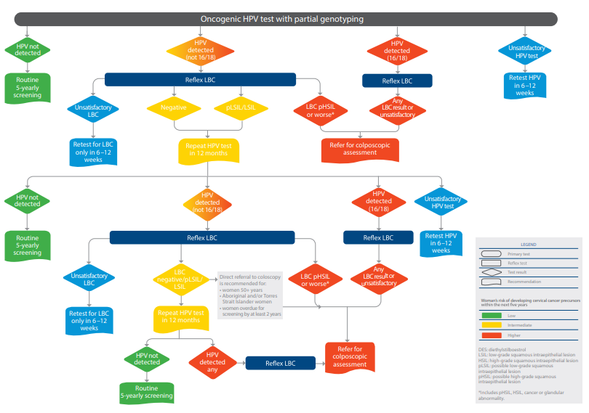

Source: National Cervical Screening Program: Guidelines for the management of screen-detected abnormalities, screening in specific populations and investigation of abnormal vaginal bleeding (153).

## Appendix B: Alignment to existing national targets and strategies

There are several existing national strategies and related targets that align with the cervical cancer elimination agenda. These are summarised in Table 13.

Table 13. Existing national strategies and relevant frameworks for the cervical cancer elimination strategy

|  |  |
| --- | --- |
| Strategy | Relevant targets |
| National Preventive Health Strategy 2021–2030 (154) | **Aim 2:** All Australians live in good health and wellbeing for as long as possible  **Target:** Australians will have at least an additional two years of life lived in full health by 2030  **Aim 3.** Health equity is achieved for priority populations  **Target:** Australians in the two lowest SEIFA quintiles will have at least an additional three years of life lived in full health by 2030  **Target:** Australians in regional and remote areas will have at least an additional three years of life lived in full health by 2030  **Target:** Aboriginal and Torres Strait Islander people will have at least an additional three years of life lived in full health by 2030  **Aim 4.** Investment in prevention is increased  **Underpinned by:** Investment in preventive health will rise to be 5% of total health expenditure across Commonwealth, state and territory governments by 2030  **Focus Area:** Increasing cancer screening and prevention  **Target**: Increase participation rates for cervical screening to at least 64% by 2025  **Target:** Eliminate cervical cancer as a public health issue in Australia by 2035  **Focus Area:** Improving immunisation coverage  **Target:** HPV immunisation rate increased to at least 85% for both boys and girls by 2030 |
| National Women’s Health Strategy 2020–2030 (155) | **Priority area 1: Maternal, sexual and reproductive health**  1. Increase access to sexual and reproductive health care information, diagnosis, treatment and services:   * Promote access to resources for students and parents to learn more about sexual and reproductive health * Improve access to information, screening services, self-education and self-management tools to encourage self-informing and help-seeking behaviours in relation to women’s sexual and reproductive health * Remove barriers to support equitable access to timely, appropriate and affordable care for all women, including culturally and linguistically sensitive and safe care * Strengthen access pathways to sexual and reproductive health services across the country, particularly in rural and remote areas     **Priority area 3: Chronic conditions and preventive health**   1. Increase awareness and primary prevention of chronic conditions and associated risk factors for women and girls and embed a life course approach in policy and practice:  * Empower women and girls to better prevent illness and manage their own health care needs  1. Invest in targeted prevention, timely detection and intervention of chronic conditions affecting women and girls:  * Increase access to, and promote uptake of, cancer screening and immunisation programs, particularly among identified priority populations * Improve the diagnosis and treatment of cancers predominantly affecting women  1. Tailor health services to meet the needs of all women and girls:  * Apply a gendered approach to tailor programs, interventions and initiatives to women, with the aim of increasing health literacy to enable self-advocacy and empowerment of women * Ensure health policy development for women and girls addresses the needs of priority populations * Allocate specific, sustainable funding for women’s health programs and services * Support educational, advocacy and support networks, providing information on available services and helping women and girls navigate the health system * Provide holistic, affordable and integrated care for women and girls with chronic conditions   **Key measures of success**   * Lower incidence of cancers − Improved rates of breast, cervical and bowel cancer screening for under-screened populations, including women from Aboriginal and Torres Strait Islander, culturally and linguistically diverse, rural and remote and LGBTQI+ communities |
| Optimal Care Pathway for Cervical Cancer (18) | Several nationally endorsed optimal timeframes related to cervical cancer prevention and treatment include:  **Care point 2.1**: **Assessments by the general or primary medical practitioner.**   * Screening test results should be available and the woman reviewed by the GP within 30 days.   **Care point 2.2: Referral to a specialist.**   * Women with a positive oncogenic HPV (any type) test result and reflex liquid-based cytology (LBC) report of invasive cancer should have a specialist appointment with a gynaecological oncologist within two weeks of the suspected diagnosis. * Women with a positive oncogenic HPV (16/18) test result and reflex LBC prediction of any abnormality should be referred for a colposcopic assessment within eight weeks. * Women with a positive oncogenic HPV (not 16/18) test result, with an LBC prediction of pHSIL/HSIL or any glandular abnormality, should be referred for a colposcopic assessment within eight weeks. * Women with a suspected diagnosis of cervical cancer (symptomatic, abnormal cervix) should have a specialist appointment with a gynaecological oncologist within two weeks of the suspected diagnosis.   **Care point 3.1:** **Diagnostic work-up.**   * For obvious abnormalities, a colposcopy within two weeks of referral. * Diagnostic investigations should be completed within two weeks of specialist review.   **Care point 3.3.1: The optimal timing for MDT planning.**   * All newly diagnosed women should be discussed in a MDT meeting so a treatment plan can be recommended.   **Care point 4.2.1:** **Surgery for primary disease.**   * Treatment should begin within four weeks of the decision to treat.   **Care point 4.2.2: Radiation therapy.**   * Treatment should begin within four weeksof the decision to treat.   **4.2.3 Chemotherapy.**   * Treatment should begin within four weeks of the decision to treat. |
| Australian Cancer Plan – under development | The Australian Cancer Plan will be a 10-year plan for national action, with two, five and ten-year goals to achieve its vision for world class cancer outcomes and experience for all Australians.  The plan, to be published in April 2023, will set out key objectives and priority areas for action including improvements in prevention, early diagnosis, treatment, survivorship, supportive and palliative care, while providing for the unique needs of specific cancer types and populations. |
| Optimal Care Pathway for Aboriginal and Torres Strait Islander people with cancer (156) | Each optimal care pathway, including the optimal care pathway for cervical cancer, is underpinned by principles such as multidisciplinary care and care coordination.  The optimal care pathway for Aboriginal and Torres Strait Islander people with cancer incorporates additional concepts to support the delivery of culturally appropriate and responsive cancer care.  It is accompanied by “A guide to implementing the optimal care pathway for Aboriginal and Torres Strait Islander people with cancer” which suggests activities to support implementation of the optimal care pathway at different levels of the health system. (157) |
| Australia’s Disability Strategy 2021–2031 (158) | **Outcome:**   * People with disability attain the highest possible health and wellbeing outcomes throughout their lives.   **Policy priorities:**   * All health service providers have the capabilities to meet the needs of people with disability. * Prevention and early intervention health services are timely, comprehensive, appropriate and effective to support better overall health and wellbeing. |
| National Aboriginal and Torres Strait Islander Health Plan 2013–2023 (159) | **Overarching goal: Equality of health status and life expectancy between Aboriginal and Torres Strait Islander people and non-Indigenous Australians by 2031**  Goals:   1. All health care, whether government, community or private, is free of racism. 2. The health system delivers clinically appropriate care that is culturally safe, high quality, responsive and accessible for all Aboriginal and Torres Strait Islander people. 3. Health policies and programs are clearly evidence-based and informed by robust health research and data systems. 4. The capabilities, potential and aspirations of Aboriginal and Torres Strait Islander people are realised and optimise their contribution as individuals to the health workforce and to strategies to achieve Aboriginal and Torres Strait Islander wellbeing. Institutional and organisational structures and processes harness human and community capability and enhance its potential. 5. Aboriginal and Torres Strait Islander people are as healthy as non-Indigenous people and enjoy the same life expectancy by 2031 6. Aboriginal and Torres Strait Islander youth get the services and support they need to thrive and grow into healthy young adults. 7. Aboriginal and Torres Strait Islander adults have the health care, support and resources to manage their health and have long, productive lives. 8. Older Aboriginal and Torres Strait Islander people can live out their lives as active, healthy, culturally secure and comfortably as possible. |
| Aboriginal and Torres Strait Islander Health Curriculum Framework (160) | The Aboriginal and Torres Strait Islander Health Curriculum Framework supports higher education providers (HEPs) to implement Aboriginal and Torres Strait Islander health curricula across their health professional training programs.  Developed with extensive input and guidance from a wide range of stakeholders around Australia, the Framework aims to prepare graduates across health professions to provide culturally safe health services to Aboriginal and Torres Strait Islander peoples through the development of cultural capabilities during their undergraduate training. |
| Closing the Gap (161) | **Target 1: Everyone enjoys long and healthy lives**   * **Outcome:** Aboriginal and Torres Strait Islander people enjoy long and healthy lives. * **Target:** Close the gap in life expectancy within a generation, by 2031.   **Target 17: People have access to information and services enabling participation in informed decision-making regarding their own lives**   * **Outcome:** Aboriginal and Torres Strait Islander people have access to information and services enabling participation in informed decision-making regarding their own lives. * **Target:** By 2026, Aboriginal and Torres Strait Islander people have equal levels of digital inclusion. |
| Fourth National Sexually Transmissible Infections Strategy 2018–2022 (162) | **Target 1:** Achieve and maintain HPV adolescent vaccination coverage of 80% by the end of 2022. |
| National Palliative Care Strategy 2018 (163) | Broad alignment with all overarching goals, including:   * Understanding * Capability * Access and choice * Collaboration * Investment * Data and evidence * Accountability |
| Implementation Plan for the National Palliative Care Strategy 2018 (164) | **Action area 1:** Access to palliative care is increased, particularly for underserved populations.  **Action area 2:** The collaboration and coordination of palliative care is improved.  **Action area 4:** Nationally consistent data collection mechanisms are implemented, and national public reporting is underway. |
| National Immunisation Strategy for Australia 2019 to 2024 (72) | **Strategic priority 1**: Improve immunisation coverage  **Strategic priority** 2: Ensure effective governance of the NIP  **Strategic priority 3**: Ensure secure vaccine supply and efficient use of vaccines for the NIP  **Strategic priority 4:** Continue to enhance vaccine safety monitoring systems  **Strategic priority 5:** Maintain and ensure community confidence in the NIP through effective communication strategies  **Strategic priority 6:** Strengthen monitoring and evaluation of the NIP through assessment and analysis of immunisation register data and vaccine-preventable disease surveillance  **Strategic priority 7**: Ensure an adequately skilled immunisation workforce through promoting effective training for immunisation providers |
| National Framework for Gynaecological Cancer Control (2016) (25) | Alignment with all overarching priority areas, particularly for the treatment pillar including:  **Priority Area One:** Enhancing the centralised model of treatment planning  **Priority Area Two:** Improving outcomes for Aboriginal and Torres Strait Islander women  **Priority Area Three:** Promoting a holistic approach to person-centred care  **Priority Area Four:** Developing sustainable models of care  **Priority Area Five:** Enhancing health promotion and public awareness  **Priority Area Six:** Targeting research funding |
| Australia’s Primary Health Care 10 Year Plan 2022–2032 (140) | Limited reference to HPV and cervical screening but broad alignment.  The plan identifies 12 action areas that are grouped under three reform streams:   * future focused primary health care. * person-centred primary health care supported by funding reform. * integrated care, locally delivered. |
| National Medical Workforce Strategy 2021–2031 (142) | The strategy does not list targets but has identified 25 actions that sit under the five priority areas of:   * collaboration on planning and design * rebalance supply and distribution * reform the training pathway * building the generalist capability of the medical workforce * flexible and responsive medical workforce.   In addition, three other cross-cutting issues are:   * supporting the Aboriginal and Torres Strait Islander workforce and improving cultural safety * changing models of care * doctor wellbeing. |
| State-based cancer plans | * The Victorian Cancer Plan 2020–2024 (165) * NSW Cancer Plan (2022–2027)(166) * South Australian state-wide Cancer Control Plan 2011-2015 (167); Current plan under development * The South Australian Aboriginal Cancer Control Plan 2016–2021 (168) * Northern Territory Cancer Care Strategy 2018–2022 (169) * Tasmanian Cancer Framework and Strategic Cancer Plan 2010–2013 (170) * Queensland Cancer Screening Strategic Framework 2019–2026 (171) * WA Cancer Plan 2020–2025 (172) |
| National Aboriginal and Torres Strait Islander Health Workforce Strategic Framework and Implementation Plan 2021–2031 (173) | There is no specific mention of cervical screening, HPV vaccination or treatment.  However, the plan’s vision broadly aligns with the current strategy: “Aboriginal and Torres Strait Islander peoples enjoy long, healthy lives that are centred in culture, with access to services that are prevention-focussed, responsive, culturally safe and free of racism and inequity.”  The National Workforce Plan’s target is out of scope for the national cervical cancer elimination project (Aboriginal and Torres Strait Islander people represent 3.43% of the national health workforce by 2031). |

# REFERENCES

1. NHMRC Centre of Research Excellence in Cervical Cancer Control. 2021 Cervical Cancer Elimination Progress Report: Australia’s progress towards the elimination of cervical cancer as a public health problem. Published online 26/3/2021, Melbourne, Australia, at <https://www.cervicalcancercontrol.org.au>
2. World Health Organization. Global strategy to accelerate the elimination of cervical cancer as a public health problem. Geneva: World Health Organization; 2020. Available at: <https://www.who.int/publications/i/item/9789240014107>
3. Hunter J, Smith C, Delaney GP, Templeman K, Grant S, Ussher JM. Coverage of cancer services in Australia and providers' views on service gaps: findings from a national cross-sectional survey. BMC Cancer. 2019;19(1):570.
4. Brisson M, Kim JJ, Canfell K, Drolet M, Gingras G, Burger EA, et al. Impact of HPV vaccination and cervical screening on cervical cancer elimination: a comparative modelling analysis in 78 low-income and lower-middle-income countries. Lancet. 2020;395(10224):575-90.
5. Hall MT, Simms KT, Lew JB, Smith MA, Brotherton JM, Saville M, et al. The projected timeframe until cervical cancer elimination in Australia: a modelling study. Lancet Public Health. 2019;4(1):e19-e27.
6. Brotherton JML, Tabrizi SN, Phillips S, Pyman J, Cornall AM, Lambie N, et al. Looking beyond human papillomavirus (HPV) genotype 16 and 18: Defining HPV genotype distribution in cervical cancers in Australia prior to vaccination. Int J Cancer. 2017;141(8):1576-84.
7. Gertig DM, Brotherton JM, Saville M. Measuring human papillomavirus (HPV) vaccination coverage and the role of the National HPV Vaccination Program Register, Australia. Sex Health. 2011;8(2):171-8.
8. Brotherton JM, Liu B, Donovan B, Kaldor JM, Saville M. Human papillomavirus (HPV) vaccination coverage in young Australian women is higher than previously estimated: independent estimates from a nationally representative mobile phone survey. Vaccine. 2014;32(5):592-7.
9. Australian Government Department of Health. Human papillomavirus (HPV) immunisation service. Updated 26 September 2019. Available at: <https://www.health.gov.au/health-topics/immunisation/immunisation-services/human-papillomavirus-hpv-immunisation-service#:~:text=The%20decision%20to%20immunise%20adults,immunisation%20provider%20under%20the%20NIP> [Accessed 28 April 2022]
10. Wnukowski-Mtonga P, Jayasinghe S, Chiu C, Macartney K, Brotherton J, Donovan B, et al. Scientific evidence supporting recommendations on the use of the 9-valent HPV vaccine in a 2-dose vaccine schedule in Australia. Commun Dis Intell . 2020;44.
11. Hull B HA, Dey A, Brotherton J, Macartney K, Beard F. Annual immunisation coverage report 2020. National Centre for Immunisation Research and Surveillance; 2021 Published 29 November 2021.
12. National Centre for Immunisation Research and Surveillance. Impact evaluation of Australian national human papillomavirus vaccination program. February 2021. <https://www.ncirs.org.au/sites/default/files/2021-11/Impact%20evaluation%20of%20national%20HPV%20vaccination%20program_February%202021%20Report_0.pdf>
13. National Centre for Immunisation Research and Surveillance. Evaluation of the National HPV program final report. 2014. <https://www.health.gov.au/resources/publications/evaluation-of-the-national-hpv-program-final-report>
14. Lew JB, Simms KT, Smith MA, Hall M, Kang YJ, Xu XM, et al. Primary HPV testing versus cytology-based cervical screening in women in Australia vaccinated for HPV and unvaccinated: effectiveness and economic assessment for the National Cervical Screening Program. Lancet Public Health. 2017;2(2):e96-e107.
15. Smith MA, Sherrah M, Sultana F, Castle PE, Arbyn M, Gertig D, et al. National experience in the first two years of primary human papillomavirus (HPV) cervical screening in an HPV vaccinated population in Australia: observational study. BMJ. 2022;376:e068582.
16. Arbyn M, Smith SB, Temin S, Sultana F, Castle P. Detecting cervical precancer and reaching underscreened women by using HPV testing on self samples: updated meta-analyses. BMJ. 2018;363:k4823.
17. Cancer Council Victoria. Optimal Care Pathways. Updated November 2021. Available at <https://www.cancervic.org.au/for-health-professionals/optimal-care-pathways> [Accessed 29 April 2022]
18. Cancer Australia. Optimal Care Pathway for women with cervical cancer. January 2020. Available at <https://www.cancer.org.au/assets/pdf/cervical-cancer-optimal-cancer-care-pathway> [Accessed 29 April 2022]
19. eviQ. Radiation Oncology – Gynaecological. NSW Government. Available at <https://www.eviq.org.au/radiation-oncology/gynaecological> [Accessed 29 April 2022]
20. eviQ. Gynaelogical Medical Oncology – Cervical. NSW Government. Available at <https://www.eviq.org.au/medical-oncology/gynaecological/cervical> [Accessed 29 April 2022]
21. Gynaecological Oncology Network. Gynaecological cancer: A guide to clinical practice in NSW. V1; ACI_0161 [05/19] ed: NSW Government; 2019.
22. Gynaecological Oncology Working Party of the Statewide Cancer Clinical Network. South Australian Gynaecological Cancer Care Pathway Optimising Outcomes for Women with Gynaecological Cancer. Department of Health, Government of South Australia. October 2011.
23. Gynaecology Oncology Radiation Oncology Collaborative (GOROC). Gynaecology Oncology Radiation Oncology Collaborative (GOROC) Position Paper on Image Guided Brachytherapy (IGBT) for Cervical Cancer. NSW: The Royal Australian and New Zealand College of Radiologists, 2017.
24. Cancer Australia. Management of women with stage IB2 cervical cancer with treatments other than chemoradiotherapy: A summary of the evidence. Canberra: 2015.
25. Cancer Australia. National Framework for Gynaecological Cancer Control. Cancer Australia, Surry Hills NSW 2016.
26. Radiation Oncology Tripartite Committee. Planning for the Best: Tripartite National Strategic Plan for Radiation Oncology 2012-2022, version 1. NSW: The Royal Australian and New Zealand College of Radiologists, 2012.
27. Yu XQ, Feletto E, Smith MA, Yuill S, Baade PD. Cancer incidence in migrants in Australia: patterns of three infection-related cancers. Cancer Epidemiol Biomarkers Prev. 2022 Mar 23:cebp.1349.2021. doi: 10.1158/1055-9965.EPI-21-1349.
28. Victorian Cancer Registry. Cancer in Victoria: Statistics & Trends 2019. Melbourne, Victoria: Cancer Council Victoria, 2020.
29. Australian Institute of Health and Welfare. National Cervical Screening Program monitoring report 2021. Cancer series 134. Cat. no. CAN 141. Canberra: AIHW, 2021.
30. Australian Institute of Health and Welfare 2020. National Cervical Screening Program monitoring report 2020. Cancer series 130. Cat. no. CAN 138. Canberra: AIHW, 2020.
31. Whop LJ, Baade P, Garvey G, Cunningham J, Brotherton JM, Lokuge K, et al. Cervical abnormalities are more common among Indigenous than other Australian women: a retrospective record-linkage study, 2000-2011. PLoS One. 2016;11(4):e0150473.
32. Li M, Roder D, Whop LJ, Diaz A, Baade PD, Brotherton JM, et al. Aboriginal women have a higher risk of cervical abnormalities at screening; South Australia, 1993-2016. J Med Screen. 2019;26(2):104-12.
33. Australian Institute of Health and Welfare 2019. Analysis of cervical cancer and abnormality outcomes in an era of cervical screening and HPV vaccination in Australia. Cancer series no. 126. Cat. no. CAN 129. Canberra: AIHW.
34. Brotherton JM, Budd A, Rompotis C, Bartlett N, Malloy MJ, Andersen RL, et al. Is one dose of human papillomavirus vaccine as effective as three?: A national cohort analysis. Papillomavirus Res. 2019;8:100177.
35. Crowe E, Pandeya N, Brotherton JM, Dobson AJ, Kisely S, Lambert SB, et al. Effectiveness of quadrivalent human papillomavirus vaccine for the prevention of cervical abnormalities: case-control study nested within a population based screening programme in Australia. BMJ. 2014;348:g1458.
36. Gertig DM, Brotherton JM, Budd AC, Drennan K, Chappell G, Saville AM. Impact of a population-based HPV vaccination program on cervical abnormalities: a data linkage study. BMC Med. 2013;11:227.
37. Brotherton JML, Malloy M, Budd AC, Saville M, Drennan KT, Gertig DM. Effectiveness of less than three doses of quadrivalent human papillomavirus vaccine against cervical intraepithelial neoplasia when administered using a standard dose spacing schedule: Observational cohort of young women in Australia. Papillomavirus Res. 2015;1:59-73.
38. Brotherton JML, Hawkes D, Sultana F, Malloy MJ, Machalek DA, Smith MA, et al. Age-specific HPV prevalence among 116,052 women in Australia’s renewed cervical screening program: A new tool for monitoring vaccine impact. Vaccine. 2019;37(3):412-6.
39. Tabrizi SN, Brotherton JM, Kaldor JM, Skinner SR, Cummins E, Liu B, et al. Fall in human papillomavirus prevalence following a national vaccination program. J Infect Dis. 2012;206(11):1645-51.
40. Tabrizi SN, Brotherton JM, Kaldor JM, Skinner SR, Liu B, Bateson D, et al. Assessment of herd immunity and cross-protection after a human papillomavirus vaccination programme in Australia: a repeat cross-sectional study. Lancet Infect Dis. 2014;14(10):958-66.
41. Machalek D, Garland S, Brotherton J, Bateson D, McNamee K, Stewart M, et al. Very low prevalence of vaccine human papillomavirus (HPV) types among 18 to 35 year old Australian women, nine years following implementation of vaccination. J Infect Dis. 2018;217.
42. Garland SM, Cornall AM, Brotherton JML, Wark JD, Malloy MJ, Tabrizi SN. Final analysis of a study assessing genital human papillomavirus genoprevalence in young Australian women, following eight years of a national vaccination program. Vaccine. 2018;36(23):3221-30.
43. McGregor S, Saulo D, Brotherton JML, Liu B, Phillips S, Skinner SR, et al. Decline in prevalence of human papillomavirus infection following vaccination among Australian Indigenous women, a population at higher risk of cervical cancer: The VIP-I study. Vaccine. 2018;36(29):4311-6.
44. Chow EPF, Tabrizi SN, Fairley CK, Wigan R, Machalek DA, Regan DG, et al. Prevalence of human papillomavirus in teenage heterosexual males following the implementation of female and male school-based vaccination in Australia: 2014-2017. Vaccine. 2019;37(46):6907-14.
45. Demarco M, Hyun N, Carter-Pokras O, Raine-Bennett TR, Cheung L, Chen X, et al. A study of type-specific HPV natural history and implications for contemporary cervical cancer screening programs. EClinicalMedicine. 2020;22:100293.
46. Shilling H, Murray G, Brotherton JML, Hawkes D, Saville M, Sivertsen T, et al. Monitoring human papillomavirus prevalence among young Australian women undergoing routine chlamydia screening. Vaccine. 2020;38(5):1186-93.
47. HPV Surveillance Working Group of the Communicable Diseases Network Australia. Human Papillomavirus (HPV) Surveillance Plan – an integrated approach to monitoring the impact of HPV vaccine in Australia. Communicable Diseases Network Australia: 2013. Available at <https://www1.health.gov.au/internet/main/publishing.nsf/Content/E5B543CE209E55C3CA257F48001D65EF/$File/HPV-Surveillance-Plan.pdf> [Accessed 30 April 2022]
48. Australian Bureau of Statistics. Multi-Agency Data Integration Project (MADIP). Available at <https://www.abs.gov.au/about/data-services/data-integration/integrated-data/multi-agency-data-integration-project-madip> [Accessed 29 April 2022]
49. Drolet M, Laprise JF, Martin D, Jit M, Bénard É, Gingras G, et al. Optimal human papillomavirus vaccination strategies to prevent cervical cancer in low-income and middle-income countries in the context of limited resources: a mathematical modelling analysis. Lancet Infect Dis. 2021;21(11):1598-610.
50. Brisson M, Bénard É, Drolet M, Bogaards JA, Baussano I, Vänskä S, et al. Population-level impact, herd immunity, and elimination after human papillomavirus vaccination: a systematic review and meta-analysis of predictions from transmission-dynamic models. Lancet Public Health. 2016;1(1):e8-e17.
51. Brotherton JM, Winch KL, Bicknell L, Chappell G, Saville M. HPV vaccine coverage is increasing in Australia. Med J Aust. 2017;206(6):262.
52. Basu P, Malvi SG, Joshi S, Bhatla N, Muwonge R, Lucas E, et al. Vaccine efficacy against persistent human papillomavirus (HPV) 16/18 infection at 10 years after one, two, and three doses of quadrivalent HPV vaccine in girls in India: a multicentre, prospective, cohort study. Lancet Oncol. 2021;22(11):1518-29.
53. Barnabas RV, Brown ER,, Onono MA, Bukusi EA, Njoroge B, et al. Efficacy of single-dose HPV vaccination among young African women. NEJM Evid 2022; 1 (5) DOI:https://doi.org/10.1056/EVIDoa2100056.
54. Watson M, Lynch J, D'Onise K, Brotherton J. Barriers to better three-dose coverage with HPV vaccination in school-based programs. Aust N Z J Public Health. 2014;38(1):91-2.
55. Staples C, Butler M, Nguyen J, Durrheim DN, Cashman P, Brotherton JML. Opportunities to increase rates of human papillomavirus vaccination in the New South Wales school program through enhanced catch-up. Sex Health. 2016;13(6):536-9.
56. Selvey LA, Roux F, Burns S. Potential process improvements to increase coverage of human papillomavirus vaccine in schools - A focus on schools with low vaccine uptake. Vaccine. 2020;38(14):2971-7.
57. Sisnowski J, Vujovich-Dunn C, Gidding H, Brotherton J, Wand H, Lorch R, et al. Differences in school factors associated with adolescent HPV vaccination initiation and completion coverage in three Australian states. Vaccine. 2021;39(41):6117-26.
58. Vujovich-Dunn C, Skinner SR, Brotherton J, Wand H, Sisnowski J, Lorch R, et al. School-level variation in coverage of co-administered dTpa and HPV dose 1 in three Australian States. Vaccines (Basel). 2021;9(10).
59. Mak DB, Bulsara MK, Wrate MJ, Carcione D, Chantry M, Efller PV. Factors determining vaccine uptake in Western Australian adolescents. J Paediatr Child Health. 2013;49(11):895-900.
60. Robbins SC, Bernard D, McCaffery K, Skinner SR. 'It's a logistical nightmare!' Recommendations for optimising human papillomavirus school-based vaccination experience. Sex Health. 2010;7(3):271-8.
61. Bernard DM, Cooper Robbins SC, McCaffery KJ, Scott CM, Skinner SR. The domino effect: adolescent girls' response to human papillomavirus vaccination. Med J Aust. 2011;194(6):297-300.
62. Cooper Robbins SC, Bernard D, McCaffery K, Brotherton J, Garland S, Skinner SR. "Is cancer contagious?": Australian adolescent girls and their parents: making the most of limited information about HPV and HPV vaccination. Vaccine. 2010;28(19):3398-408.
63. Robbins SC, Bernard D, McCaffery K, Brotherton JM, Skinner SR. "I just signed": Factors influencing decision-making for school-based HPV vaccination of adolescent girls. Health Psychol. 2010;29(6):618-25.
64. O'Neill J, Newall F, Antolovich G, Lima S, Danchin M. The uptake of adolescent vaccinations through the School Immunisation Program in specialist schools in Victoria, Australia. Vaccine. 2019;37(2):272-9.
65. Netfa F, King C, Davies C, Rashid H, Tashani M, Booy R, et al. Knowledge, attitudes, and perceptions of the Arabic-speaking community in Sydney, Australia, toward the human papillomavirus (HPV) vaccination program: a qualitative study. Vaccines (Basel). 2021;9(9).
66. Davies C, Marshall HS, Zimet G, McCaffery K, Brotherton JML, Kang M, et al. Effect of a school-based educational intervention about the human papillomavirus vaccine on psychosocial outcomes among adolescents: analysis of secondary outcomes of a cluster randomized trial. JAMA Network Open. 2021;4(11):e2129057-e.
67. Nyanchoga MM, Lee P, Barbery G. Exploring electronic health records to estimate the extent of catch-up immunisation and factors associated with under-immunisation among refugees and asylum seekers in south east Queensland. Vaccine. 2021;39(42):6238-44.
68. Kerr L, Fisher C, Jones T. TRANScending Discrimination in Health & Cancer Care: A Study of Trans & Gender Diverse Australians, (ARCSHS Monograph Series No. 115). Bundoora: ARCSHS, 2019.
69. Sutherland L, Feeney L, Samodurov K. A community perspective: on Human Papillomavirus (HPV)-related cancer among women and trans and gender diverse people. NSW: Positive Life NSW, 2019.
70. Skinner SR, Davies C, Cooper S, Stoney T, Marshall H, Jones J, et al. HPV.edu study protocol: a cluster randomised controlled evaluation of education, decisional support and logistical strategies in school-based human papillomavirus (HPV) vaccination of adolescents. BMC Public Health. 2015;15(1):896.
71. Davies C, Skinner SR, Stoney T, Marshall HS, Collins J, Jones J, et al. ‘Is it like one of those infectious kind of things?’ The importance of educating young people about HPV and HPV vaccination at school. Sex Education. 2017;17(3):256-75.
72. Tull F, Borg K, Knott C, Beasley M, Halliday J, Faulkner N, Sutton K, Bragge P. Short Message Service Reminders to Parents for Increasing Adolescent Human Papillomavirus Vaccination Rates in a Secondary School Vaccine Program: A Randomized Control Trial. J Adolesc Health. 2019 Jul;65(1):116-123. doi: 10.1016/j.jadohealth.2018.12.026.
73. Mak DB, Bulsara M, Goggin LS, Effler PV. Resending a consent form and information package to non-responders increases school-based consent return rate. Aust N Z J Public Health. 2011 Feb;35(1):89-90. doi: 10.1111/j.1753-6405.2010.00669.x
74. Australian Government Department of Health. National Immunisation Strategy for Australia 2019–2024. Canberra: Commonwealth of Australia, 2018.
75. Munro A, Spilsbury K, Leung Y, O'Leary P, Williams V, Codde J, et al. The human papillomavirus Test of Cure: A lesson on compliance with the NHMRC guidelines on screening to prevent cervical cancer. Aust N Z J Obstet Gynaecol. 2015;55(2):185-90.
76. Tan JHJ, Malloy MJ, Brotherton JML, Saville M. Compliance with follow-up Test of Cure and outcomes after treatment for high-grade cervical intraepithelial neoplasia in Victoria, Australia. Aust N Z J Obstet Gynaecol. 2020;60(3):433-7.
77. Whop LJ, Garvey G, Baade P, Cunningham J, Lokuge K, Brotherton JM, et al. The first comprehensive report on Indigenous Australian women's inequalities in cervical screening: A retrospective registry cohort study in Queensland, Australia (2000-2011). Cancer. 2016;122(10):1560-9.
78. Dasgupta P CS, Baade P, et al. Regional variation in cervical cancer screening participation & outcomes among Aboriginal and non-Aboriginal Australian women: New South Wales (2006-2013). Cancer Council Queensland; 2018.
79. Butler TL, Anderson K, Condon JR, Garvey G, Brotherton JML, Cunningham J, et al. Indigenous Australian women's experiences of participation in cervical screening. PLoS One. 2020;15(6):e0234536.
80. Whop LJ, Butler TL, Lee N, Cunningham J, Garvey G, Anderson K, et al. Aboriginal and Torres Strait Islander women's views of cervical screening by self-collection: a qualitative study. Aust N Z J Public Health. 2022;46(2):161-9.
81. Morgan DL, Slade MD, Morgan CM. Aboriginal philosophy and its impact on health care outcomes. Aust N Z J Public Health. 1997;21(6):597-601.
82. Kelaher MA, Ferdinand AS, Paradies Y. Experiencing racism in health care: the mental health impacts for Victorian Aboriginal communities. Med J Aust. 2014;201(1):44-7.
83. Mak D, Straton JA. Effects and sustainability of a cervical screening program in remote Aboriginal Australia. Aust N Z J Public Health. 1997;21(1):67-70.
84. Read CM, Bateson DJ. Marrying research, clinical practice and cervical screening in Australian Aboriginal women in western New South Wales, Australia. Rural Remote Health. 2009;9(2):1117.
85. Panaretto KS, Dallachy D, Manessis V, Larkins S, Tabrizi S, Upcroft J, et al. Cervical smear participation and prevalence of sexually transmitted infections in women attending a community-controlled Indigenous health service in north Queensland. Aust N Z J Public Health. 2006;30(2):171-6.
86. Dutton T, Marjoram J, Burgess S, Montgomery L, Vail A, Callan N, et al. Uptake and acceptability of human papillomavirus self-sampling in rural and remote Aboriginal communities: evaluation of a nurse-led community engagement model. BMC Health Serv Res. 2020;20(1):398.
87. McLachlan E, Anderson S, Hawkes D, Saville M, Arabena K. Completing the cervical screening pathway: Factors that facilitate the increase of self-collection uptake among under-screened and never-screened women, an Australian pilot study. Curr Oncol. 2018;25(1):e17-e26.
88. Saville M, Hawkes D, McLachlan E, Anderson S, Arabena K. Self-collection for under-screened women in a National Cervical Screening Program: pilot study. Curr Oncol. 2018;25(1):e27-e32.
89. Alam Z, Shafiee Hanjani L, Dean J, Janda M. Cervical cancer screening among immigrant women residing in Australia: a systematic review. Asia Pac J Public Health. 2021;33(8):816-27.
90. Anaman JA, Correa-Velez I, King J. A survey of cervical screening among refugee and non-refugee African immigrant women in Brisbane, Australia. Health Promot J Austr. 2017;28(3):217-24.
91. Anderson de Cuevas RM, Saini P, Roberts D, Beaver K, Chandrashekar M, Jain A, et al. A systematic review of barriers and enablers to South Asian women’s attendance for asymptomatic screening of breast and cervical cancers in emigrant countries. BMJ Open. 2018;8(7):e020892.
92. Alam Z, Deol H, Dean JA, Janda M. Reasons behind low cervical screening uptake among South Asian immigrant women: a qualitative exploration. Int. J. Environ. Res. Public Health 2022, 19,1527. <https://doi.org/10.3390/ijerph19031527>
93. Alam Z, Dean J, Janda, M. What do South Asian immigrant women know about HPV, cervical cancer and its early detection: A cross-sectional Australian study. J. Migr. Health 2022;5:100102. <https://doi.org/10.1016/j.jmh.2022.100102>
94. Bartlett R, Robinson T, Anand J, Negussie F, Simons Smith J, Boyle JA. Empathy and journey mapping the healthcare experience: a community-based participatory approach to exploring women's access to primary health services within Melbourne's Arabic-speaking refugee communities. Ethn Health. 2022 Apr;27(3):584-600. doi: 10.1080/13557858.2020.1734780.
95. Parajuli J, Horey D, Avgoulas M-I. Perceived barriers to cervical cancer screening among refugee women after resettlement: A qualitative study. Contemporary Nurse. 2020;56(4):363-75.
96. Yeasmeen T, Kelaher M, Brotherton JML, Malloy MJ. Understanding the participation in cervical screening of Muslim women in Victoria, Australia from record-linkage data. Journal of Cancer Policy. 2019;22:100201.
97. Creagh N, Nightingale C, Verbunt E, Zhang A, Eghrari D and Kelaher M. Ways to Engage with Culturally and Linguistically Diverse (CALD) Groups About National Cancer Screening Programs (Bowel, Cervical and Breast) and Developing Materials and Initiatives to Assist in Boosting Participation. 2021. University of Melbourne [Commonwealth commissioned- cited with permission]
98. Yuill S, Egger S, Smith MA, Velentzis L, Saville M, Bateson D, Canfell K. Participation in the National Cervical Screening Program in NSW women by place of birth: a data linkage analysis using the 45 and up study. [Manuscript in Preparation].
99. Kerr L, Fisher CM, Jones T. Improving cervical screening in trans and gender-diverse People. Cancer Nurs. 2022;45(1):37-42.
100. Weyers S, Garland SM, Cruickshank M, Kyrgiou M, Arbyn M. Cervical cancer prevention in transgender men: a review. BJOG. 2021;128(5):822-6.
101. Connolly D, Hughes X, Berner A. Barriers and facilitators to cervical cancer screening among transgender men and non-binary people with a cervix: A systematic narrative review. Prev Med. 2020;135:106071.
102. Dhillon N, Oliffe J, Kelly M, Krist J. Bridging barriers to cervical cancer screening in transgender men: a scoping review. Am J Mens Health.. 2020;14:155798832092569.
103. Curmi C, Peters K, Salamonson Y. Barriers to cervical cancer screening experienced by lesbian women: a qualitative study. J Clin Nurs. 2016;25(23-24):3643-51.
104. Brand A, Pather S, Roseke L, Wrede D, Cancer Council Australia Cervical Screening Guidelines Working Party. Clinical Guidelines Cervical Cancer Screening 16. Screening in immune-deficient women - Clinical Question 2018. Cancer Council Australia, updated 16 August 2018. Available at <https://www.cancer.org.au/clinical-guidelines/cervical-cancer-screening/screening-in-immune-deficient-women> [Accessed 29 April 2022]
105. Meeuwis KA, Melchers WJ, Bouten H, van de Kerkhof PC, Hinten F, Quint WG, et al. Anogenital malignancies in women after renal transplantation over 40 years in a single center. Transplantation. 2012;93(9):914-22.
106. Dal Maso L, Franceschi S, Lise M, De' Bianchi PS, Polesel J, Ghinelli F, et al. Self-reported history of Pap-smear in HIV-positive women in Northern Italy: a cross-sectional study. BMC Cancer. 2010;10:310.
107. Courtney AE, Leonard N, O'Neill CJ, McNamee PT, Maxwell AP. The uptake of cervical cancer screening by renal transplant recipients. Nephrol Dial Transplant. 2009;24(2):647-52.
108. Dyer G, Larsen SR, Gilroy N, Brice L, Greenwood M, Hertzberg M, et al. Adherence to cancer screening guidelines in Australian survivors of allogeneic blood and marrow transplantation (BMT). Cancer Med. 2016;5(7):1702-16.
109. Low ESL, Gow PJ, Testro A, Sinclair M. Low participation in preventative health measures in a cohort of liver transplant recipients: A cross-sectional analysis. Clin Transplant. 2021;35(5):e14257.
110. Wong G, Webster AC, Chapman JR, Craig JC. Reported cancer screening practices of nephrologists: results from a national survey. Nephrology Dialysis Transplantation. 2009;24(7):2136-43.
111. Victorian Department of Health and Human Services. Victorian population health survey of people with an intellectual disability 2013. Melbourne: Health Intelligence Unit, Systems Intelligence and Analytics, Department of Health and Human Services, 2015.
112. Ramjan L, Cotton A, Algoso M, Peters K. Barriers to breast and cervical cancer screening for women with physical disability: a review. Women Health. 2016;56(2):141-56.
113. Johnson K, Strong R, Hillier L, Pitts M. Screened Out: Women with Disabilities and Preventive Health. Scandinavian Journal of Disability Research. 2006;8:150-60.
114. Halcomb E, Peters K, Smyth E. Health screening for women with physical disability in Australian general practice: A survey. Collegian. 2018;26.
115. Nightingale C, Verbunt E, Creagh N, Brotherton J, English D, Flander L, Jenkins M, Saville M, and Kelaher M. Development of a Strategic Approach to Achieve Increased Participation in the Bowel, Breast and Cervical National Cancer Screening Programs. 2020. University of Melbourne [Commonwealth commissioned. Cited with permission]
116. Whop LJ, Smith MA, Butler TL, Adcock A, Bartholomew K, Goodman MT, et al. Achieving cervical cancer elimination among Indigenous women. Preventive Medicine. 2021;144:106314.
117. Diaz A, Vo B, Baade PD, Matthews V, Nattabi B, Bailie J, et al. Service level factors associated with cervical screening in Aboriginal and Torres Strait Islander primary health care centres in Australia. Int J Environ Res Public Health. 2019;16(19).
118. Yeh P, Kennedy C, Vuyst H, Narasimhan M. Self-sampling for human papillomavirus (HPV) testing: A systematic review and meta-analysis. BMJ Global Health. 2019;4:e001351.
119. Landy R, Hollingworth T, Waller J, Marlow LA, Rigney J, Round T, et al. Non-speculum sampling approaches for cervical screening in older women: randomised controlled trial. Br J Gen Pract. 2022;72(714):e26-e33.
120. Cancer Australia. Cervical cancer in Australia Statistics 2022. Updated 3 January 2022. Available at <https://www.canceraustralia.gov.au/cancer-types/cervical-cancer/statistics#:~:text=Survival,from%2071%25%20to%2074%25> [Accessed 29 April 2022].
121. Cancer Australia. National Cancer Control Indicators - Radiotherapy treatment activity. 2017. Available at <https://ncci.canceraustralia.gov.au/treatment/radiotherapy-treatment-activity/radiotherapy-treatment-activity> [Accessed 29 April 2022]
122. Cancer Australia. National Cancer Control Indicators - Surgical treatment activity – top 5 incident cancers. 2017. Available at <https://ncci.canceraustralia.gov.au/treatment/surgical-treatment-activity-top-5-incident-cancers/surgical-treatment-activity-top-5-incident-cancers> [Accessed 30 April 2022]
123. Australian Institute of Health and Welfare. Cancer in Australia 2021. Cancer series no.133. Cat. No. CAN 144 Canberra: AIHW, 2021.
124. Australian Institute of Health and Welfare. Radiotherapy in Australia 2018-19.Cat. no. HSE 248. Canberra: AIHW. Available at <https://www.aihw.gov.au/reports/radiotherapy/radiotherapy-in-australia-2018-19> [Accessed 29 April 2022]
125. Australian Institute of Health and Welfare. Palliative care services in Australia. Canberra: AIHW, 2021. Web report. Available at <https://www.aihw.gov.au/reports-data/health-welfare-services/palliative-care-services/overview> [Accessed 2 May 2022]
126. Queensland Government. Queensland Cancer Quality Index: Indicators of safe, quality cancer care. Cancer care in Public and Private Hospitals 2005-2014. Brisbane: Queensland Health, 2017.
127. Queensland Government . Queensland Cancer Quality Index: Indicators of safe, quality cancer care. Cancer care in public and private hospitals 2003-2017. Brisbane: Queensland Health, 2020.
128. Walpole E, Theile D, Philpot S, Youl P. Development and implementation of a Cancer Quality Index in Queensland, Australia: a tool for monitoring cancer care. Journal of Oncology Practice. 2019;15:JOP.18.00372.
129. Cancer Alliance Queensland. New QOOL. Available at <https://cancerallianceqld.health.qld.gov.au/applications/qool/> [Accessed 29 April 2022]
130. Department of Health and Human Services. Victorian Cancer Quality Index 2008–2015. Melbourne: State of Victoria, 2018.
131. Roder D, Davy M, Selva-Nayagam S, Gowda R, Paramasivam S, Adams J, et al. The value of local registry data for describing cervical cancer management and outcomes over three decades in Australia. Eur J Cancer Care (Engl). 2018;27(1).
132. Kang YJ, O'Connell DL, Tan J, Lew JB, Demers A, Lotocki R, et al. Optimal uptake rates for initial treatments for cervical cancer in concordance with guidelines in Australia and Canada: Results from two large cancer facilities. Cancer Epidemiol. 2015;39(4):600-11.
133. Whop L, Bernardes C, Kondalsamy-Chennakesavan S, Darshan D, Chetty N, Moore S, et al. Indigenous Australians with non-small cell lung cancer or cervical cancer receive suboptimal treatment. . Asia Pac J Clin Oncol. 2017 Oct;13(5):e224-e231. doi: 10.1111/ajco.12463.
134. Lim A, Sia S. Outcomes of chemoradiotherapy in cervical cancer--the Western Australian experience. Int J Radiat Oncol Biol Phys. 2012;82(4):1431-8.
135. Chiew KL, Chong S, Duggan KJ, Kaadan N, Vinod SK. Assessing guideline adherence and patient outcomes in cervical cancer. Asia Pac J Clin Oncol. 2017;13(5):e373-e80.
136. Shanthi AR, Genevieve B, Nigel PS, et al. General practitioner referral patterns for women with gynaecological symptoms: a randomised incomplete block study design. Med J Aust. 2011;195(10).
137. Marcusson-Rababi B, Anderson K, Whop LJ, Butler T, Whitson N, Garvey G. Does gynaecological cancer care meet the needs of Indigenous Australian women? Qualitative interviews with patients and care providers. BMC Health Serv Res. 2019;19(1):606.
138. Beesley VL, Staneva A, Nehill C, Milch V, Hughes F, Webb PM. Patterns of, and barriers to supportive care needs assessment and provision for Australian women with gynecological cancer and their caregivers: a mixed-methods study of clinical practice. Palliat Support Care. 2020;18(2):170-7.
139. Herrmann A, Carey ML, Zucca AC, Boyd LAP, Roberts BJ. Australian GPs’ perceptions of barriers and enablers to best practice palliative care: a qualitative study. BMC Palliative Care. 2019;18(1):90.
140. Commonwealth of Australia Department of Health. Future focused primary health care: Australia’s Primary Health Care 10 Year Plan 2022-2032. Canberra 2022.
141. Commonwealth of Australia Department of Health. What we're doing for nurses and midwives. 2021 [Available from: https://www.health.gov.au/health-topics/nurses-and-midwives/what-we-do#nurse-practitioner-10year-plan.]
142. Commonwealth of Australia Department of Health. National Medical Workforce Strategy 2021 - 2031. Canberra 2021.
143. Commonwealth of Australia Department of Health. Overview of program status for the MMDR reforms. Therapeutic Goods Administration 2020 [Available from: https://www.tga.gov.au/hubs/mmdr/overview-program-status-mmdr-reforms.]
144. Australian Institute of Health and Welfare. Private health insurance. Canberra 2020 [Available from: https://www.aihw.gov.au/reports/australias-health/private-health-insurance.]
145. Organisation for Economic Co-operation and Development. Out-of-Pocket Spending: Access to care and financial protection. April 2019. [Available at https://www.oecd.org/health/health-systems/OECD-Focus-on-Out-of-Pocket-Spending-April-2019.pdf]
146. NSW Cancer Council. Paying for treatment [Cited 2/05/2022] [Available from: https://www.cancercouncil.com.au/cancer-information/legal-work-and-financial-issues/cancer-care-and-your-rights/health-care-in-australia/paying-for-treatment/.]
147. Bygrave A, Whittaker K, Paul C, Fradgley EA, Varlow M, Aranda S. Australian experiences of out-of-pocket costs and financial burden following a cancer diagnosis: a systematic review. Int J Environ Res Public Health. 2021;18(5).
148. Consumers Health Forum of Australia. Out of Pocket Pain Research Report. Deakin ACT; 2018. [Available at: <https://chf.org.au/sites/default/files/20180404_oop_report.pdf>]
149. Rodriguez-Acevedo AJ, Chan RJ, Olsen CM, Pandeya N, Whiteman DC, Gordon LG. Out-of-pocket medical expenses compared across five years for patients with one of five common cancers in Australia. BMC Cancer. 2021;21(1):1055.
150. Slavova-Azmanova NS, Newton JC, Saunders CM. Marked variation in out-of-pocket costs for cancer care in Western Australia. Med J Aust. 2020;212(11):525-6.
151. Commonwealth of Australia Digital Health Agency. Safe, seamless and secure: evolving health and care to meet the needs of modern Australia. Australia’s National Digital Health Strategy. Canberra. 2017
152. Australian Institute of Health and Welfare. Safety and quality of health care. Canberra 2020 [Available from: https://www.aihw.gov.au/reports/australias-health/safety-and-quality-of-health-care.]
153. Cancer Council Australia. Clinical pathway: Cervical screening pathway. National Cervical Screening Program: Guidelines for the management of screen detected abnormalities, screening in specific populations and investigation of abnormal vaginal bleeding. [Version URL: <https://wiki.cancer.org.au/australiawiki/index.php?oldid=215735>, cited 2022 Apr 30]. Available from: <https://wiki.cancer.org.au/australia/Guidelines:Cervical_cancer/Screening>
154. Commonwealth of Australia Department of Health. National Preventive Health Strategy 2021–2030. Canberra 2021.
155. Commonweath of Australia Department of Health. National Women's Health Strategy 2020-2030. Canberra 2018.
156. Commonwealth of Australia Cancer Australia. Optimal Care Pathway for Aboriginal and Torres Strait Islander people with Cancer. 2018.
157. Cancer Australia 2020. A guide to implementing the optimal care pathway for Aboriginal and Torres Strait Islander people with cancer. Available at https://www.canceraustralia.gov.au/publications-and-resources/cancer-australia-publications/guide-implementing-optimal-care-pathway-aboriginal-and-torres-strait-islander-people-cancer. [Last accessed, 2 May 2022]
158. Commonwealth of Australia. Department of Social Services. Australia’s Disability Strategy 2021-2031. Canberra 2021.
159. Commonwealth of Australia Department of Health and Aging. National Aboriginal and Torres Strait Islander Health Plan 2013–2023. Canberra 2013, last updated 15 December 2021.
160. Commonwealth of Australia Department of Health. Aboriginal and Torres Strait Islander Health Curriculum Framework. Canberra 2014, last updated 3 August 2021.
161. Commonwealth of Australia. Closing the Gap Partnerships Canberra 2020 [Available from: https://www.closingthegap.gov.au/national-agreement/targets.]
162. Australian Government Department of Health. Fourth National Sexually Transmissible Infections Strategy 2018–2022. Canberra 2018.
163. Commonwealth of Australia Department of Health. National Palliative Care Strategy 2018. Canberra 2019.
164. Commonwealth of Australia Department of Health. Implementation Plan for the National Palliative Care Strategy 2018. Canberra 2020.
165. State Government of Victoria, Department of Health. Victorian Cancer Plan 2020 – 2024, Melbourne: Victoria, 2020 [Available from: https://www.health.vic.gov.au/health-strategies/victorian-cancer-plan.]
166. Cancer Institute NSW. NSW Cancer Plan 2022–2027. Sydney:Cancer Institute NSW, 2022.
167. Government of South Australia. Statewide Cancer Control Plan 2011–2015. South Australia Health, 2011.
168. Government of South Australia. South Australian Aboriginal Cancer Control Plan 2016-2021. South Australia 2017. Department for Health and Ageing ISBN: 978-1-74243-838-2
169. Northern Territory Government. Northern Territory Cancer Care Strategy 2018 – 2022. March 2019 Edition. Department of Health 2019.
170. Tasmanian Government. Cancer Framework and Strategic Cancer Plan 2010 –2013. Published 2010. [Available at: https://www.health.tas.gov.au/publications/cancer-framework-and-strategic-cancer-plan-2010-2013]
171. Queensland Government. Cancer Screening Strategic Framework - 2019 to 2026. Brisbane: Queensland Health, 2019
172. Western Australian Department of Health. WA Cancer Plan 2020–2025. Perth: Health Networks, Western Australian Department of Health; 2020.
173. Department of Health, Commonwealth of Australia 2022. National Aboriginal and Torres Strait Islander Health Workforce Strategic Framework and Implementation Plan 2021–2031. Publications number: DT0002620. Available at https://www.health.gov.au/resources/publications/national-aboriginal-and-torres-strait-islander-health-workforce-strategic-framework-and-implementation-plan-2021-2031 [Last accessed 2 May 2022]

# ABBREVIATIONS

|  |  |
| --- | --- |
| Abbreviations | Definitions |
| ACPCC | Australian Centre for the Prevention of Cervical Cancer |
| AIR | Australian Immunisation Register |
| AIHW | Australian Institute of Health and Welfare |
| BMT | Bone Marrow Transplant |
| BT | Brachytherapy |
| CRE | Centre for Research Excellence |
| CIN2+ | Cervical Intraepithelial Neoplasia, grade 2 or above |
| CRT | Chemoradiotherapy |
| CPG | Clinical Practical Guidelines |
| CI | Confidence Interval |
| CALD | Culturally and Linguistically Diverse |
| EBRT | External Beam Radiotherapy |
| FPNSW | Family Planning NSW |
| GP | General Practitioner |
| GOROC | Gynaecology Oncology Radiation Oncology Collaborative |
| HSIL | High Grade Squamous Intraepithelial Lesion |
| HEP | Higher Education Provider |
| HIV | Human Immunodeficiency Virus |
| HPV | Human Papillomavirus |
| IGBT | Image Guided Brachytherapy |
| FIGO | International Federation of Gynaecology and Obstetrics |
| LLETZ | Large Loop Excision of the Transformation Zone |
| LGBTQI+ | Lesbian, Gay, Bisexual, Transexual, Queer and Intersex |
| LBC | Liquid Based Cytology |
| LEEP | Loop Electrosurgical Excision Procedure |
| LMIC | Low and Low-Middle Income Countries |
| LSIL | Low Grade Squamous Intraepithelial Lesion |
| MBS | Medicare Benefits Schedule |
| MMDR | Medicines and Medical Devices Regulation |
| MDT | Multidisciplinary Team |
| NHVPR | National HPV Vaccination Program Register |
| NCSR | National Cancer Screening Register |
| NCIRS | National Centre for Immunisation Research and Surveillance |
| NCSP | National Cervical Screening Program |
| NHMRC | National Health and Medical Research Council |
| NIP | National Immunisation Program |
| NGO | Non-government Organisation |
| NAT | Nucleic Acid Testing |
| OR | Odds Ratio |
| OMIS | Oncology Information Systems |
| OCED | Organisation for Economic Co-operation and Development |
| PBS | Pharmaceutical Benefits Scheme |
| PCR | Polymerase Chain Reaction |
| PrEP | Pre-exposure Prophylaxis |
| QOR | Queensland Oncology Repository |
| RWH | Royal Women's Hospital |
| SEIFA | Socio-economic Indexes for Areas |
| SES | Socio-economic Status |
| TOC | Test of Cure |
| VAED | Victorian Admitted Episodes Dataset |
| VCR | Victorian Cancer Registry |
| VRMDS | Victorian Radiotherapy Minimum Data Set |
| WPR | Western Pacific Region |
| WHO | World Health Organization |

# LIST OF TABLES

Table 1. Cervical cancer elimination progress indicators, Australia. 12

Table 2. School-based coordinators’ perceptions of reasons for parents not consenting by tertile of school coverage. 45

Table 3. WHO Strategic actions to achieve 90% coverage of HPV vaccination. 51

Table 4. Alignment between WHO Strategic Actions and National Immunisation Strategy. 52

Table 5. Summary of barriers to screening participation. 68

Table 6. Summary of enablers to screening participation. 68

Table 7. Strategic actions to achieve 70% coverage for screening and 90% treatment of precancerous lesions identified in the WHO strategy. 72

Table 8. Selected Queensland Cancer Quality Index metrics for cervical cancer, 2003-2017. 78

Table 9. The estimated percentage of patients with cervical cancer who should receive each treatment type according to the guidelines, compared with the observed rates from a pattern of care study at the Royal Women’s Hospital, Melbourne in 1999–2008. 83

Table 10. Adherence to Clinical Practice Guidelines amongst 208 cervical cancer patients, Sydney 2005–2011. 85

Table 11. WHO strategic actions to achieve 90% treatment and care for cervical cancer cases 91

Table 12. WHO strategy’s nine priority actions to strengthen health systems 93

Table 13. Existing national strategies and relevant frameworks for the cervical cancer elimination strategy 105

# LIST OF BOXES

Box 1. Overview of the National HPV Vaccination Program 18

Box 2. Overview of the National Cervical Screening Program 21

Box 3. Overview of cervical cancer treatment in Australia 24

Box 4. Recommendations to improve gynaecological cancer services to better meet the needs of Indigenous women in Queensland. 86

# LIST OF FIGURES

Figure 1. Continuum of control, elimination and eradication. 13

Figure 2. Conceptual framework of cervical cancer elimination. 15

Figure 3. Dynamics of cervical cancer incidence after HPV vaccination and cervical screening. 16

Figure 4. The predicted (A) age-standardised annual incidence of invasive cervical cancer and (B) associated mortality. 17

Figure 5. National female quadrivalent HPV vaccine coverage by dose number, initial program cohorts aged 12-26 in 2007 19

Figure 6. National cervical cancer incidence per 100,000 women, by Indigenous status*, socioeconomic status and remoteness, Australia 2012–2016. 27

Figure 7. Adjusted incidence rate ratio and 95% confidence intervals for cervical cancer diagnosed in Australia in 2005–2014 relative to Australian-born (A) by country of birth and (B) by region of birth. 28

Figure 8. Age-standardised incidence rates (with 95% confidence intervals) by country of birth for invasive cervical cancer in Victoria, 2009–2018. 28

Figure 9. Cervical cancer mortality per 100,000 women, Australia, 2015-2019. 29

Figure 10. Cervical precancer rate per 1,000 women screened, 2004–2017, Australia. 31

Figure 11. Cervical precancer rate per 1,000 women screened, 2006–2020, Australia. 32

Figure 12. Oncogenic HPV positivity amongst screening women aged 25–74, Australia, 2019 33

Figure 13. National female HPV vaccine completed course coverage at age 15, 2020 cohort (2005 birth cohort) 38

Figure 14. National male HPV vaccine completed course coverage at age 15, 2020 cohort (2005 birth cohort) 39

Figure 15. National HPV vaccine completed course coverage at age 15 years, 2020 cohort (2005 birth cohort) by sex and Indigenous status stratified by socioeconomic status, remoteness and jurisdiction. 40

Figure 16. National HPV vaccine completed course coverage at age 15, 2016-2020 by sex and Indigenous status. 41

Figure 17. National HPV vaccine dose 1 coverage at age 15 by sex and Indigenous status, socioeconomic status, remoteness and jurisdiction. 42

Figure 18. National HPV vaccine dose 1 coverage at age 15, 2020 cohort (2005 birth cohort) by sex and Indigenous status stratified by socioeconomic status, remoteness and jurisdiction. 43

Figure 19. National HPV vaccine dose 1 coverage at age 15, 2016-2020 by sex and Indigenous status. 44

Figure 20. Percentage of eligible women aged 35 with at least one primary HPV test and aged 45 with at least one primary HPV test plus one earlier screening test, as of 31 December 2019. 54

Figure 21. Percentage* of eligible women (aged 25–69) up to date with screening by the end of calendar year – observed versus expected. 55

Figure 22. Percentage of women (aged 25–74) up to date with screening at the end of 2019 and 2020 by age group. 55

Figure 23. Percentage of women (aged 25–69) up to date with screening as at the end of 2019 and 2020 by area of residence and socioeconomic status. 56

Figure 24. Percentage of eligible women aged 25–69 with a test within the appropriate screening interval as at the end of the calendar year (age-standardised, Australia 2001 population). 57

Figure 25. Trends in the percentage of eligible women with a test in the recommended screening interval as at the end of the calendar year, by age. 58

Figure 26. Percentage of higher risk women with colposcopy, by referral indication, socioeconomic quintile, remoteness, and jurisdiction, among women aged 25-74 years referred to colposcopy in 2018 59

Figure 27. Five -year relative survival for cervical cancer, 1988–1992 to 2013–2017 75

Figure 28. Percentage of women who received suboptimal care in 105 women diagnosed with cervical cancer in Queensland between January 1998 and December 2004. 83

Figure 29. Survival analysis for FIGO stage I and II disease by receipt of guideline adherent care (n = 106, 15 cancer-related deaths, 91 censored). 85

Figure 30. WHO surveillance and monitoring for the elimination initiative 97