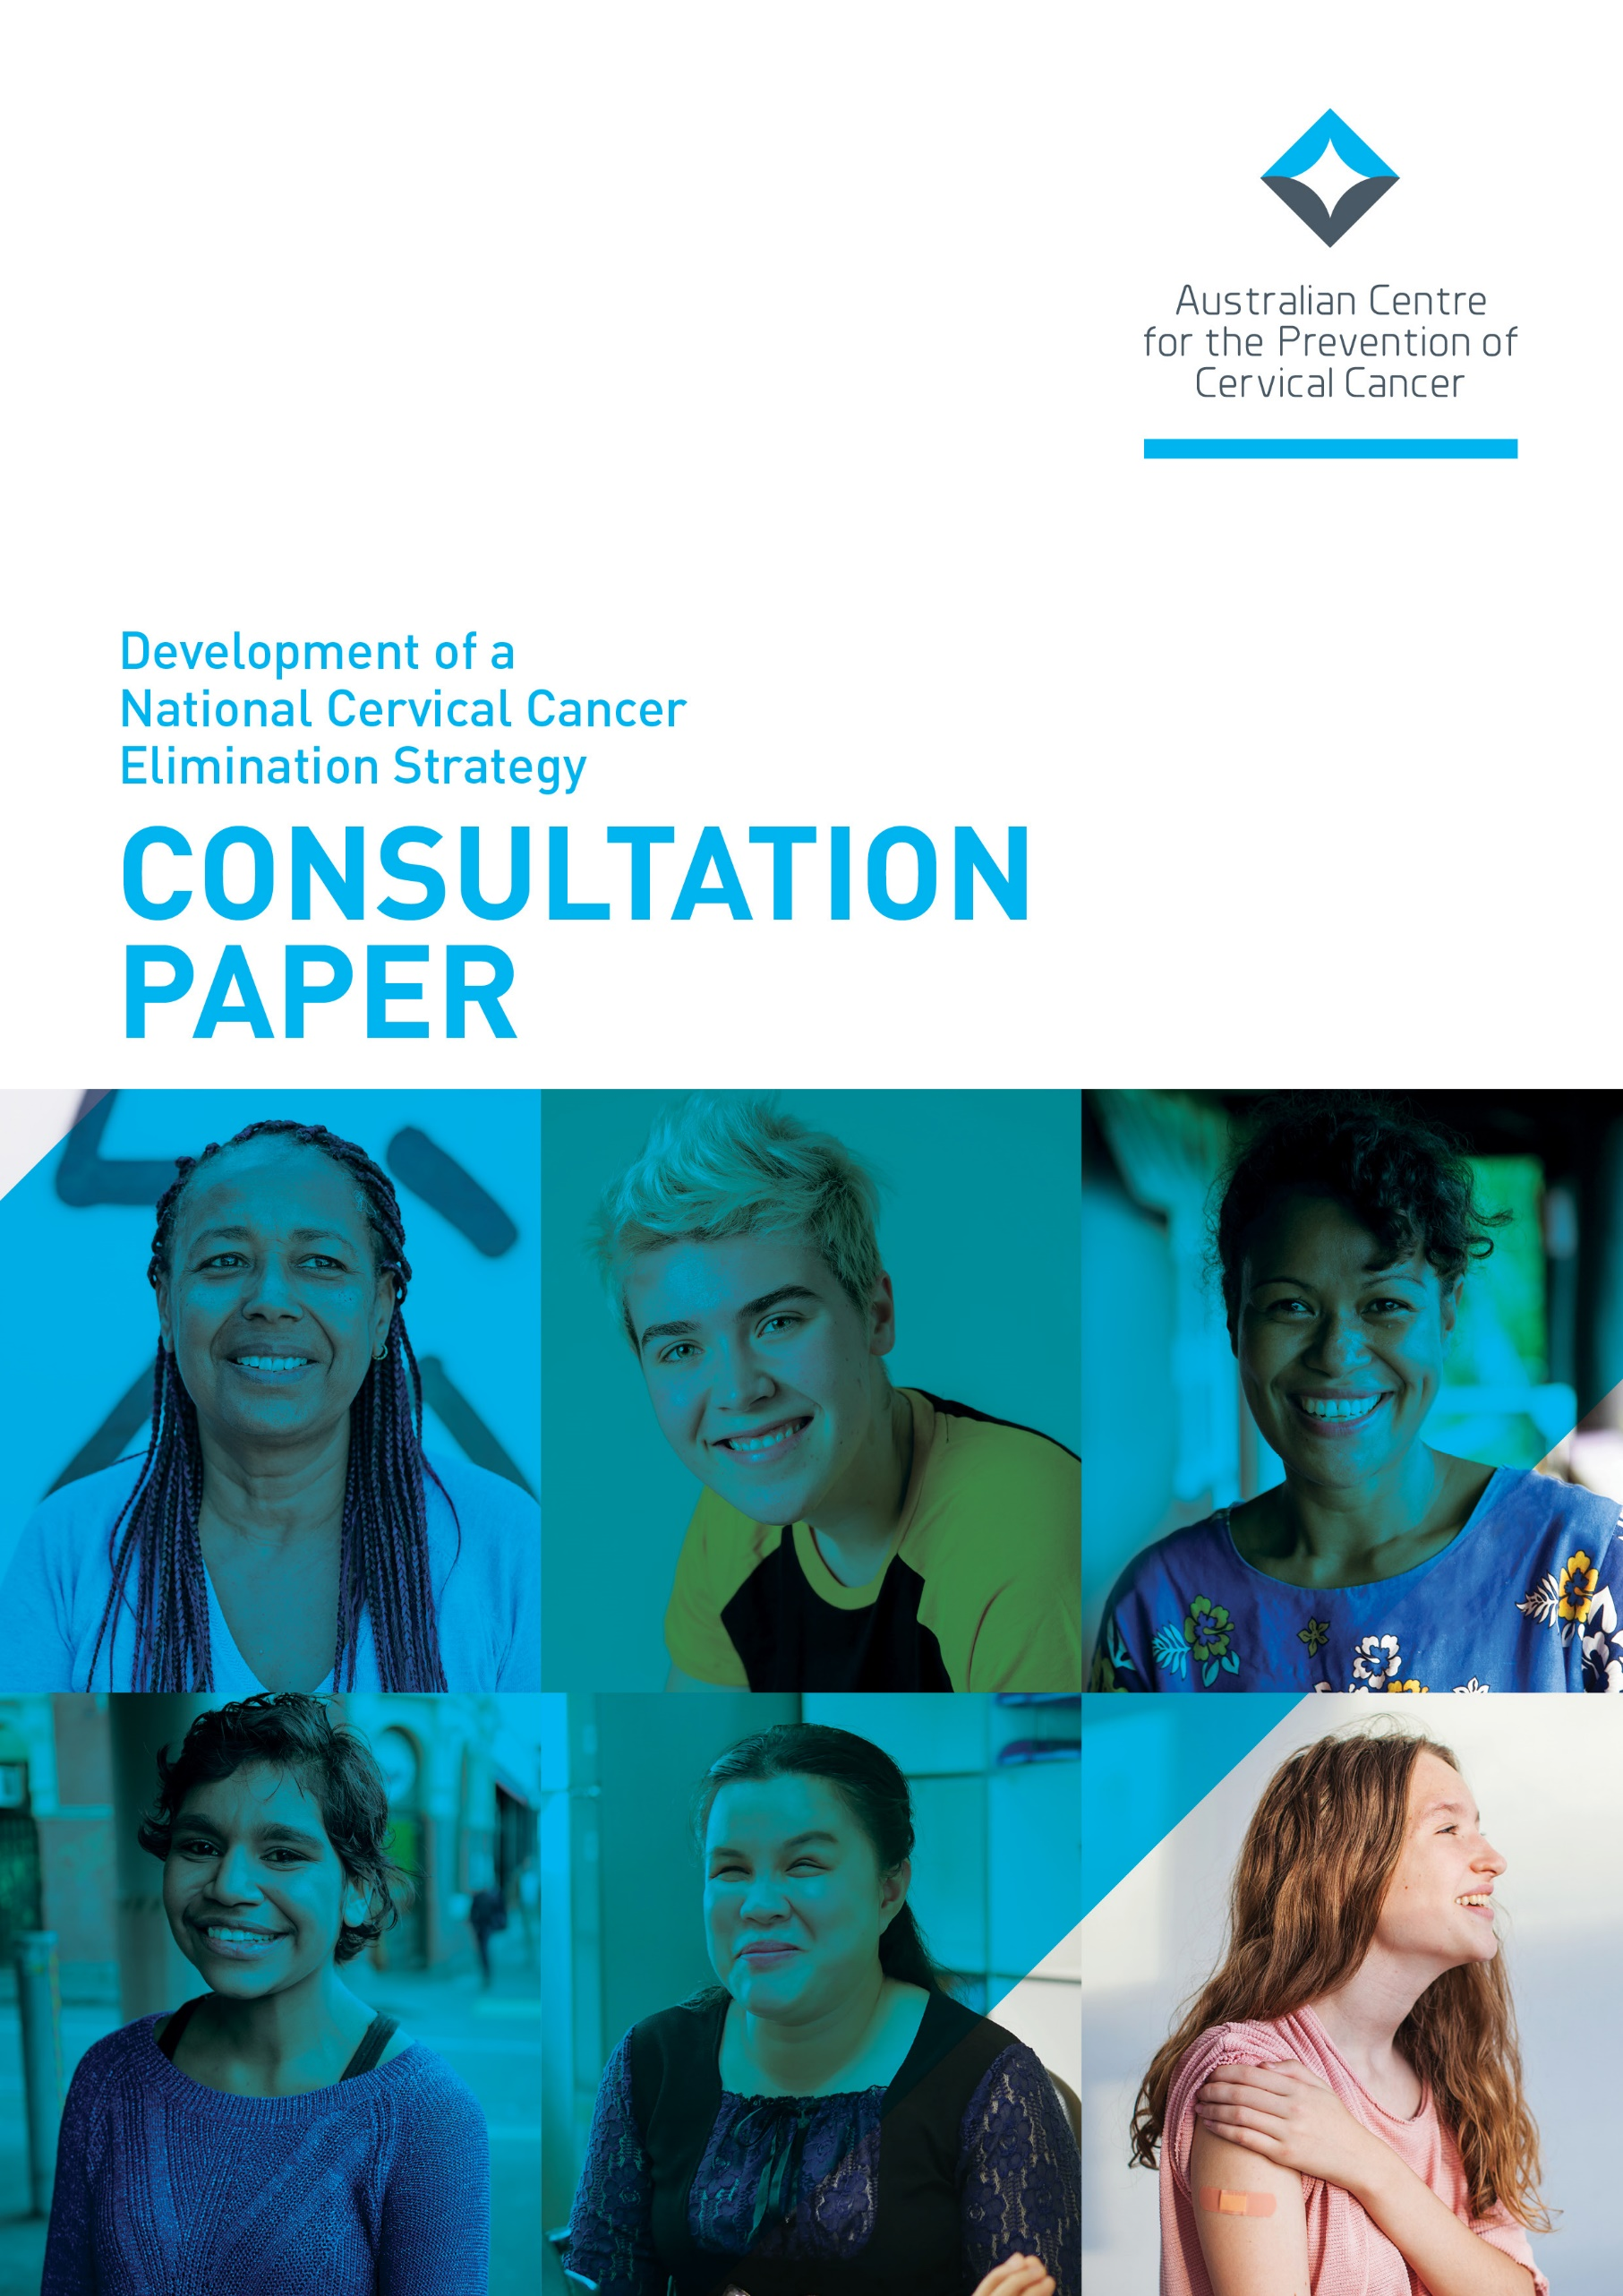

© 2022 Australian Centre for the Prevention of Cervical Cancer (ACN 609 597 408)
All Rights Reserved.
This document is the property of Australian Centre for the Prevention of Cervical Cancer and may not be copied, transmitted, distributed or reproduced by any means without the written permission of Australian Centre for the Prevention of Cervical Cancer.

Contents
Introduction 1
Who should respond to this Consultation Paper? 2
Foreword 3
Instructions for responding to this Consultation Paper 4
Background 5
The Global Strategy to Eliminate Cervical Cancer as a Public Health Problem 5
Developing a National Cervical Cancer Elimination Strategy for Australia 6
Equity and a strengths-based approach 6
Cervical Cancer in Australia 7
Australia’s progress against the WHO elimination targets 7
Incidence, Survival and Mortality Rates 8
Incidence 8
Survival 9
Mortality 9
Proposed Vision for Cervical Cancer Elimination in Australia 10
Pillar 1: HPV Vaccination 11
Vaccination: What have we learned 12
Lived Experience Questions 13
Vaccination: Tell us what works well or how to do things better 15
Vaccination: What have you learned that you could share with us? 16
Comparing a female-only HPV vaccination program and both-sex HPV vaccination program 16
Pillar 2: Screening and Treatment of Precancers 17
Screening: What have we learned 19
Lived Experience Questions 20
Screening: Tell us what works well or how to do things better 22
Pillar 3: Treatment 23
Treatment: What have we learned 24
Lived Experience Questions 26
Treatment: Tell us what works well or how to do things better 28
Treatment: What have you learned that you could share with us? 29
Appendices 30
Abbreviations and Acronyms 30
Important Concepts Explained 31
What does ‘a public health problem’ mean? 31
Underscreened and Neverscreened 32
Priority Groups 32
Tools to conquer cervical cancer, also called ‘the three pillars of elimination’ 33
Key events in Cervical Cancer Prevention in Australia 34
Related documents and links 34

Introduction
For the first time ever, it is possible to eliminate a cancer in our community. Australia is developing a national strategy to eliminate cervical cancer as a public health problem by 2035.
This goal can be achieved by making sure all women and people with a cervix* have access to three important tools to conquer cervical cancer:
- Vaccination against human papillomavirus (HPV) which causes most cervical cancers
- Cervical screening and treatment of precancers to find HPV infections and signs of changes in the cervix, and treat any abnormalities that are found
- Timely cervical cancer treatment and access to appropriate care and support services including palliative care.
This Consultation Paper provides information about how Australia is tracking in its goal to conquer cervical cancer. This Consultation Paper and an accompanying Technical Paper point to gaps and inequities in both services and outcomes, which mean that some groups of people experience higher rates of illness and death from cervical cancer than the wider community.
On the elimination journey to 2035, we need creative ideas and innovation to bridge these gaps and inequities so that all women and people with a cervix in Australia can enjoy a future free from cervical cancer.
We invite you to help develop the National Cervical Cancer Elimination Strategy by sharing your perspectives and answering the questions in this Consultation Paper.

* The National Cervical Cancer Elimination Strategy is for every Australian with a cervix, including women and people who do not identify their gender as female but have a cervix.

Who should respond to this Consultation Paper?
We are seeking responses from all individuals and organisations who have an interest in eliminating cervical cancer in Australia. You do not need to be an expert in cervical cancer, just be willing to share your experiences and ideas. Contributions from all sectors and parts of the community are important to help Australia eliminate this disease by 2035.
There are many people and organisations who already play a very important role in preventing, detecting and treating cervical pre-cancers and cancers, including those who are members of priority communities and/or provide health services to priority communities. For example:
- Aboriginal Community Controlled Health Organisations and their staff members
- Community-based primary care health services, including those led by peers of priority communities and nurse-led services
- LBGTIQ+ health services
- Multicultural community-led organisations
- Young people’s organisations and networks that have an interest in health and wellbeing
- Rural and remote area health service providers, including outreach services
- Immunisation services and nurses
- General practices and their staff
- Pathology laboratories and their staff
- Gynaecology clinics and colposcopists
- Oncology services and medical practitioners in public and private health services
- Palliative care services and staff
- Allied health and community-based support programs and services that serve people diagnosed with cancer and their families and carers
- Cancer Councils and other cancer-focused organisations and charities who provide information, support and programs right across the cancer pathway
- Colleges and associations for medical professionals, nurses
- Secondary schools and teachers providing health education, including special schools and non-mainstream schools, and staff who support the HPV vaccination program in their school
- Healthcare providers working in justice settings
- State and Territory Departments of Health
- Non-government organisations working to promote and protect public health
- And many more…

We encourage all these stakeholders to participate and we also warmly welcome feedback from stakeholders who are not listed here.

Foreword
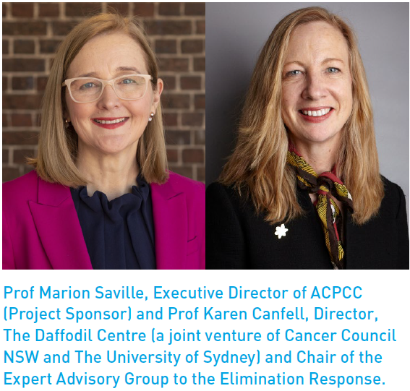
On the one-year anniversary of the Global Strategy to Accelerate the Elimination of Cervical Cancer, 17 November 2021, the Australian Government announced the development of a collaborative National Cervical Cancer Elimination Strategy (the Strategy), led by the Australian Centre for the Prevention of Cervical Cancer (ACPCC). This project will inform the Australian Government Department of Health’s future activities to eliminate cervical cancer as a public health problem in Australia by 2035.

Thank you for participating in the consultation process for the development of the National Cervical Cancer Elimination Strategy (the Strategy).
To achieve Australia’s aim to eliminate cervical cancer by 2035 for all women and people with a cervix, we need to hear from diverse voices including individuals with a personal experience to share, community members, subject matter experts, people working in health and other sectors, and representatives from many different organisations.
If you have a personal experience you’d like to share about HPV vaccination, cervical screening, and/or cervical cancer treatment the survey asks some specific questions related to lived experience. Your stories are incredibly important to helping Australia develop a a plan to eliminate cervical cancer and we are grateful to receive them.
We recognise that not all the topics and questions in this consultation will be relevant to all people, so please just answer those where you feel you can contribute.
The information you provide will be used to inform the Strategy but will in no way identify you unless you allow us to do so.
We encourage everyone to share your perspectives, help us learn from successful initiatives, and suggest innovative approaches to building an enabling environment for all communities across the three pillars of cervical cancer elimination - vaccination, screening, and treatment.
Warm regards
Prof Marion Saville & Prof Karen Canfell

Instructions for responding to this Consultation Paper
- Please read the Consultation Paper and then respond to the questions in it by completing the online survey on the Project Website.
  - The online survey contains questions sections on Lived Experience for all women and people with a cervix and families and carers who would like to share their experiences of HPV vaccination, cervical screening and/or cervical cancer and contribute their ideas to the Strategy.
  - The survey includes Technical questions for any organisation or individual who wishes to contribute to the development of the Strategy by sharing their knowledge about what works and what could be strengthened in Australia’s cervical cancer control programs and services.

- An Easy English version of the Consultation Paper and Lived Experience Questions is also available.
- The questions appear throughout the Consultation Paper so that you can think about them as you read each section. There is a Consultation Questions List if you would like to look at all the questions in one place.
- A technical paper contains in-depth data and literature about Australia’s current progress towards eliminating cervical cancer and key findings which highlight priorities that the Strategy will need to address. This paper also refers to related documents, such as the National Women’s Health Strategy 2020-2030.
- If you would like to know more about key topics, concepts and language we have used, please look at the extra information in the Appendices.
- Written submissions to the Consultation Paper on key topics are also welcome. Please use the guide provided on the Project Website which includes instructions for preparing and lodging a written submission.
All documents mentioned above can be found on the Project Website: https://acpcc.org.au/elimination/get-involved/
DUE DATE

Responses to the Consultation Paper, including via the online survey and written submissions, are due by FRIDAY 29 JULY 2022.

Contact the National Elimination Project Team for any queries: elimination@acpcc.org.au

Background
On 17 November 2020, the World Health Organization (WHO) launched an exciting Global Strategy with the ambition that within 100 years, cervical cancer can be eliminated in all countries around the world. For the first time in human history, it is now possible to make a common cancer into one that is very rare for all people around the world.
Australia has a proud history of global leadership in cervical cancer control prevention programs, research, and treatment. Our success in this field means that we currently have one of the lowest rates of illness and death from cervical cancer in the world, and we are on track to become the first country to eliminate this preventable cancer.
The Australian Government and our leading cervical cancer research experts provided strong support for the WHO’s efforts to develop the Global Strategy to Accelerate the Elimination of Cervical Cancer. Australia led the way by sponsoring a successful resolution at the 73rd World Health Assembly which called on all countries to adopt the Global Strategy.
We also want to lead the way by being the first country to achieve elimination and be an inspiration for other countries to do the same.

The Global Strategy to Eliminate Cervical Cancer as a Public Health Problem
The Global Strategy means that the world has made a collective commitment to take sustained action to eliminate cervical cancer as a public health problem within the next 100 years. This goal will be achieved when the number of people with cervical cancer falls to fewer than 4 per 100,000 women and people with a cervix in each country per year and can be maintained at this low level by countries over time.
To help all nations start working towards this goal, the WHO set three targets that each country should achieve by 2030 and then maintain and improve upon in the coming decades. The targets are linked to the three tools we have available to conquer cervical cancer: human papillomavirus (HPV) vaccination, cervical screening and treatment for cervical precancers, and treatment and care of people diagnosed with cervical cancer.
These three tools are often called the ‘three pillars of elimination’.

WHO 2030 Targets*
- 90% of girls to be fully vaccinated with the HPV vaccine by 15 years of age
- 70% of women to be screened by 35 and again by 45 years of age using a high precision test i.e., an HPV polymerase chain reaction (PCR) test
- 90% of women identified with cervical disease receive treatment for precancerous lesions or management of invasive cancer
* The WHO 2030 targets have been developed for a global context, particularly for Low- and Middle-income countries and therefore focus only on cis-gender girls and women. We respectfully acknowledge that these targets may not be inclusive of all people with a cervix as they are currently written.

Developing a National Cervical Cancer Elimination Strategy for Australia

Equity and a strengths-based approach
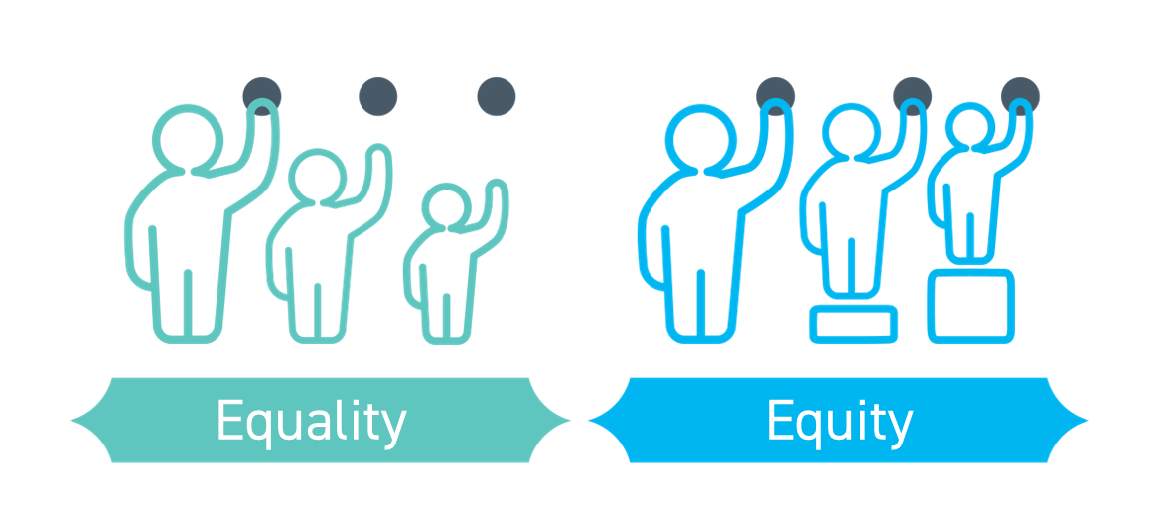

Equity is the key underpinning principle driving this Strategy. What do we mean by health equity?
- Health equity is about all people having a fair opportunity to attain their full health potential, and no one should be disadvantaged in achieving this potential if it can be avoided.
- Health and health equity are determined by the conditions in which people are born, grow, live, work, play and age, as well as by biological and structural determinants (political, legal, and economic)

Health inequities are differences in health status between population groups that are socially produced, systematic in their unequal distribution across the population, avoidable and unfair. Groups who experience inequity can be defined by where they live, their socioeconomic background, their sex, gender, ethnicity, disability, or sexual orientation. These are called the social and cultural determinants of health – such as where you were born, where you live, the community or communities you belong to, what work you do and your level of education all contribute to this. Achieving health equity means providing health services that address these inherent differences so that these factors are accounted for.
This Strategy aims to be equitable – that elimination of cervical cancer is achieved across all our diverse communities in Australia by addressing the social, systemic and avoidable issues that currently exist in relation to cervical cancer control.
The Strategy will embed the diversity of communities across Australia, including the diversity of cultures, languages, backgrounds, knowledge systems and beliefs.
- It must be developed with input from people from all walks of life, across all parts of the country.
- The knowledge, strengths and skills of people with lived experience across the the pillars of cervical cancer elimination must be at the centre of implementation.
- The experience and ideas of organisations working with diverse communities will also be key to a successful implementation of the Strategy, such as Aboriginal Community Controlled Services, disability services, LGBTIQ+ health services and many others.

Cervical Cancer in Australia

Australia’s progress against the WHO elimination targets
Incidence:
- Australia: 6.3 new cases per 100,000 (2012-2016)
- WHO target: <4 new cases per 100,000
Vaccination:
- Australia: 80.5% of females aged 15 years in 2020 were fully HPV vaccinated.
- WHO target: 90% of girls to be fully vaccinated with the HPV vaccine by 15 years of age
Screening:
- Australia: 54.9% of women aged 35 had been screened at least once with an HPV test by end 2019. HPV screening has not been available long enough for women and people with a cervix to have had two HPV tests by age 45.
- WHO target: 70% of women to be screened by 35 and again by 45 years of age using a high precision test i.e., an HPV PCR-based test.
Treatment:
- Australia: No national data available. Queensland data (2011-2014) show 94% of women with cervical cancer in metropolitan/ regional areas were treated and 92% in rural/remote areas.
- WHO target: 90% of women identified with cervical disease to receive treatment for precancerous lesions or management of invasive cancer.

Incidence, Survival and Mortality Rates
Australia has one of the lowest rates of illness and death from cervical cancer in the world. In low- and middle-income countries cervical cancer is one of the most common cancers amongst women and people with a cervix and it kills around 340,000 people each year globally. In Australian women and people with a cervix, it has almost become a rare cancer. Nevertheless, a diagnosis of cervical cancer is devastating for people and their families; we want to prevent and cure as many cases as possible.

It is estimated that in 2021 in Australia, 913 new cases of cervical cancer will have been diagnosed and 213 people will have died from cervical cancer. Over 70% of these new cases would be in people who underscreened or neverscreened.

Why is Australia doing so well in controlling cervical cancer? The National Cervical Screening Program, which began in 1991, helps to find cervical precancers and cancers at their earliest stage which gives a very high chance of successful cure. This program is well supported by healthcare practitioners and health promotion teams who are dedicated to strengthening community awareness about the importance of screening and providing inclusive, welcoming screening services, including the Aboriginal Community Controlled Health sector, community-based and nurse-led health services, Cancer Councils and others. In addition, our cancer treatment services are high-quality and improving all the time. Since 2007, we have also prevented many cervical cancers from developing in an ever-growing group of Australians through the introduction of HPV vaccination.

Incidence
The most recently available national data for the period 2012-2016 shows that the national incidence of cervical cancer was 6.3 cases per 100,000 women. However this incidence rate varies for some groups in the community who experience higher rates of cervical cancer than the national average. For example:
- Aboriginal and Torres Strait Islander women and people with a cervix are twice as likely to be diagnosed with cervical cancer (12.7 cases per 100,000 women)
- The further a woman or person with a cervix lives from a major city the higher the likelihood of being diagnosed with cervical cancer (in very remote areas the incidence rate was 9.6 cases per 100,000 women)
- The likelihood of being diagnosed with cervical cancer increases for women and people with a cervix living in areas with higher levels of socio-economic disadvantage (7.7 cases per 100,000 in the most disadvantaged areas vs 5.3 cases per 100,000 in the least disadvantaged areas)
More information about cervical cancer incidence can be found on page 26 of the Technical Paper.

Survival
Cancer survival is measured by the percentage of people who have been diagnosed with a cancer who are alive five years after their diagnosis.
74% of Australians are alive five years after their cervical cancer diagnosis. However there are inequities in survival as there are in incidence. For example:
- Only 58% of Aboriginal and Torres Strait Islander people survive for 5 years after their cervical cancer diagnosis, compared to 73% for Non-Aboriginal and Torres Strait Islander Australians.
- People who live in socio-economically disadvantaged areas are less likely to survive cervical cancer for five years or more (64.7% ) than those living in the most advantaged areas (78.9%)
More information about cervical cancer survival can be found on page 75 of the Technical Paper.

Mortality
The mortality rate measures the number of deaths per 100,000 people who are diagnosed with a disease.
In 2018, there were 232 deaths from cervical cancer in Australia and the cervical cancer mortality rate was 1.4 per 100,000 women in 2014-2018. Again, there are some groups in the community who are more likely to die from cervical cancer than the national average. For example:
- Aboriginal and Torres Strait Islander women and people with a cervix are 3.5 times more likely to die from cervical cancer
- Women and people with a cervix living in very remote areas are 3 times more likely to die from cervical cancer
- Women and people with a cervix living in the Northern Territory are twice as likely to die from cervical cancer
- The likelihood of dying from cervical cancer increases for women and people with a cervix living in areas with higher levels of socio-economic disadvantage⁵
More information about cervical cancer mortality can be found on page 29 of the Technical Paper.

Proposed Vision for Cervical Cancer Elimination in Australia
We want to create a short statement that explains the ‘vision’ of the Strategy. It is important that this vision statement helps to inspire the Australian community to get behind future efforts to eliminate cervical cancer.
Here is a proposed vision statement. We’d like to know what you think about it:

'Let's make Australia cervical cancer free.'
Our vision is of an Australia where cervical cancer is a disease of the past, in which our diverse communities receive information and access to culturally safe vaccination and screening services and when a now rare cancer is found, timely treatment and care are provided.

Survey Questions
- Please rate the proposed vision statement on a scale from 1-5 (where 1 is strongly disagree and 5 is strongly agree):
- The vision statement is clear
- The vision statement is meaningful
- The vision statement is inclusive
Ki. Please comment or share your revised statement:
- What key messages are important to raise awareness about the Strategy in your community?
- Which organisations should be invited to endorse this strategy?

Pillar 1: HPV Vaccination
Providing high coverage and equitable HPV vaccination programs is one of the three key pillars of the WHO Global Strategy. The WHO target for vaccination is to ensure 90% of 15-year-old girls are fully vaccinated against HPV.
In 1985, German scientists made a major breakthrough when they found that specific types of human papillomavirus (HPV) cause cancer of the cervix. Building on this discovery, Australian immunologist Professor Ian Frazer and his late Chinese colleague Dr Jian Zhou developed a vaccine to protect against the two most oncogenic (cancer-causing) types of HPV.
Australia was the first country in the world to introduce a national HPV vaccination program in 2007. Initially, the program offered the HPV vaccine to all female students aged 12-13 (as well as all girls and women aged up to 26 years until the end of 2009) and then in 2013 the program was expanded to include male students. The HPV vaccine is provided by immunisation nurses in secondary schools and can also be requested from a doctor at a primary care clinic. This ensures that if any doses are missed in school, young people can catch up at a clinic.
The type of HPV vaccine available through the program and the number of doses that are recommended has changed over time as knowledge has increased and vaccines improve. For example, scientists developed a vaccine that protects people against seven more oncogenic types of HPV and research showed that fewer doses of the vaccine were needed to achieve very long-lasting protection from HPV.
In 2018, a vaccine called Gardasil-9 was introduced in the Australian program. Gardasil-9 protects against nine different types of HPV that can cause cervical cancer and genital warts. Today, young people are recommended to have two doses of Gardasil-9, with the second dose required between six to twelve months after their first dose. Young people who have their first dose when they are aged 15 or older or are immunocompromised are still recommended to have three doses.
Most young Australian people receive all the doses of the HPV vaccine that is recommended by the age of 15, however there are some groups who are missing out on their second or third doses or not receiving any doses at all. HPV vaccination completion is lower for Aboriginal and Torres Strait Islander girls, for those living in remote areas, for those living in the most socio-economically disadvantaged areas, and it also varies across states and territories.
- 75% for Aboriginal and Torres Strait Islander young people vs 81% for non-Aboriginal and Torres Strait Islander young people
- 78% for lowest SES vs 82.5% for highest SES
- 75% for remote vs 80.7% for major cities
However, it is very encouraging that young Australians uptake of the first dose is quite similar when we compare dose one coverage between Aboriginal and Torres Strait Islander and non- Aboriginal and Torres Trait Islander young people, socio-economic groups, and geographical areas. In particular, Aboriginal and Torres Strait Islander girls have a higher coverage (87.8%) compared to non-Aboriginal and Torres Strait Islander girls (83%).
Research studies are increasingly beginning to show that one dose could be sufficient to provide very long lasting protection against infections of the types of HPV the vaccine prevents. In early April 2022, the World Health Organization’s Strategic Advisory Group of Experts on Immunization (SAGE) endorsed the use of just one dose of HPV vaccine to protect against cervical cancer. This is based on recent randomised trial data and long term observational data from key global studies. Australia’s immunisation experts are paying close attention to this evidence so that Australia can consider any potential future changes to the recommended immunisation schedule for HPV. The decision to change to a single dose schedule would be made by the Australian Technical Advisory Group on Immunisation (ATAGI), considering all available evidence.
More information about the National HPV Vaccination Program can be found on page 18 of the Technical Paper.

Vaccination: What have we learned
The HPV vaccination course completion rate (the proportion of young Australians who have had all the recommended doses) has gradually improved over time since the program began in 2007. National data from the Australian Immunisation Register show that in 2020, 80.5% of girls aged 15 years old were fully vaccinated against HPV. Whilst the WHO target does not include vaccination for both sexes, we do know that 76.5% of Australian males aged 15 years in 2020 were fully HPV vaccinated.
We do not have national data to show the differences in HPV vaccination coverage for some population groups, such as people living with a disability, LGBTIQ+ Australians, Australians who are culturally and linguistically diverse, and those in medical high-risk groups (e.g., living with HIV or immunosuppressed). However, some studies have found:
- 41% of trans and gender diverse Australian people reported having received HPV vaccination
- 7.8% of refugees and asylum seekers in a south-east Queensland clinic had a record of HPV vaccination.
- Uptake of adolescent school-based immunisations among students with a disability in 28 special schools in 2017 in Victoria showed that coverage of dose 1 HPV vaccine was 67% in females and 66% in males. Dose 3 coverage was approximately 40% for females and 43% for males. The main reasons for missed immunisations were absence from school, lack of consent and inability to immunise due to the student’s behaviour and/or anxiety.
More information about HPV vaccination coverage in Australia can be found on page 37 of the Technical Paper.

The following factors are known to help improve vaccination uptake, including groups that are currently experiencing lower vaccination rates:
- National HPV vaccine dose 1 coverage is higher than 2 dose coverage, including groups belonging to Aboriginal and Torres Strait Islander communities, remote areas and lower socioeconomic status.
- Known enablers to completing HPV vaccination in schools include:
  - Trust
  - Peer support for students
  - Convenience
  - Education about HPV and the vaccine
Known barriers to completing HPV vaccination in schools include:
- School absenteeism
- Low levels of student and parent knowledge about HPV and the vaccine
- Parents being unaware that the HPV vaccination course was not complete or unaware that they could complete the course at a GP clinic
- Logistical barriers
- Obtaining informed consent from parents: reasons including parental literacy, language and religious concerns, mixed views on paper-based compared to electronic consent forms
School factors are also known to impact vaccination uptake, for example:
- A study of school coverage in NSW, Western Australia and Tasmania found that smaller schools and special schools had lower uptake of dose one and that smaller and remote schools had lower rates of finishing the vaccine course.
A short summary of the key issues found in the review of HPV vaccination data and research studies can be found on page 49 in the Technical Paper.

Lived Experience Questions
LV1. Do you want to share your experience with HPV vaccination?

LV2. Have you or your child received the HPV vaccine?
- Yes, I did
- Yes, my child did
- No, but I would like to tell you about my experiences.
LV2a. If Yes, What was the most important thing that helped you decide to have HPV vaccination? (tick all that apply)
- Provided free at school
- My parents told me to
- Approval from family/friends
- Concerns about developing cervical cancer
- Recommended by a doctor
- Other reason. Please specify:
- Don’t know
LV2b. If no, why not?
- I am concerned about how safe the vaccine is
- I do not think I am at risk
- I am scared of needles
- I missed school that day
- My parents have anti-vaccination views
- My doctor told me I didn’t need it
- The vaccine was too new
- I needed more information
- I was not eligible (e.g., HPV Vaccination program hadn’t started, or only available for girls)
- Other reason. Please specify:
- Don’t know
LV2c. What helped you decide to consent to your child having the vaccine?
- Provided free at school
- Approval from family/friends
- Concerns about my child developing cervical cancer
- Recommended by a doctor
- Other reason. Please specify:
- Don’t know

LV3. Did you experience any difficulties accessing information about HPV vaccination?

LV4. Please share your ideas to improve information and support on HPV vaccination for young people and families.
LV5. Did you or your child have a positive experience in accessing HPV vaccination?
LV5a. Please describe the reasons for your answer

LV6. At what age do you think you should be able to decide for yourself about having the HPV vaccination?

LV7. Are you comfortable with information, such as gender, disability status, country of birth and language spoken at home being recorded about you or your child by the HPV vaccination program if it can be shared securely by linking records e.g. the National Disability Insurance Scheme, My Health Record?

LV8. Have you seen anything help to improve numbers of young people being vaccinated in your community or school?

LV8a. Please tell us more
LV9. Please share one idea to improve numbers of young people being vaccinated in your community, school or in general.

Vaccination: Tell us what works well or how to do things better
Technical Questions
V1. Please tell us about any successful initiatives to improve HPV vaccination.
V2. Please share one idea on improving HPV vaccination uptake either in communities, in schools, or at a wider health system level.

V3: Please rank the following areas of HPV Vaccination in terms of their importance for focus in the Strategy:
- HPV coverage estimates for priority populations
- Disparities in vaccine course completion
- Innovations addressing known access issues
- Education and health service partnerships
- Outreach and primary care strategies
- Strategies for a one-dose HPV vaccine schedule
- Funding and delivery models for targeted vaccination
- Parental reasons for decline
- Strategies to support access for adolescents with a disability
- Translation of learning from COVID vaccination programs
- Routine monitoring for priority groups
V3a: Are there any areas we have missed?

V3b: If yes, please specify

V4. What information do young people and their families need to make informed decisions about HPV vaccination?
V5. Please share new outreach strategies to increase the reach of the vaccination program to young people who may miss out on receiving the HPV vaccine.
V6. One request under consideration is a policy change that would permit secure access of demographic information obtained from other datasets such as the National Disability Insurance Scheme or Medicare to link with HPV vaccination data – do you support this request for a policy change?

V6a. Please explain your answer

Vaccination: What have you learned that you could share with us?
Technical Questions
V7. Are you conducting research on HPV vaccination implementation or working on a local initiative that could inform improvements to Australia’s HPV vaccination program?
V7a: If Yes: Please provide a short summary of this work

V7b: Does the National Elimination Project Team have permission to contact you or the project coordinator to find out more about the project/s?

V7c: Please provide name / contact details

Comparing a female-only HPV vaccination program and both-sex HPV vaccination program
HPV vaccination of males is not part of the WHO strategy for the elimination of cervical cancer, however Australia already has a HPV vaccination program for females and males. Modelling suggests that over a 70-year time period at coverage rates over 80% in a both-sex vaccination program or coverage over 90% in a single-sex vaccination program, local elimination of the HPV types that the vaccination protects against can be achieved.
The Vaccination Sub-Advisory Group for the Elimination Strategy project will collaborate with immunisation experts across Australia to assess the evidence and make recommendations to the Australian Government Department of Health about suitable vaccination coverage target/s for the Strategy. Subject matter experts who wish to provide feedback about this specific issue are invited to contact the Project Team at elimination@acpcc.org.au

Single Dose HPV Vaccination
Technical Question:
V8. If Australia chose to implement a single-dose HPV vaccination schedule, what issues need to be considered? (tick all that apply)
- Cost
- Logistics
- Acceptability
- Integration with other vaccination programs
- Maintaining equity in coverage
- Other. Please specify:
V8a. Please make any comments about implementation issues you wish to add.

Pillar 2: Screening and Treatment of Precancers
An organised National Cervical Screening Program (NCSP) began in Australia in 1991, recommending 2-yearly cytology screening (known as a Pap test) starting at age 18-20 years until age 69 years. The cytology test looks at a sample of cells taken from the cervix to find any abnormal cell changes which indicate that the screening participant has a precancerous lesion or a cancer.
When any abnormal result is found from a participant’s screening test, they may be recommended to have a repeat test in 12 months to monitor change over time (known as surveillance) or they may be referred to have a colposcopy. A colposcopy is a procedure to look closely at the cervix for abnormal cell changes (called lesions). A biopsy may be taken where a small amount of tissue is taken from the area of the lesion to be examined by a pathologist. Cervical precancers are often treated during a colposcopy procedure by removing tissue that has abnormal cell changes. For more information about colposcopy and biopsy, visit the Cancer Council Australia website here.
The program has changed significantly in the last ten years to respond to improved knowledge about what causes cervical cancer (HPV) and new ways to prevent it. A review of the NCSP began in 2011, in light of:
- Advances in screening test technologies
- The impacts of the HPV vaccination program on the optimal cervical screening age range and interval (time between routine screening tests)
- The decline in the incidence of cervical cancer had plateaued
In 2014 the Australian Government announced that there was strong evidence that cervical screening would become safer and more effective in detecting cervical precancers by changing from the two-yearly Pap test to 5-yearly HPV tests.
The HPV test involves a pelvic examination, where the doctor or nurse inserts a speculum into the vagina and takes a small sample of cells from the cervix using a soft brush. Modelling done during the review of the NCSP predicted that 5-yearly HPV based screening would lead to further decreases in cervical cancer incidence and mortality of at least 20% compared to the 2-yearly Pap test program. The review also recommended that the starting age for screening should change to 25 years and that women aged between 70-74 years should have a final cervical screening test before they exit the program.
The transition to five-yearly HPV screening and changes to the age range occurred in December 2017, and was called the Renewal of the NCSP.
Also in December 2017, a new National Cancer Screening Register (NCSR) replaced the eight state and territory cervical screening registers (which held screening histories, provided a safety net reminder and follow up service for screening participants and provided data to monitor program outcomes). The NCSR supports the NCSP by sending invitations to eligible people to join the program, reminders for those who are due or overdue to attend for routine screening or follow up tests, and records a complete cervical screening history for all women and people with a cervix who participate in screening. To assist healthcare practitioners in readily accessing a person’s screening history, the NCSR provides a secure healthcare provider portal. In addition, clinics can set up an ongoing link between NCSR records and their medical record software which is a very efficient way for GPs and nurses to access their patients’ screening histories. The NCSR also provides data for program monitoring, evaluation and research.
In early 2018, a new cervical screening option called ‘self-collection’ was made available on a limited basis to underscreened or neverscreened women and people with a cervix. Self-collection is an alternative option to the cervical screening test collected by a doctor or nurse using a speculum. Self-collection is a way for a screening participant to take their own test by inserting a thin swab (similar to the swab used for COVID-19 tests) into their vagina and rotating it a few times. The end of the swab doesn’t need to touch the cervix. This test is equally as effective for detecting cervical precancers as the test taken by a clinician or Nurse Cervical Screening Provider.

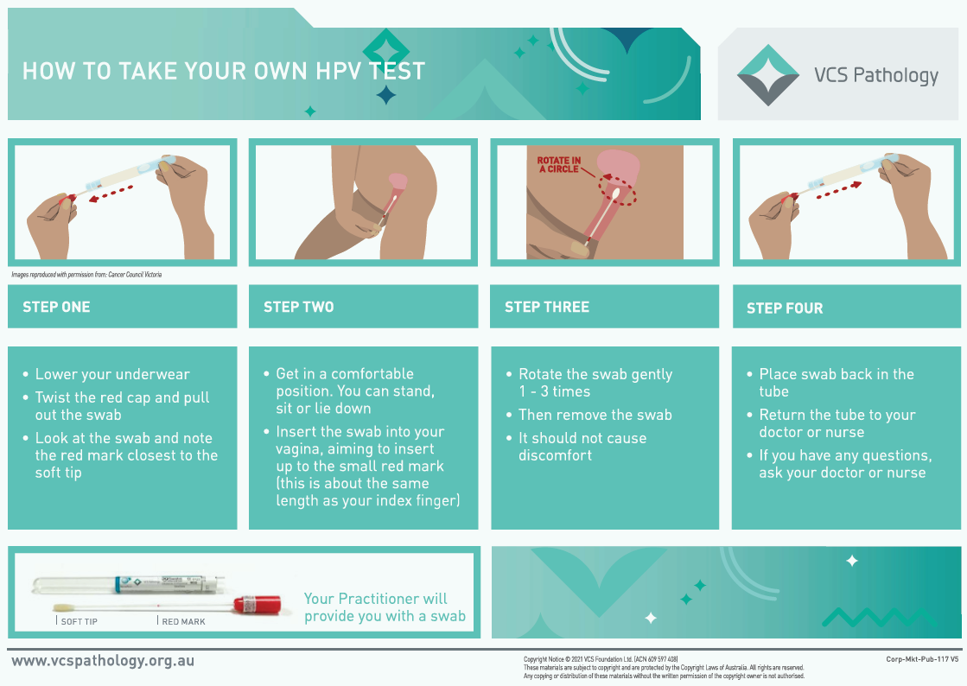

Self-collection is currently available to people who are aged 30 years or older, who are overdue for screening by at least two years or who have never had a screening test, and who decline a clinician-collected test using a speculum. However, from 1 July 2022 it will become an option for everyone when they have a cervical screening test. Screening participants will be able to choose which test option is right for them.

Screening: What have we learned
Screening participation among women and people with a cervix aged 25-69 years (selected as this age group has been consistently eligible for screening since 1991) has declined somewhat over time, from a peak of 64.9% in 1999, to 53.8% in 2019. The change from a two-year test interval to a five-year test interval means that the participation rate is difficult to measure accurately until the Renewed NCSP has been in place for more than five years. Note that, screening intervals differ for some population groups, for example, immune compromised people including those living with HIV should be screening more frequently, at 3-yearly intervals rather than 5-yearly.
We know that there are some population groups who are less likely to participate in cervical screening for a wide range of reasons. Who you are, where you live, and your level of access to resources to meet your healthcare needs can all impact on your ability and choice to participate in cervical screening. Populations in Australia that are more likely to be underscreened or neverscreened include:
- Aboriginal and Torres Strait Islander peoples
- Some culturally and linguistically diverse communities
- People with disability
- LGBTIQ+ communities
- People living in rural and remote areas
- People living in areas that are socio-economically disadvantaged
- People who have experienced sexual violence
- People with severe mental ill-health
- People experiencing homelessness
- People living in prisons
- People experiencing drug and/or alcohol dependence
- People living with obesity
- Younger women and people with a cervix aged 25-34
- Older women and people with a cervix aged 65 to 74
Program data also shows that certain population groups experience barriers to attending follow up tests and colposcopies. Among women and people with a cervix with an initial screening test in 2018 and 2019 who needed further follow up, the proportion who completed their follow up test was lower amongst:
- Aboriginal and Torres Strait Islander people
- People living in more remote areas
- People who are socioeconomically disadvantaged
A similar pattern is found when looking at program data for colposcopy; the same groups of women and people with a cervix are less likely to have a colposcopy within the recommended time period.
More information about equity in cervical screening participation can be found on page 54 in the Technical Paper.
A definition of equity in relation to this project is also provided in the Background section of this paper
Research studies have helped us understand more about the reasons some populations face challenges in participating in cervical screening, what are the strengths in those communities that can help overcome these challenges, and effective strategies that communities, healthcare services and programs can use to enable people to access and participate in the program.
Accessing screening can be made more difficult by barriers such as cost, lack of access to transport, distance to services, clinic opening hours, not receiving adequate reminders to have a screening test, or systemic racism in some healthcare settings. The experience people have when visiting a healthcare clinic and engaging with a healthcare provider about screening can also affect their choice to screen or not, as can individuals’ feelings, beliefs and knowledge about cervical screening. Some are also reluctant to see male healthcare providers for screening and colposcopy.
However, there are great strengths in underscreened communities which help women and people with a cervix feel confident and comfortable to access cervical screening. Examples include sharing positive screening experiences with family and friends, working side by side with health services to design programs and services that meet their communities’ needs, and advocating for better information and supports that meet the specific needs of priority groups.
Gaining a better understanding what these barriers and enablers are for underscreened and neverscreened groups and how we can overcome them is important for developing the Strategy.
To achieve elimination of cervical cancer, we need to ensure everyone can participate in screening in a way that feels safe, inclusive and meets their needs.
More information about barriers and enablers to cervical screening for a range of groups in the community can be found in the Technical Paper on page 68.

Lived Experience Questions

LS1. Do you want to share your experience relating to cervical screening?
LS2. Have you had a cervical screening test?
LS3. Have you ever delayed your cervical screening test?
LS3a. What are your reasons for not taking or delaying a cervical screening test? (tick all that apply)
- Lack of access – for example, remoteness, transport, not available at a convenient time
- Cost
- Fear, shame, embarrassment
- Language barriers
- Lack of services that feel safe for me
- Cultural beliefs about cancer or fear of stigma due to cancer
- Cultural beliefs about women’s bodies for example, sacredness, modesty
- Lack of information that was relevant to me – for example, not in your preferred language or without consideration of your culture
- I am not aware of the benefits of screening or my cervical cancer risk
- I am concerned about pain or discomfort with the speculum exam
- I have a negative previous experience with screening
- I have previous trauma that makes me concerned about screening
- I have other health issues that are more urgent
- I don’t have symptoms or feel sick
- I did not get an invitation or a reminder
- Other. Please specify
LS3b. Was your cervical screening test a positive experience?
LS3c. Please describe the reasons for your answer
LS4. A colposcopy is the procedure used when a doctor or nurse takes a close look to find changes to the cells of your cervix using a speculum. A colposcopy is the procedure used when your cervical screening test showed some abnormal cells and you tested positive for HPV. Have you had a colposcopy?

LS4a. Was your colposcopy a positive experience?
LS4b. Please describe the reasons for your answer:
LS5. What has helped you feel able to participate in cervical screening? (tick all that apply)
- Invitation and reminders
- Reducing logistical barriers, for example, flexibility on appointments
- Offer of self-collection
- Trusted providers
- Female providers
- Healthcare provider offers when I am attending health clinic for other reasons
- Awareness campaigns
- Education and promotion in my community
- A peer support person who encouraged me and/or came to appointments
- My GP or nurse recommended it
- The service where I had screening made sure I felt safe and included
- Opportunities to talk about screening in my community
- Recommendations from people who have had concerns about screening but do get screened
- Recommendations from peers or leaders in my community
- Understanding that screening prevents cervical cancer in future
- Understanding that detecting disease early prevents bigger problems in future
- Other. Please specify

LS6a. Have you experienced discrimination at your healthcare clinic and/or from a healthcare practitioner when you attended for cervical screening or a colposcopy?
LS6b. If yes, please tell us how this has influenced your participation in screening:
LS7. Please share one idea to improve cervical screening participation
LS8a. Do you know of an initiative (e.g. communications campaign, local project) that increases cervical screening access and participation?
LS8b. If yes, please describe the initiative and why you think it works
LS9. Before you read this Consultation Paper, had you heard about the option to take your own cervical screening test called self-collection?
LS10. Please share your views on what you like or don’t like about the option to take your own test.

Screening: Tell us what works well or how to do things better
Technical Questions
S1. Please tell us about successful initiatives to improve cervical screening participation.

S2. Please share one idea to improve cervical screening participation either in communities, in schools, or at a wider health system level.

S3. Please rank the following areas of cervical screening in terms of their importance for focus in the Strategy:
- Data completeness - histopathology and colposcopy
- Data completeness for priority populations across the full screening pathway
- Access to culturally safe and inclusive services
- Optimal implementation of self-collection
- Partnerships between service providers and community-led organisations to meet priority populations' needs
- Workforce reform to increase access to screening and colposcopy
- Routine monitoring of precancer treatment rates/ test-of-cure completion rates
- Digital technology for sending screening histories and reminders
- Tailored messaging for priority populations
- Developing alternative service models to address access barriers and needs
- Use of social media to deliver public education
- Healthcare provider awareness of symptoms/screening and follow up pathway

S3a: Are there any areas we have missed?

S3b: If yes, Please specify

S4. Are you directly involved in provision of cervical screening services?

S4a. If yes, what would help you to implement the new NCSP self-collection policy (commencing 1 July 2022)?

S5. What makes attending a cervical screening appointment feel inclusive and safe for the communities you work with? (Please include details of the community)

S6. Please share specific messages that help the communities you work with participate in cervical screening.

Pillar 3: Treatment
The WHO target for the treatment pillar of elimination is that, by 2030, “90% of women with invasive cervical cancer are managed". No national data are available but data from Queensland indicates that we are meeting this target in this state.
Ensuring that people diagnosed with cervical cancer receive high quality, timely, affordable and effective treatment, support, and palliative care when required is an important part of achieving cervical cancer elimination in Australia.
It is important to consider the delivery of cervical cancer treatment and palliative care services from the following perspectives:
- Access to treatment. Are we providing the best possible treatment and care to people with cervical cancer no matter where they live and what level of resources and income they have access to? Are there people, systems or resource factors that need to be addressed?
- Access to information. Are people diagnosed with cervical cancer and their families and carers provided with information that meets their specific needs and concerns?
- Following evidence-based or clinical guidelines with recognition of shared decision-making principles. Examples of shared decision-making include discussing options for people who wish to retain their fertility, and with those who wish to avoid certain types of treatment.
- Access to palliative care services and social supports.
- Participation in cancer multidisciplinary case conference and care.
An important question for developing the Strategy is whether all people with cervical cancer have the same treatment access and quality of care and support no matter where they live, and what level of resources or income they have.
Management of invasive cervical cancer is complicated. Management can include surgery, radiotherapy, or systemic therapy (chemotherapy and immunotherapy), or a combination of these treatment types. The type of treatment used depends on many factors including a person's cancer stage, their age and any other health conditions, what is being offered or available, and a patient's wishes. Cervical cancer treatment can occur in private or public healthcare services and can be delivered by one type of healthcare professional, such as a gynaecological oncologist, radiation oncologist, medical oncologist, or palliative care physician; or a team of professionals, called a Multidisciplinary Team (MDT).
Treatment of early stage cervical cancer depends on certain factors (e.g., future childbearing, level of invasion of the cancer) and could be one or a combination of:
- A large cone biopsy (removing tissue from the cervix)
- Trachelectomy (removing the cervix)
- Hysterectomy (removing the uterus and cervix)
- Radical hysterectomy (removing the uterus, cervix, adjacent connective tissue and upper vagina)
- Pelvic lymphadenectomy (removing the pelvic lymph nodes)
Later stage cervical cancer that has spread beyond the cervix is treated with chemoradiation, usually beginning with external beam radiation and then completed with brachytherapy.
If the cervical cancer has spread to distant organs or bones, stage IVB, the treatment is palliative. This includes treatment to reduce pain, bleeding or any other discomfort, including local radiation therapy to affected parts of the body and chemotherapy that may prolong (but not cure) life. It also includes psychosocial supports that the patient and their family and carers may need to ensure they have the best possible quality of life. Cancer Council Australia provides a helpful description of palliative care:
The aim of palliative care is to enhance your quality of life and help you maintain your independence. It also provides support to families and carers.
The role of palliative care is to:
- help you achieve the best quality of life
- make sure your physical, practical, emotional and spiritual needs are met
- help you make decisions about your treatment and ongoing care.

Treatment: What have we learned
Currently, Australia’s national cancer database does not contain the information we need to see the full picture of how Australia is tracking against the WHO elimination target for treatment. This is because treatment data is held separately across different systems, for example: across private clinics, private hospitals and public hospitals. Data is not captured and accessed through a single registry as in the case in other places across the world, for example in some European countries.
There are also currently no detailed national clinical guidelines for all types of treatment of cervical cancer. Australia’s Optimal Care Pathways contain a set of principles for optimal care, but these are very broad compared to clinical treatment guidelines available in other countries e.g., NCCN guidelines (USA) or British Columbia Cancer Network (Canada). There could be opportunities to develop more detailed Australian guidelines for all types of cervical cancer treatment.
Whilst there are no national data available on cervical cancer treatment, smaller studies have found some trends in cervical cancer treatment in Australia:
- Over 90% of people in Queensland diagnosed with cervical cancer receive some form of treatment (surgery, chemotherapy or radiotherapy).
- Around 80% of people in Victoria diagnosed with cervical cancer receive treatment (when defined as major surgery, chemotherapy or radiotherapy).
- Over 95% of people in South Australia received treatment for their cervical cancer.

Factors that may impact the care you receive
Where you live
People living in regional and metropolitan areas are more likely to receive treatment for cervical cancer than those living in rural and remote areas. This may be because certain treatment types are very specialised and need to happen at a large hospital with the right equipment, for example brachytherapy which is a specific type of radiotherapy often used to treat cervical cancer. Larger hospitals that have this specialised equipment also tend to have access to multidisciplinary teams, run clinical trials, and are typically based in metropolitan areas of the country. We also know that having access to a multidisciplinary team that includes psychologists and allied health professionals is very important to ensure the best quality care is provided for people being treated for cervical cancer.
Who you are
- Younger patients (under 40 years old) are more likely to receive surgery than another type of treatment.
- Older patients that need surgery are more likely to undergo a hysterectomy, instead of than more “conservative” surgical treatment, which includes conisation, Loop Electrosurgical Excision Procedure (LEEP), Large Loop Excision of the Transformation Zone (LLETZ), or less commonly, laser treatment.
- Aboriginal and Torres Trait Islander women and people with a cervix are seven times more likely to receive suboptimal care than non- Aboriginal and Torres Trait Islander women.
- Aboriginal and Torres Trait Islander women and people with a cervix in Queensland faced substantial challenges associated with late referral, misdiagnosis, miscommunication, lack of information, logistical challenges in accessing treatment and services, background life crises, and cultural insensitivities in the system.
- We know very little about the differences in access to treatment for different communities. For example, most datasets do not list information that can help understand if a person being treated for cervical cancer is from a Culturally and Linguistically Diverse (CALD) community, if they identify as LGBTIQ+ or is living with a disability. However, the groups of people with cervical cancer that health professionals have identified as having high needs include: those living in rural and remote locations, Aboriginal and Torres Strait Islander women and people with a cervix, culturally and linguistically diverse women, refugee women, lesbian, gay, bisexual, transgender, and/or intersex people, women with pre-existing mental health disorders, and women from other vulnerable groups (sexual abuse victims, frail aged, young adults)¹⁵.

Lived Experience Questions

LT1: What is your lived experience with cervical cancer?
- No lived experience (end of survey)
- Diagnosed with cervical cancer
- Cared for/supported/close to someone with cervical cancer
- Other. Please specify:

LT2. At diagnosis, did you receive information in a way that helped you understand cervical cancer and the treatment options for you (or the person you were caring for)?
- Yes, understood most of it
- Yes, understood some of it
- No
- Not sure

LT3. Were you told how you could get more information and who you could contact for support?

LT4. Which of the following information and supports for patients could be improved? (tick all that apply)
- More access to specialists, for example a second opinion
- Less complicated referrals
- Access to early supportive and palliative care
- Access to clinical trials
- Fewer diagnosis or treatment delays
- Better communication between my doctors (e.g., GP and specialist)
- Information at diagnosis
- Information about treatment options
- Information after I finished treatment
- Others: please specify
LT5. Did you (or the person you were caring for) have trouble accessing treatment after your diagnosis?
LT5a. If yes, tell us about these issues and what kind of support would have made a difference.

LT5b. If no, what made accessing treatment easy for you?

LT6. How long was it between diagnosis of cervical cancer and the first appointment for you (or the person you were caring for) with a specialist such as an oncologist?
- Cannot recall
- A month or less
- Between 1 and 3 months
- Between 3 and 6 months
- Longer than 6 months

LT7a. Was cervical cancer treatment for you (or the person you were caring for) delayed for any reason?

LT7b.If yes, please share the reasons.

LT8a. Were you (or the person you were caring for) offered the opportunity to participate in a clinical trial during your treatment?

LT8b. If no, would you (or the person you were caring for) have liked to have this option?

LT9a. Did you feel welcome and that you were treated respectfully when you (or the person you were caring for) were receiving cancer treatment and other types of care services?

LT9b. If yes, please tell us what made you feel this way:

LT9c. If no, please tell us what could be done better to make services more inclusive and respectful of different people’s needs and wishes:
LT10a. Did you/your carer receive appropriate information and assistance to be of most support?

LT10b. If yes, please tell us what made a difference:

LT10c. If no, please tell us what could be done better to support carers:
LT11. Please share one idea to improve treatment and care at the individual patient level, or within the health service you used, or at a state/national health system level?

Treatment: Tell us what works well or how to do things better
Technical Questions
T1. What improves access to timely treatment for people with cervical cancer? (tick all that apply)
- Communication & Information
- Referral processes
- Access to clinical staff
- Access to specialised centres
- Patient Assistance Travel Scheme
- Culturally safe and inclusive services
- Accommodation
- IT systems
- Presence of caregiver
- Others: Please specify

T2. Please share reasons for delays in diagnosis of cervical cancer where you work.
T3. Please share reasons for delays in start of cervical cancer treatment where you work.
T4. Please share measures that improve provider adherence to evidenced-based care and clinical guidelines.
T5. What improves access to appropriate palliative care and social supports for people with cervical cancer?
- Communication & Information
- Referral processes
- Access to clinical staff
- Access to specialised centres
- Patient Assistance Travel Scheme
- Culturally safe and inclusive services
- Accommodation
- IT systems
- Presence of caregiver
- Others. Please specify:

T6. Please share one idea for improving cervical cancer treatment and care at the level of the patient, health service, or state/national health system.
T7. Please share successful initiatives to promote health literacy in cervical cancer care where you work.

T8. Please rank the following areas of cervical cancer treatment and palliative care in terms of their importance for focus in the Strategy:
- Improved national data for monitoring treatment outcomes
- Structural/cultural barriers for priority populations
- Exploring use of a National Gynae-Oncology Register
- Sentinel surveillance through local clinical cancer registries or tertiary centres
- Developing an Implementation strategy for the Optimal Care Pathway

T8a: Are there any areas we have missed?

T8b: Please specify

T9. Would you like to see Australia develop more detailed evidence-based clinical guidelines for the range of cervical cancer treatment modalities? If yes, please indicate for which modalities:
- Surgery
- Radiotherapy
- Systemic Treatment
- Palliative care
T9a. If you are aware of any inconsistencies in how current treatment guidelines and protocols are applied in these four modalities across the country, please describe the inconsistencies.
T10. Are there models of care that Australia could learn from?
T10a. If yes, please provide a link or describe

Treatment: What have you learned that you could share with us?
Technical Questions
T11. Are there critical principles required to address the need for health services to engage with and care for priority groups in ways that meet their specific needs?
T11a. If yes, please provide a link or describe these principles, in general or for a specific group:

T11b. Please share one successful model for meeting the information and care needs of priority groups.

T12. Please share specific messages that help the communities you work with access timely diagnosis, treatment, and palliative care:

Final Comments
Please share any other comments that you would like to be considered in the Strategy to eliminate cervical cancer.

Appendices

Abbreviations and Acronyms
ACPCC | Australian Centre for the Prevention of Cervical Cancer
AIHW | Australian Institute of Health and Welfare
AIR | Australian Immunisation Register
ATAGI | Australian Technical Advisory Group on Immunisation
CALD | Culturally and linguistically diverse
HPV | Human Papillomavirus
DOH | Australian Government Department of Health
LGBTIQ+ | People who identify as Lesbian, Gay, Bisexual, Trans, Intersex, Queer, and '+' represents minority gender identities and sexualities not explicitly included in the term LGBTIQ.
NCSP | National Cervical Screening Program
NCSR | National Cancer Screening Registry
SAGE | World Health Organization’s Strategic Advisory Group of Experts on Immunization
Three pillars | The three tools to eliminate cervical cancer as a public health problem:  - Pillar 1: human papillomavirus (HPV) vaccination  - Pillar 2: cervical screening and treatment for cervical precancers  - Pillar 3: treatment and care of cervical cancer.
WHO | World Health Organization

Important Concepts Explained

What does ‘a public health problem’ mean?
“Public health” is defined as the science of protecting the safety and improving the health of communities through education, policy making and research for disease and injury prevention. In the context of cervical cancer in Australia, there is a national vaccination and screening program to protect people from the disease, and optimal care pathways to support those who are diagnosed with it.
A “public health problem” means that a medical issue affects a significant portion of a population and public health measures are needed to control this issue. In the context of cervical cancer, it is a public health problem in Australia (and globally) because it is a preventable disease, so the current level of cases and deaths are at a level that is not acceptable, particularly in certain community groups where cases and deaths are higher.
The technical definitions are explained below:
- Cervical cancer is considered ‘eliminated’ if the number of new cases is less than 4 per 100,000 women and people with a cervix in Australia
- Cervical cancer is considered ‘rare’ if new cases are less than 6 per 100,000 women and people with a cervix
- Cervical cancer is considered ‘eradicated’ if there are zero new cases.

What does elimination of cervical cancer as a public health problem mean?
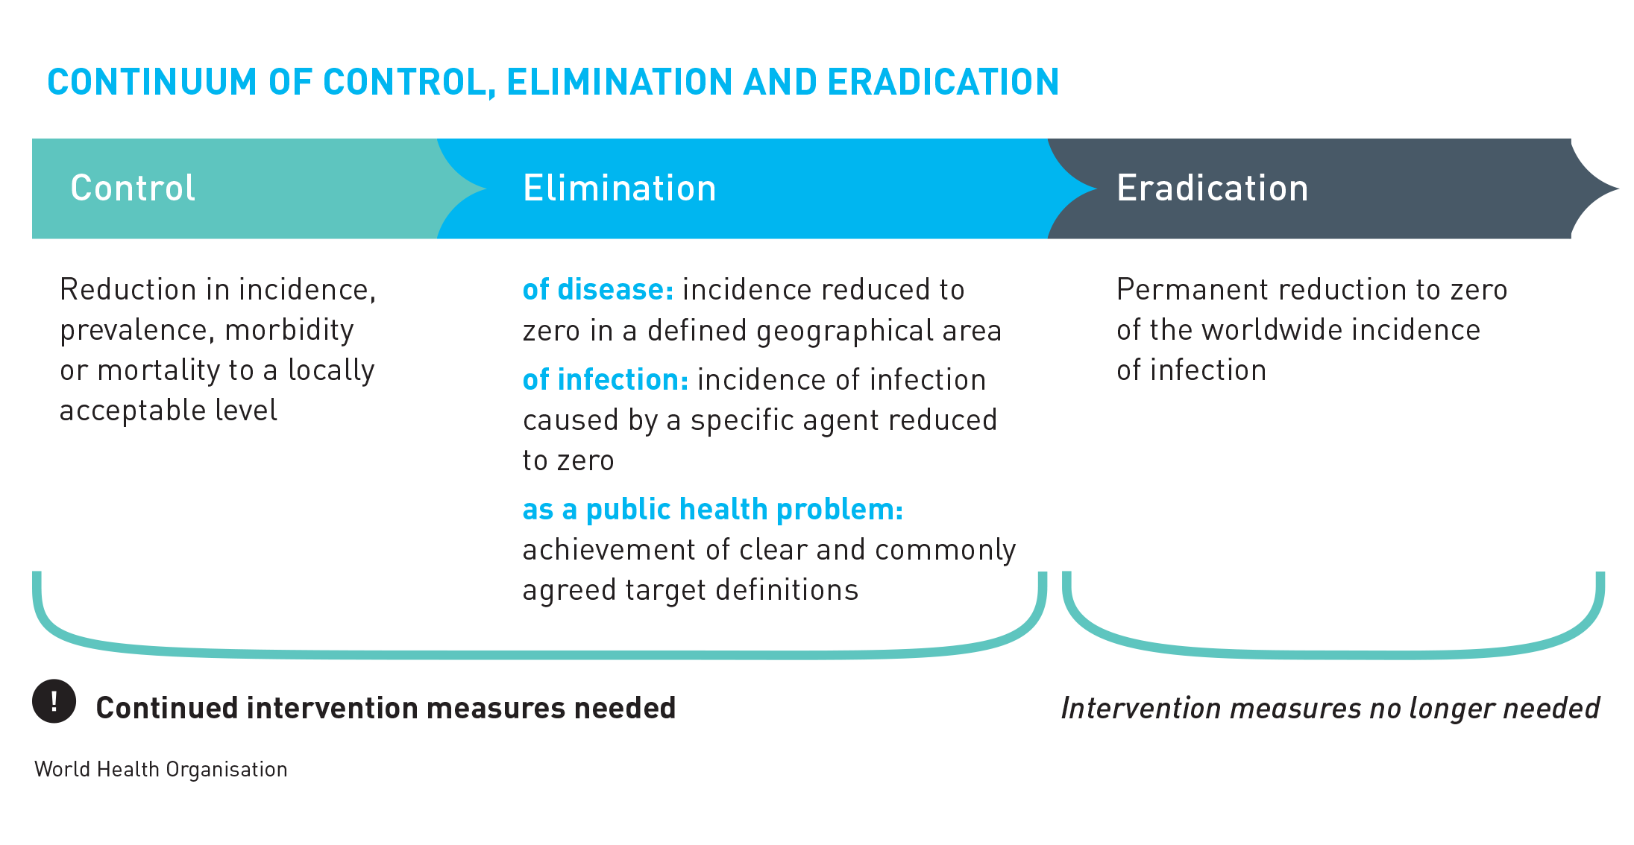Eliminating cervical cancer means that the number of women and people with a cervix who are diagnosed with cervical cancer is reduced to a very low number. It’s important to understand that it does not mean there will be no cases of cervical cancer in the Australian community at all.
No cases at all would be described as ‘eradication’. This is only possible when there is a single cause of a condition, and it is possible to permanently remove that cause. An example of where the world has permanently eradicated a disease, so that there are zero infections from that disease, is smallpox. Cervical cancer cannot be eradicated, as there are certain types of cervical cancers that are not caused by HPV and therefore cannot be prevented.These cervical cancers occur in 2 per 100,000 of women and people with a cervix in Australia.
The World Health Organization (WHO) says that elimination of cervical cancer is achieved by a country when fewer than 4 cases of cervical cancer are diagnosed for every 100,000 women in its population, and that it can keep the number of cases at this very low level. Australia aims to reach this goal by 2035.

Underscreened and Neverscreened
The term underscreened includes women and people with a cervix who have had a cervical screening test at least once and are eligible to have another screening test through the National Cervical Screening Program, but they are currently significantly overdue for their next screening test for any reason.
The term neverscreened refers to women and people with a cervix who are eligible to have a cervical screening test through the National Cervical Screening Program but have never had one, for any reason.

Priority Groups
When we refer to priority groups or priority populations in this Consultation Paper, this includes communities who are underscreened and neverscreened. It also includes groups of people who experience inequities in access to HPV vaccination and cervical cancer treatment and palliative care.

Tools to conquer cervical cancer, also called ‘the three pillars of elimination’
In this Consultation Paper, we refer to the tools to conquer cervical cancer, which are also often called ‘the three pillars of elimination’. It is possible to prevent cervical cancer and, when it does occur, to find it early and treat it. First though, it is important to understand the cause of cervical cancer.
Human papillomavirus, known as HPV, causes almost all cases of cervical cancer. HPV is an extremely common sexually transmitted virus that around 90% of people will have at least once in their lifetime. It is transmitted very easily during sexual activities through skin-to-skin or skin-to-mouth contact of the genital parts of the body.
Most people will never know they have an HPV infection, except when it is found during a cervical screening test. Most HPV infections do not cause symptoms and the body usually clears the infection by itself within 18 months. It is only when an HPV infection is persistent (which means it stays in the body for a long time) that it can cause changes to the cells in the cervix. These cell changes can, over many years, lead to cancer of the cervix if they are not found and treated early.

Tools to conquer cervical cancer | How do these tools work?
PREVENT cervical cancers by vaccinating young girls and people with a cervix against the human papillomavirus (HPV) by the time they turn 15. | Australia’s HPV Vaccination Program offers a HPV vaccine that protects against nine different types of HPV which can cause cancer (or gential warts). All young Australians are offered this vaccination at school at the age of 12-13 years, or they can also have it at their doctor’s clinic.
PREVENT & DETECT cervical pre-cancer and cervical cancer by providing cervical screening tests to all women and people with a cervix, and treating precancers | Cervical screening tests look for HPV infections in the cervix. If HPV is found, the screening participant can be monitored and have further tests to make sure any signs of abnormal cell changes are found early and can be treated.  In Australia, women and people with a cervix can have a screening test every five years from age 25 to 74 through the National Cervical Screening Program. An HPV test is the recommended cervical screening test for the best prevention and early detection outcomes.
TREAT cervical cancer | It is important that women and people with a cervix who who are diagnosed with cervical cancer receive appropriate treatment and care, including palliative care when this is needed.  People with cervical cancer have the best chance of receiving effective treatment to cure their cancer or to live longer with their cancer when it is found early.

Key events in Cervical Cancer Prevention in Australia
1991: The National Cervical Screening Program (NCSP) then known as the "Organised Approach for the Prevention of Cervical Cancer", was established by the Australian Government in partnership with state and territory governments. This recommended all women who have been sexually active at any stage in their lives to have a Pap smear every 2 years until age 70 years.
1994: First NHMRC Guidelines released – Screening to Prevent Cervical Cancer: Guidelines for the Management of Women with Screen Detected Abnormalities
2006: New NHMRC Guidelines for the Management of Asymptomatic Women with Screen Detected Abnormalities released
2007: School-based vaccination program introduced (routine age 12-13 years) for girls with “catch up” vaccination to older adolescent girls and young women up to age 26 through to end 2009 under the National HPV Vaccination Program
2013: School based vaccination for boys introduced, with catch up to age 15 years
2016: The National Cancer Screening Register was established, gradually replacing the eight state and territory cervical screening registers by 2019
2017: Commencement of Renewed NCSP utilising primary HPV screening with partial genotyping and reflex cytology
2017: Funded catch up of all vaccines, including HPV vaccine, commences through primary care to the age of 19 years (ongoing)
2018: The HPV vaccination program changed from 3-dose quadrivalent HPV vaccine to 2-dose nonavalent HPV vaccine
2021: Australian government announces that HPV self-collection will become available to all screening participants from 1 July 2022

Related documents and links
The following related documents can be found on the Project Website at https://acpcc.org.au/elimination/get-involved/
- Consultation Questions List: a full list of all consultation questions. Available here:
https://acpcc.org.au/wp-content/uploads/2022/05/Consultation-Questions-List_PUBLISH.pdf

- Technical Paper: a strategic overview of data and relevant research, and current practice and policy, to inform the development of Australia’s National Cervical Cancer Elimination Strategy. Available here: https://acpcc.org.au/wp-content/uploads/2022/05/Technical-Paper-for-National-Cervical-Cancer-Elimination-Strategy.pdf

Australian Immunisation Register via the National Centre for Immunisation Research and Surveillance. Sex (Female) as recorded on AIR (Medicare derived).
Australian Institute of Health and Welfare 2021. Cancer in Australia 2021. Cancer series no. 133. Cat. no. CAN 144. Canberra: AIHW.
Cancer Australia. Cervical cancer in Australia statistics. Updated 3 January 2022. Available at https://www.canceraustralia.gov.au/cancer-types/cervical-cancer/statistics#:~:text=Survival,from%2071%25%20to%2074%25 [Accessed 28 April 2022]
Australian Cancer Database 2017
NHMRC Centre of Research Excellence in Cervical Cancer Control. 2021 Cervical Cancer Elimination Progress Report: Australia’s progress towards the elimination of cervical cancer as a public health problem.
World Health Organization. https://www.who.int/news/item/11-04-2022-one-dose-human-papillomavirus-(hpv)-vaccine-offers-solid-protection-against-cervical-cancer, accessed 12 April 2022.
Kerr, L., Fisher, C.M., Jones, T. 2019. TRANScending Discrimination in Health & Cancer Care: A Study of Trans & Gender Diverse Australians, (ARCSHS Monograph Series No. 117), Bundoora: Australian Research Centre in Sex, Health & Society, La Trobe University.
Nyanchoga MM et al. Exploring electronic health records to estimate the extent of catch-up immunisation and factors associated with under-immunisation among refugees and asylum seekers in south east Queensland. Vaccine 2021;39:6238-34.
O’Neill J et al. The uptake of adolescent vaccinations through the School Immunisation Program in specialist schools in Victoria, Australia. Vaccine 2019; 37: 272-279.
Davies C et al. School-based HPV vaccination positively impacts parents’ attitudes toward adolescent vaccination. Vaccine 2021;39:4190-98.
Brisson M et al. Population-level impact, herd immunity, and elimination after human papillomavirus vaccination: a systematic review and meta-analysis of predictions from transmission-dynamic models. Lancet Public Health. 2016 Nov;1(1):e8-e17.
Australian Gynaecological Cancer Foundation. Cervical Cancer: Treatment of Cervical Cancer. Available at https://agcf.org.au/cervical-cancer/ [Accessed 7 April 2022]
Cancer Council Australia. Palliative Care. Updated August 2021. Available at https://www.cancer.org.au/cancer-information/treatment/palliative-care [Accessed 7 April 2022]
Beesley VL, Staneva A, Nehill C, Milch V, Hughes F, Webb PM. Patterns of, and barriers to supportive care needs assessment and provision for Australian women with gynecological cancer and their caregivers: a mixed-methods study of clinical practice. Palliat Support Care. 2020;18(2):170-7.
Whop L, Bernardes C, Kondalsamy-Chennakesavan S, Darshan D, Chetty N, Moore S, et al. Indigenous Australians with non-small cell lung cancer or cervical cancer receive suboptimal treatment. Asia-Pacific journal of clinical oncology. 2016;13.
Marcusson-Rababi B, Anderson K, Whop LJ, Butler T, Whitson N, Garvey G. Does gynaecological cancer care meet the needs of Indigenous Australian women? Qualitative interviews with patients and care providers. BMC Health Services Research. 2019;19(1):606.

